Name ………………………………………………………Signature …………………
END OF TERM I, 2018
S.6 BIOLOGY (THEORY)
PAPER 1
TIME: 2 HOURS 30 MINUTES

INSTRUCTIONS
- Attempt ALL questions

Table for answers for section A.
Qn: |  | Qn: |  | Qn: |  | Qn: |  | Qn: |  | Qn: |  | Qn: |  | Qn:
1 |  | 6 |  | 11 |  | 16 |  | 21 |  | 26 |  | 31 |  | 36
2 |  | 7 |  | 12 |  | 17 |  | 22 |  | 27 |  | 32 |  | 37
3 |  | 8 |  | 13 |  | 18 |  | 23 |  | 28 |  | 33 |  | 38
4 |  | 9 |  | 14 |  | 19 |  | 24 |  | 29 |  | 34 |  | 39
5 |  | 10 |  | 15 |  | 20 |  | 25 |  | 30 |  | 35 |  | 40

SECTION A (40 MARKS)

- Which one of the following pairs of hormones would be most active during periods of physiological stress in plants?
- Ethane and abscissic acid
- Cytokinins and ethene
- Abscissic acid andgibberellins
- Ethane and auxins

- Contraction of the internal intercostal muscles results into
- increased pressure in the thorax
- the ribs moving inwards and downwards
- lowering the volume of the chest cavity
- flattening of the diaphragm

- Simple diffusion of hydrophobic molecules is aided across the plasma membrane by;
- glycoprotein
- globular protein
- transmembrane protein
- lipids

- The synthesis and assembly of cell wall components is a function of the
- Golgi body C. microtubules
- Ribosomes D. cell membrane

- The walls of sclerenchyma cells stain yellow in aniline chloride because they
- are very thick C. contain lignin
- are thickened by cellulose D. contain suberin

- The diameter of glomerular capillaries is much less than that of the arterioles in order to
- eliminate glucose from the filtrate
- raise the filtration pressure
- eliminate proteins from urine
- slow down the process of filtration

- During carbon dioxide transport the movement of chloride ions from the plasma into red blood cells is aimed to
- restore its water potential
- maintain the blood PH
- restore electroneutrality of the cell
- maintain a larger diffusion gradient for ions3

- Below are some features of members in phylum arthropoda
- Distinct head
- Water proof exoskeleton
- Herbivorous nature
- Bilateral symmetry

Which of the above features are common to both Chilopoda and Diplopoda
- 1,2 and 3 only C. 1,2,3 and 4
- 1 and 3 only D. 1,2 and 4 only

- Which of the following epithelial tissues lines the oviduct?
- Stratified C. Cuboidal
- Squamous D. Ciliated

- Which of the following characteristics in an insect is least suitable for use in identification keys?
- Body colour. C. number of hairs on the body
- Shape of the abdomen D. length of wings

11. Which property of water is important in the translocation of water through the stem?
- Solvent properties C. high surface tension
- High heat of fusion D. high heat of vaporization
12. Which of the following statements describes the structure of amylopectin?
- A branched chain with 1,2 and 1,4 glycosidic bonds
- A branched chain with 1,4 and 1,6 glycosidic bonds
- An unbranched chain with only 1,4 glycosidic bonds
- An unbranched chain with 1,4 and 1,6 glycosidic bonds

13. A rat requires more energy per unit body mass than man because the rat
- has a large surface area C. has higher body temperature
- is more active D. has a higher metabolic rate

14. Which of the following methods of controlling malaria would cause least damage to the environment?
- draining swamps
- Spraying swamps and ponds with insecticides
- Spreading oil over the stagnant water
- Introducing fish in swamps and ponds

15. Which of the following type of cells is unlikely to be found in the mammalian intestines?
- Stratified C. Ciliated
- Columnar D. Squamous

- Which of the following is true of meiosis I but not of mitosis ?
- Two daughter cells are produced
- Disappearance of the nucleolus
- Spindle fibers are formed
- Bivalents are formed

- Production of red blood cells in the mammalian fetus is carried out by the
- bone marrow C. liver
- spleen D. lymph nodes

- Which of the following factors determines the ecological range of a mobile animal?
- Breeding space C. Availability of food
- High temperatures D.Size of the community

- The cell wall and cell membrane are;
A semi-permeable and permeable respectively
C. semi-permeable
B. permeable
D. permeable and semi-permeable respectively

- A couple has two sons and two daughters but each belongs to a different blood group. The blood groups of this couple are:-
A. A and B B. B and AB
C. AB and O D. A and O

- An athletics competition organized on highlands required participants from low lands to report three months before the competition in order to enable them
A. get familiar with the place.
B. develop strong muscles.
C. acquire high red blood cell count
D. have extensive deposition of fat under their skins

- Figure 2 shows the four patterns of population dispersion.
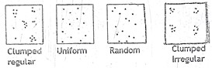

Which of the following occurs in homogenous environment?
A. Clumped regular B. Uniform
C. Random D. Clumped irregular

- Figure 1 shows a structure found in a chloroplast
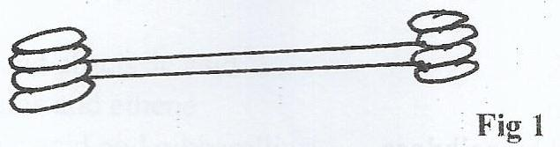

Which of the following is the correct function of this structure?
- Storage of starch C. Oxidation of chloroplast
- Synthesis of electron carriers D. Harnessing light energy

- Which of the following is a direct ecological effect of global warming?
- Extinction of species C. Death of organisms
- Reduction in diversity D. Melting of ice caps

- Which one of the following may result into pest resurgence?
- Incorporation of the pesticide into the food chain
- Use of a broad spectrum pesticide
- Using more than two treatments on the same pest
- Use of a persistent pesticide
- When drosophila flies that are heterozygous for size of wing and body color were crossed with flies that have vestigial wings and ebony bodies the F₁ offspring that resulted are as follows;
Normal wing grey body :522
Vestigial wing grey body : 98
Normal wing ebony body: 104
Vestigial wing, ebony body:486

The cross over value for this cross is
A.8% B. 9%
C. 17% D. 20%

- Which one of the following statements is consistent with the mass flow theory?
- Only organic molecules can be transported in the vascular tissues
- Molecules tend to move independently of each other
- Only inorganic molecules can be transported in the conducting tissues
- All materials are transported together at similar velocities

- Active chondrin secreting cells are called
A. oesteoblasts B. fibroblasts
C. chondrocytes D. chondroblasts

- Which of the following is a function of the Golgi complex?
- Protein synthesis C. Ribosome synthesis
- DNA replication D. Packaging proteins

- Which one of the mineral elements from the central part of chlorophyll in green plants?
A. Magnesium B. Manganese
C. Nitrogen D. Calcium

- Which one of the following is a conjugated protein?
A. Keratin B. Haemoglobin
C. Pepsinogen D. Collagen

- Transcription refers to
A. DNA copying.
B. reading RNA strand.
C. production of mRNA molecule using DNA as a template.
D. the coding of tRNA.

- The most predominant component of biological membranes is
- Lipids C. Sugars
- Nucleic acids D. Starches
- The following parts have ciliated epithelium except
A. ventricles of the brain. B. oviduct.
C. spiral canal. D. kidney duct

- During gaseous exchange, termination of inspiration is caused by
- Vagus nerve C. stretch receptors
- Afferent nerve D: expansion of the lungs

- In which prophase stage are chromosomes longer and thinner?
A: zygotene B: pachytene
C: leptotene D: Diplotene

- The most critical factor that pre-occupies land plants is to ensure that they:
A: are pollinated B: Receive adequate sunlight
C: have adequate water D: have carbondioxide gas.

- Self pollination in flowering plants may be inhibited by
A: Anthers outside the perianth B: monoecious condition
C: Anthers shorter than the stigma D: Dioecious condition

- In plants, the problem of obtaining oxygen for purposes of respiration is solved by
A: very large intercellular spaces in their tissues
B: A compact palisade mesophyll
C: A thin lower epidermis, and thick upper epidermis
D: A compact spongy mesophyll.

SECTION B (60 MARKS)

- (a) The figure below shows changes in permeability of an axon cell surface
membrane to sodium and potassium ions.
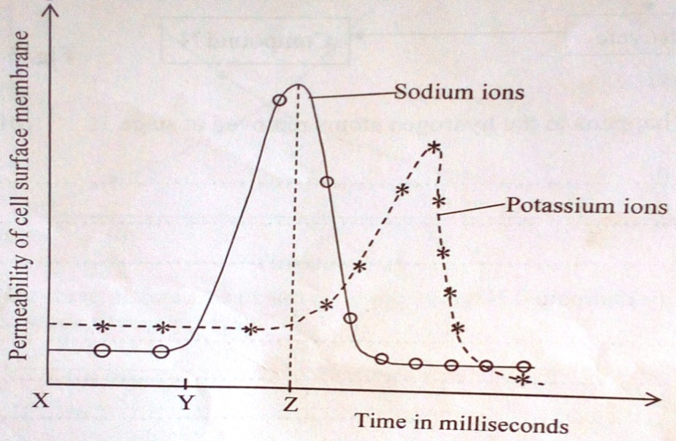

(a) Explain the permeability of the cell surface membrane to:
(i) Sodium and potassium ions between X and Y. (02marks) ………………………………………………………………………………………
………………………………………………………………………………………
………………………………………………………………………………………
………………………………………………………………………………………
(ii) Sodium ions between Y and Z (02 marks)

………………………………………………………………………………………
………………………………………………………………………………………
………………………………………………………………………………………
………………………………………………………………………………………
………………………………………………………………………………………
(b) (i) Describe how the sensory system creates an impulse. (03 marks)

………………………………………………………………………………………
………………………………………………………………………………………
………………………………………………………………………………………
………………………………………………………………………………………
(ii) Explain how a resting potential is actively maintained along an
axon. (03 marks)
………………………………………………………………………………………
………………………………………………………………………………………
………………………………………………………………………………………
………………………………………………………………………………………
- The figure shows the relationship between substrate concentration and the initial rate of an enzyme catalyzed reaction under different conditions.
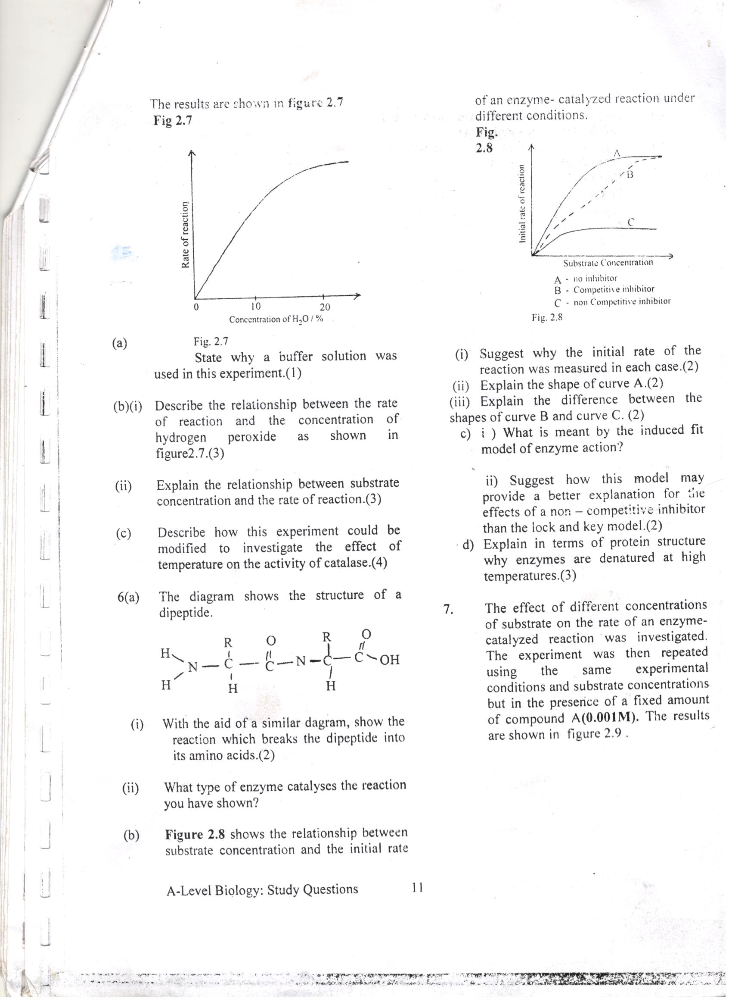

- (i) Suggest why the initial rate of the reaction was measured in each
case. (2 marks)
………………………………………………………………………………………………………………………………………………………………………………
………………………………………………………………………………………
(ii) Explain the shape of curve A. (04 marks)
………………………………………………………………………………………………………………………………………………………………………………………………………………………………………………………………………………………………………………………………………………………………………………………………………………………………………………………………………………………………………………………………………………
(iii) Explain the difference between the shape of curve B and C. (04 marks)

………………………………………………………………………………………………………………………………………………………………………………………………………………………………………………………………………………………………………………………………………………………………
43. (a) What is meant by the term saprophyte? (2 marks)

………………………………………………………………………………………………………………………………………………………………………………………………………………………………………………………………………
………………………………………………………………………………………
(b) Compare saprophytes with parasites (04 marks)

……………………………………………………………………………………………………………………………………………………………………………… ……………………………………………………………………………………………………………………………………………………………………………… ……………………………………………………………………………………………………………………………………………………………………………… (c) State the significance/ importance of saprophytes to human beings.
(04 marks)
………………………………………………………………………………………………………………………………………………………………………………………………………………………………………………………………………………………………………………………………………………………………………………………………………………………………………………………………………………………………………………………………………………
44. (a) Describe briefly what happens in the light stage of photosynthesis.
(4 marks)

………………………………………………………………………………………………………………………………………………………………………………………………………………………………………………………………………………………………………………………………………………………………………………………………………………………………………………………………………………………………………………………………………………………………………………………………
………………………………………………………………………………………………

(b) A sample of Chlorella (a green unicellular prototist) was allowed to photosynthesize at high and very low carbon dioxide levels. The figure below shows the concentrations of phosphoglyceric acid (PGA) and ribulose bisphosphate (RUBP) during the investigation.
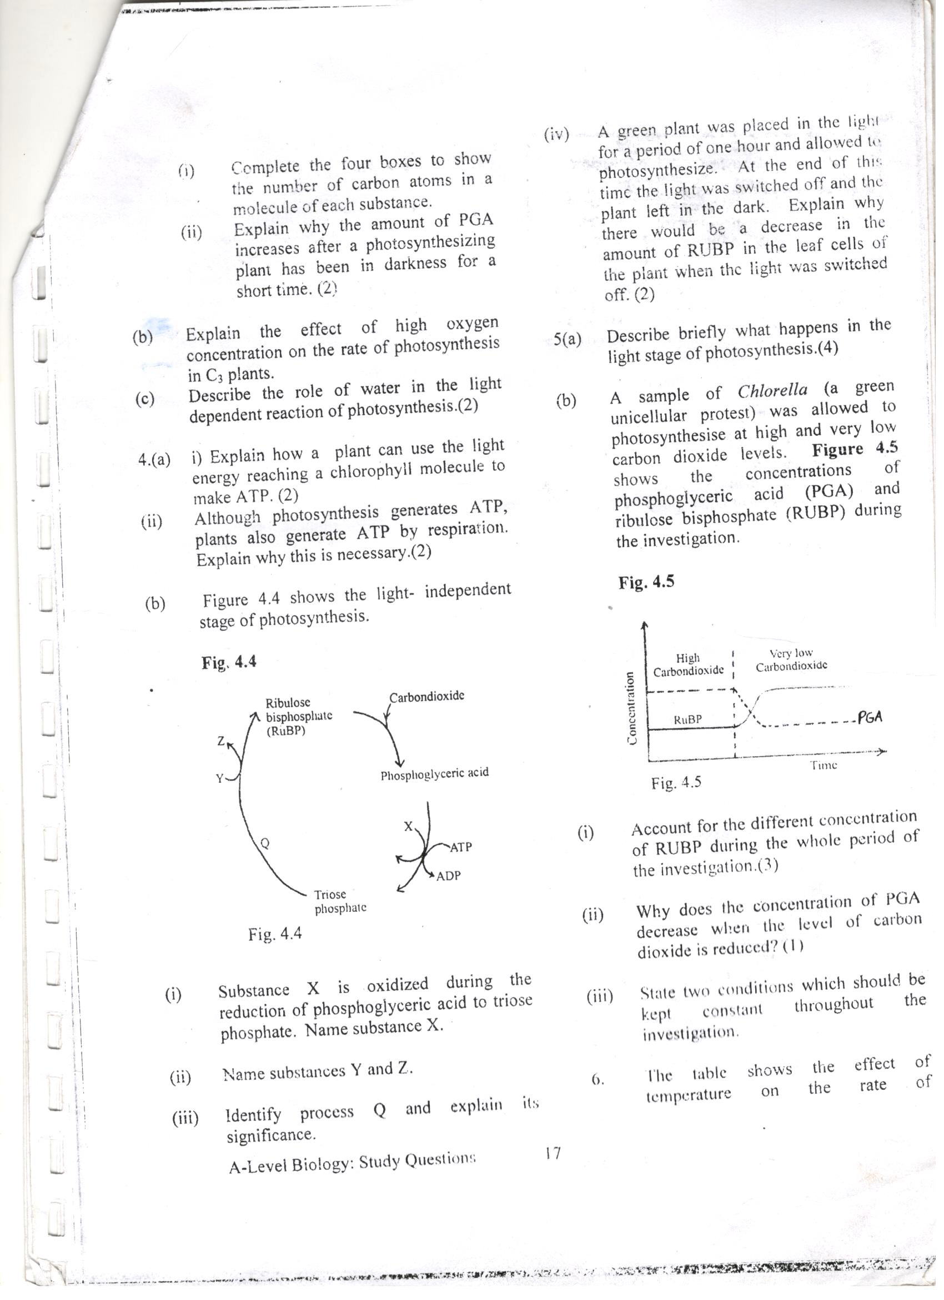
- Account for the different concentration of RUBP during the whole period of the investigation. (3 marks)

………………………………………………………………………………………………………………………………………………………………………………………………………………………………………………………………………………………………………………………………………………………………………………………………………………………………………………………………………………………………………………………………………………
- Why does the concentration of PGA decrease when the level of carbon dioxide is reduced? (1mark)

………………………………………………………………………………………………………………………………………………………………………………………………………………………………………………………………………………………………………………………………………………………………
- State two conditions which should be kept constant throughout the investigation. (02 marks)

………………………………………………………………………………………………………………………………………………………………………………………………………………………………………………………………………
45. (a) Explain
(i) Why water movement in the xylem depends on transpiration.
(02marks)
.………………………………………………………………………………………………………………………………………………………………………………………………………………………………………………………………………
………………………………………………………………………………………
………………………………………………………………………………………
………………………………………………………………………………………

(ii) How hydrogen bonds play an important role in the transport of water up the xylem. (03 marks)
………………………………………………………………………………………………………………………………………………………………………………………………………………………………………………………………………
………………………………………………………………………………………………………………………………………………………………………………………………………………………………………………………………………
………………………………………………………………………………………

(b) Describe how the structure of xylem vessels aids the transport of water.
(03 marks)
………………………………………………………………………………………………………………………………………………………………………………………………………………………………………………………………………
………………………………………………………………………………………
………………………………………………………………………………………………………………………………………………………………………………………………………………………………………………………………………
(c) Two cuttings, X and Y were taken from shoots of the same plant and the cut ends placed into water. Both shoots wilted after about 40 minutes. The shoot of cutting X was then cut under water 5cm above the original cut. Cutting X recovered from wilting but cutting Y did not. Explain these observations. (02 marks)

………………………………………………………………………………………………………………………………………………………………………………………………………………………………………………………………………………………………
………………………………………………………………………………………………
46. The graph below shows the saturation of haemoglobin with oxygen in two mammals that live at different altitudes.
% saturation of Haemoglobin with oxygen
Y
X
Oxygen partial pressure (Kpa)

- Suggest the altitudes at which mammals X and Y live.

X : .............................................................................. (01 mark)
Y : ................................................................................. (01 mark)
- Explain the relative positions of the Haemoglobin’s oxygen dissociation curves for mammals X and Y.
- Mammal X (02 marks)

………………………………………………………………………………………………………………………………………………………………………………………………………………………………………………………………………
- Mammal Y. (02 marks)

………………………………………………………………………………………………………………………………………………………………………………………………………………………………………………………………………
- State the significance of the difference in the behavior of Haemoglobin molecules for both mammals. (04 marks)

………………………………………………………………………………………………………………………………………………………………………………………………………………………………………………………………………………………………………………………………………………………………………………………………………………………………………………………………………………………………………………………………………………

END

