PRE-REGISTRATION EXAM TERM I 2018
S6 BIOLOGY PAPER 1
TIME: 2½ hours

Instructions:
- Attempt ALL questions in both sections.
- Use the boxes provided for Section A.
- Answers to Section B must be written in the spaces provided.

SECTION A (40 MARKS)

1. Centrioles are short cylinders with a pattern of microtubule triplets a pattern described as ;
A. 9 + 2
B. 9 + 0
C. 9 + 3
D. 9 + 4

- Which of the following is the role of the ATP molecules added in the initial stages of glycolysis?
- to stabilize the cell
- to activate the hexose sugar
- ATP provides energy for pyruvate formation
- It enables the glucose molecules to escape from the cell.

- Which of these is the correct number of ATP molecules generated in glycolysis only
as net?
- 3 B. 2
- 4 D. 8

4. Which of the following zones of an aquatic ecosystem has the highest concentration of oxygen?
A. Benthic zone B. Profundal zone
C. Littoral zone D. Hyperlimnion

5. The base sequence of which of the following molecules is similar in all organisms
- tRNA B. mRNA
- rRNA D. DNA

6. When there is no environmental resistance in a population, it
A. grows exponentially. B. decelerates in growth.
C. remains constant. D. grows slowly.

7. A fundamental difference between the skeleton in vertebrates and insects is that in vertebrates the skeleton is?
- jointed and flexible
- Living and can grow
- Made up of cells with chitin
- Tough light and flexible

8. A fundamental niche represents the range of conditions under which a species could survive if
- There were no predators or or competitors
- There were no predators or other negative influences
- There were no competitors, predators and other negative influences
- Environmental conditions were ideal

9. The pressure that tends to force water out of the cell is called
A. osmotic potential.
B. turgor pressure.
C. pressure potential.
D. water potential.

10. In the figure below, the curves represent the rates of enzyme – controlled reactions for three different enzymes A, B and C.

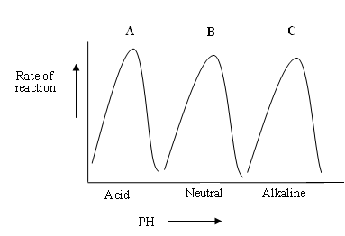
Which of the following statements can be regarded as the MOST correct conclusion about the effect of pH on enzyme activity?
- The rate of action of enzymes decreases with pH
- Enzymes work best within a narrow range of pH which is different for different enzymes.
- Enzymes work best in alkaline conditions
- Enzymes are active in a particular pH only.

- Which of the following shows the correct coding sequence
  - DNA mRNA tRNA rRNA amino acids
  - rRNA tRNA mRNA polypeptide
  - RNA mRNA tRNA protein
  - DNA mRNA rRNA tRNA amino acids

12. An example of a climax community would be
A. marsh B. forest
C. pond D. all the above

13. The figure below shows the effect of substrate concentration on an enzyme catalyzed reaction.
Rate of
reaction
Substrate concentration
A
B
C
D

The rate of reaction can be increased between C and D by
- Lowering the substrate concentration
- Doubling the substrate concentration
- Increasing the concentration of enzyme molecules
- Decreasing the concentration of enzyme molecules

- Which one of the following water relations is not true about a plasmolysed plant cell?
A: Turgor pressure is zero
B: pressure potential is equal to osmotic potential of sap
C: pressure potential is zero
D: Water potential of the sap is equal to its osmotic potential

15. The presence of cholesterol in the plasma membrane is important for
A. cell recognition.
B. reception of hormones.
C. controlling entry of specific molecules.
D. regulating membrane fluidity.

16. During which transfer of energy is most energy lost in an ecosystem
A. Producers Primary consumers
B. Primary consumers secondary consumers
C. Secondary consumers tertiary consumers
D. Tertiary consumers decomposers

17. Which of the following would speed up the process of diffusion?
A. reducing the concentration gradient
B. increasing the distance across which diffusion occurs
C. increasing the area over which diffusion occurs
D. lowering the temperature of the medium

18. Functionally, the most diverse tissue in animals is
A. epithelial. B. connective.
C. blood. D. muscular.

19. Hydrophytes do not have wax covered leaves because
A. they need much air for fast respiration.
B. they do not need to conserve water.
C. the wax would make the leaves heavy and sink.
D. their leaves cannot synthesize wax.

20. A common features belonging to annelids and arthropods is the
A. exoskeleton. B. jointed body form.
C. metameric segmentation. D. chitinous cuticle.

21. What would be the code of the anti-codon on tRNA that binds with mRNA whose DNA template was AGT?
- AGT
- AGU
- UCA
- TCA

22. A nucleotide is made up of phosphate (P), Sugar (S) and base (B) molecules. Which of the following is the correct position of these molecules?
P S P S

A. B – S B. P – B C. S – B D. B – P

P S P S

- The competitive exclusion principle attempts to explain why
  - particular niche contains only one species
  - Pioneer plants are not found in established communities
  - There are rarely more than 5 trophic levels in an ecosystem.
  - The diversity of a habitat increases as succession proceeds

22. With in a cell, protein synthesis takes place
A. in the nucleus where DNA codes for amino acids
B. in the cytoplasm where ribosomes and amino acids are
C. in the nucleus where tRNA codes for amino acids
D. in the cytoplasm where transcription occurs

23. In the upward movement of water in the xylem vessels, the water molecules do not easily pull apart because of
A. its high viscosity
B. cohesive force
C. dissolved mineral salts
D. its adhesive property

24. Which one of the following is a conjugated protein?
A. Keratin
B. Haemoglobin
C. Pepsinogen
D. Collagen

25. Which one of the following conversions of the Kreb’s cycle leads to direct formation of ATP without electron carrier system?
A. Pyruvic acid to acetyl COA.
B. Oxoglutaric acid to succinyl COA.
C. Acetyl COA to succinic acid.
D. Succinic acid to fumaric acid.
26. Which one of the following activities doesn’t contribute to global warming?
A. Use of pesticides B. Deforestation
C. Burning fossil fuels D. Use of CFCs

27. During what stage of prophase I of meiosis are homologous chromosomes attracted to each other and come together?
A. Leptotene B. Zygotene
C. Pachytene D. Diplotene

28. Which one of the following structures plays an important role in the formation of primary cell wall?
  - golgi apparatus B. rough endoplasmic reticulum
- lysosome D. ribosomes

29. A young herbaceous plant maintains an erect position due to
A. lignified tissue in the stem.
B. water pressure in the xylem vessels.
C. high turgor pressure in the parenchyma cells.
D. high osmotic pressure in the parenchyma cells.

- One of the organism below has metameric segmentation, which one is it;
A. earth worm B. round worm
B. tape worm D. star fish

31. The tissues in plants where there is active mitosis is
A. phloem. B. cambium.
C. pith. D. xylem.

32. Glutamic acid + Pyruvic acid Alpha-ketoglutaric acid + Alanine.
Which of the following groups of enzymes would catalyse the above reaction?
A. Sucrase
B. Transferases
C. Lyases
D. Ligases
- Hyaline cartilage is considered a simple matrix consisting of
  - collagen fibres and chondrin
  - Elastic fibres and chondroblasts
  - Chondrin and chondroblasts
  - Ground substance and fibroblasts
- Which of the following statements is not true about cardiac muscles?
- Pacemaker cells initiate spontaneous contractions of muscles
- contractions of cardiac muscles are neurogenic in origin
- Action potentials spread from one muscle to another
- An action potential usually lasts about as long as the mechanical response

- The figure below represents a stage of cell division
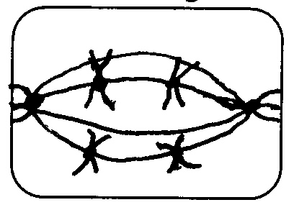

Which of the following stages is represented in the figure?
A. metaphase of mitosis
B. interphase
C. anaphase I of meiosis
D. metaphase I of meiosis

36. Which of the following have a sole function of offering support to the plant?
A. sclerenchyma and tracheids
B. vessel elements and tracheids
C. sclerenchyma and collenchyma
D. parenchyma and collenchyma

- A climax community is one in which
  - succession is at its peak
  - a carrying capacity has been reached
  - Succession has ceased
  - death rate of organisms is at its lowest

38. The following cells are dead except:
- Xylem B. Sieve tubes
- Tracheids D. Sclereids

39. One of the pairs below has organisms belonging to two different phyla? Which one is it?
A. trypanosome and plasmodium
B. round worm and tapeworm
C. fish and frog
D. centipede and cockroach

40. Microvilli in animal cells are for
A. exocytes of excretory products
B. endocytosis of particles
C. limited movement of the cell
D. increasing surface area for absorption

SECTION B(60 MARKS)
41. Two drops of water containing motile bacteria were added onto a piece of filamenteous alga on a microscope slide. A cover slip was inserted and the set up placed in light for 15 minutes. The results were as shown in the drawings below.

At the start
Motile bacteria
Algal filament
Motile bacteria
Algal filament

After 15 minutes

(a) (i) Compare the distribution of bacteria at the beginning and at the end of the 15 minutes. (02 Marks)
…………………………………………………………………………………………
…………………………………………………………………………………………
…………………………………………………………………………………………
…………………………………………………………………………………………
…………………………………………………………………………………………
(ii) Account for the distribution of the bacteria observed after 15 minutes. (02 Marks)
…………………………………………………………………………………………
…………………………………………………………………………………………
…………………………………………………………………………………………
…………………………………………………………………………………………
…………………………………………………………………………………………
(b) If the above set up was transferred in the dark for some hours, make a drawing of the possible resultant bacterial distribution and explain your answer.
(03 Marks)

42 (a) The figure below shows the pressure changes during respiration cycle in a mammal
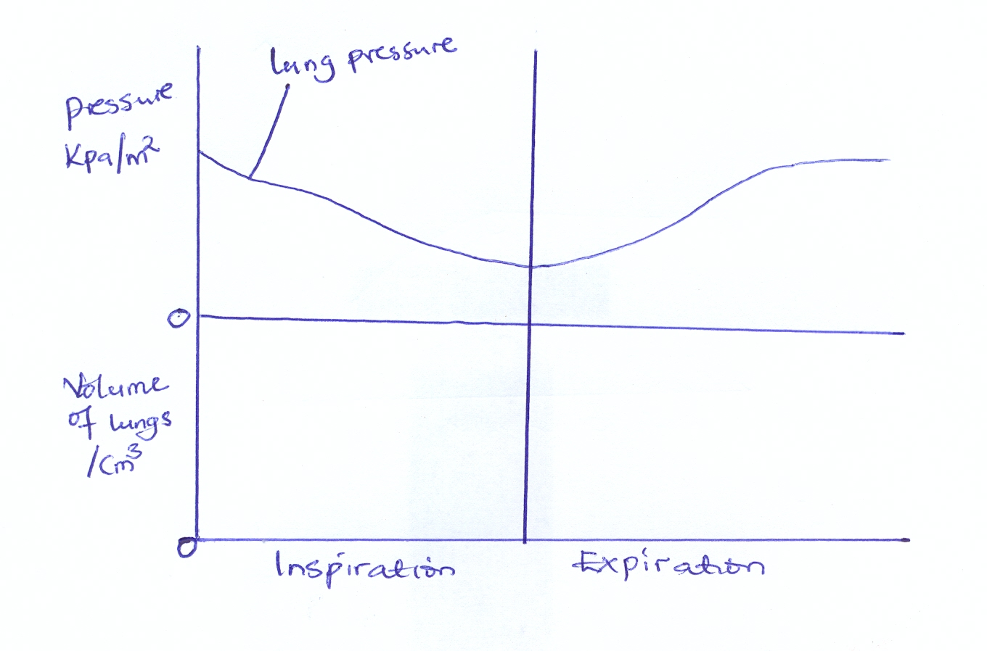

(a) On the figure above draw curves to show:
(i) Changes in the pleural pressure during expiration. (01 mark)
(ii) Changes in volume of the lungs during inspiration. (01 mark)

(b) Explain the shape of your curve drawn in (b) above. (05 marks)
(i) Changes in the pleural pressure during expiration.

………………………………………………………………………………………………………………………………………………………………………………………………………………………………………………………………………………
…………………………………………………………………………………………
………………………………………………………………………………………… …………………………………………………………………………………………
(ii) Changes in volume of the lungs during inspiration.
…………………………………………………………………………………………
………………………………………………………………………………………… ………………………………………………………………………………………… ………………………………………………………………………………………… …………………………………………………………………………………………
…………………………………………………………………………………………

c) Explain the advantage of countercurrent flow over parallel flow system in gills of bony fish. (03 marks)
…………………………………………………………………………………………
………………………………………………………………………………………… ………………………………………………………………………………………… ………………………………………………………………………………………… …………………………………………………………………………………………
…………………………………………………………………………………………
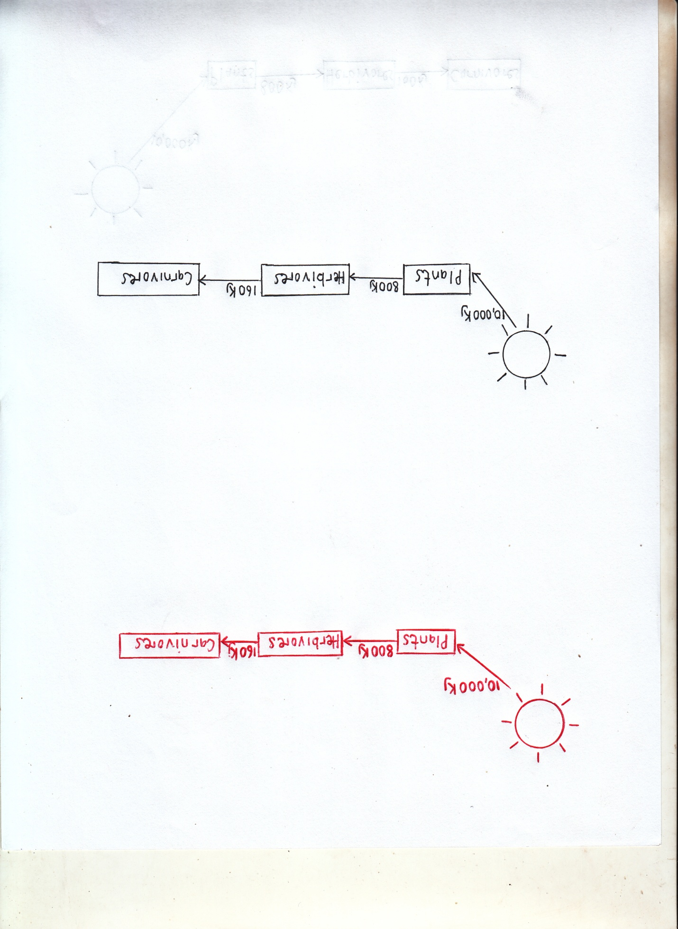
43. Figure 5 shows energy flow in a food chain.

- Assuming 10% of the energy received by the herbicious is lost. Calculate the energy retained. (03 marks)

………………………………………………………………………………………..
………………………………………………………………………………………..
………………………………………………………………………………………..
………………………………………………………………………………………..
- Explain why;
- Energy transfer from herbivores to carnivores is more efficient than that from producers to habivores. (03 marks)

………………………………………………………………………………………..
………………………………………………………………………………………..
………………………………………………………………………………………..
………………………………………………………………………………………..

- The efficiency of energy transfer from herbivores to carnivores is less than 100%. (02 marks)

………………………………………………………………………………………..
………………………………………………………………………………………..
………………………………………………………………………………………..
- State the factors which limit the numbers of tropic levels in a food chain.
(02 marks)

………………………………………………………………………………………..
………………………………………………………………………………………..
………………………………………………………………………………………..
- (a) State how the following tissues are adapted to their roles in animals.
- Pseudo – stratified epithelia. (02 marks)

………………………………………………………………………………………..
………………………………………………………………………………………..
………………………………………………………………………………………..
………………………………………………………………………………………..
- Stratified squamous epithelia. (03marks)

………………………………………………………………………………………..
………………………………………………………………………………………..
………………………………………………………………………………………..
………………………………………………………………………………………..
………………………………………………………………………………………..
(b) Outline parenchyma tissue structural modifications enabling them perform
various functions in plants. (05 marks)

………………………………………………………………………………………..
………………………………………………………………………………………..
………………………………………………………………………………………..
………………………………………………………………………………………..
………………………………………………………………………………………..
………………………………………………………………………………………..
………………………………………………………………………………………..
………………………………………………………………………………………..
………………………………………………………………………………………..
………………………………………………………………………………………..
45. (a) The figure below shows the action spectrum for photosynthesis and the
absorption spectrum for chlorophyll plotted on the same graph.
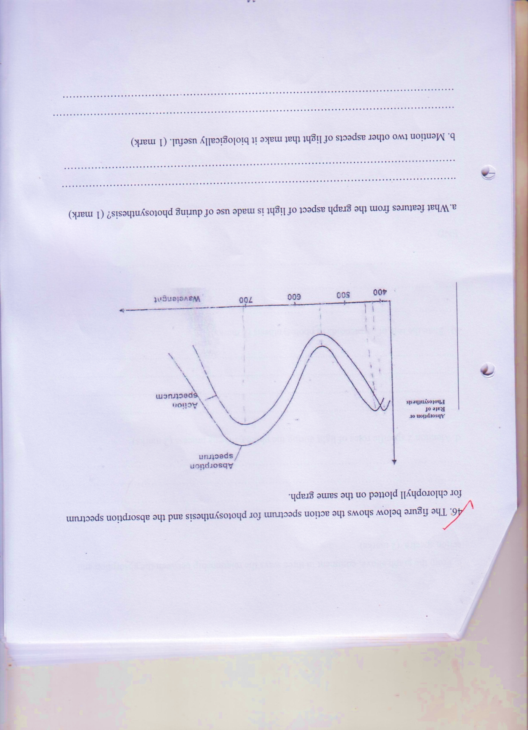

- What feature from the graph aspect of light is made use of during photosynthesis? (01 marks)

……………………………………………………………………………………………………………………………………………………………………………………………
……………………………………………………………………………………………

- Mention two other aspects of light that make it biologically useful. (02 mark)

………………………………………………………………………………………………
………………………………………………………………………………………………
- From the graph above, comment in three ways the relationship between the absorption and action spectra. (03 marks)

………………………………………………………………………………………………
………………………………………………………………………………………………
………………………………………………………………………………………………

- Mention two specific roles of light during the photosynthesis process.
(02 marks)
………………………………………………………………………………………………
………………………………………………………………………………………………
- State the role of carotenoids in photosynthesis. (02 marks)

………………………………………………………………………………………………
………………………………………………………………………………………………

46. a) Define the following and in each case give an example. (03marks)
- Essential amino acids.
………………………………………………………………………………………………………………………………………………………………………………………………………………………………………………………………………
- Unsaturated fatty acid.
………………………………………………………………………………………………………………………………………………………………………………………………………………………………………………………………………………………………………………………………………………………………
(b) (i) Write down the structure of an amino acid. (01mark)
………………………………………………………………………………………………………………………………………………………………………………………………………………………………………………………………………………
- Basing on the structure of an amino acid given above, show how a dipeptide is
formed. (02marks)

………………………………………………………………………………………………………………………………………………………………………………………………………………………………………………………………………………………………………………………………………………………………
(c) Outline the physiological functions of lipids in the human body. (04Marks)
………………………………………………………………………………………………………………………………………………………………………………………………………………………………………………………………………………………………
END

