END OF TERM I 2018 EXAMINATION
S.5 BIOLOGY
PAPER ONE
TIME : 2 HOURS 30 MINUTES

INSTRUCTIONS
- Attempt ALL questions

Table for answers for section A.
Qn: |  | Qn: |  | Qn: |  | Qn: |  | Qn: |  | Qn: |  | Qn: |  | Qn:
1 |  | 6 |  | 11 |  | 16 |  | 21 |  | 26 |  | 31 |  | 36
2 |  | 7 |  | 12 |  | 17 |  | 22 |  | 27 |  | 32 |  | 37
3 |  | 8 |  | 13 |  | 18 |  | 23 |  | 28 |  | 33 |  | 38
4 |  | 9 |  | 14 |  | 19 |  | 24 |  | 29 |  | 34 |  | 39
5 |  | 10 |  | 15 |  | 20 |  | 25 |  | 30 |  | 35 |  | 40

SECTION A

- Which one of the following organelles is connected to the nucleus?
- Smooth endoplasmic reticulum B. Lysosome
C. Rough endoplasmic reticulum D. Golgi body

- Which of these is an example of a prokaryote?
- Bacteria B. Mesophyll cell
C. Spirogyra D. Amoeba

- Which of the following is found in the internal structure of a mitochondrion?
- Cristae C. Cisternae
- Lamellae D. Granum

- Which one of the following properties is true about water?
- Non polar
- Low heat capacity
- Solid form less dense than liquid form.
- Low surface tension.

- Which of the following is not true about rough endoplasm reticulum?
- It stores proteins which have been produced by ribosomes.
- The ribosomes are permanently attached to it.
- It is continuous from the nuclear membrane.
- It is an intercellular system with flattered cavities.

- Which of the following is true about channel proteins?
- They transport non polar molecules.
- They don’t play any role in transport of ions across the membrane.
- They have a variable shape.
- They have a fixed shape.

- Which of the following is absent in plant cells?
- Chloroplasts and nucleus
- Centrioles and lysosomes
- Centrioles and vesicles
- Centrioles and vacuoles

- The property of water that makes it a suitable habitat in places that experience snow fall is;
- Density B. Surface tension
C. Viscosity D. Visibility

- Which of the following elements is a component of vitamin B₁₂?
- Manganese B. Cobalt
C. Zinc D. Molybdenum

- Which one of the following elements is not a component of nucleic acids?
- Nitrogen B. Sulphur
C. Phosphorous D. Hydrogen

- Which one of the following refers to groups of individuals of at least two species living together?
- Community B. Population
C. Habitat D. Niche

- Which one of the following ecological pyramids may be used to determine productivity in an ecosystem?
- Pyramid of energy B. Pyramid of biomass
C. Pyramid of numbers D. Pyramid of productivity

- Which one of the following constitutes the most energy transfer?
- Preying mantis feeding on flies
- Aphids feeding on plant sap
- Cat feeding on small mammals
- Beetle larvae feeding on dung

- Which one of the following has the greatest biomass in an ecosystem?
- Tertiary consumers B. Primary producers
C. Secondary consumers D. Primary consumers

- The number of organisms in each trophic level reduces as one moves up a food chain because;
- Energy is lost in moving from one trophic level to another
- Energy is lost from the top trophic levels
- Organisms in higher tropic levels are less productive
- Of high level of predation at the top trophic levels.

- Which of the following is not a structural component of an ecosystem?
- Producers B. Solar energy
C. Detritivores D. Scavengers

- There is a limited biomass at each trophic level in a food chain because at each level, there is progressive;
- Reduction in numbers of organisms B. Loss of energy
C. Reduction in size of organisms D. Reduction in amount of food

- Which one of the following is not true about the fluid mosaic model?
- Continuous protein layer
- Scattered protein layer
- Branching carbohydrate chains
- Hydrocarbon tails face inwards

- A phospholipid consists of;
- Phosphates, fat and oil.
- Phosphoric acid, glycerol, fatty acid.
- Phosphoric acid, fats and oil.
- Phosphate, glycerol and fatty acid.

- Which one of the following limited the use of a light microscope?
- Its magnifying power. C. Its size
- Its resolving power. D. Its inability to reveal natural colours.
- Which one of the following is the main function of the Golgi apparatus?
- Destruction of worn out cell organelles.
- Synthesis of cell wall components.
- Synthesis of proteins.
- Intracellular transport.

- The following are properties of Disaccharides except
- They can be broken down into simple sugars by dilute mineral acids.
- They change the colour of Benedict’s solution when heated with it.
- They can be crystallized.
- They do not change the colour of Benedict’s solution when heated with it.

- The competitive exclusion principle attempts to explain why;
- Particular niche contains only one species.
- Pioneer plants are not found in established communites.
- There are rarely more than five trophic levels in an ecosystem.
- The diversity of a habit increases as succession proceeds.

- Which one of the following organs would most probably contain the greatest number of mitochondria?
- Liver C. Pancreas
- Stomach D. Anus

- The feeding relationship between the colonial hydroid Hydratiniaechinata and the hermit crab Pagurusbernhardus is;
- Mutualism. C. Commensalism.
- Parasitism D. Saprotrophism.

- Which of the following is the major role of the lysosomes in a cell?
- Protection B. Secretion
C. Digestion D. Protein synthesis

- The fluid – mosaic model of the plasma membrane shows that;
- Membrane contains intrinsic globular proteins
- The membrane is too thick
- Plasma membrane is rigid
- Membrane is impermeable to glucose

- The element that is essential for formation of plant cell wall and bone in animals is;
- Iron B. Magnesium
C. Phosphorous D. Calcium
- The movement of ions and large polar molecules across the plasma membrane is
facilitated by;
- Cholesterol B. Phospholipids
C. Glycolipids D. Channel proteins

- Which of the following cells is likely to have the largest number of mitochondria?
- Sperm B. Ovum
C. Alveolar cell D. Red blood cell

- What is actual length of an animal cell that appears 4mm long when viewed through a magnification of X400?
- 0.1 mm B. 1.6 mm
C. 10 mm D. 100 mm

- Evaporation of water from a body surface causes cooling because water has a high ;
A. Latent heat of vaporization B. Latent heat of fusion
C. Boiling point D. Specific heat capacity

- Which one of the following elements is not essential to human life?
- Magnesium B. Aluminium
C. Copper D. Zinc

- Which part of a phospholipid molecule contributes most to the thickness of a cell surface membrane?
- Glycerol
- Hydrocarbon chain
- Hydrophilic head
- Phosphate group

- Which one of the following is a reserve food formed from excess glucose during photosynthesis?
- Cellulose. C. Chitin
- Lipids D. Starch.

- Which one of the following enzymes has the lowest optimum pH?
- Pancreatic juice C. Pancreatic amylase
- Pepsin D. Salivary amylase

- Water reaches its maximum density at
- 4⁰C C. 25⁰C
- 0⁰C D. -5⁰C
- The main distinguishing character of eukaryotic cells is
- Membrane organelles.
- Lack of nuclear membrane.
- Presence of nucleus.
- Presence of DNA double strands.

- Reactions involving building up of large molecules from smaller ones and usually require input of energy are known as
- Polymerization. C. Condensation.
- Catabolism. D. Anabolism.

- The technique of attaining in microscopy increases
- Magnifying power. C. Resolution.
- Transmission. D. Contrast.

SECTION B (60 marks)

41(a) In what ways are the cells of prokaryotes fundamentally different from those
of eukaryotes? (04 marks)

Prokaryotes | Eukaryotes

(b) (i) Define the term organelle. (01 mark)

…………………………………………………………………………………………
…………………………………………………………………………………………
(ii) State two principal structural similarities between cilia and flagella. (02 marks)

…………………………………………………………………………………………
…………………………………………………………………………………………
…………………………………………………………………………………………
…………………………………………………………………………………………
(iii) The movement of cilia and flagella produce forces that may be used in various ways. State these ways. (03 marks)

…………………………………………………………………………………………
…………………………………………………………………………………………
…………………………………………………………………………………………
…………………………………………………………………………………………
…………………………………………………………………………………………
42. a) Define the following and in each case give an example. (03marks)
- Essential amino acids.
………………………………………………………………………………………………………………………………………………………………………………………………………………………………………………………………………………………………………………………………………………………………
- Unsaturated fatty acid.
………………………………………………………………………………………………………………………………………………………………………………………………………………………………………………………………………………………………………………………………………………………………
(b) (i) Write down the structure of an amino acid. (01mark)

………………………………………………………………………………………………………………………………………………………………………………………………………………………………………………………………………………
- Basing on the structure of an amino acid given above, show how a dipeptide is
formed. (02marks)

………………………………………………………………………………………………………………………………………………………………………………………………………………………………………………………………………………………………………………………………………………………………
(c) Outline the physiological functions of lipids in the human body. (04Marks)

…………………………………………………………………………………………………………………………………………………………………………………………………………………………………………………………………………………………………………………………………………………………………………………………………………

- The table below shows the concentration of an organic chloride (used in water treatment) in different organisms inhabiting a pond. Study the table and answer the questions that follow;

Organisms | Planktons | Large fish | Small fish | Fish Eagle
Concentration of organic chloride (ppm) | 0.04 | 0.5 | 0.1 | 0.9

- Comment on the data given in the table above. (1 mark)

………………………………………………………………………………………………………………………………………………………………………………………………………………………………………………………………………
- Using the information given in the table, construct a possible food chain in the pond.
(1 mark)
………………………………………………………………………………………………………………………………………………………………………………………………………………………………………………………………………………………………………………………………………………………………
- Explain the high concentration of the chloride in the fish eagle. (4 marks)

………………………………………………………………………………………………………………………………………………………………………………………………………………………………………………………………………………………………………………………………………………………………
- Suggest the properties you would recommend for a suitable chemical to use in water purification.

………………………………………………………………………………………………………………………………………………………………………………………………………………………………………………………………………………………………………………………………………………………………
- The figure below shows part of the endomembrane system of a cell from the
nucleus to the Golgi apparatus. Use it to answer the questions that follow.

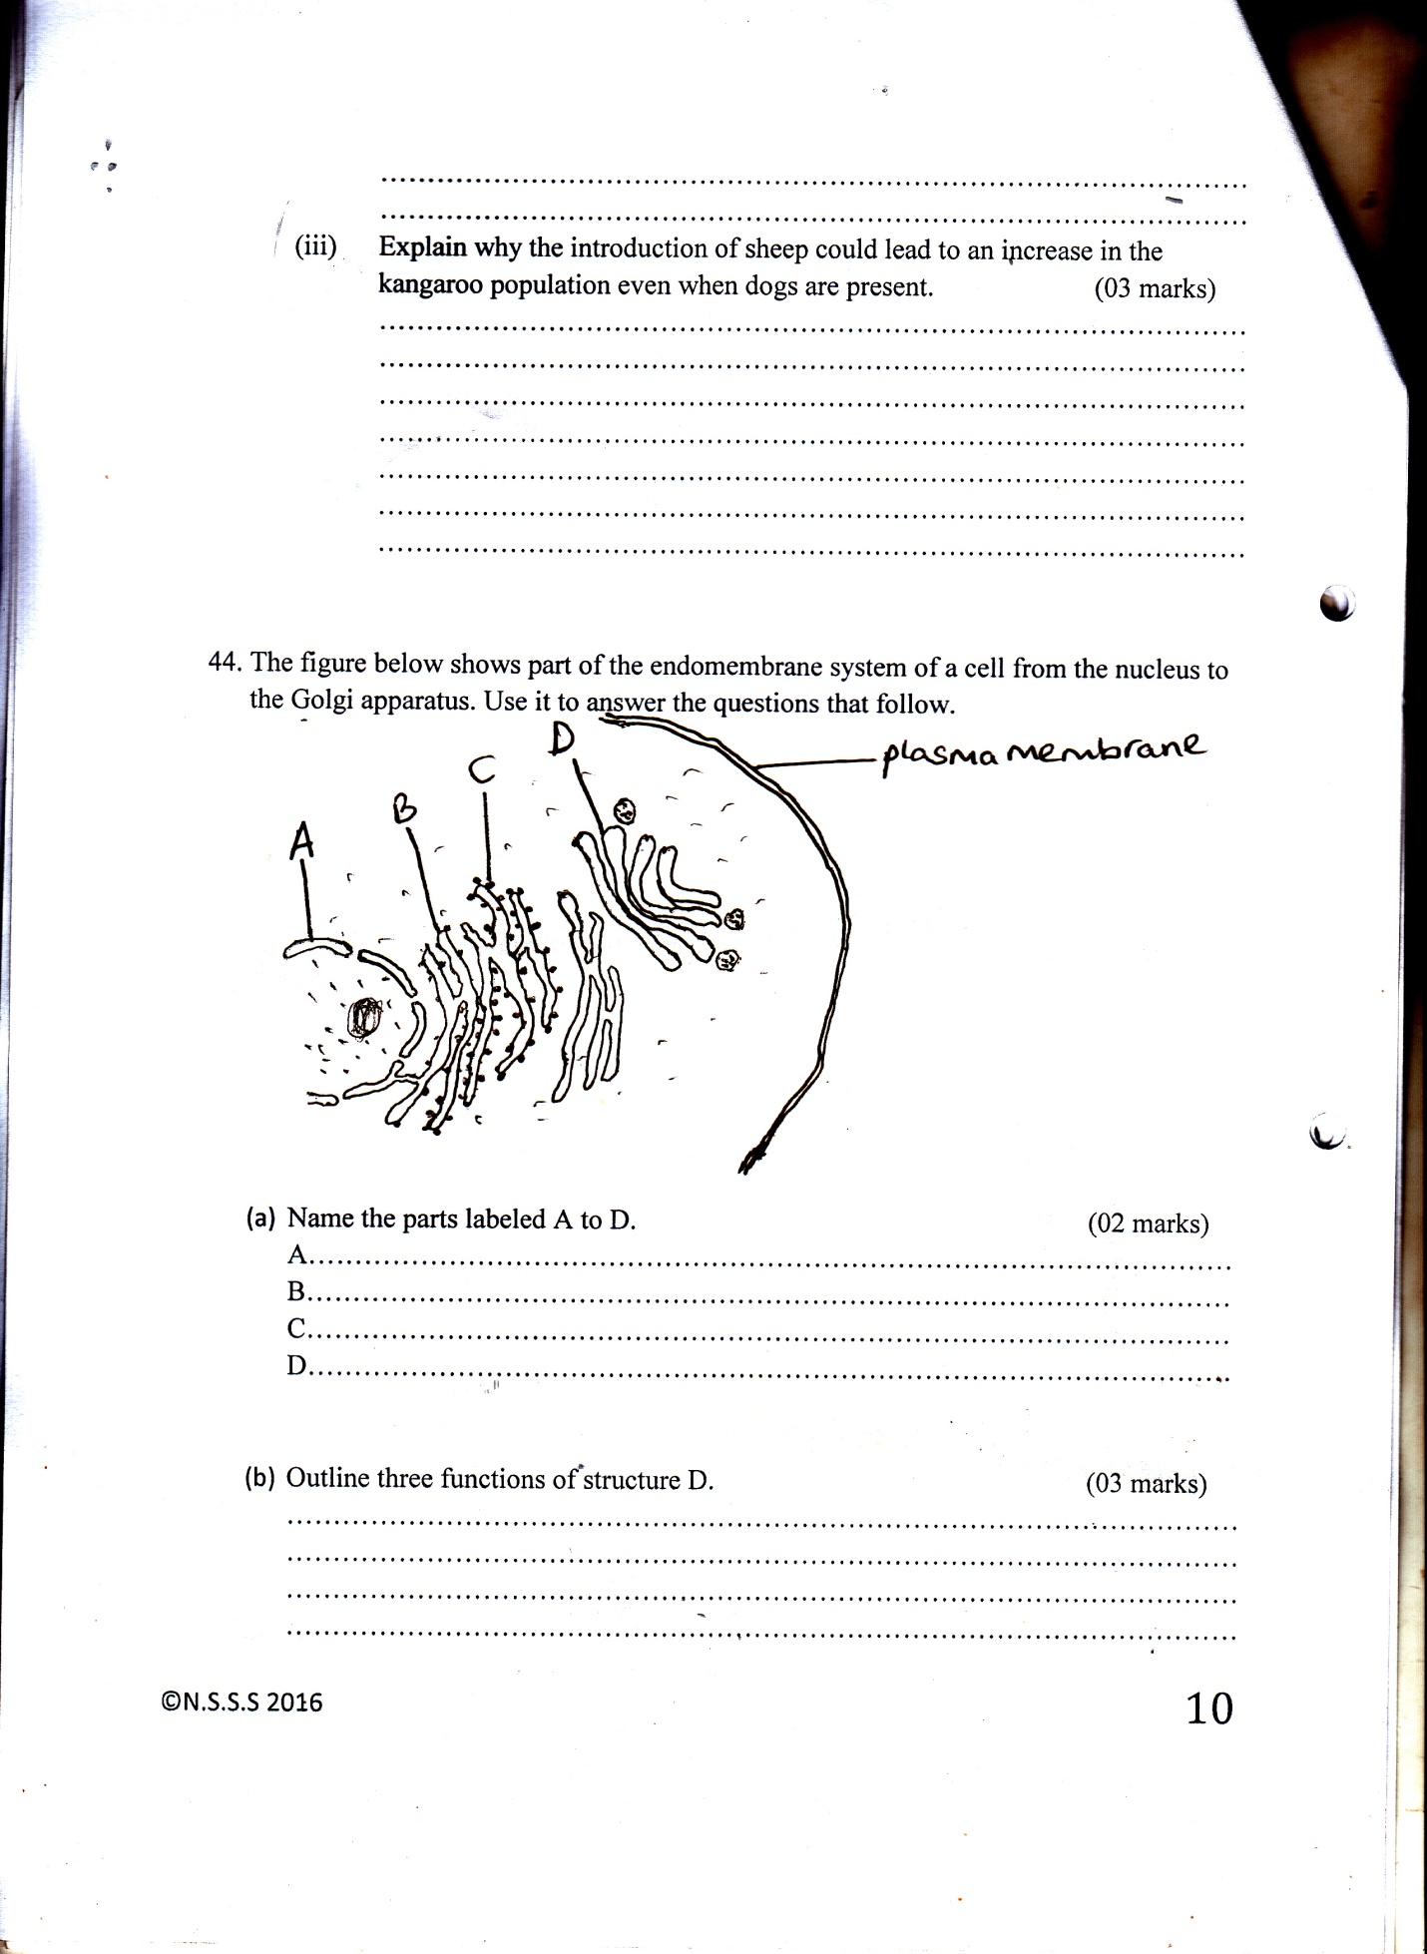

- Name the parts labeled A to D. (02 marks)

A……………………………………………………………………………………
B……………………………………………………………………………………
C……………………………………………………………………………………
D……………………………………………………………………………………

- Outline three functions of structure D. (03 marks)

………………………………………………………………………………………………………………………………………………………………………………………………………………………………………………………………………………………………………………………………………………………………………………………………………………………………………………………………………………………………………………………………………………
- How is the structure of B related to its functions? (02 marks)

………………………………………………………………………………………………………………………………………………………………………………………………………………………………………………………………………………………………………………………………………………………………………………………………………………………………………………………

- Compare the structure of the smooth and rough ER. (02marks)

………………………………………………………………………………………………………………………………………………………………………………………………………………………………………………………………………

- a) Below is a graph showing DNA content of a cell in the cell cycle
Time
W
Y
X

Z
DNA Content
4n
2n
n

    - Identify the type of nuclear division shown above. (1 mark)

…………………………………………………………………………………………
    - State the phases shown on the graph above (3 marks)

W…………………………………………………………………………………
X…………………………………………………………………………………
Y…………………………………………………………………………………

    - Name the cells shown by letter Z (1 mark)

…………………………………………………………………………………..
    - Explain how the above type of nuclear division may lead to variation. (4 marks)

……………………………………………………………………………………………………………………………………………………………………………………………………………………………………………………………………………………………………………………………………………………………………………………………………………………………………………………………………
    - In which parts of a human being doe the above type of cell division occur?
(1 mark)

………………………………………………………………………………………………
- Study structure of the plasma membrane below and answer the questions that
follow it;

- (i) Give the general name given to the structure above. (1 mark)

…………………………………………………………………………………
(ii) Describe the distribution of the following in the plasma membrane protein
molecules. (3 marks)

………………………………………………………………………………………………………………………………………………………………………………………………………………………………………………………………………………………………………………………………………………………………………………………………………………………………………………………………………………………………………………………………………………
(iii) Phospholipids molecules. (2 marks)

…………………………………………………………………………………………………………………………………………………………………………………………………………………………………………………………………………………………………………………………………………………………………………………………………………………………………………………………………………………...............................................................................................
- State how the above structure is adapted to absorption of materials.
(3 marks)

………………………………………………………………………………………………………………………………………………………………………………………………………………………………………………………………………………………………………………………………………………………………………………………………………………………………………………………………………………………………………………………………………………

END

