Name…………………………………………………............... signature………………..
P525/1
CHEMISTRY
2 ¼ hrs

END OF TERM 1 EXAMINATIONS
S5 CHEMISTRY
PAPER 1
2 Hours 15 Minutes

INSTRUCTIONS
- Answer all questions in SECTION A and six questions in SECTION B
- All questions are to be answered in the spaces provided.
- The periodic table, with relative atomic masses is supplied at the end of the paper.
- Use the following where necessary.
(H=1, 0=16, N=14, 1 mole of a gas occupies 22.4litres at s.t.p, R=8.314Jmol⁻¹k⁻¹)

FOR EXAMINER’S USE ONLY
1 | 2 | 3 | 4 | 5 | 6 | 7 | 8 | 9 | 10 | 11 | 12 | 13 | 14 | 15 | TOTAL

SECTION A
- (a) Define radioactivity
..................................................................................................................................................................................................................................................................................................................................................................................................................................................................
- Polonium undergoes radioactive decay to give element Y according to the following equation.
Y + .

Calculate;
- the atomic number of Y (½ mark)
.......................................................................................................................................
- the mass number of Y (½ mark)
.......................................................................................................................................
- Y decays further as shown by the equation below
Y Z +
Calculate;
- the atomic number of Z (½ mark)
.......................................................................................................................................
- the mass number of Z (½ mark)
.......................................................................................................................................
- A sample of Y had an initial activity of 260 counts per second on a Geiger counter. After 30 minutes the activity had declined to 250 counts per second. Calculate the half life of Y. (4marks)
..............................................................................................................................................................................................................................................................................................................................................................................................................................................................................................................................................................................................................................................................................................................................................................................................................................................................................................................................................................................................................................................................................................................................................................................................................................................................................................................................................................................................................................................................................................................................
- (a) What is meant by the term electronic configuration (1marks)
..................................................................................................................................................................................................................................................................................................................................................................................................................................................................
- Write down the ground state electronic configuration the following elements @1mark
- Sodium
...................................................................................................................................................

- Copper
...................................................................................................................................................
- Chromium
...................................................................................................................................................
(Na=23, Cu=29 and Cr=24)
- Explain the ground state electronic configuration of a copper atom in b(ii) above (1mark)
............................................................................................................................................................................................................................................................................................................
- When 142cm³ of a hydrocarbon A of molecular mass 58 was exploded with excess oxygen and cooled to room temperature, the volume of the residual gas was 694cm³. After addition of concentrated potassium hydroxide solution, the volume decreased to 126cm³.
- Determine the molecular formula of A (3marks)
................................................................................................................................................................................................................................................................................................................................................................................................................................................................................................................................................................................................................................................................................................................................................................................................................................................................................................................................................................................................................................................................................................................................................................................................................................................
- Write the structural formula and isomers of A (2marks)
..................................................................................................................................................................................................................................................................................................................................................................................................................................................................
- (a) State Dalton’s law of Partial pressure (2marks)
………………………………………………………………………………………………………………………………………………………………………………………………………………………………………………………………………………………………………
- A closed vessel contains 5.6g of nitrogen and 4.0g of helium at 101.3KPa and 0ºC. What will be the partial pressure of helium if the temperature is raised to 150ºC? (3marks)
………………………………………………………………………………………………………………………………………………………………………………………………………………………………………………………………………………………………………………………………………………………………………………………………………………………………………………………………………………………………………………………………………………………………………………………………………………
……………………………………………………………………………………………………………………………………………………………………………………………………........................................................................................................................................................
- (a) Define an isomer (1mark)
..................................................................................................................................................................................................................................................................................................................................................................................................................................................................
- Give the IUPAC name of each of the isomers of C₇H₁₆ @1mark
CH₃
- CH₃CHCH₂ ...........................................................................................................
CH₂CH₂CH₂
CH₂CH₃
- CH₃CHCHCH₃ ............................................................................................................
CH₃
- Write the structural formula of the following @1mark
- 2,3-dimethylbutane
.........................................................................................................................................................................................................................................................................................................................................................................................................................................................
- 4-ethyl-2-methylpentane
.........................................................................................................................................................................................................................................................................................................................................................................................................................................................
- (a) Define the term critical temperature (1mark)
..................................................................................................................................................................................................................................................................................................................................................................................................................................................................

- The diagram in figure 1 shows isotherms of a gas
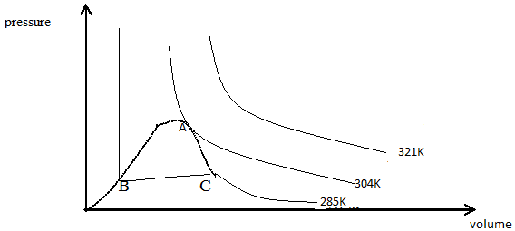
- What is the critical temperature of the gas (1mark)
…………………………………………………………………………………………………………………………………………………………………………………….......................
- Which isotherm almost represents the behavior of an ideal gas? (1mark)
……………………………………………………………………………………………………………………………………………………………………………………........................
- What does the region ABC represent? (1mark)
…………………………………………………………………………………………………………………………………………………………………………………….......................
(b) State one condition necessary for liquefying a gas (1mark)
……………………………………………………………………………………………………………………………………………………………………………………........................
- 1.55g of an acid, C_{n}H_{2n} (COOH)₂ was dissolved in water and the solution made up to 250cm³. 25 cm³ of the solution required 23.5cm³ of 0.1M aqueous sodium hydroxide for complete neutralization. (1mole of the acid reacts with 2moles of NaOH)

(a) Calculate
- the molar concentration of the acid (3marks)
…………………………………………………………………………………………………………………………………………………………………………………….......................
…………………………………………………………………………………………………………………………………………………………………………………….......................
…………………………………………………………………………………………………………………………………………………………………………………….......................
…………………………………………………………………………………………………………………………………………………………………………………….......................
- the molecular mass of the acid (2marks)
……………………………………………………………………………………………………………………………………………………………………………………........................
…………………………………………………………………………………………………………………………………………………………………………………….......................
…………………………………………………………………………………………...........
- (a) Methane, a component of natural gas belongs to a homologous series of organic compounds known as “alkanes”. What is meant by the term homologous series? (2marks)
........................................................................................................................................................................................................................................................................................................................................................................................................................................................................................................................................................................................................................
- Alkanes also known as paraffins are not very reactive. Give a reason to explain why alkanes are not very reactive (1mark)
............................................................................................................................................................................................................................................................................................................
- Methane in the presence of sunlight reacts with chlorine to form chloromethane. Write a mechanism for the reaction (3marks)
....................................................................................................................................................................................................................................................................................................................................................................................................................................................................................................................................................................................................................................................................................................................................................................................................................................................................................................................................
- A gaseous hydrocarbon was found by analysis to contain 85.7% carbon. If the compound has a vapour density of 1.250g per litre at stp, determine its molecular formula (4marks)
....................................................................................................................................................................................................................................................................................................................................................................................................................................................................................................................................................................................................................................................................................................................................................................................................................................................................................................................................................................................................................................................................................................................................................................................................................................................................................................................................................................................................................................................................................................................................................................................................................................................................................................................................................................................................................................................................................................................................................................................................................................................................................................................................................................................
SECTION B
- (a) State Graham’s law of diffusion (1mark)
..................................................................................................................................................................................................................................................................................................................................................................................................................................................................
- A gaseous compound X contained 46.1% of carbon and 53.9% nitrogen. In 20seconds 50cm³ of X diffused through a porous plug and the same volume of oxygen diffused in 15.7seconds. Determine the;
- Empirical formula of X (2marks)
..................................................................................................................................................................................................................................................................................................................................................................................................................................................................................................................................................................................................................................................................................................................................................................................................................................................................................................................
- Molecular formula of X (3marks)
..................................................................................................................................................................................................................................................................................................................................................................................................................................................................................................................................................................................................................................................................................................................................................................................................................................................................................................................
- What volume of carbon dioxide would diffuse in 20seconds under the same conditions?
(3marks)
.....................................................................................................................................................................................................................................................................................................................................................................................................................................................................................................................................................................................................................................................................................................................................................................................................................................................................................................................................................................................................................................................................
- (a) What is isomerism? (2marks)
..................................................................................................................................................................................................................................................................................................................................................................................................................................................................
- State the type of isomerism exhibited by each of the following pairs of components @1mark
- CH₃CH₂CH₂CH₃ and CH₃CHCH₃
CH₃
......................................................................................................................................................
- CH₃CH₂CH₂Cl and CH₃CHCH₃
Cl
.....................................................................................................................................................
- CH₃CH₂OH and CH₃OCH₃
.....................................................................................................................................................
- Write the IUPAC names of the compounds whose structural formulae are given below
- CH₃CH₂CHCH₂CH₂CH₃ (2mark)
CH₂
CH₃
............................................................................................................................................................................................................................................................................................................
CH₃ CH₃
- CH₃CHCHCHCH₂CH₃ (2marks)
CH₂
CH₃
............................................................................................................................................................................................................................................................................................................
- (a) Define the term nuclear stability (1mark)
..................................................................................................................................................................................................................................................................................................................................................................................................................................................................
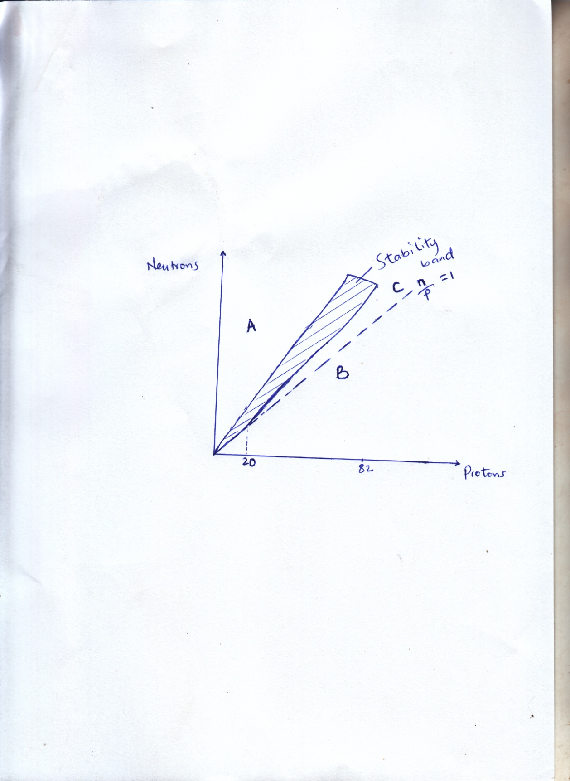
- The graph below shows the neutron/proton ratio of some nucleid

State how unstable nuclei in the regions A, B and C gain stability (use relevant equations)
@2marks
- Region A .........................................................................................................................................................................................................................................................................................................................................................................................................................................................
- Region B .........................................................................................................................................................................................................................................................................................................................................................................................................................................................
- Region C .........................................................................................................................................................................................................................................................................................................................................................................................................................................................

- Complete the following equations @1mark
- .............. ${}_{89}^{228}{Ac}$. + ${}_{-1}^{0}e$
- ${}_{84}^{216}{Po}$ ............ + ${}_{2}^{4}{He}$
- (a) Briefly explain how a hydrogen spectra is formed (4marks)
............................................................................................................................................................................................................................................................................................................................................................................................................................................................................................................................................................................................................................................................................................................................................................................................................................................................................................................................................................................................................................................................................................................................................................................................................................................................................................................................................................................................................................................................................................................................................................
- State three ways in which the hydrogen spectrum provides evidence for existence of various energy levels in an atom (3marks)
................................................................................................................................................................................................................................................................................................................................................................................................................................................................................................................................................................................................................................................................................................................................................................................................................................................................................................................................................................................................................................................................................................................................................................................................................................................
- State two uses of emission spectra (2marks)
........................................................................................................................................................................................................................................................................................................................................................................................................................................................................................................................................................................................................................
- (a) Define the following as applied in analytical chemistry
- A standard solution (1mark)
............................................................................................................................................................................................................................................................................................................
- A primary standard (1mark)
............................................................................................................................................................................................................................................................................................................
- Give two reasons to explain why sodium hydroxide is not used as a primary standard
(2marks)
..................................................................................................................................................................................................................................................................................................................................................................................................................................................................
- 25.0cm³ of aqueous sodium hydroxide solution was added to 50cm³ of a 0.25M hydrochloric acid. The resultant was found to require 20.0cm³ 0f a 0.125M sodium hydroxide solution for complete reaction. Calculate the concentration of the original sodium hydroxide solution in gdm⁻³ (5marks)
........................................................................................................................................................................................................................................................................................................................................................................................................................................................................................................................................................................................................................................................................................................................................................................................................................................................................................................................................................................................................................................................................................................................................................................................................................................................................................................................................................................................................................................................................................................................................................................................................................................................................................................................................................................................................................................................................
- (a) Distinguish Diffusion and Effusion (2marks)

........................................................................................................................................................................................................................................................................................................................................................................................................................................................................................................................................................................................................................

- Ammonia and hydrogen chloride gases are released simultaneously from the two opposite ends of a 100cm long glass tube. The two gases diffuse through the tube until they meet; the point at which this occurs is indicated by the formation of a white ring, solid ammonium chloride. At what position in the tube is the white ring formed?
(N=14, H=1, Cl=35.5)
(7marks)
.............................................................................................................................................................................................................................................................................................................................................................................................................................................................................................................................................................................................................................................................................................................................................................................................................................................................................................................................................................................................................................................................................................................................................................................................................................................................................................................................................................................................................................................................................................................................................................................................................................................................................................................................................................................................................................................................................................................................................................................................................................

END

