END OF TERM I 2018 EXAM
S.5 CHEMISTRY
P525/2
TIME : 2 HOURS

INSTRUCTIONS
- Attempt ALL question
- Written the answers in the answer sheet provided
- Begin each question on a fresh page

- (a) Define the terms;
- Atomic mass (01 mark)
- Relative atomic mass (01 mark)
(b) Describe how the relative atomic mass of an element can be determined using the mass spectrometer. (08 marks)
(c) The table below shows the information for a sample of a naturally occurring element A in a mass spectrometer.

Isotope | Detector current / arbitruary units
70  72  73  74  76 | 6.83  9.13  2.60  12.17  2.60

Calculate
- The percentage abundance of each isotope. (04 marks)
- The relative atomic mass of element A. (02 marks)
(d) Explain the following
(i) the relative atomic mass of an element has no units. (01 mark)
(ii) the relative atomic mass of a naturally occurring element is not a whole
number. (01 mark)
(e) Give two other uses of the mass spectrometer. (02 marks)

- (a) (i) What is structural isomerism? (01 mark)
(ii) Describe the types of structural isomerism giving suitable examples in each case. (06 marks)

(b) An alkane W of vapour pressure 36 was vapourised in a closed gas cylinder at 27ºC and 1 atmosphere pressure.
(1 mole of gas at standard temperature and pressure is 22.4L)
- Determine the molecular formular of W (1½ marks)
- Write the structural formula and give the I.U.P.A.C names of all the possible isomers of W. (03 marks)
(c) (i) Arrange the isomers of W in order of decreasing boiling points.
(01 marks)
(ii) Explain the trend given in (c) (i) above. (03 marks)

(d) Explain each of the following terms as applied to alkanes. Give an example in each case.
(i) Nucleophile (1½ marks)
(ii) Free radical (1½ marks)
(iii) Carbon cation (1½ marks)
(iv) Inductive effect (1 mark)

- (a) Describe the structure of the hydrogen spectrum. (04 marks)
(b) Explain how the spectrum of the hydrogen atom;
(i) is formed (03 marks)
(ii) provides evidence for the existence of energy levels in an atom.
(04 marks)
(c) The ionization energy of the hydrogen atom can be determined from the frequencies of the spectral lines in the lyman’s series of hydrogen given in the table below.
Line | 1 | 2 | 3 | 4 | 5 | 6
Frequency V x 10¹⁴ / Hz | 24.66 | 29.23 | 30.83 | 31.57 | 31.97 | 32.21

- What is ionization energy? (01 mark)
- Plot a graph of difference in frequency ($∆V)$ against frequency (V).
(04 marks)
- Calculate the ionization energy of hydrogen in KJmol⁻¹. (Plank’s constant = 6.626 x 10⁻³⁴ J / atom,
Avogadro’s constant = 6.02 x 10²³ atoms / mole). (03 marks)
(d) Give one other application of the spectral lines in the emission spectrum of an element. (01 mark)

- (a) What is meant by the term ideal gas ? (02 marks)
(b) Explain how liquefaction of a gas can be affected by;
(i) pressure (2½ marks)
(ii) temperature (2½ marks)
(c) The curves below show deviations of some gases such as oxygen, hydrogen and carbon dioxide gas from ideal behavior.
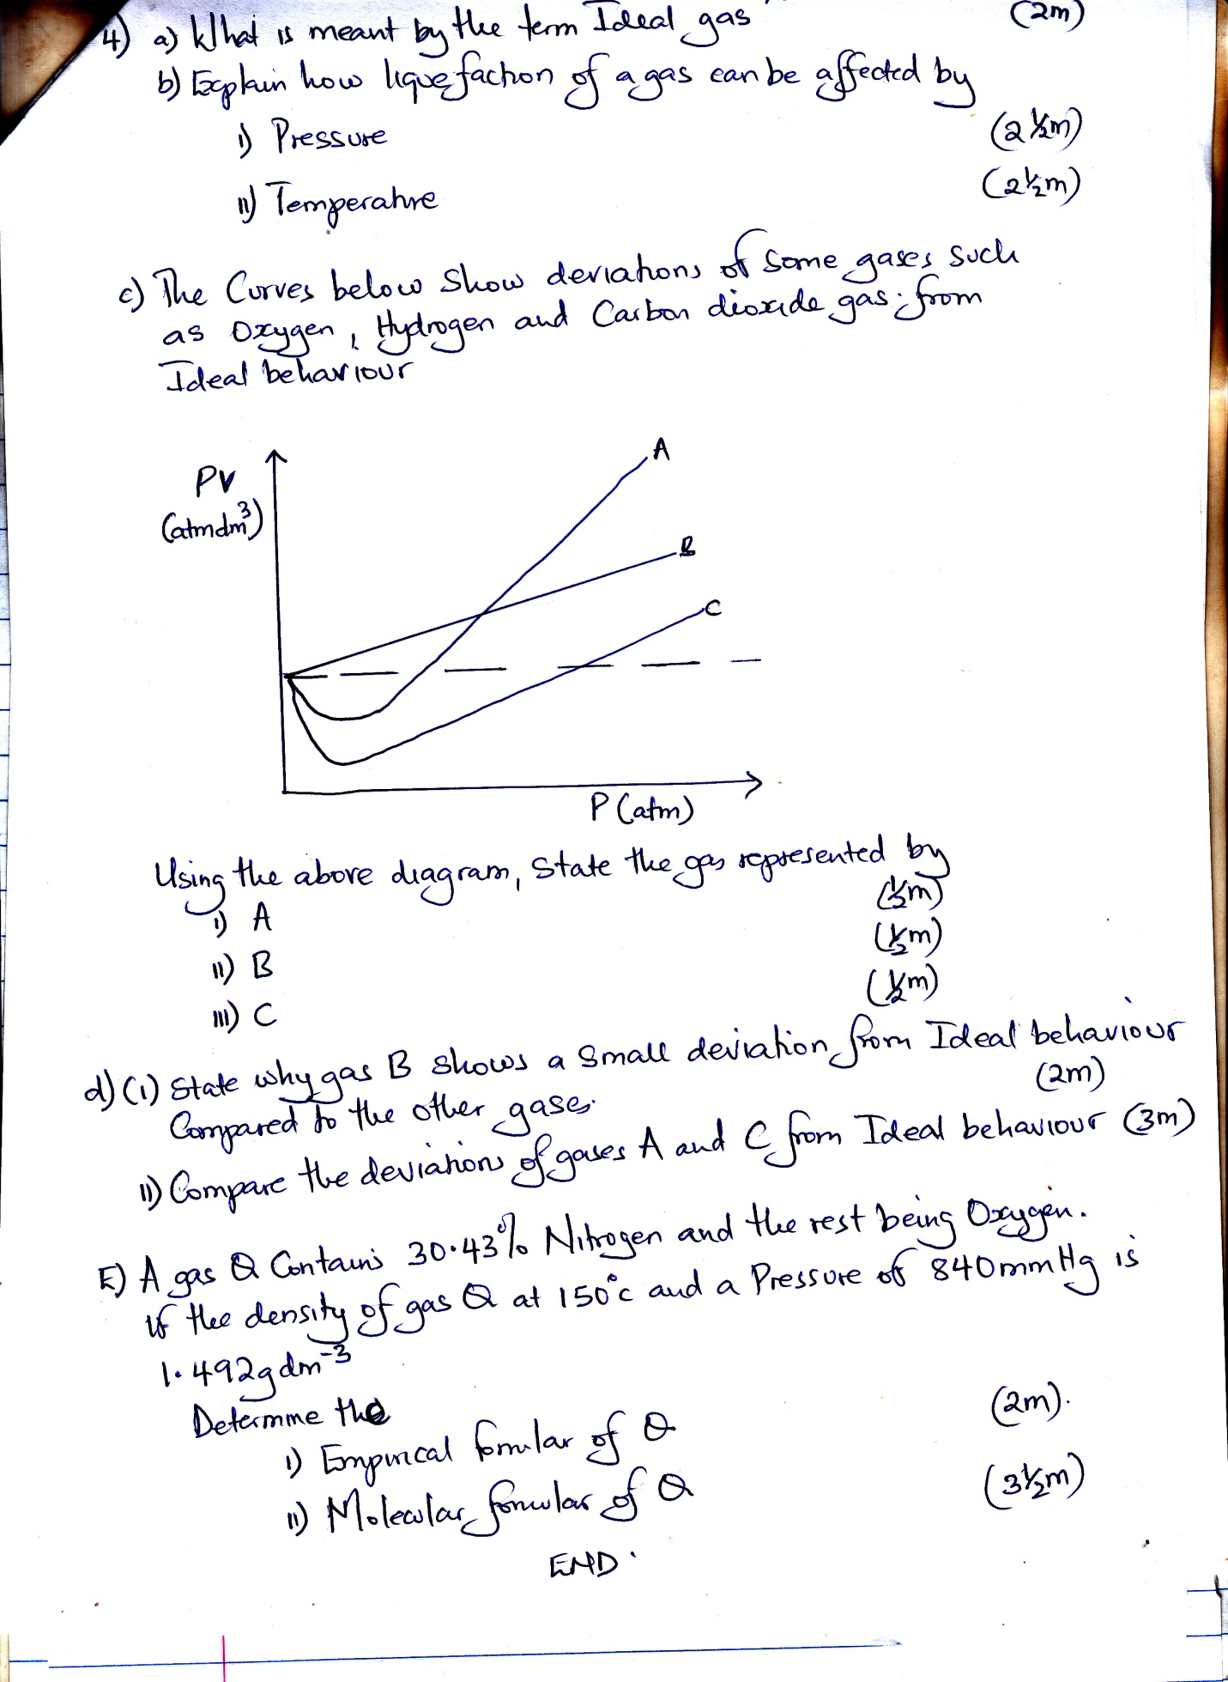

Using the above diagram, state the gas represented by;
- A (½ mark)
- B (½ mark)
- C (½ mark)
(d) (i) State why gas B shows a small deviation from ideal behavior compared
to the other gases. (02 marks)
(ii) Compare the deviations of gases A and C from ideal behavior. (03 marks)
(e) A gas Q contains 30.43% Nitrogen and the rest being oxygen.
If the concentration of gas Q at 150ºC and a pressure of 840 mmHg
is 1.492g dm⁻³.
Determine the;
- Empirical formular of Q (02 marks)
- Molecular formula of Q (3½ marks)
(N = 14, O = 16, r = 314 Jmol⁻¹)

END

