Name: ………………………………………………Signature: ………………

P530/1
BIOLOGY
Paper 1
July / Aug. 2018
2 ½ hours

INTERNAL MOCK EXAMINATIONS 2018
UGANDA ADVANCED CERTIFICATE OF EDUCATION
BIOLOGY
Theory
Paper 1
2 hours 30 minutes

INSTRUCTIONS:

Answer ALL questions in Sections A and B, in the spaces provided on the question paper.

SECTION A: ANSWER GRID.

1 |  | 11 |  | 21 |  | 31
2 |  | 12 |  | 22 |  | 32
3 |  | 13 |  | 23 |  | 33
4 |  | 14 |  | 24 |  | 34
5 |  | 15 |  | 25 |  | 35
6 |  | 16 |  | 26 |  | 36
7 |  | 17 |  | 27 |  | 37
8 |  | 18 |  | 28 |  | 38
9 |  | 19 |  | 29 |  | 39
10 |  | 20 |  | 30 |  | 40

SECTION A: (40 MARKS)

1. Movement of long and large polar molecules across the plasma membrane is repelled mostly by
A. Cholesterol
B. Phospholipids
C. Glycoproteins
D. Channel proteins

2. A short – term physiological adaptation by humans to high altitude is
A. Increased heart rate.
B. Concentration of blood.
C. Increased red blood cell production.
D. Increased capillary density.

3. Which of the following is not an adaptation for photosynthesis in shade plants?
A. High chlorophyll content
B. Low compensation point
C. Thin leaves
D. Thick leaves

4. A homeostatic role played by the mammalian gut is removal of
A. water
B. bile pigments
C. salts
D. undigested food

5. In the Calvin cycle, energy is required during
A. fixation of carbon dioxide by ribulose biphosphate.
B. conversion of glycerate phosphate to triose phosphate.
C. conversion of ribulose phosphate to triose phosphate
D. activation of the enzyme ribulose biphosphate carboxylase

6. Which of the following is not the function of a larval form during animal development?
A. Distribution of species
B. Feeding and growth.
C. Asexual reproduction
D. Sexual reproduction.

7. The following are typical features of submerged hydrophytes except
A. large floating leaves.
B. elongated petioles
C. well – developed xylem
D. aerial flowers
8. How many nucleotides are needed to code for a polypeptide that has 120 amino acids?
A. 30 B. 40
C. 360 D. 480

9. What cause and result suit the enhanced planetary greenhouse effect?

A. Release of CFC’s | Kin cancer
B. Burning of fossil fuels | Acid rain
C. Burning of fossil fuels | Climate change
D. Release of CFC’s | Urban pollution

10. Which bonds are used in maintaining the primary structure of proteins?
A. Peptide linkage
B. Hydrogen bonds
C. Ionic bonds
D. Glycosidic linkage

11. What is the role of oxygen in aerobic respiration?
A. To provide energy for the Krebs’ cycle.
B. To allow glycolysis of hexose sugar.
C. To accept electrons at the end of the respiratory chain.
D. To accept hydrogen from NADH + H⁺

12. What is the role of B cells in immune responses?
A. Stimulate division of T cells.
B. Release antigens into the plasma.
C. Release antibodies into the plasma.
D. Engulf antigens

13. The antibiotic streptomycin is thought to bind irreversibly to the ribosomes in bacteria, preventing them from functioning normally. Which process will be affected first?
A. Translation
B. Transcription
C. Active transport
D. Cellular respiration

14. Colchicine disrupts microtubule assembly. Which activity would be most affected by colchicines?
A. Photosynthesis
B. Replication of DNA
C. Separation of chromatids during anaphase.
D. Active transport by membrane proteins.
15. Eukaryotic cells are grown in a medium containing radioactive uracil. Where in the cell is radioactivity most likely to be detected?
A. Cell membrane
B. Ribosomes
C. Golgi apparatus
D. Lysosomes

16. Atherosclerosis is a condition where arteries become progressively blocked and lose ability to stretch. What is the most unlikely effect of this?
A. Occasional reduced oxygen supply to the brain.
B. A build – up of metabolic wastes in the tissues.
C. High blood pressure
D. Reduced blood flow to the heart

17. Which process would allow the movement of large protein molecules out of the cell?
A. Active transport
B. Exocytosis
C. Facilitated diffusion
D. Pinocytosis

18. In opening and closing of stomata, the osmotic theory is associated with
A. conversion of starch into sugars in the guard cells.
B. accumulation of mineral salts in the guard cells.
C. synthesis of abscicic acid in the guard cells.
D. production of starch in the guard cells during photosynthesis.

19. The restoration of the resting potential of a neurone after an impulse is based on
A. counter – current flow.
B. surface area to volume ratio of axoplasm.
C. active transport.
D. diffusion.

20. In the mammalian body, regeneration is least possible in the
A. buccal cavity
B. skin
C. liver
D. brain

21. Which statement is true of cellulose, but not true for protein?
A. Found in cell surface membrane.
B. Synthesised from identical sub-units.
C. Used as an energy source.
D. May be a structural component.

22. What is the ecological definition of the term community?
A. All the food webs in an ecosystem.
B. All the individuals of one species in an area.
C. All the organisms in an area.
D. The living organisms and their non – living environment.

23. All prokaryotic cells possess
A. capsules
B. flagella
C. pili
D. ribosomes

24. Which level of protein structure maintains the globular shape of enzymes?
A. Primary
B. Secondary
C. Tertiary
D. Quarternary

25. During transpiration, from where does the evaporation of water occur?
A. Intercellular spaces
B. Leaf surface
C. Mesophyll cell walls
D. Stomatal pores

26. Which statement explains how mass flow arises in sieve tube elements?
A. Sucrose activity loaded into sieve tube elements decreases the water potential causing the hydrostatic pressure to increase.
B. Sucrose actively loaded into sieve tube elements increases the water potential causing the hydrostatic pressure to decrease.
C. Sucrose diffused into sieve tube elements decreases the water potential causing the hydrostatic pressure to increase.
D. sucrose diffused into sieve tube elements increases the water potential causing the hydrostatic pressure to decrease.

27. Antibodies can act in a number of ways to protect the body from pathogenic bacteria. Which event will not occur following antigen – antibody binding?
A. Agglutination of bacteria to reduce their spread.
B. Increased susceptibility to phagocytosis.
C. Neutralisation of toxins to make them harmless.
D. Secretion of histamine to produce an allergic reaction.

28. Which is correct about the affinity between haemoglobin and the gases carbon dioxide, carbon monoxide and oxygen?

 | Highest affinity | lowest affinity
A | Carbon monoxide | Carbon dioxide | Oxygen
B | Carbon monoxide | Oxygen | Carbon dioxide
C | Oxygen | Carbon dioxide | Carbon monoxide
D | Oxygen | Carbon monoxide | Carbon dioxide

29. An increase in carbon dioxide in the human blood shifts the oxyhaemoglobin dissociation curve to the right. What explanation accounts for this effect?
A. An increase in carbon dioxide concentration increases the ventilation rate.
B. Carbon dioxide is more soluble than oxygen and displaces it.
C. Diffusion of carbon dioxide between the alveoli and the blood is more
rapid.
D. Increasing the H⁺ concentration decreases haemoglobin affinity for oxygen.

30. Only flowering plants undergo the process of
A. Asexual reproduction
B. Fertilization
C. Double fertilization
D. Sexual reproduction

31. All the following electrical changes of neurones are graded events except
A. action potentials
B. depolarisation caused by stimuli
C. excitatory post – synaptic potential
D. inhibitory post – synaptic potential.

32. The control of one part of a plant by another via the influence of growth substances is termed
A. correlation
B. synergism
C. antagonism
D. abscission

33. Which of the conditions is needed by almost all seeds to break dormancy?
A. Abrassion of the seed coat.
B. Exposure to light.
C. Imbibition of water
D. Vernalization

34. Which function of the liver results in the production of bile pigments?
A. Breakdown of haemoglobin.
B. Deamination of amino acids.
C. Detoxification of metabolic poisons.
D. Release of stored vitamin A.

35. Biological magnification indicates that certain toxic chemicals
A. cannot be broken down.
B. multiply within the body.
C. spread rapidly
D. undergo biodegradation

36. In a mark – recapture study of a pond tilapia population, 40 fish were captured marked and released. In a second capture 45 fish were captured, 9 of which were marked. What is the estimated number of tilapia in the pond?
A. 96 C. 360
B. 200 D. 800

37. Which of the following is not recycled in ecosystems?
A. Carbon C. Sulphur
B. Energy D. Water

38. In which form is carbondioxide mainly transported in blood?
A. As carbamino-haemoglobin
B. As carbonic acid.
C. As haemoglobinic acid.
D. As hydrogen carbonate.

39. Which of the following defines an ecological niche? The
A. habitat in which an organism finds its food supply.
B. habitat in which an organism finds the most suitable climate.
C. relationships between an organism and other species.
D. way in which the environment is exploited by an organism.

40. Which of the following enzymes has the lowest pH optimum?
A. Pancreatic lipase
B. Pepsin
B. Pancreatic amylase
D. Salivary amylase

SECTION B (60 MARKS)

41. (a) The diagram below represents an enlarged section of part of the
retina and choroid of a human eye.
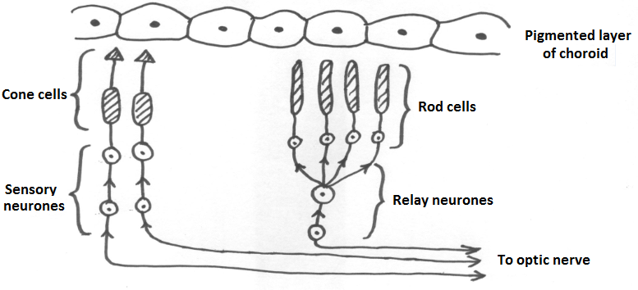

(a) (i) Draw an arrow on the sketch of the diagram to show the
direction in which light passes through the retina. (1 mark)

(ii) Suggest three functions of the black pigment, which is found in
the choroid of the eye. (3 marks)

…………………………………………………………………………………………………..
…………………………………………………………………………………………………..
…………………………………………………………………………………………………..
…………………………………………………………………………………………………..
…………………………………………………………………………………………………..
…………………………………………………………………………………………………..
(b) Using information in the diagram explain how a person is able to;
(i) see light of low intensity. (3 marks)

…………………………………………………………………………………………………..
…………………………………………………………………………………………………..
…………………………………………………………………………………………………..
…………………………………………………………………………………………………..
…………………………………………………………………………………………………..
…………………………………………………………………………………………………..

(ii) see in great detail in bright light. (3 marks)

…………………………………………………………………………………………………..
…………………………………………………………………………………………………..
…………………………………………………………………………………………………..
…………………………………………………………………………………………………..
…………………………………………………………………………………………………..
………………………………………………………………………………………………..
………………………………………………………………………………………………..
42. (a) Explain the following;
(i) If a rhesus negative mother of blood group O is carrying a rhesus positive
child of any blood group other than O, haemolytic disease of the newborn
does not arise. (3marks)

…………………………………………………………………………………………………..
…………………………………………………………………………………………………..
…………………………………………………………………………………………………..
…………………………………………………………………………………………………..
…………………………………………………………………………………………………..
(ii) The oxygen dissociation curve of a cat lies to the right of that for humans.
(3 marks)
…………………………………………………………………………………….…………..
………………………………………………………………………………………………..
………………………………………………………………………………………………..
(b) Describe the main features of the foetal blood circulation which do not occur in the adult man. (4 marks)

………………………………………………………………………………………………..
………………………………………………………………………………………………..
………………………………………………………………………………………………..
………………………………………………………………………………………………..
………………………………………………………………………………………………..
………………………………………………………………………………………………..
………………………………………………………………………………………………..
………………………………………………………………………………………………..
………………………………………………………………………………………………..

43. (a) The graphs A and B below indicate biotic interactions between different
species of Paramecia when bred in two mixed cultures in two different beakers. Study them and answer the questions that follow;

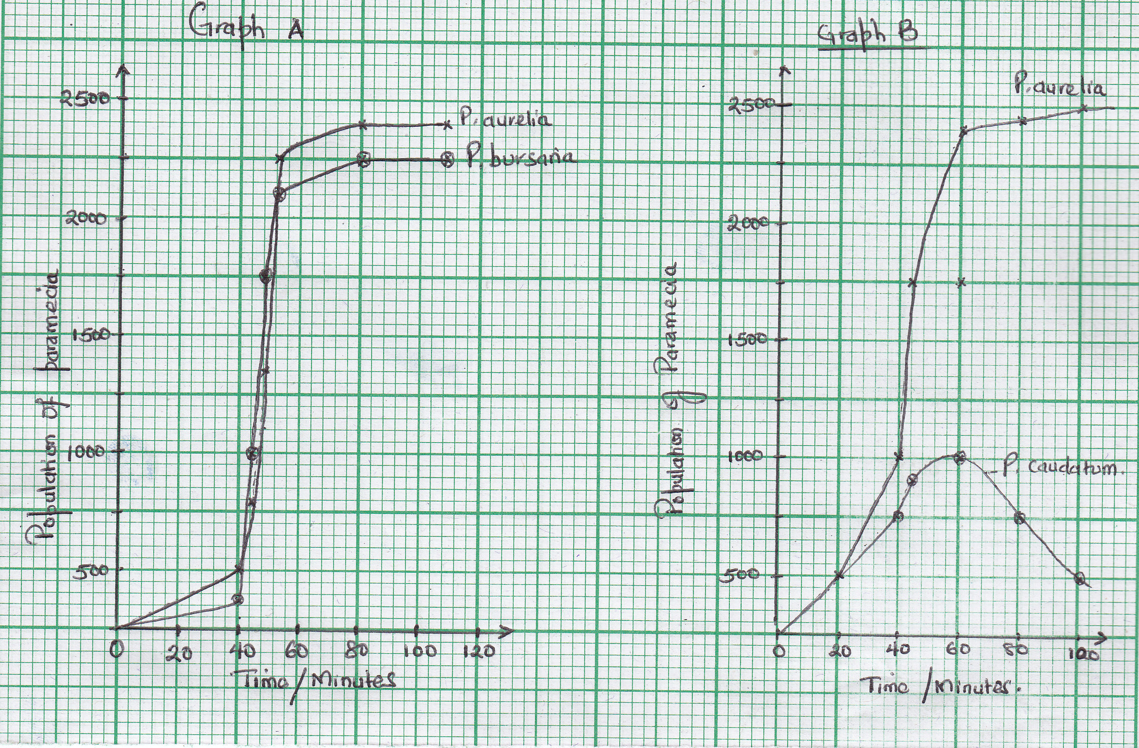

a) Propose the interactions shown by;
i) Graph A (01 mark)
………………………………………………………………………………………………..........
ii) Graph B
………………………………………………………………………………………………………

b) Explain the interaction between the two species as shown by graph A. (3 marks)
………………………………………………………………………………………………..
…………………………………………………………………….…………………………..
………………………………………………………..………………………………………..
………………………………………………………..………………………………………..
c) Suggest the adaptations of Paurelia, as shown by graph B. (2 marks)
………………………………………………………………………………………………..
…………………………………………………………………….…………………………..
………………………………………………………..………………………………………..
………………………………………………………..………………………………………..
d) What is the evolutionary significance of the interaction of the species in graph B?
(04 marks)
………………………………………………………………………………………………..
…………………………………………………………………….…………………………..
………………………………………………………..………………………………………..
………………………………………………………..………………………………………..
44. With respect to the use of pesticides
a) Distinguish the terms pest resurgence and biological magnification. (2 mark)
……………………………………………………………………………………………………..
……………………………………………………………………………………………………..
……………………………………………..……………………………………………………..
……………………………………………….…………….……………………………………..
……………………………………………………..……………………………………………..
b) Give the causes of pest resurgence. (4 marks)
………………………………………………………………………………………………..
…………………………………………………………………….…………………………..
………………………………………………………..………………………………………..
………………………………………………………..………………………………………..
……………………………………………….…………………….…………………………..
……………………………………………………………………………….………………..
c) Explain the qualities of an ideal pesticide. (4 marks)
………………………………………………………………………………………………..
…………………………………………………………………….…………………………..
………………………………………………………..………………………………………..

45. The figure below shows the mechanism of exchange of gases between the blood and water in a fish.

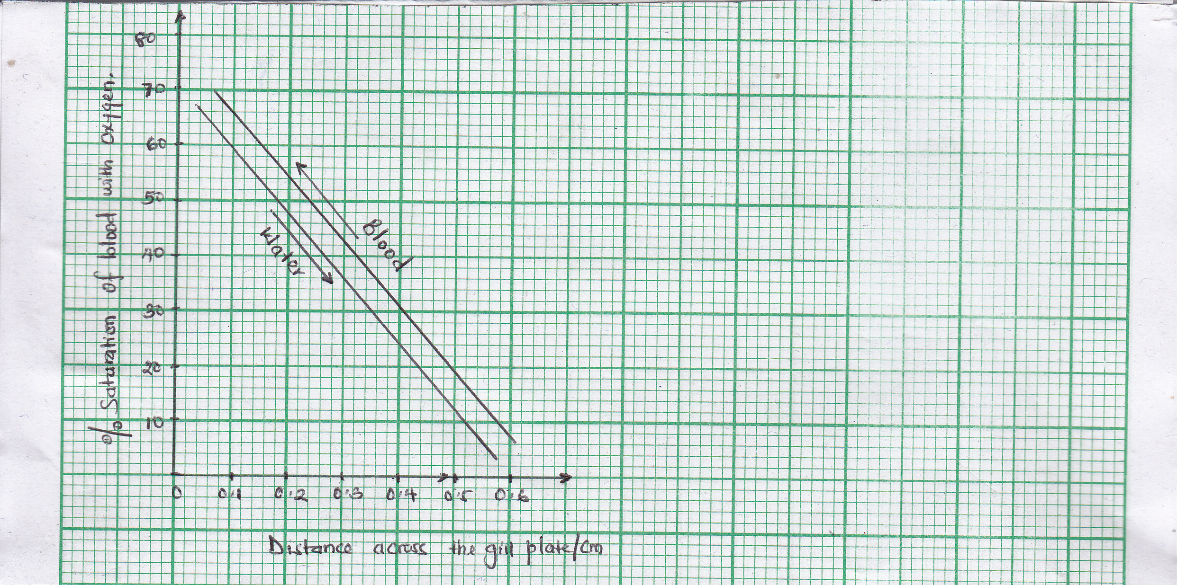

a) Identify the flow system illustrated above. (1mark)
…………………………………..……………………………………………………………..
…………………………….…………………………………………………………………….
b) Comment on the efficiency of the mechanism of exchange of gases shown.
(5 marks)
………………………………………………………………………………………………..
………………………………………………………..………………………………………..
………………………………………………………..………………………………………..
……………………………………………….…………………….…………………………..
c) Explain how the teleost gill is more efficient for gaseous exchange than the dog
fish gill. (3 marks)

………………………………………………………………………………………………..
…………………………………………………………………….…………………………..
………………………………………………………..………………………………………..
……………………………………………….…………………….…………………………..

46. (a) How are the angiosperms adapted for sexual reproduction on land? (4 marks)
………….………………………………………………………………………………………
……………………………………………………………………….………………………….
……..…………………………………………………..………………………………………..
………………………………………………………..………………………………………..
…………….………………………………….…………………….…………………………..
(b) Describe the structure of the male gamete in angiosperms. (4 marks)
………………………………………………………………………………………………..
…………………………………………………………………….…………………………..
………………………………………………………..………………………………………..
………………………………………………………..………………………………………..
(c) Mention the role of the nuclear material of the male gamete in the angiosperms. (2 marks)

………………………………………………………………………………………………..
…………………………………………………………………….…………………………..
………………………………………………………..………………………………………..
……………………………………………….…………………….…………………………..

END

