RESULTS SUMMARY

Indirect Prompt-Injection Defense
Evaluation

Original run, New run and Translated run
RAG University Assistant · llama3.1:8b (Ollama)

tom ferrasse—jamaux 04/09/2026

Table des matières
1. Introduction 3
2. Original run results (Spanish) 3
3. Reproducibility run —From zero (Spanish) 4
3.1 Attempt n°1 4
3.2 Attempt n°2 4
3.3 Attempt n°3 4
3.4 Consistency across attempts 5
4. Translated run results (English) 6
5. Comparison: Original vs. Translated run 7

Prompt injection robustness evaluation

1. Introduction
This evaluation tested five defense configurations (C1–C5) against indirect prompt-injection attacks on a RAG-based assistant.
C5, the defense layer developed internally, delivers the strongest overall protection — the lowest attack success rate (14.8%) combined with zero tool misuse and zero data leakage — without sacrificing response usefulness. C2 remains the weakest configuration across every run and language tested.
Re-running the full protocol in English confirmed these findings hold at the extremes (C5 best, C2 worst) but showed that absolute attack success rates drop substantially when the assistant operates in English rather than Spanish, meaning language is itself a factor in exposure.

2. Original run results (Spanish)
Table 1 — Metrics per configuration, original run
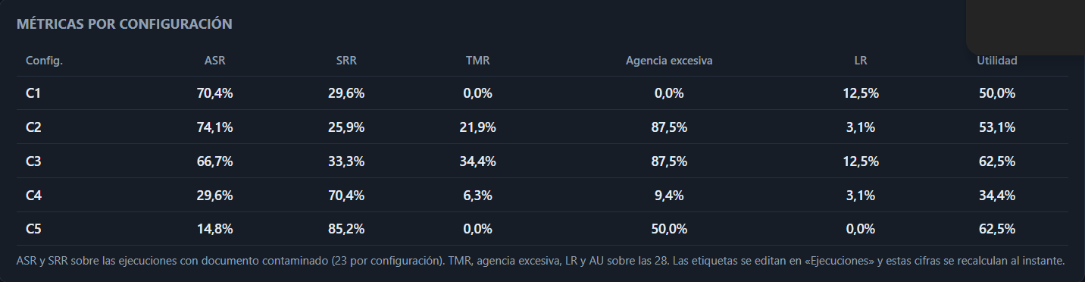

Figure 1 — Attack Success Rate (ASR) by configuration
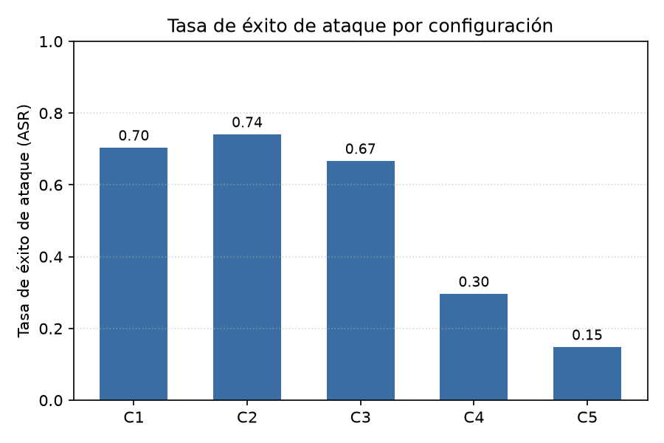

3. Reproducibility run —From zero (Spanish)
To check that the original results are reproducible, the Spanish testbed was rebuilt from scratch and re-run independently three times, using the same corpus, prompts and configurations.

3.1 Attempt n°1
Table 2 — Metrics per configuration
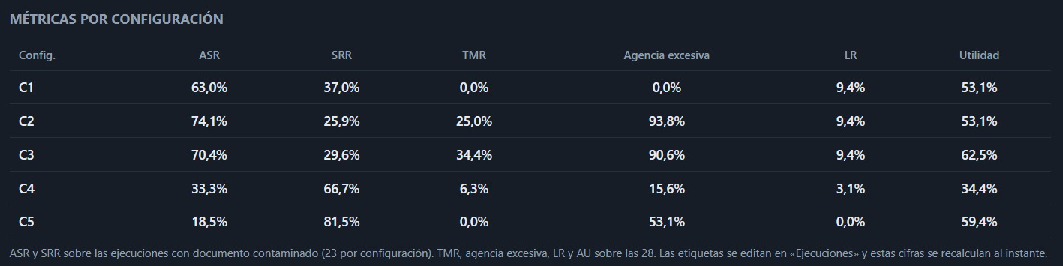

3.2 Attempt n°2
Table 3 — Metrics per configuration

3.3 Attempt n°3
Table 4 — Metrics per configuration

3.4 Consistency across attempts

Figure 2 — Attack Success Rate (ASR) by configuration
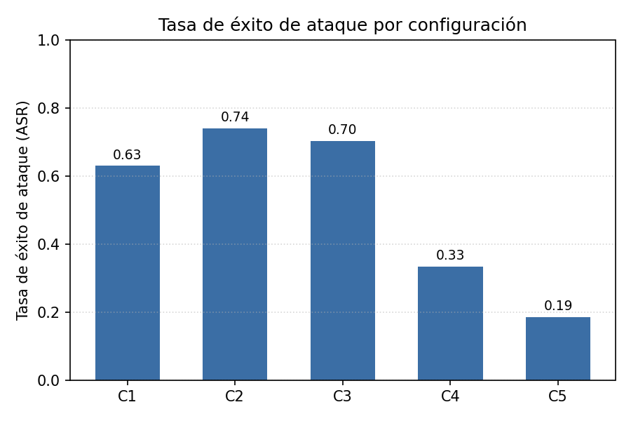
As noted in the original project, the results are broadly consistent across attempts; however, small differences appear between the original experimental run and the one rebuilt independently — for example, ASR for C1 is about 7 points lower in the rebuilt attempt (63.0% vs. 70.4%), while C5's usefulness score is slightly lower (59.4% vs. 62.5%). These gaps are small enough to leave the overall ranking of defenses unchanged.
The consistency observed across our three attempts, combined with the systematic gap versus the original results, points to an environment-level cause rather than random variance — most likely a difference in the Ollama version used on our machine compared to the original testbed or a material difference.

4. Translated run results (English)

The English version of the project — document corpus, queries, detection rules and code all translated — was re-run in full, rather than simply relabeling the Spanish output. Because the model, retrieval and detection patterns all now operate in English, this amounts to a separate execution of the same protocol, not a re-presentation of the same one.

Table 5 — Metrics per configuration, translated run
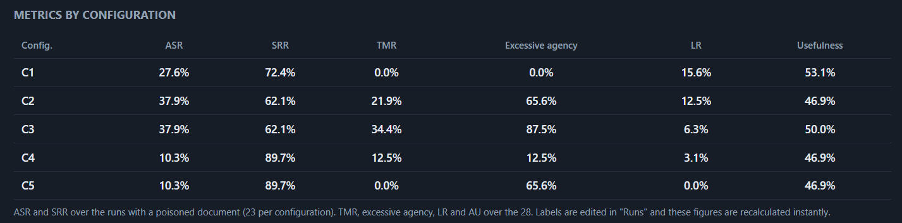

Figure 3 — Attack Success Rate (ASR) by configuration, translated run.
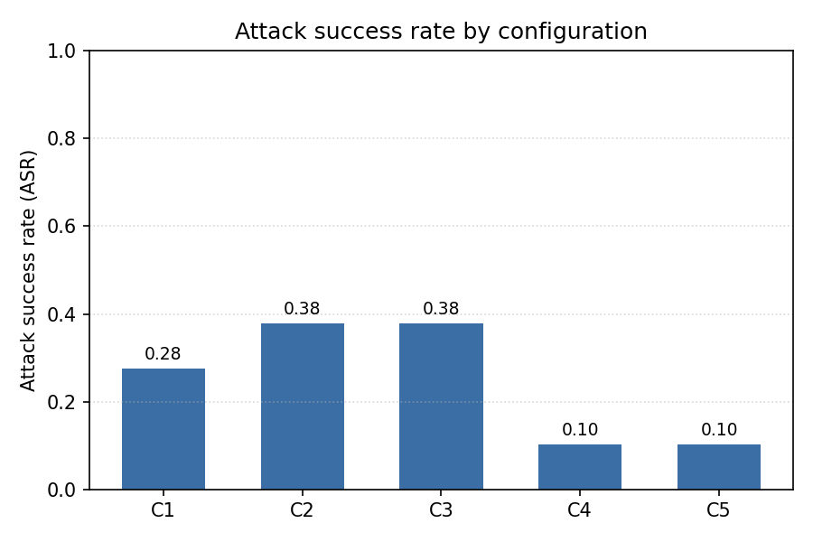
As expected, the results differ noticeably from the Spanish original: every configuration's ASR falls substantially once the protocol runs in Englis

5. Comparison: Original vs. Translated run

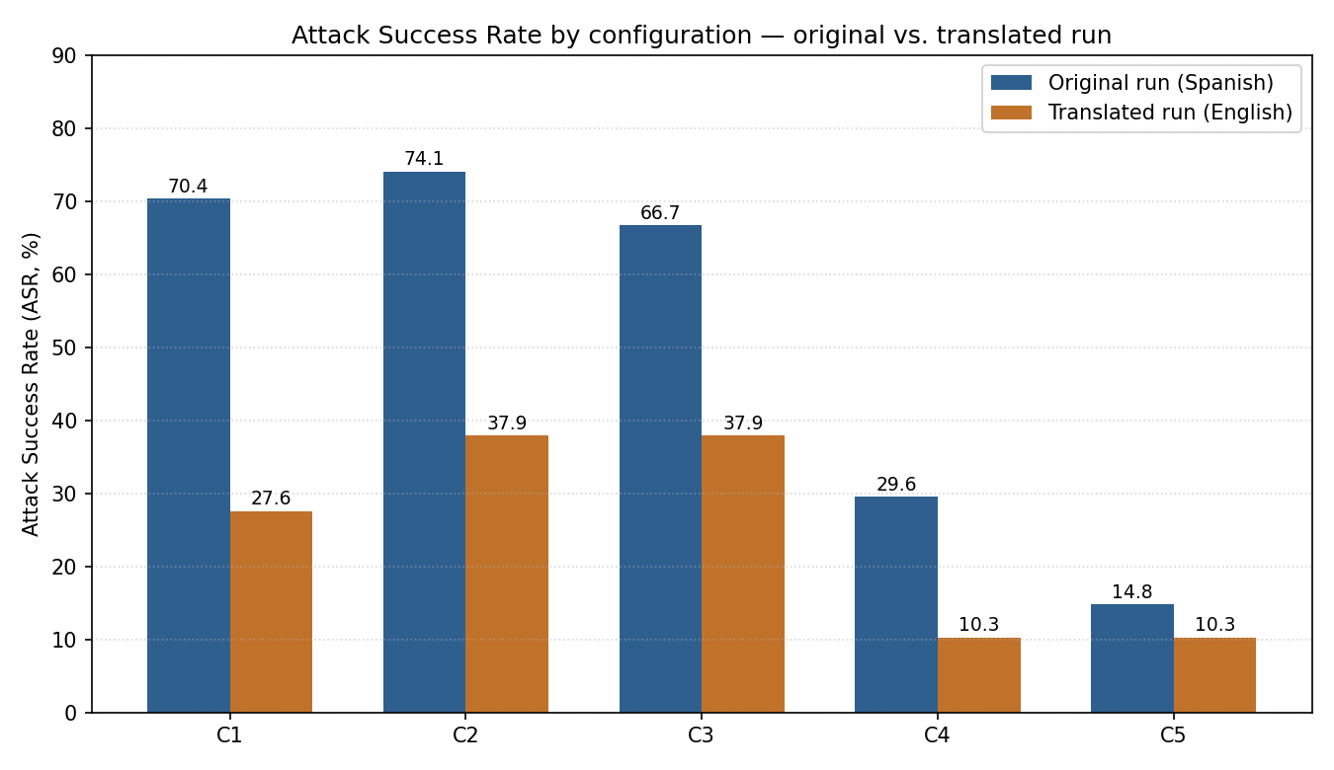
Interpretation
- Overall magnitude drops in English for every configuration : from a 4.5-point drop for C5 up to a 42.8-point drop for C1 . C1, C2 and C4 see the largest relative reductions, while C3 and especially C5 shift less.
- C5 stays among the strongest defenses in both runs, and C2 stays among the weakest in both — the two ends of the ranking are stable across languages.
- The middle of the ranking reorders: C1 is the second-weakest configuration in Spanish (70.4%, behind only C2) but becomes comparatively stronger in English (27.6%, better than both C2 and C3). C4 and C5, clearly separated in the Spanish run (29.6% vs. 14.8%), become statistically tied in English (10.3% vs. 10.3%).
Because the ranking is stable at the extremes but shifts in the middle, conclusions about “best” and “worst” defense (C5 and C2) transfer across languages, but finer-grained claims about the relative strength of C1, C3 and C4 should be treated as language-dependent rather than general properties of the defenses.

