CPU: Intel i5 10500H, base 2.5GHz freq. turbo to 4.5GHz

6 cores, 12 logical

GPU: 3050 Ti Notebook version

**CPU-Z Benchmark** (pe baterie, in priza cam dublu)

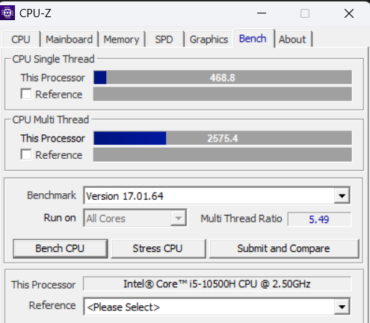

**SuperPi Benchmark**

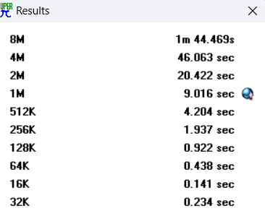

**NovaBench Benchmark**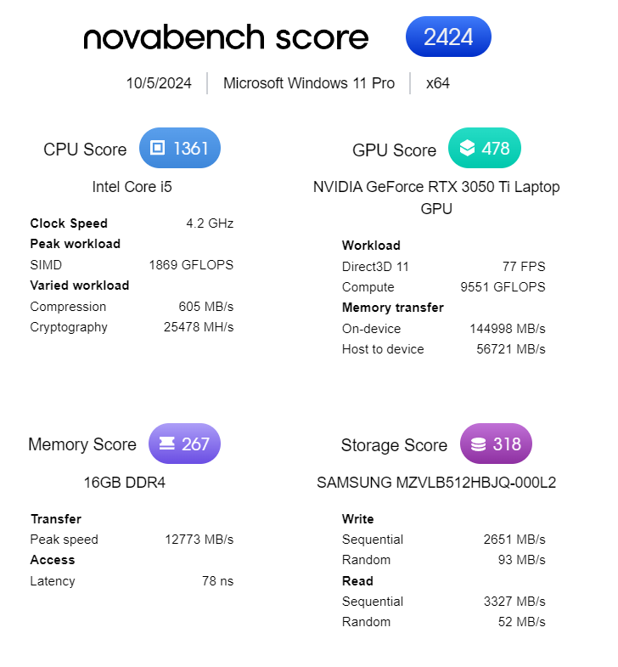

**Sandra Benchmarks**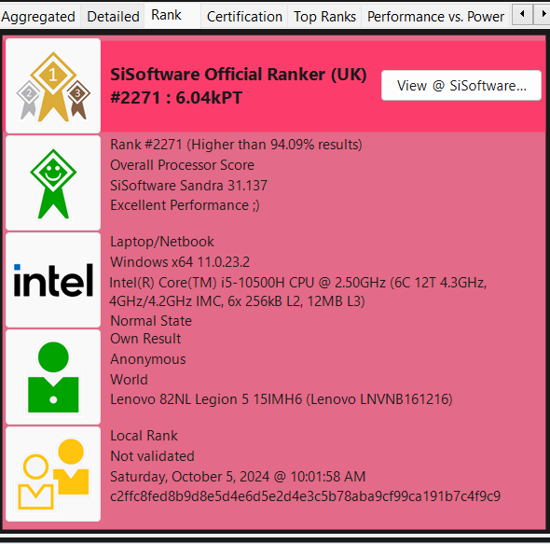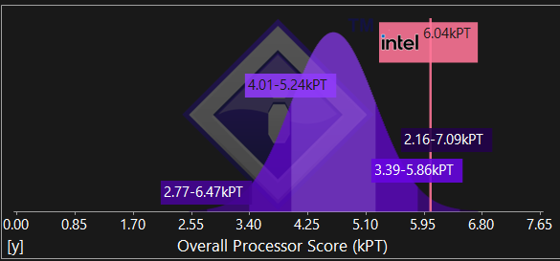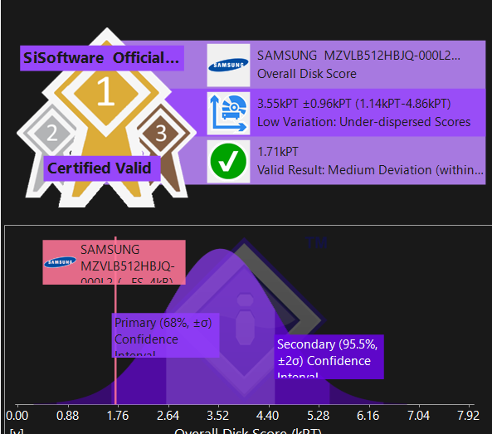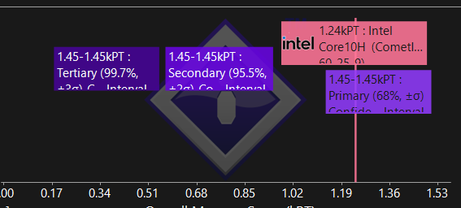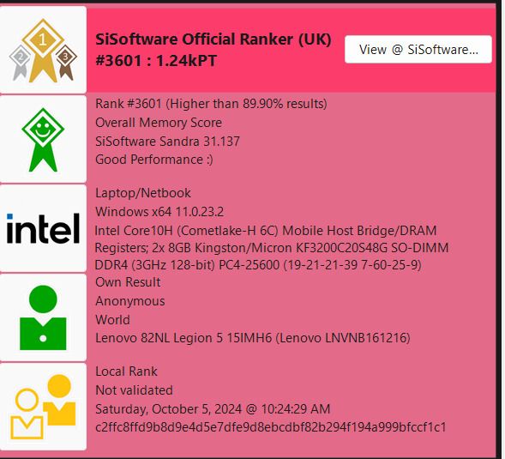

**Exercise 2**

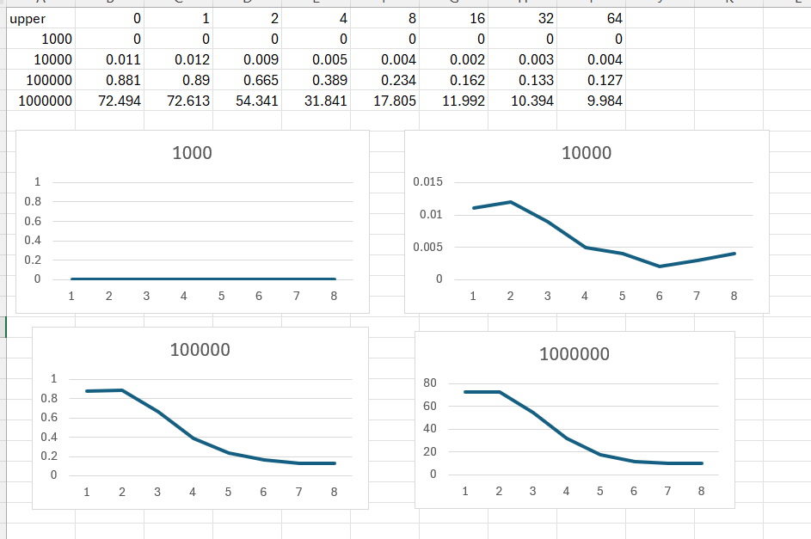

**Lab 2**

**Exercise 1**

**Exercise 2**

Se poate observa ca diferenta intre static si dynamic este una neglijabila. In schimb, complexitatea algoritmului ( Bubblesort O(n^2) vs std::sort (quicksort hybrid + alte optimizari) O(n*logn)).