CS7641 Machine Learning Assignment III by Georgia Tech
Unsupervised Learning
T. Ruzmetov
Introduction

K-means Clustering
Randomly initialize K centroids in a given space (2D, 3D, ..), where N-features defines dimension.
Then for each data point calculate distance to all centroids and choose the closest centroid to assign
a label. After assignment is complete, move each centroid to the geometrical center of corresponding
class(label). Reiterate until locations of centroids converge to some position.
In practice, the k-means algorithm is very fast (one of the fastest clustering algorithms available),
but it is prone to fall into local minima. That’s why it can be useful to restart it several times.
The k-means++ algorithm offers a smart procedure to initialize the cluster centers, where it guarantees to find a solution that is O(log k) competitive to the optimal k-means solution.

Expectation Maximization Algorithm and Gaussian Mixture Models
Expectation maximization (EM) is a numerical method for maximum likelihood estimation. EM
guarantees to approach a local or global optima by increasing maximum likelihood of the data with
subsequent iteration. Here we use EM with gaussian mixture model. The algorithm basically consists of two main steps, where in a first step known as Expectation step, we calculate expectation of the component assignment(labels) for each data point given the model parameters(Gaussian parameters: means μ k , weights φ k , standard deviations σ k ). The second step is Maximization step, which consists of maximizing the expectations calculated in a first step with respect to the model parameters. This step involves updating above mentioned parameters iteratively. The entire process repeats until the algorithm converges to maximum likelihood estimate.

Dimentionality Reduction: PCA, ICA, RPA, Other
PCA
Principal component analysis (PCA) is a dimensionality reduction technique which converts
a set of possibly correlated variables(features) into principal components which happens to be di-
rections that capture most variance in data. For instance, if I have a data set composed of features
X1 = f (x) , X2 = g(x) and X3 = a ∗ X1 + b ∗ X2 that is linear combination of 1st and second
features. Then, applying PCA to above data can transform it from 3D to 2D. It is obvious that
1st and second features are sufficient to explain all variance in the model and 3rd feature is just a
linear combination of those two.

ICA
Independent Component Analysis (ICA) is a powerful technique to separate linearly mixed sources. It transforms original features, assuming they are linearly mixed, into independent components with zero mutual information. The latent variables are assumed non-gaussian and mutually independent, and they are called the independent components of the observed data. After applying ICA to whole data number of components can be reduced by choosing components with highest kurtosis, which is the fourth central moment divided by the square of the variance.

Random Projection
Random projection is a technique used to reduce the dimensionality. Method is powerful, simple and
good at preserving distances well after projection. In random projection, the original d-dimensional
data is projected to a k-dimensional (k << d) subspace, using a random k × d - dimensional matrix
R whose rows have unit lengths. Using matrix notation: If X d × N is the original set of N d-dimensional observations, then X k × N R P = R k × d X d × N is the projection of the data onto a lower k-dimensional subspace. Random projection is computationally simple: form the random matrix “R” and project the d × N data matrix X onto K dimensions of order O ( d k N )

Other

K-means & EM on Adult Data

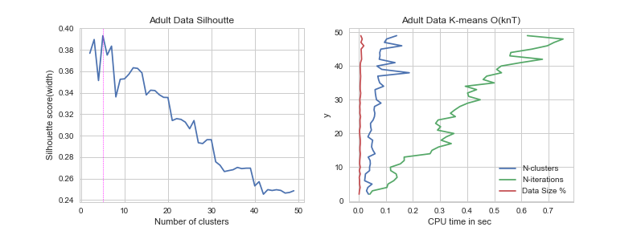

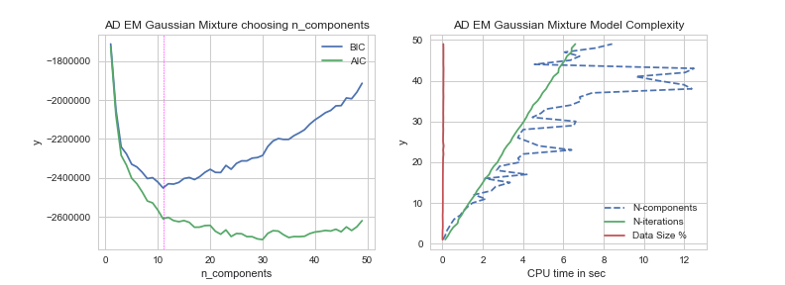

K-means & EM on Lending Club Data

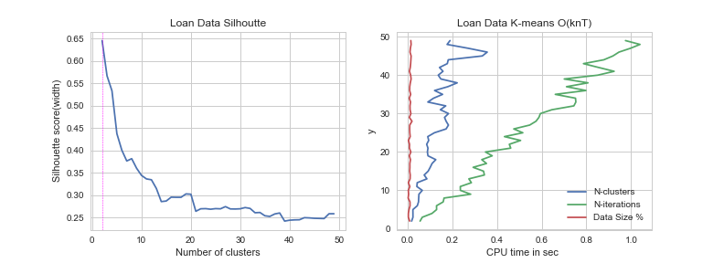

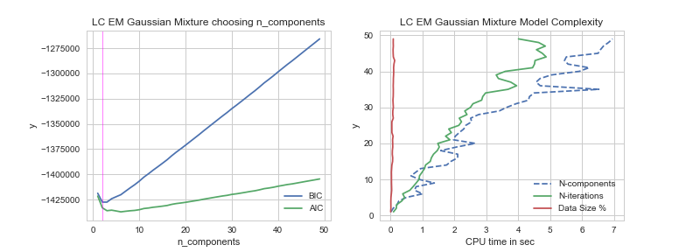

Dimensionality Reduction PCA
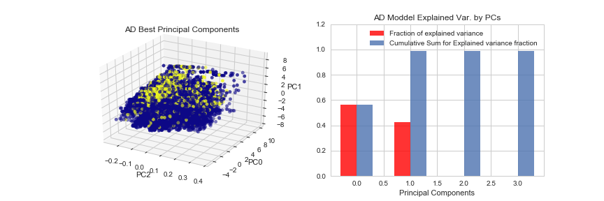
wededcweded

wedwed
wedewd

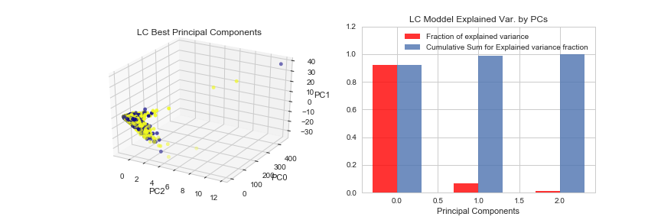

ICA

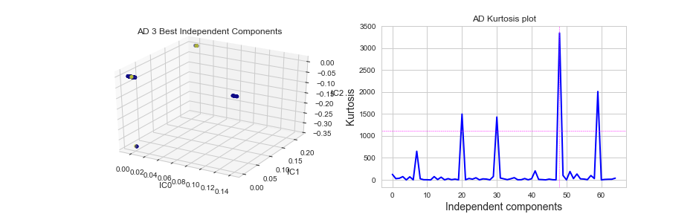

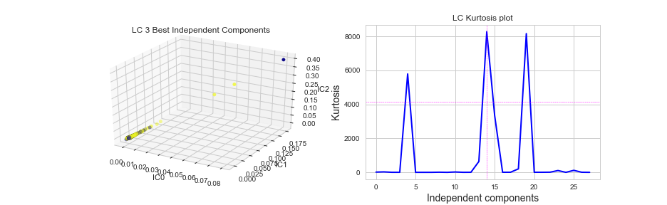

Random Projections

