# Approach

Our GCAM representation of “learning by doing”, a component of technological change, follows Wright’s Law, which states that every cumulative doubling of a technology’s production or deployment will reduce its cost by a constant percentage. This percentage is called the learning rate, denoted *r*. For example, if *r = 0.2*, then the technology cost will decrease by 20% each time that the cumulative deployment doubles. Using Wright’s law, the cost of a technology in year *t*, *Ct*, can be written as:

$$C_{t}=AQ_{t}^{\log_{2}{(1-r)}}$$

where *Qt* is the cumulative deployment of the technology in year *t* and *A* is a constant representing the first-of-a-kind (FOAK) cost of the technology (i.e., the cost of the first unit produced or deployed, such that *Ct = A* when *Qt = 1*).

This equation can also be expressed in terms of the cost and deployment of the technology at any given reference year *t0* rather than the FOAK cost:

$$C_{t}=C_{t_{0}}{\left(\frac{Q_{t}}{Q_{t_{0}}}\right)}^{\log_{2}{(1-r)}}$$

# Application to power sector technologies in GCAM

For power sector technologies, cumulative deployment in a period *t* (Qt) can be interpreted as the cumulative electric capacity deployed (i.e., the sum of new capacity added in each year up to and including year t). To apply Wright’s law, we need to know the learning rate of each technology as well as either (a) the cost $C_{t_{0}}$ and cumulative deployment $Q_{t_{0}}$ in the reference year $t_{0}$ or (b) the FOAK cost for technologies not yet deployed as of a given reference year $t_{0}$.

GCAM power sector technologies may be made up of multiple components with different learning rates. For example, most sources estimate the learning rate of solar PV modules at around 20%. However, the cost of the rest of a utility scale solar PV plant, or the balance-of-system (BOS), may not decrease as rapidly with cumulative PV deployment due to the need for more site-specific customization. Therefore, we should not assume that the entire capital cost of utility scale solar PV decreases at a learning rate of 20%. Instead, we can assign learning rates and reference year or FOAK costs to individual “learning components” which may correspond with either an entire GCAM technology (e.g., offshore wind) or a component of a GCAM technology (e.g., PV module, utility PV BOS, rooftop PV BOS, grid storage, or CCS).

This framework allows for the cumulative deployment of multiple GCAM technologies combined to contribute to the learning curve of one learning component (e.g., PV, rooftop_pv, and PV_storage all contribute to learning for PV modules). It also allows for the capital cost of a single GCAM technology to be derived from the learning curves of multiple learning components (e.g., the PV_storage endogenous capital cost is derived from the learning curve outputs of PV modules, utility PV BOS, and grid battery storage). The diagram below shows the relationships between GCAM technologies and learning components. Each learning component in the middle column is assigned learning curve parameters, including a learning rate and either a FOAK cost or a base year cost and deployment level. In any given future period, the cumulative deployment of GCAM technologies in the left column are applied to the learning curves of the learning components in the middle column, resulting in endogenous costs of all learning components. The endogenous costs of GCAM technologies in the right column are then determined based on the sum of their respective learning components’ costs. These endogenous costs are applied to the GCAM technologies in the following period.

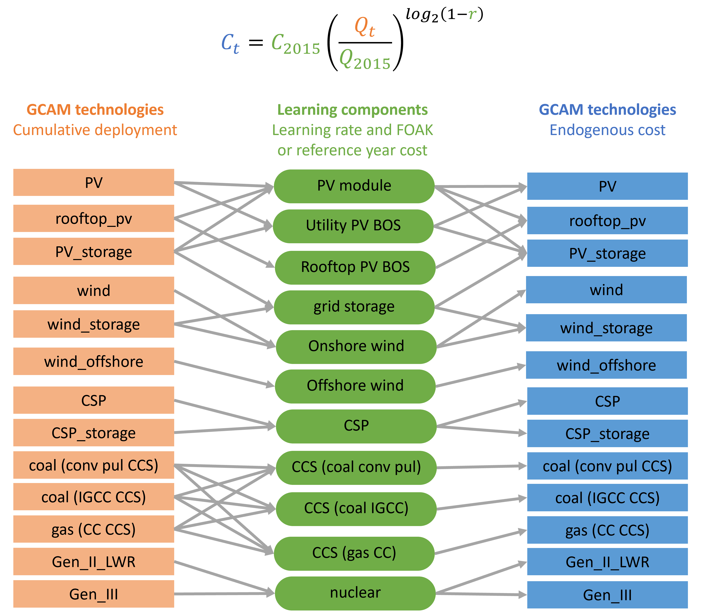

Figure 1. Mappings between GCAM power sector technologies and learning components.

For consistency with GCAM’s current base year, we use 2015 for the reference year cost and deployment in the learning curve equations. The table below summarizes the values of *r*, *C2015*, and *Q2015* used for each learning component and the sources of these values. Note that for CCS technologies, which were not yet deployed in 2015, we set *Q2015 = 1* and use an assumed FOAK cost for *C2015*.

Table 1. Learning curve (Wright’s Law) parameters for each GCAM learning component.

|  |  |  |  |  |  |  |
| --- | --- | --- | --- | --- | --- | --- |
| **Learning component** | **Learning rate** | **Learning rate source** | **C2015 (1975$/kW)** | **C2015 source** | **Q2015 (kW)** | **Q2015 source** |
| PV module | 0.215 | [Malhotra & Schmidt](https://doi.org/10.1016/j.joule.2020.09.004) | 188 | [NREL 2018](https://data.nrel.gov/submissions/103) | 25,689,000 | [NREL 2018](https://data.nrel.gov/submissions/103) |
| Utility PV BOS | 0.14 |  | 345 | [NREL 2018](https://data.nrel.gov/submissions/103) | 14,907,000 | [NREL 2018](https://data.nrel.gov/submissions/103) |
| Rooftop PV BOS | 0.145 | [Malhotra & Schmidt](https://doi.org/10.1016/j.joule.2020.09.004) | 566 | [NREL 2018](https://data.nrel.gov/submissions/103) | 10,782,000 | [NREL 2018](https://data.nrel.gov/submissions/103) |
| CSP | 0.073 | [Malhotra & Schmidt](https://doi.org/10.1016/j.joule.2020.09.004) | 2270 | GCAM (2015) | 1,810,800 | [CSP Guru](https://zenodo.org/records/8191855) |
| Onshore wind | 0.152 | [Malhotra & Schmidt](https://doi.org/10.1016/j.joule.2020.09.004) | 451 | GCAM (2015) | 55,052,083 | GCAM |
| Offshore wind | 0.088 | [NREL 2024](https://www.nrel.gov/docs/fy24osti/88988.pdf) | 1118 | GCAM (2015) | 1 | Assumed FOAK |
| Grid storage | 0.1 | [PNNL 2020](https://www.pnnl.gov/sites/default/files/media/file/Final%20-%20ESGC%20Cost%20Performance%20Report%2012-11-2020.pdf) | 1228 | GCAM (2015) | 292,000 | EIA SEDS |
| Coal (conv pul CCS) | 0.12 | [Rubin 2007](https://ieaghg.org/publications/estimating-the-future-trends-in-the-cost-of-co2-capture-technologies/) | 540 | GCAM (2020) | 1 | Assumed FOAK |
| Coal (IGCC CCS) | 0.12 | [Rubin 2007](https://ieaghg.org/publications/estimating-the-future-trends-in-the-cost-of-co2-capture-technologies/) | 718 | GCAM (2020) | 1 | Assumed FOAK |
| Gas (CC CCS) | 0.12 | [Rubin 2007](https://ieaghg.org/publications/estimating-the-future-trends-in-the-cost-of-co2-capture-technologies/) | 380 | GCAM (2020) | 1 | Assumed FOAK |
| Nuclear | 0.068 | [Malhotra & Schmidt](https://doi.org/10.1016/j.joule.2020.09.004) | 1703 | GCAM (2015) | 105,264,389 | GCAM |

# Calibration

The learning curves described above only take into account learning by doing, and do not explicitly incorporate other components of technological change like research and development and spillovers. Therefore, it is helpful to include an exogenous adjustment to account for these other factors. We do this by calibrating endogenous capital costs in the GCAM reference scenario to the NREL ATB cost projections, which are typically used to exogenously set capital costs in GCAM. The ATB projections take into account all predicted technological change effects, so calibrating to the baseline ATB projection in the GCAM reference scenario allows us to capture the components of technological change not included in the learning by doing framework. The calibration process follows these steps:

1. Run the GCAM reference scenario without endogenous technological change (i.e., with the default GCAM exogenous capital costs from the ATB)
2. Calculate technologies’ cumulative deployment in each period using results from step 1. Apply these cumulative deployment levels to the learning curves described above.
3. Derive a calibration adder for each technology in each period, defined as the difference between the endogenous capital costs calculated in step 2 and the default GCAM exogenous capital costs used in step 1.
4. For subsequent GCAM runs with endogenous technology change, add the respective calibration adder to the endogenous capital cost calculated for each technology in each period.

This process ensures that, when the reference scenario is run with endogenous technological change, the capital costs will remain the same as their default (ATB) values. Thus, the reference scenario with exogenous technological change is identical to the reference scenario without exogenous technological change. Note that the philosophy of this approach is analogous to the method of calibrating total factor productivity (TFP) when running GCAM with GDP feedbacks, wherein TFP is calibrated based a reference scenario without GDP feedbacks, such that GDP matches some reference trajectory (e.g., SSP2) when feedbacks are turned on in the reference scenario.

# Overview of gcamwrapper workflow

We use gcamwrapper to endogenously update the costs of power sector technologies between model periods to reflect ETC using the learning curves and calibration adders described above Figure 2). Starting with the base year, following each model period, we calculate cumulative capacity of each GCAM technology of interest and map these capacities to the corresponding learning components as shown in Figure 1. Then, we apply the learning curve (Wright’s law) to the total cumulative capacity associated with each learning component using the parameters in Table 1. We aggregate the resulting learning component capital costs back to the corresponding GCAM technologies using the mappings in Figure 1, and we apply the appropriate calibration adder to each technology. Finally, we use the resulting adjusted capital costs to update the capital costs of GCAM technologies for the next period.

Figure 2. Workflow implemented in gcamwrapper to endogenously update capital costs of GCAM technologies.

## gcamwrapper workflow parameters

### Exogenous *inputs*

* t0_cost_deployment: For each learning component, the cost (1975$) and deployment (kW) in the reference year (2015). For technologies that were not yet deployed in the reference year (e.g., CCS), the deployment is set to 1, i.e., and the cost is the assumed FOAK cost. See Table 1.
* learning_rates: assumed learning rate (r) for each learning component. See Table 1.
* tech_FCR: fixed charge rates (FCR) for GCAM technologies (note: this is a GCAM input). Used for converting between levelized and capital costs.
* non_learning_capital: GCAM technologies’ remaining capital costs that are not included in learning components. Currently, these consist of storage capital for CSP_storage and non-CCS capital for coal and gas CCS technologies. They are based on the capital costs of the GCAM technologies without the respective learning component (e.g., the non-learning capital for the gas combined cycle with CCS technology is the capital cost of the gas combined cycle technology). Note that eventually, the goal is to represent learning on all components of technologies, at which point this input will no longer be necessary.

### Mappings

* cooling_tech_map: maps cooling tech-level electricity technologies to their corresponding pass thru technologies in the electricity sector. Used to aggregate electricity generation from different cooling tech level technologies when calculating cumulative capacities.
* learning_components_deployment_map: Used to determine the GCAM technologies whose cumulative deployment contributes to learning for each learning component (see the left side of Figure 1). A single technology can contribute to multiple learning components (e.g., cumulative deployment of PV_storage contributes to learning for PV module, utility PV BOS, and grid storage). A single learning component can incorporate contributions from multiple technologies (e.g., grid storage learns from the cumulative deployment of PV_storage and wind_storage combined).
* learning_components_learning_map: Used to determine the technologies whose endogenous capital costs are impacted by learning occurring for each learning component (see the right side of Figure 1).

### Calibrated inputs

* cal_adders: adders to calibrate capital costs in the reference scenario to a reference cost trajectory (see section 3). When running scenarios with ETC using gcamwrapper, these calibrated adders are added to the endogenous costs.