CprE 381, Computer Organization and

Assembly-Level Programming

Lab 2 Report

Student Name Trent Walraven

Submit a typeset pdf version of this on Canvas by the due date. Refer to the highlighted language in the lab document for the context of the following questions.

After talking with the substitute TA for my lab, he suggested I put this here, to show I did this since my main TA was not in the lab.
[Part 0 (prelab)] Describe the provided DFF in dffg.vhd in terms of edge sensitivity and reset type
(active low/high and synchronous/asynchronous).
This flip flop looks has active high, where I high value is used to select when a new value is being loaded in, and when the value should be cleared. This has a rising edge sensitivity where the value will change based on the values on the rising edge of the clock. This makes it a synchronous since it will change with all other devices on the clock.

[Part 2 (a)] Draw the interface description for the MIPS register file. Which ports do you think are necessary, and how wide (in bits) do they need to be?
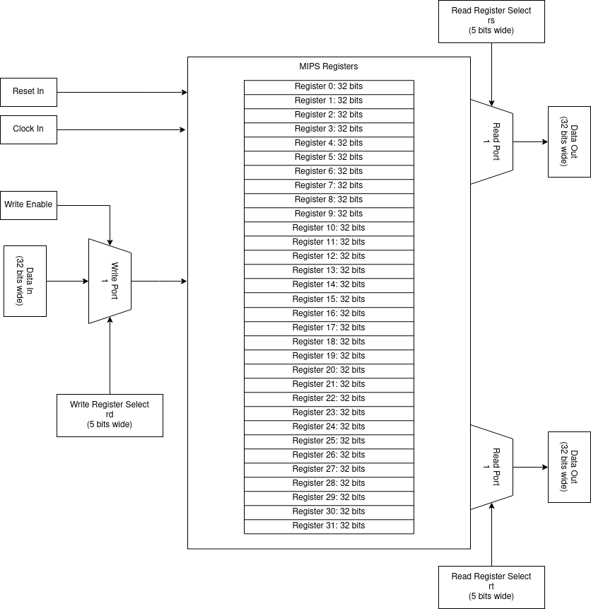

[Part 2 (b)] Create an N-bit register using this flip-flop as your basis.

[Part 2 (c)] Waveform.
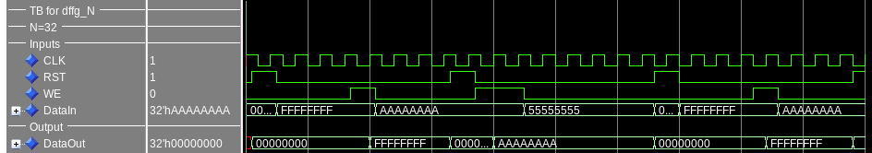
This waveform shows values being loaded into the output register on write-enable and positive clock edge, and resetting when reset is enabled.
[Part 2 (d)] What type of decoder would be required by the MIPS register file and why?
The MIPS register file will need a 5:32 to decoder to properly set the individual write enables for a single register at a time.

[Part 2 (e)] Waveform.
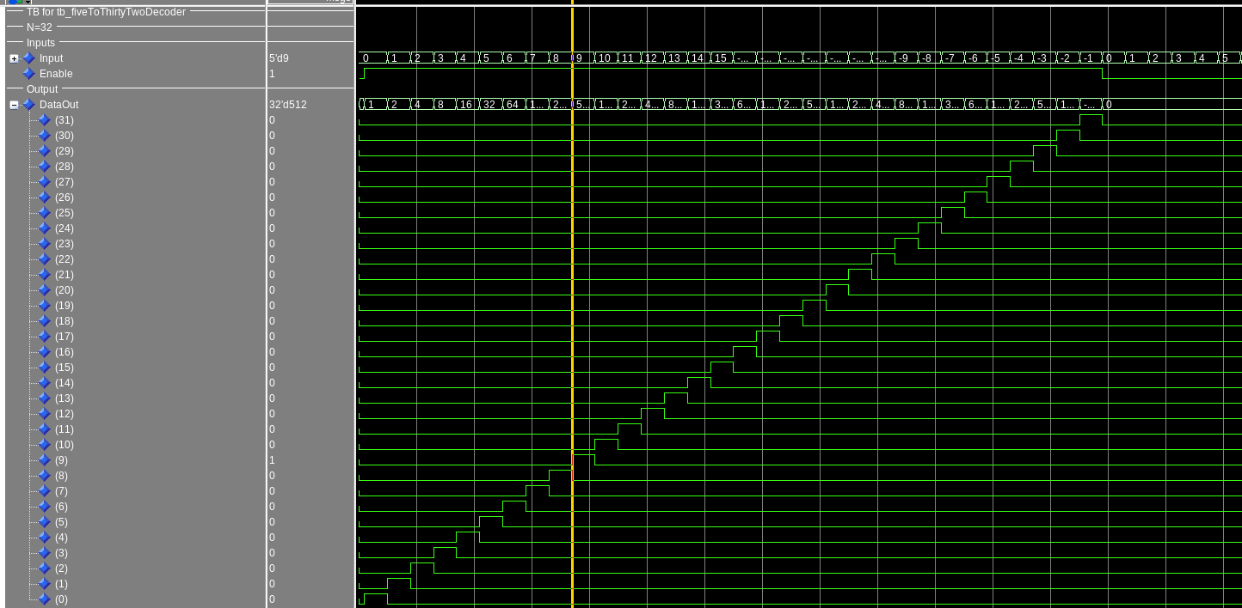
This shows the decoder going through all input values of the decoder with write enabled, and showing that no output is given when the enable is turned off.
[Part 2 (f)] In your write-up, describe and defend the design you intend on implementing for the next part.
I’m planning on using the dataflow method similar to the decoder, with a when statement based on the incoming select value will direct the correct 32 bit input to the output. This to me seems like the quickest method as it directly takes the input, and uses it for directing the output value with little extra logic needed. Making it the most likely to take the least amount of time.

[Part 2 (g)] Waveform.
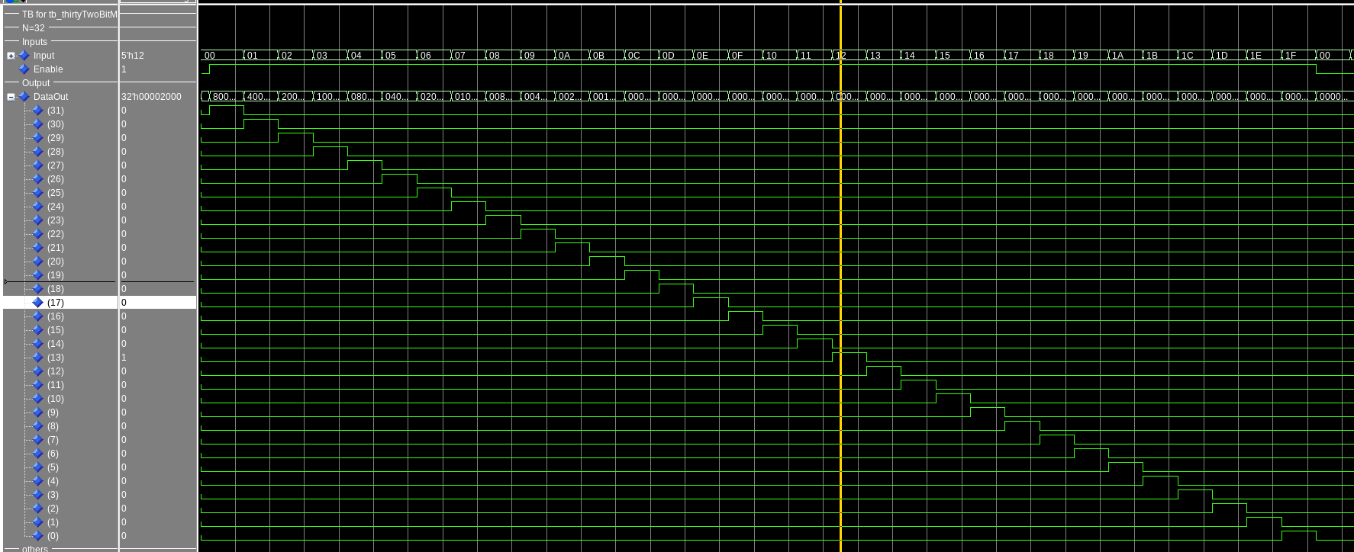
This waveform shows the 32 bits output from the selected input with data0 having bit 31 on, through data31 having bit 0 on. It also shows when enable is turned off that no output is given
[Part 2 (h)] Draw a (simplified) schematic for the MIPS register file, using the same top-level interface ports as in your solution describe above and using only the register, decoder, and mux VHDL components you have created.

[Part 2 (i)] Waveform.
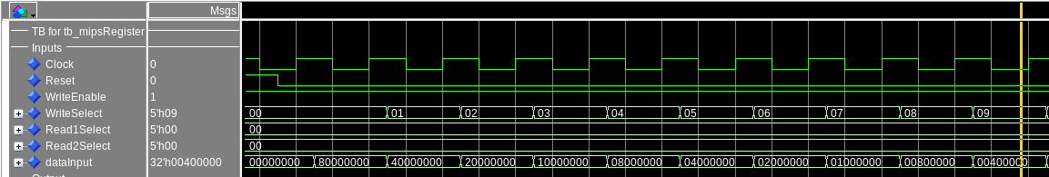
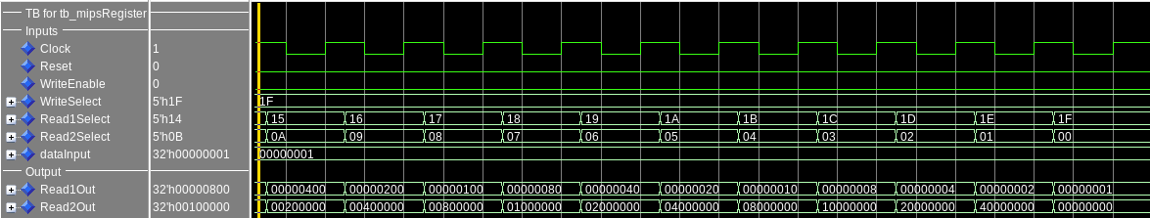
This first image shows how write enabled is on, and values are being written to registerX where X is the bit being written. Reading of these values can be seen in the next screenshot. This waveform shows readports 1, and 2 increasing and decreasing value the register they are reading from. With the registers being set to their corresponding bits set so register31 bit 31 is set, register30 bit 30 is set, and so on. This also shows how register0 always reads zero even though data has been written to it.

[Part 3 (b)] Draw a symbol for this MIPS-like datapath.

[Part 3 (c)] Draw a schematic of the simplified MIPS processor datapath consisting only of the component described in part (a) and the register file from problem (1).

[Part 3 (d)] Include in your report waveform screenshots that demonstrate your properly functioning design. Annotate what the final register file state should be.

[Part 4 (a)] Read through the mem.vhd file, and based on your understanding of the VHDL implementation, provide a 2-3 sentence description of each of the individual ports (both generic and regular).

[Part 4 (c)] Waveforms.

[Part 5 (a)] What are the MIPS instructions that require some value to be sign extended? What are the MIPS instructions that require some value to be zero extended?

[Part 5 (b)] what are the different 16-bit to 32-bit “extender” components that would be required by a MIPS processor implementation?

[Part 5 (d)] Waveform.

[Part 6 (a)] what control signals will need to be added to the simple processor from part 2? How do these control signals correspond to the ports on the mem.vhd component analyzed in part 3?

[Part 6 (b)] Draw a schematic of a simplified MIPS processor consisting only of the base components used in part 2, the extender component described in part 4, and the data memory from part 3.

[Part 6 (c)] Waveform.

