For Village 60 Plus, I’d use four core colours:
- Warm Ivory — #F7F3EA → main backgrounds. Softer and more premium than stark white.
- Deep Heritage Green — #18352D → major sections, footer, Oracle/SAGE moments.
- Antique Gold — #A88A42 → buttons, fine lines, icons and small highlights. Not huge gold areas.
- Charcoal — #20211F → primary text instead of pure black.
Hero: cinematic/dark → white typography + subtle gold
Introduction: warm ivory → charcoal typography
Oracle: deep green/darker cinematic treatment
Our Homes: warm ivory/white
Living & Care: light neutral
Silver Roots: its own slightly fresher identity while still belonging to V60
Final CTA/Footer: deep heritage green + ivory/gold

ENQUIRE → “I want information / contact me.”
ARRANGE A PRIVATE VISIT → “I am interested enough to come to Oracle.”
EXPLORE THE ROOMS → “Show me the accommodation.”

Use www.village60plus.lk
For tranquility serenity
Enchanted fields
House on the hill

01 — HERO
*[Full-screen cinematic video — Oracle exterior, beautiful interiors, gardens, dining, quiet everyday moments. Very little text.]*NAVIGATION
VILLAGE 60 PLUS
Home | Oracle | Our Homes | Living & Care | Destination Retirement | Silver Roots | Our Story
ENQUIRE

LIVE WELL.
AGE EXCEPTIONALLY.
More than care. A better way to live after 60.
Beautiful places to live.
Thoughtful support when you need it.
And the freedom to keep living life your way.
[ EXPLORE VILLAGE 60 PLUS ] should take someone into the whole Village 60 Plus world, not Oracle specifically.
I’d make it go to a page called Living & Care or a dedicated Explore Village 60 Plus page where they immediately understand:
More than a place to live.
A lifetime of support, built around you.
Then present the main pathways:
- Our Homes — Explore Village 60 Plus residences and living options.
- Oracle — The new generation of independent living.
- Living & Care — Residential care, respite, rehabilitation and support.
- Silver Roots — Services that help people live well, whether at a Village 60 Plus residence or in their own home.
- Our Story — Since 2008: how Village 60 Plus developed and what it stands for.
Then finish with:
Not sure what you need?
Tell us about yourself or your family, and we'll help you find the right option.
[ FIND THE RIGHT OPTION ] - Find the care that fits you.
Not every person needs the same kind of care — or the same kind of home.
Silver Roots connects individuals and families with suitable care homes, living options and support services across Sri Lanka, including Village 60 Plus and registered partner providers.
Tell us what matters to you.
We'll help you find the right fit.
[ calling number email ]
Powered by Silver Roots
And strategically, this is important: Village 60 Plus is a care provider. Silver Roots is the platform.
+[ ENQUIRE ]+ should open a simple enquiry panel/form, not send people to Silver Roots.
It should ask only what you need:
- Name
- Phone / WhatsApp
- Email
- I’m enquiring about: Oracle / Village 60 Plus Home / Living & Care / Recovery & Respite / Destination Retirement / Silver Roots / Other
- Who is this for? Myself / Parent / Relative / Someone else
- Message
- Preferred contact: Call / WhatsApp / Email
Then:
[ SEND ENQUIRY ]
After submission:
Thank you. We’ll be in touch.
A member of the Village 60 Plus team will contact you to discuss what you’re looking for.
There should also be a smaller option:
Not sure what you need?
[ FIND THE RIGHT OPTION WITH SILVER ROOTS ]

The distinction becomes very clean:
DISCOVER ORACLE → “Show me Oracle.”
EXPLORE VILLAGE 60 PLUS → “Show me everything you offer.”
OUR HOMES → “Show me where I can live.”
SILVER ROOTS → “Show me services and support.”
[ ARRANGE A PRIVATE VISIT ]
Established 2008 · Sri Lanka

02 — INTRODUCTION
A More Meaningful Tomorrow.
For nearly two decades, Village 60 Plus `been creating places where people can feel safe, supported and — most importantly — at home.
But getting older is changing.
And so are we.
Today, Village 60 Plus is more than residential care.
We are building a connected way of living that brings together independent living, personalised care, beautiful homes, recovery support, lifestyle services and intelligent technology.
All built around one person.
You.
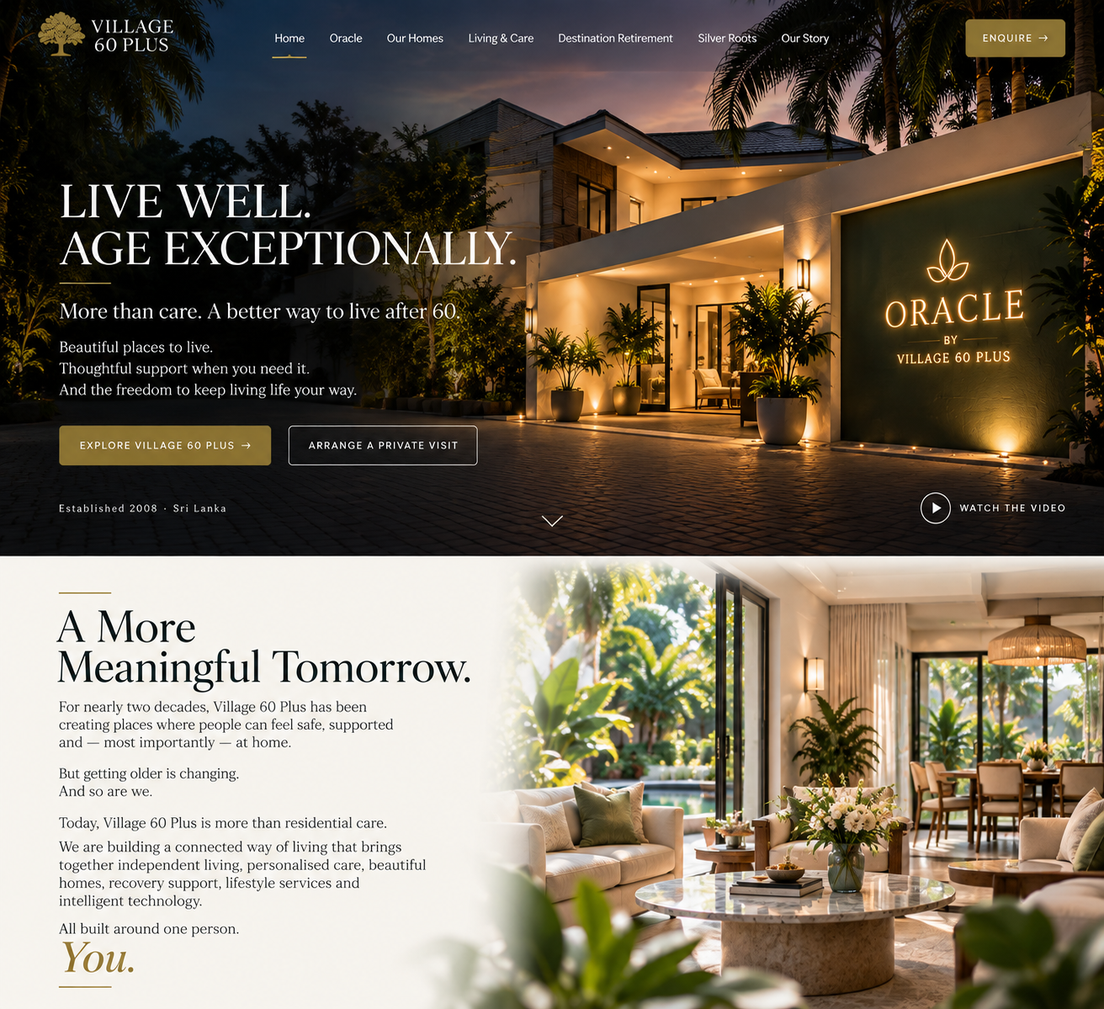

03 — ORACLE
[Large cinematic photograph/video of Oracle — this section should feel different from the rest of the page.]
INTRODUCING
ORACLE
A New Standard of Living.
Not an elders' home.
A home designed around you.
Oracle is the new generation of Village 60 Plus — created for independent adults who want privacy, comfort and freedom, with the reassurance that support is there when needed.
Ten individually designed rooms.
Beautiful shared spaces.
Dining, housekeeping and everyday support.
Personal services through Silver Roots.
And SAGE technology working quietly behind the scenes.
Live independently.
We take care of the rest.
[ DISCOVER ORACLE ] takes them from the homepage Oracle teaser into the dedicated Oracle page
ORACLE
A New Standard of Living.
Not an elders' home.
A home designed around you.
Oracle is a new approach to later living by Village 60 Plus.
Created for independent adults who value their privacy, freedom and way of life, Oracle combines the comfort of a beautiful home with thoughtful everyday support — without taking away the independence that matters.
This is your home.
Your room. Your routine. Your life.
We simply make living it easier.
[ ARRANGE A PRIVATE VISIT ] should open a booking flow specifically for visiting Oracle.
I would not send them to the general Enquire form. They have already shown stronger intent: “I want to come and see it.”
A clean pop-up/slide-over asks:
Arrange Your Private Visit
Choose a preferred date
Choose a preferred time
Your name
Phone / WhatsApp
Email
Number of visitors
Optional: Anything you'd like us to know?
[ REQUEST MY VISIT ]

[ VIEW THE ROOMS ]
YOUR HOME
Ten Rooms. Ten Identities.
Oracle is intentionally small.
Just ten individually designed private rooms, each with its own name, character and carefully considered details.
Jade · Onyx · Ruby · Ivory · Coral (house 1)
Pearl · Amber · Sapphire · Opal · Emerald (House 2)
From comfortable private rooms to our larger signature spaces, every room is designed to feel personal rather than institutional.
A place you can make your own.

[ EXPLORE THE ROOMS ]
LIFE AT ORACLE
Live Your Day, Your Way.
There is no prescribed version of life at Oracle.
Start your morning slowly. Have breakfast when the house comes to life. Spend time in the garden. Read somewhere quiet. Watch a film. Meet friends. Have family over. Go out for the afternoon.
Or simply close your door and enjoy your own space.
Oracle gives you the freedom of independent living with the reassurance of knowing that everyday support is close by.

LIFE AT ORACLE
Live Your Day, Your Way.
There is no prescribed version of life at Oracle.
Start your morning slowly. Have breakfast when the house comes to life. Spend time in the garden. Read somewhere quiet. Watch a film. Meet friends. Have family over. Go out for the afternoon.
Or simply close your door and enjoy your own space.
Oracle gives you the freedom of independent living with the reassurance of knowing that everyday support is close by.

SHARED SPACES
More Than Your Room.
Your private room is only part of your home.
Oracle has been designed with comfortable shared spaces where residents can eat, relax, talk, entertain visitors or simply enjoy a change of scenery.
Dining spaces.
Comfortable lounges.
TV and movie areas.
Gardens and outdoor spaces.
Quiet corners.
Spaces for family and friends.
Nothing should feel clinical.
Because Oracle isn't designed around an institution.
It's designed around a home.

EVERYDAY LIVING
We Take Care of the Rest.
Living independently shouldn't mean having to manage everything yourself.
At Oracle, the everyday things are taken care of so you can spend more time living.
Dining and meals
Housekeeping
Laundry support
Home maintenance
Everyday assistance
Security and reassurance
Shared facilities and entertainment
And when you want something beyond the everyday, additional personal services can be arranged through Silver Roots.

SILVER ROOTS
A Little More, When You Want It.
Some days you may want a driver.
Another day, a physiotherapy appointment.
Perhaps a haircut, an appointment escort, shopping assistance, grooming, a special meal or help arranging something for your family.
Through Silver Roots, residents can access a wider network of lifestyle, wellbeing and support services when they choose.
You don't have to organise everything yourself.
[ EXPLORE SILVER ROOTS ]

SAGE
Technology That Stays in the Background.
Technology should make life easier — not more complicated.
Oracle is supported by SAGE, Village 60 Plus's intelligent living and management system.
SAGE is being designed to quietly connect residents, staff and the home around them.
From reminders and communication to entertainment, daily information and connected-room features, SAGE helps make everyday life simpler while supporting the team behind Oracle.
You don't need to understand the technology.
You simply experience what it makes possible.
[ DISCOVER SAGE ]

INDEPENDENT LIVING
Independence Comes First.
Oracle has been created primarily for adults who can live independently but appreciate the comfort of having support nearby.
We believe getting older should not automatically mean giving up privacy, choice or control.
And when someone's needs change, Village 60 Plus can help families understand the next level of support that may be appropriate.
Because good care isn't about keeping someone in one place.
It's about finding what is right for them.

COME AND SEE ORACLE
Some Places Need to Be Experienced.
Photographs can show you the rooms.
They can't show you how Oracle feels.
Come in. Walk through the house. See the rooms. Sit in the garden. Meet the people behind it.
Then decide whether it feels like home.
[ ARRANGE A PRIVATE VISIT ]
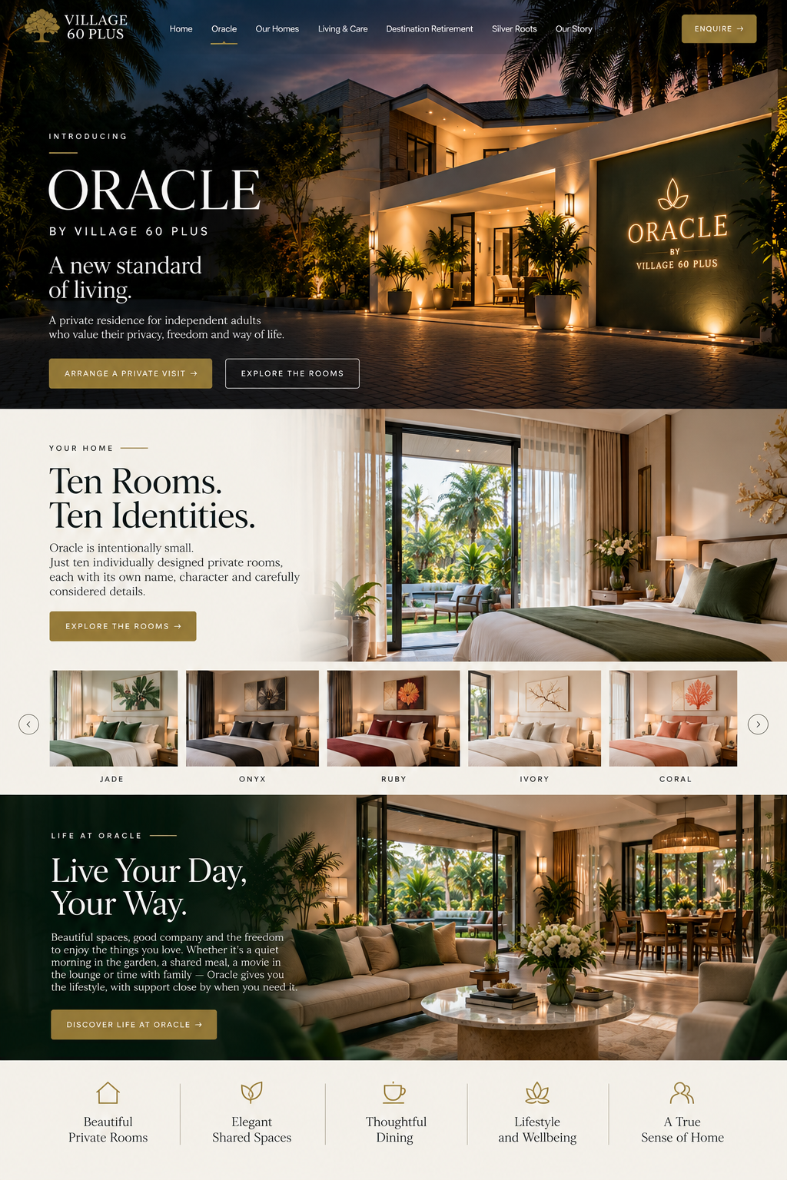
[ ENQUIRE ABOUT ORACLE ]Oracle by Village 60 Plus Sri Lanka · established 2008
OUR HOMES
VILLAGE 60 PLUS RESIDENCES
A Place for Every Chapter.
No two people live the same life.
And we don't believe later life should come with only one way to live.
Across Village 60 Plus, our homes offer different environments, levels of support and ways of living — from comfortable residential care to a new generation of independent living.
TRANQUILITY
Narahenpita
SERENITY
Railway Avenue
HOUSE ON THE HILL
Kirulapone
ENCHANTED FIELDS
Homagama
ORACLE
Pepiliyana
THE GROVE
kottawa Coming soon

[ EXPLORE OUR HOMES ]

What connects them is simple.
A place that feels like home.
People who know you.
Support when you need it.

OUR RESIDENCES
Different Homes. One Philosophy.
Village 60 Plus has been creating homes for older adults since 2008.
Some are peaceful and intimate. Some are closer to the city. Some offer more support. And our newest residences are introducing an entirely different approach to independent later living.
The right home depends on the person.
Explore our residences and find the one that feels right for you.

ORACLE
PEPILIYANA
A New Standard of Living.
Oracle represents the next generation of Village 60 Plus.
Created primarily for independent adults, Oracle offers just ten individually designed rooms within a private residential environment.
Privacy when you want it.
Beautiful shared spaces when you want company.
And thoughtful support quietly available when you need it.
[ DISCOVER ORACLE ]

TRANQUILITY
NARAHEPITA
Comfortable City Living.
A welcoming Village 60 Plus residence in the heart of Colombo.
Tranquility offers a comfortable residential environment where residents can enjoy their own routines while remaining connected to the people, places and services around them.
A familiar home environment with everyday support close at hand.
[ EXPLORE TRANQUILITY ]

SERENITY
RAILWAY AVENUE
Calm. Comfortable. Familiar.
Serenity was created around something simple: making everyday life feel comfortable and familiar.
Residents have their own space, welcoming shared areas and the reassurance of a team nearby when assistance is needed.
A smaller home where people can settle in, build relationships and feel known.
[ EXPLORE SERENITY ]

HOUSE ON THE HILL
KIRULAPONE
A Home With Character.
Set within a residential neighbourhood, House on the Hill offers a quieter Village 60 Plus living environment with the warmth and personality of a traditional home.
Comfortable spaces, familiar routines and personal support create an atmosphere designed around everyday living rather than institutional care.
[ EXPLORE HOUSE ON THE HILL ]

ENCHANTED FIELDS
HOMAGAMA
Space to Breathe.
A greener, more open Village 60 Plus setting away from the pace of central Colombo.
Enchanted Fields combines residential living with outdoor space, peaceful surroundings and the reassurance of support nearby.
For those who value a little more nature, a little more space and a slower rhythm of life.
[ EXPLORE ENCHANTED FIELDS ] - Information from www.village60plus.lk

THE GROVE
AND WE'RE JUST GETTING STARTED.
THE NEXT GENERATION OF VILLAGE 60 PLUS
80 New Rooms.
Village 60 Plus is entering its next chapter.
We are developing 80 new rooms across our next generation of residences — significantly expanding the number of people and families we can support.
But growth isn't simply about becoming bigger.
It's about creating better choices.
New homes.
Modern environments.
Different ways of living.
Greater choice for individuals and families.
All while preserving the personal approach that has defined Village 60 Plus since 2008.
80 new rooms. One continuing purpose.
To create places people are proud to call home.
[ DISCOVER WHAT'S COMING ]
[ REGISTER YOUR INTEREST ]

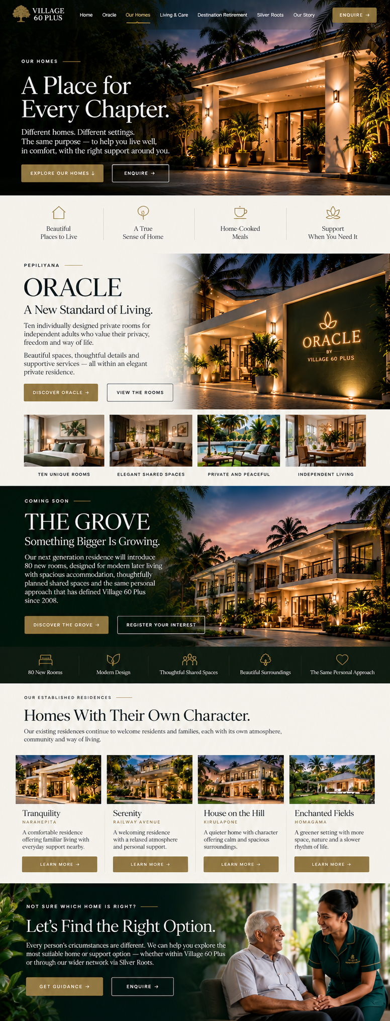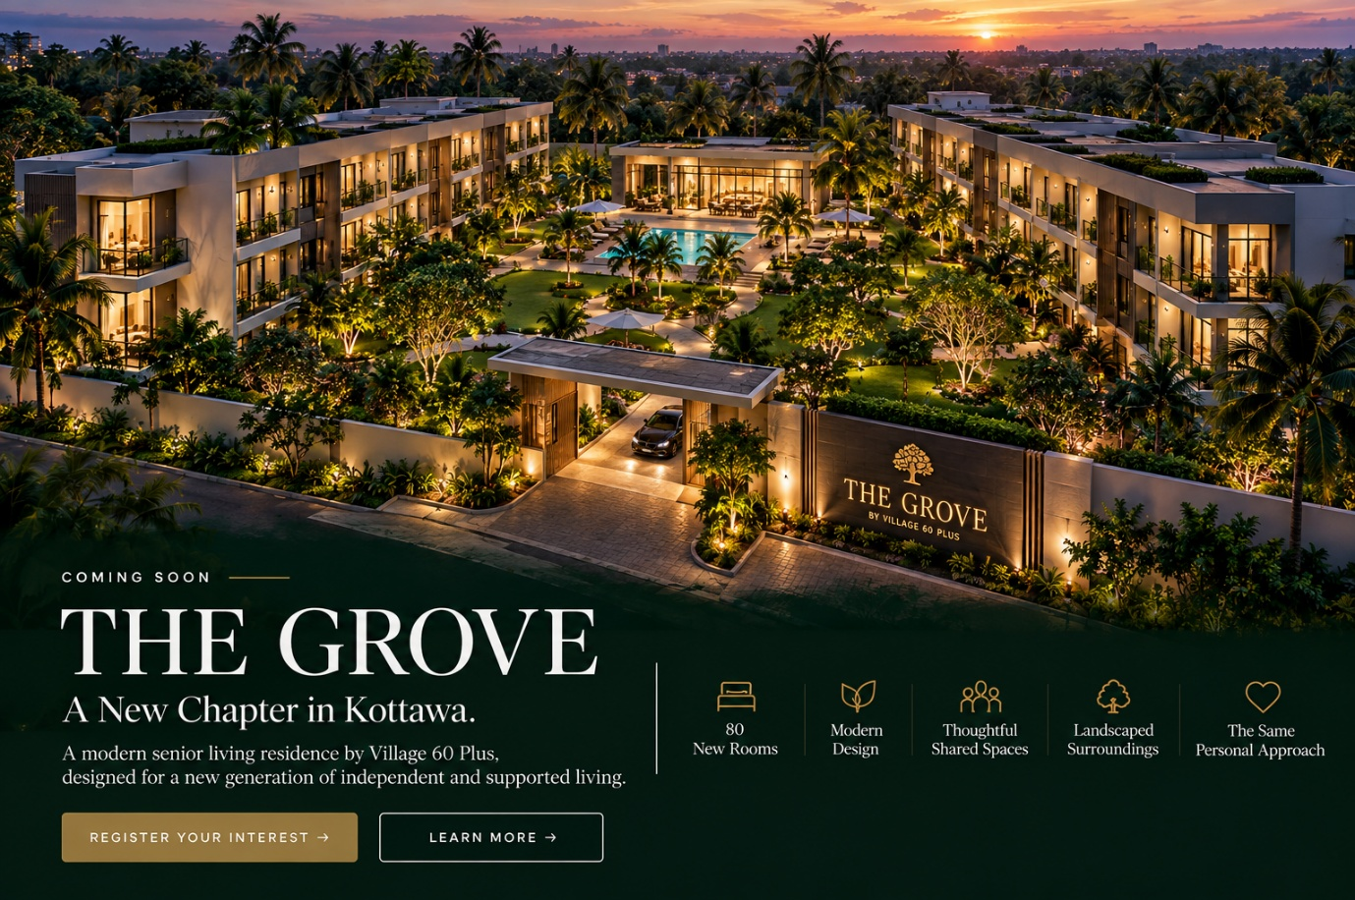

05 — LIVING & CARE
[Warm lifestyle photography rather than hospital/medical imagery.]
LIVING & CARE
As Independent as You Want.
As Supported as You Need.
Good care shouldn't take over your life.
It should make life easier.
Whether someone is living independently, needs a little everyday assistance, requires greater support, or is staying with us temporarily for recovery, our approach begins with the individual.
Independent Living
Privacy, freedom and the reassurance of support when required.
Supported Living
Personal assistance shaped around individual routines and needs.
Residential Care
A safe, comfortable home with attentive day-to-day support.
Medical & Recovery
Short-term stays, post-surgical support, rehabilitation and respite in a comfortable residential environment.
[ EXPLORE LIVING & CARE ] should be one of the most practical pages on the site. Someone should be able to scan it quickly and understand what Village 60 Plus actually provides, without reading walls of marketing copy.

LIVING & CARE
Support That Changes With You.
Everyone needs something different.
Some people simply want a beautiful place to live without the hassle of managing a home.
Others need help with everyday activities, recovery after an operation, medication, mobility or more regular care.
Village 60 Plus brings together different levels of living, care and support — so you can find what works for you.

WHAT WE OFFER
INDEPENDENT LIVING
For people who are able to live independently but want greater comfort, convenience and reassurance.
- Private accommodation
- Freedom to maintain your own routine
- Meals and dining
- Housekeeping
- Laundry support
- Comfortable shared spaces
- Gardens and outdoor areas
- Social activities
- Security and reassurance
- Support available when required
- Optional lifestyle and personal services
- Family visits and social connection
[ EXPLORE INDEPENDENT LIVING ]

RESIDENTIAL LIVING & CARE
A comfortable home with everyday support available around you.
- Private rooms
- Daily meals
- Housekeeping
- Laundry
- Assistance with everyday activities
- Personal care support where appropriate
- Medication assistance
- Mobility support
- Regular wellbeing observation
- Social interaction and companionship
- Activities and recreation
- Family communication
- Support arranging medical appointments
- Emergency assistance and coordination
[ EXPLORE RESIDENTIAL CARE ]

RESPITE CARE
Short-term residential support when you or your family need it.
Suitable for:
- Family caregiver breaks
- Temporary care requirements
- Short stays
- Support while family members travel
- Transition periods
- Additional support following illness
- Trial stays before considering longer-term living
Residents receive accommodation, meals and an agreed level of daily support throughout their stay.
[ ENQUIRE ABOUT RESPITE CARE ]

POST-HOSPITAL & POST-SURGICAL RECOVERY
A supportive place to recover before returning home.
Suitable following:
- Surgery
- Hospital discharge
- Orthopaedic procedures
- Reduced mobility
- Periods of illness
- Extended hospital stays
- Situations where additional support is temporarily required
Support can include:
- Comfortable accommodation
- Meals
- Assistance with daily activities
- Medication assistance
- Mobility assistance
- Appointment coordination
- Physiotherapy coordination
- Transport to follow-up appointments
- Recovery monitoring
- Family updates
[ DISCUSS A RECOVERY STAY ]

REHABILITATION SUPPORT
Helping people regain confidence, mobility and independence following illness, injury or surgery.
Support may include:
- Physiotherapy coordination
- Mobility exercises
- Walking support
- Assistance with daily routines
- Recovery planning
- Nutrition and meals
- Medication assistance
- Transport for medical appointments
- Progress observation
- Family communication
Our aim is simple:
Help you become as independent as possible again.
[ ENQUIRE ABOUT REHABILITATION ]

EVERYDAY CARE & SUPPORT
Depending on the resident and agreed care plan, support may include:
- Bathing and showering assistance
- Dressing and grooming
- Toileting assistance
- Mobility support
- Getting in and out of bed
- Meal assistance
- Medication reminders and assistance
- Personal hygiene
- Daily wellbeing checks
- Appointment organisation
- Escort to appointments
- Hospital coordination
- Family communication
- Emergency support
Care should support independence — not unnecessarily replace it.

MEALS & DINING
Good Food Is Part of Good Living.
Our living environments include meal and dining support designed around everyday life.
This may include:
- Breakfast
- Lunch
- Dinner
- Tea and refreshments
- Individual dietary requirements
- Meal assistance where required
- Special meals and celebrations
- Guest meals
- Nutrition considerations
- Dining together or greater privacy depending on the residence

HOUSEKEEPING & DAILY LIVING
We take care of the things that make a home comfortable.
- Room cleaning
- Shared-area cleaning
- Bed linen
- Laundry
- General household maintenance
- Waste management
- Room upkeep
- Assistance organising personal belongings
- Everyday household support

HEALTH & WELLBEING
Residents can be supported in coordinating their wider health and wellbeing needs.
This may include:
- Doctor appointments
- Medication management support
- Pharmacy coordination
- Prescription collection or delivery
- Physiotherapy
- Medical appointments
- Hospital visits
- Health assessments
- Routine wellbeing reviews
- Mobility support
- Nutrition
- Grooming and personal wellbeing
Clinical or specialist services can be coordinated with appropriate external healthcare professionals where required.

STAYING ACTIVE
Later life shouldn't mean stopping.
Depending on the residence and individual preferences, residents can enjoy:
- Gentle exercise
- Walking
- Gardening
- Games
- Movies
- Music
- Reading
- Celebrations
- Group activities
- Outings
- Social events
- Family visits
- Community activities
- Opportunities for companionship
Participation is always about choice.

FAMILY CONNECTION
Families Should Never Feel Shut Out.
We want families to remain part of everyday life.
Our approach includes:
- Family visits
- Regular communication
- Updates where appropriate and authorised
- Care discussions
- Emergency contact
- Participation in important decisions
- Visitor coordination
- Family involvement in celebrations and activities
Technology will increasingly make this connection easier through our Village 60 Plus digital systems.

PERSONAL SERVICES
Sometimes It's the Little Things.
Additional lifestyle and personal services can be arranged through Silver Roots.
These may include:
- Transport
- Appointment escorts
- Shopping and errands
- Grooming
- Haircuts and salon services
- Manicure and pedicure
- Podiatry coordination
- Physiotherapy
- Medicine delivery
- Personal shopping
- Guest arrangements
- Concierge assistance
- Special outings
- Additional lifestyle support
[ EXPLORE SILVER ROOTS ]

TRANSPORT & APPOINTMENTS
Support can be arranged for:
- Doctor appointments
- Hospital visits
- Physiotherapy
- Diagnostic appointments
- Personal appointments
- Shopping
- Family visits
- Social outings
- Other planned journeys
Escort assistance can also be arranged when required.

TECHNOLOGY & SAGE
Better Care, Quietly Connected.
Village 60 Plus is developing SAGE, our intelligent management and living platform.
SAGE is designed to help connect:
- Residents
- Families
- Care teams
- Management
- Daily care records
- Medication information
- Appointments
- Reminders
- Visitor schedules
- Resident requests
- Communication
- Services
- Deliveries
- Entertainment
- Room technology
The technology stays in the background.
The person stays at the centre.
[ DISCOVER SAGE ]

CHOOSING THE RIGHT LEVEL OF SUPPORT
Start With the Person.
Before recommending a living or care option, we need to understand the individual.
We consider things such as:
- Current independence
- Mobility
- Daily living needs
- Medication requirements
- Medical history
- Personal preferences
- Diet
- Social needs
- Family circumstances
- Preferred location
- Length of stay
- Budget
- Future care requirements
From there, we can discuss an appropriate option.

WHEN VILLAGE 60 PLUS ISN'T THE RIGHT FIT
We won't pretend that one organisation is right for everyone.
Some people may require a different environment, specialist service or level of care.
Through Silver Roots, families will be able to explore participating care homes and service providers across Sri Lanka based on their individual requirements.
That means the objective isn't simply to find a Village 60 Plus room.
It's to help find the right solution.
[ FIND THE RIGHT OPTION ]
Powered by Silver Roots

TALK TO US
You Don't Need to Know Exactly What You Need.
Tell us what's happening.
We'll ask the right questions, understand the person's circumstances and explain the options available.
[ SPEAK TO OUR TEAM ]
[ ARRANGE AN ASSESSMENT ]
[ ENQUIRE ]
Village 60 Plus · Established 2008 · Sri Lanka
For the actual website, this should not visually appear as one giant list. The top should show the five big choices immediately — Independent Living / Residential Care / Respite / Recovery / Rehabilitation — as large clickable cards. Everything underneath then explains those services in more detail.

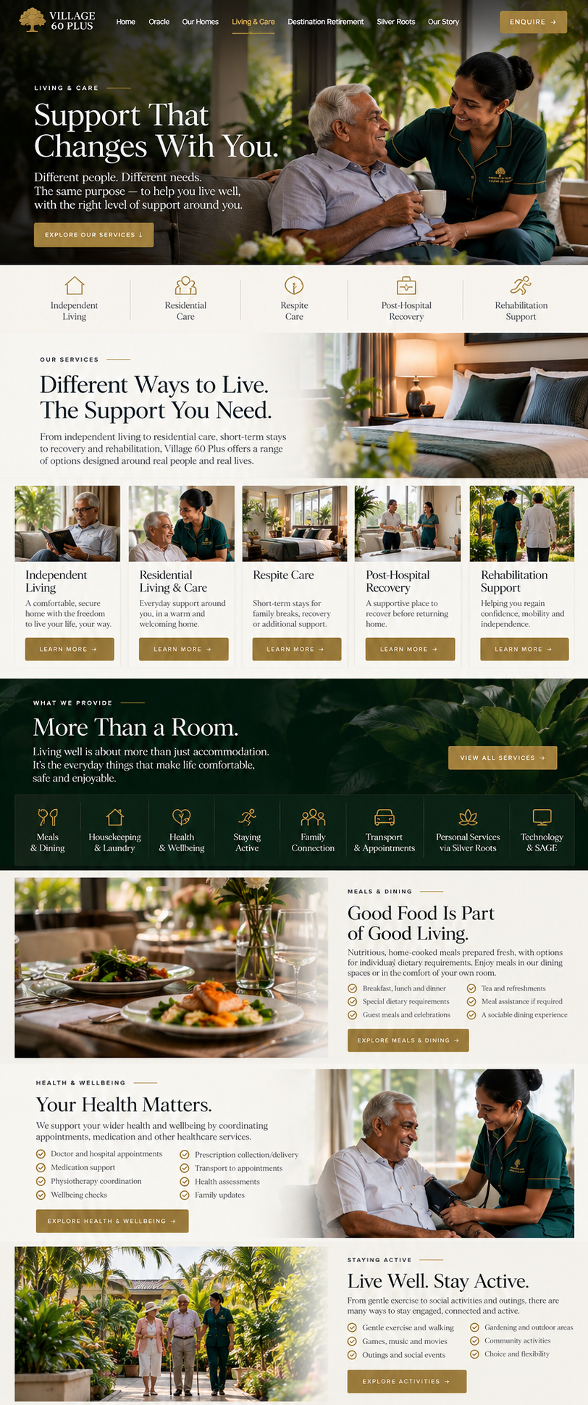

06 — SILVER ROOTS
[Clean, modern visual — phone/app + lifestyle photography.]
BY VILLAGE 60 PLUS
SILVER ROOTS
Care, connected.
Life doesn't begin and end at the doors of a Village 60 Plus residence.
Silver Roots extends our support into everyday life.
It connects older adults and their families with the people and services that make independent living easier — whether they live with us or in their own home.
Transport and escorts.
Appointments and everyday errands.
Grooming and personal services.
Physiotherapy coordination.
Household and lifestyle assistance.
Care and support services.
Trusted partners and providers.
Family connections.
Bookings and payments.
All brought together through one growing ecosystem.
Your life. Your services. One connection.
[ DISCOVER SILVER ROOTS ] , I’d position it very differently from Village 60 Plus. It is not another care-home brand. It is the platform connecting people with care, services, providers and support across Sri Lanka.

SILVER ROOTS
BY VILLAGE 60 PLUS
Everything You Need to Live Well.
In One Place.
Finding the right support shouldn't be complicated.
Silver Roots connects older adults and families with care homes, home care, health and wellbeing services, everyday assistance and trusted service providers across Sri Lanka.
Whether you're planning ahead, looking for care for someone you love, or simply need a little help at home — start here.
[ FIND THE RIGHT OPTION ]
[ EXPLORE SERVICES ]

FIND CARE
The Right Care. For the Right Person.
Every person is different.
Tell Silver Roots what you need and we'll help you explore suitable options from participating providers across Sri Lanka.
Search based on:
- Location
- Type of care
- Level of support
- Independence
- Short or long-term stay
- Room preferences
- Facilities
- Budget
- Health and mobility needs
- Lifestyle preferences
Options can include Village 60 Plus residences and independent partner care homes within the Silver Roots network.
The goal isn't to send you to one particular home.
It's to help you find the right one.
[ FIND CARE ]

CARE HOMES
Explore Places to Live.
Discover participating care homes and later-living residences in one place.
View information such as:
- Location
- Photographs
- Accommodation
- Room options
- Facilities
- Services
- Care available
- Pricing
- Availability
- Reviews and information
- Contact details
Compare your options before making a decision.
[ EXPLORE CARE HOMES ]

LIVE AT HOME
Support Without Leaving Home.
Sometimes the best place to live is exactly where you already are.
Silver Roots connects people with services that can make independent living at home easier.
Services may include:
- Home care
- Nursing
- Companionship
- Meal support
- Housekeeping
- Laundry
- Shopping
- Medicine delivery
- Transport
- Appointment escorts
- Physiotherapy
- Personal assistance
- Home maintenance
- Everyday errands
Choose the support you need, when you need it.
[ EXPLORE HOME SERVICES ]

HEALTH & WELLBEING
Look After Yourself.
Find and arrange services that support everyday health, mobility and wellbeing.
Including:
- Physiotherapy
- Doctor appointments
- Nursing
- Pharmacy and medicine delivery
- Health assessments
- Mobility support
- Podiatry
- Grooming
- Hair and beauty
- Manicure and pedicure
- Nutrition support
- Exercise and wellbeing services
[ EXPLORE HEALTH & WELLBEING ]

GETTING AROUND
Wherever You Need to Go.
Silver Roots can help arrange transport and assistance for everyday journeys.
- Medical appointments
- Hospital visits
- Shopping
- Family visits
- Social outings
- Airport transfers
- Personal appointments
- Events
- Assisted transport
- Appointment escorts
[ ARRANGE TRANSPORT ]

EVERYDAY SERVICES
Life, Made Easier.
There are hundreds of little things that can become a hassle.
Silver Roots is designed to help with them.
- Shopping
- Errands
- Deliveries
- Household assistance
- Cleaning
- Laundry
- Grooming
- Transport
- Appointment booking
- Escorts
- Personal shopping
- Guest arrangements
- Lifestyle requests
- Concierge assistance
One place to organise the things that make everyday life easier.
[ EXPLORE SERVICES ]

RESPITE, RECOVERY & REHABILITATION
Support When Life Changes.
Sometimes care is only needed for a while.
Silver Roots can help families explore participating providers offering:
- Respite stays
- Post-hospital support
- Post-surgical recovery
- Rehabilitation
- Physiotherapy
- Temporary residential care
- Short-term nursing support
- Transitional care
[ FIND RECOVERY SUPPORT ]

FOR FAMILIES
Stay Close. Even When You're Not Nearby.
Silver Roots is being designed to make it easier for families to stay involved in the care and support of someone they love.
Through the Silver Roots platform, families will be able to manage and view services such as:
- Care arrangements
- Service bookings
- Care notes
- Appointments
- Invoices and payments
- Agreements
- Provider information
- Family communication
- Service history
- Important updates
All from one place.

FOR CARE PROVIDERS
Grow With Silver Roots.
Silver Roots isn't only for families.
Care homes, healthcare professionals and service businesses can join the network and make their services easier to discover.
Partners may include:
- Care homes
- Home-care agencies
- Nurses
- Physiotherapists
- Doctors and healthcare providers
- Pharmacies
- Transport providers
- Meal providers
- Cleaning services
- Grooming and wellbeing providers
- Medical equipment suppliers
- Lifestyle and concierge services
Silver Roots gives providers a platform to be discovered, receive enquiries, manage bookings and connect with people looking for their services.
[ BECOME A PARTNER ]

SILVER ROOTS APP
Care. Connected.
Silver Roots is being built as more than a website.
The Silver Roots app will bring people, families and providers together through one connected platform.
For individuals
Find care.
Book services.
Manage appointments.
Arrange transport.
Make payments.
Keep important information together.
For families
Stay informed.
View care information.
Manage services.
Communicate with providers.
Follow appointments and arrangements.
For providers
Receive enquiries.
Manage services.
Connect with clients.
Manage bookings.
Build your presence within the network.
One platform. Many possibilities.

BY VILLAGE 60 PLUS
Built From Experience.
Silver Roots wasn't created by people looking at ageing from the outside.
It grew from the experience of Village 60 Plus.
Since 2008, we have worked with older adults, families, caregivers and care providers and seen how difficult it can be to find, organise and coordinate the right support.
Silver Roots is our answer to that problem.
A simpler way to connect people with the support they need.

YOU DON'T HAVE TO KNOW WHERE TO START.
Tell us what you're looking for.
Silver Roots can help you explore care, accommodation and services based on what matters to you.
One person.
One place to start.
A network of possibilities.
[ FIND THE RIGHT OPTION ]
[ EXPLORE SERVICES ]
[ BECOME A PARTNER ]
SILVER ROOTS
by Village 60 Plus
Care. Connected.
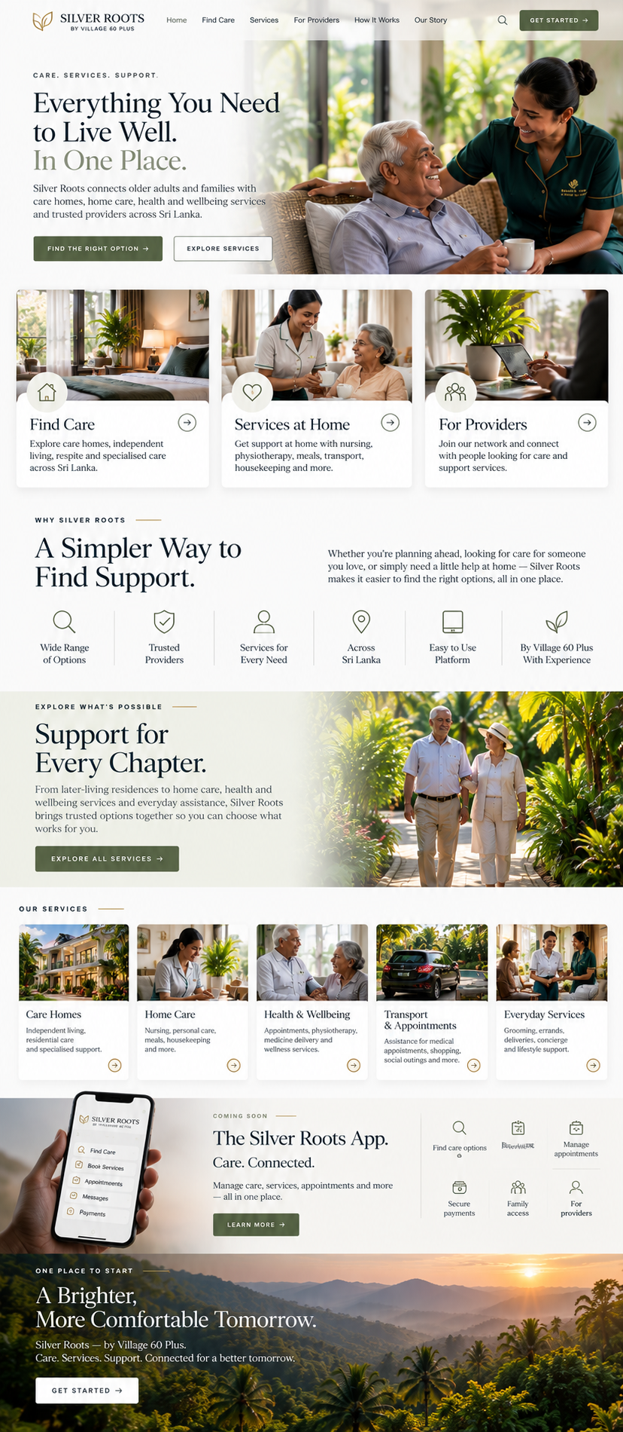
07 — DESTINATION RETIREMENT
[Huge landscape image — Sri Lankan coast, hills or beautiful villa/resort.]
DESTINATION RETIREMENT
Perhaps Retirement
Needs a Different View.
What if retirement wasn't about slowing down?
What if it meant finally having the time to live differently?
Destination Retirement by Village 60 Plus brings together supported retirement, extended stays and carefully selected experiences in Sri Lanka and beyond.
Beautiful destinations.
Comfortable living.
Support when required.
And the freedom to experience something new.
You've spent a lifetime getting here.
Make the next chapter worth remembering.
[ DISCOVER DESTINATION RETIREMENT ] DESTINATION RETIREMENT
BY VILLAGE 60 PLUS
Your Next Chapter
Could Be Somewhere Extraordinary.
Retirement can be more than staying where you've always been.
It can mean waking somewhere warmer. Spending more time outdoors. Discovering new places. Meeting new people. And finally having the time to enjoy life at your own pace.
Destination Retirement brings together beautiful places to stay, memorable experiences and everyday support — giving you the freedom to experience retirement differently.
Stay for a while. Stay for longer. Make yourself at home.
[ EXPLORE DESTINATIONS ]
[ PLAN YOUR STAY ]

A DIFFERENT WAY TO RETIRE
Don't Just Retire.
Go Somewhere.
You've spent years working, building a life and looking after responsibilities.
This chapter can be different.
Spend a few weeks somewhere beautiful.
Escape the winter for several months.
Try living somewhere completely new.
Or discover a place that eventually feels like a second home.
Destination Retirement is designed to make longer stays easier, more comfortable and better supported.

DISCOVER SRI LANKA
Island Life, Your Way.
Warm weather. Tropical landscapes. Beaches, mountains, ancient cities, wildlife, food and a culture built around hospitality.
Sri Lanka offers remarkably different experiences within one island.
Spend time beside the ocean.
Wake among the hills.
Explore historic cities.
Stay somewhere peaceful surrounded by nature.
Or remain close to Colombo with everything within reach.
One island. Many ways to live.
[ DISCOVER SRI LANKA ]

MORE THAN A HOLIDAY
Live There.
Don't Just Visit.
Destination Retirement isn't about rushing from attraction to attraction.
It's about having time.
Stay for weeks or months rather than days.
Find your favourite café.
Take a morning walk.
Spend an afternoon by the pool.
Invite family to visit.
Explore when you feel like it.
Do absolutely nothing when you don't.
Travel slowly. Live comfortably.

WELLNESS & RETREATS
Time to Actually Relax.
This chapter of life should leave room for yourself.
Destination Retirement can connect your stay with a collection of relaxation, wellness and lifestyle experiences designed to make your time away feel effortless.
Depending on your destination and availability, experiences can include:
- Wellness retreats
- Spa days
- Ayurveda spa experiences
- Traditional massage
- Relaxation therapies
- Fish therapy
- Yoga
- Meditation
- Gentle exercise
- Nature retreats
- Wellness programmes
- Beauty and grooming
- Manicure and pedicure
- Physiotherapy
- Nutrition and healthy living experiences
Choose a single experience or make wellness part of your stay.
Slow down. Reset. Enjoy yourself.
[ EXPLORE WELLNESS EXPERIENCES ]

CONNECTED SERVICES
Everything Around You.
A relaxing stay shouldn't involve spending half your time organising things.
Destination Retirement connects with our wider services and partner network to help make everyday life seamless.
From the moment you arrive, we can help coordinate what you need.
- Airport collection
- Private transport
- Drivers
- Accommodation
- Housekeeping
- Laundry
- Meals
- Shopping
- Medicine delivery
- Appointment booking
- Appointment escorts
- Restaurant reservations
- Personal shopping
- Grooming
- Spa and wellness bookings
- Retreats
- Excursions
- Private tours
- Concierge requests
One stay. One connected experience.
You enjoy it. We help organise the rest.

PLACES TO STAY
Find Your Kind of Place.
Everyone imagines retirement differently.
Through Destination Retirement, we aim to bring together a selection of places suited to longer, more comfortable stays.
Options may include:
- Villas
- Apartments
- Resorts
- Boutique properties
- Serviced residences
- Retirement communities
- Village 60 Plus residences
- Partner properties
Whether you prefer the coast, countryside, hills or city life, we'll help you explore what suits you.
[ EXPLORE PLACES TO STAY ]

YOUR STAY. YOUR WAY.
As Independent As You Want.
Destination Retirement isn't about putting retirement on a schedule.
Want complete independence?
Perfect.
Want your driver waiting in the morning, a spa booked for the afternoon and dinner arranged that evening?
We can help organise it.
Need some additional support during your stay?
That can be explored too.
You decide how much — or how little — you want us involved.

SERVICES THROUGH SILVER ROOTS
Whatever You Need.
One Place to Start.
Destination Retirement connects with Silver Roots, giving you access to a wider network of lifestyle, wellbeing and support services.
Depending on availability, this can include:
- Transport and drivers
- Home services
- Personal assistance
- Health and wellbeing
- Physiotherapy
- Medicine delivery
- Grooming
- Concierge services
- Shopping and errands
- Appointment assistance
- Home care
- Nursing support
- Partner services
Use what you need.
Ignore what you don't.
[ EXPLORE SILVER ROOTS ]

EXPERIENCE SRI LANKA
There's Still Plenty to Discover.
Your stay can be as peaceful or adventurous as you choose.
Explore:
- Beaches
- Wildlife
- Tea country
- Ancient cities
- Scenic train journeys
- Local cuisine
- Wellness retreats
- Cultural experiences
- Golf
- Nature
- Shopping
- Festivals
- Private tours
- Day trips
Or find a beautiful pool, order something cold and cancel everything you had planned.
That's retirement too.

TRY BEFORE YOU DECIDE
Start With a Stay.
You don't need to make a permanent decision.
Come for a few weeks.
Experience the destination.
Discover the lifestyle.
Try the services.
Meet people.
See how you feel.
Then stay longer, come back next year, explore somewhere else — or make it part of your new way of life.
Retirement doesn't need one permanent address.
[ PLAN A TRIAL STAY ]

BEYOND SRI LANKA
One Idea.
More Destinations.
Sri Lanka is where the Destination Retirement journey begins.
As Destination Retirement grows, we aim to introduce carefully selected international destinations, properties and experiences.
Different countries.
Different lifestyles.
The same idea.
Beautiful places. Memorable experiences. Seamless support.

WHY VILLAGE 60 PLUS?
Nearly Two Decades of Understanding Later Life.
Village 60 Plus has worked with older adults and families since 2008.
That experience taught us something important:
Later life isn't simply about care.
It's about living.
Where you wake up.
What you do with your day.
The people around you.
The experiences you still want to have.
And having the freedom to enjoy them.
Destination Retirement was created around that idea.

WHERE WOULD YOU LIKE
YOUR NEXT CHAPTER TO BEGIN?
Tell us what kind of experience you're looking for.
A month beside the ocean.
A wellness retreat.
A longer stay in Sri Lanka.
A peaceful escape.
Or simply something different.
We'll help you put the pieces together.
[ PLAN YOUR STAY ]
[ EXPLORE DESTINATIONS ]
[ ENQUIRE ]
DESTINATION RETIREMENT
by Village 60 Plus
Live somewhere extraordinary.

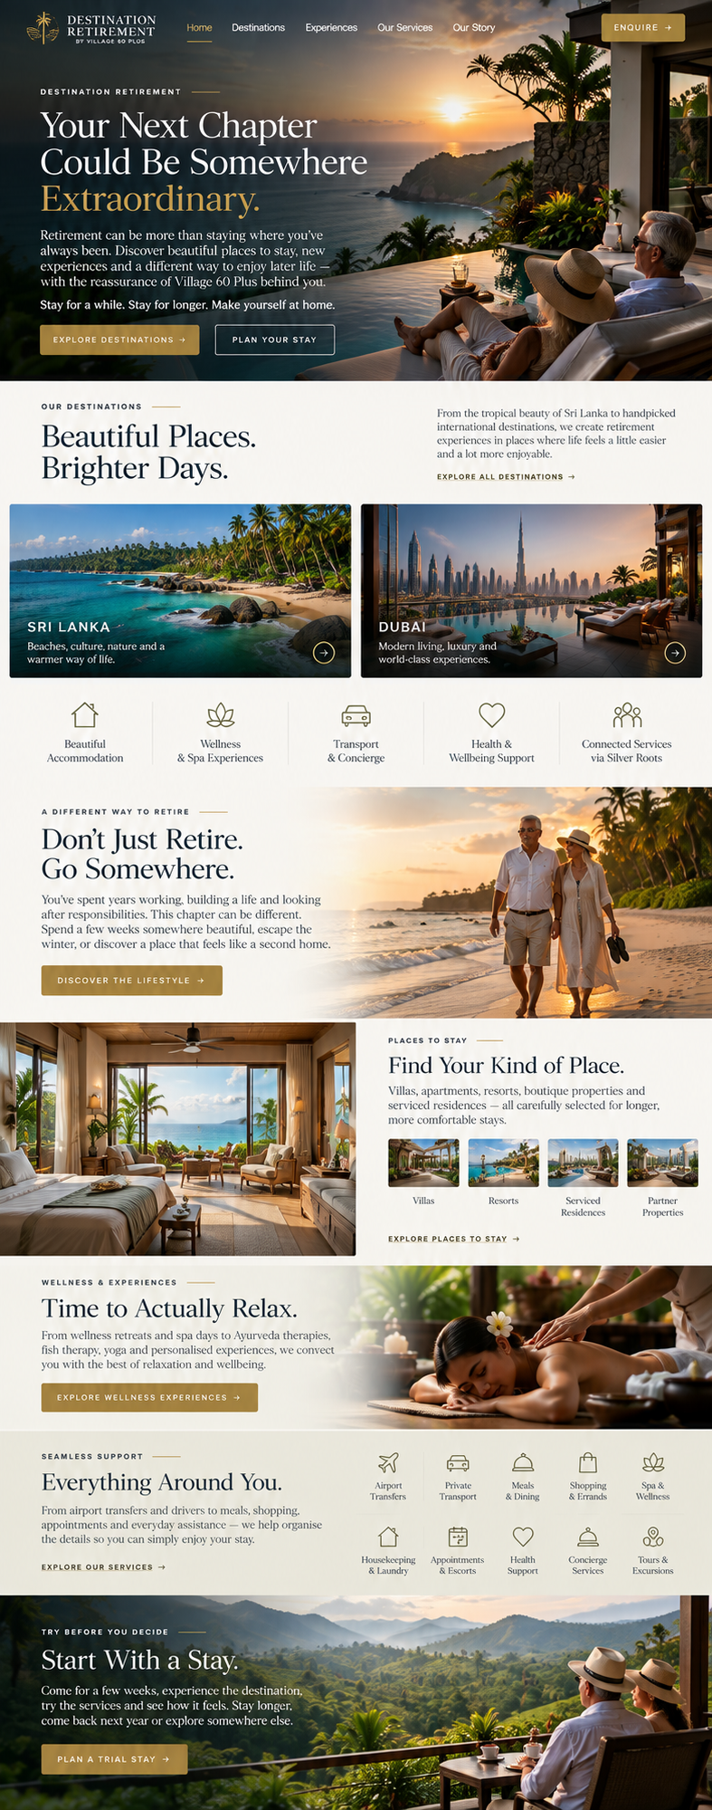
08 — SAGE
[Minimal dark or elegant technology section. No robots. No cliché AI graphics.]
TECHNOLOGY BY VILLAGE 60 PLUS
SAGE
Technology that quietly makes life easier.
The best technology shouldn't demand attention.
It should simply work.
SAGE is the intelligent layer being developed across Village 60 Plus — connecting residents, families, staff, services and our homes.
From everyday reminders and communication to care information, family updates, services and management, SAGE is designed to keep everything connected behind the scenes.
Not technology for the sake of technology.
Technology with purpose.
[ DISCOVER SAGE ] SAGE
THE INTELLIGENCE BEHIND VILLAGE 60 PLUS
Technology That Takes Care
of the Little Things.
The best technology shouldn't demand your attention.
It should simply make life easier.
SAGE is the intelligent system being developed to connect residents, families, care teams, services and the everyday operation of Village 60 Plus.
Quietly working in the background.
Helping the right people know the right things at the right time.
[ DISCOVER SAGE ]

ONE CONNECTED SYSTEM
Everything Works Better
When Everything Works Together.
A resident shouldn't have to repeat the same request to three different people.
A family shouldn't have to make several calls to understand what's happening.
And our teams shouldn't have to search through disconnected systems to find important information.
SAGE is being designed to bring it together.
Residents. Families. Care teams. Management. Services. Communication.
One connected environment.

FOR RESIDENTS
Technology That Feels Human.
SAGE isn't about filling a home with complicated technology.
It's about making everyday life simpler.
Residents may be able to use SAGE for:
- Daily reminders
- Medication reminders
- Meal information
- Activities and events
- Visitor information
- Personal requests
- Service bookings
- Entertainment
- Music
- Communication
- Transport information
- Appointment reminders
And where connected devices are available, some of these experiences can appear naturally through screens and voice-enabled devices within the home.
Less technology to learn.
More life to enjoy.

YOUR DAY, A LITTLE EASIER
Good Morning.
Imagine waking up and your room already knows what matters today.
Your screen can welcome you.
Your favourite music can begin.
Your appointments can be displayed.
You can see who's visiting.
Your medication reminder can appear at the right time.
And if you need something, you can simply ask.
SAGE is being designed around those small moments.
Because small things make a big difference to everyday life.

FOR FAMILIES
Stay Connected.
Even When You're Not There.
Families should be able to feel involved without constantly having to call the home.
Through connected Village 60 Plus services, SAGE is being developed to help make relevant information easier to access and communication easier to manage.
Depending on permissions and the services being used, this can include:
- Updates
- Appointments
- Care information
- Important notifications
- Service requests
- Visits
- Communication
- Documents
- Payments
- Family coordination
Access to personal and care information will always depend on appropriate permissions, privacy controls and authorisation.

FOR OUR CARE TEAMS
More Time With People.
Less Time Chasing Information.
Care should happen around the person — not around paperwork.
SAGE is being designed to support our teams with:
- Resident information
- Daily notes
- Care records
- Medication information
- Tasks
- Appointments
- Assessments
- Incidents
- Family communication
- Service requests
- Visitor information
- Handover information
- Reminders
Giving teams a clearer picture of what is happening across the day.

THE HOME, CONNECTED
One Home.
Working Together.
Within Village 60 Plus residences, SAGE can connect different parts of everyday living.
ROOMS
Reminders, entertainment, communication and personal information.
CARE
Care records, observations, medication information and daily notes.
DINING
Meal information, preferences and requests.
VISITORS
Scheduled visits, notifications and coordination.
SERVICES
Transport, appointments, grooming, physiotherapy and other requests.
ACTIVITIES
Events, entertainment and daily programmes.
MANAGEMENT
Operations, staffing, reporting, accounts and oversight.

CONNECTED WITH SILVER ROOTS
Ask for Something.
Let the Network Handle the Rest.
SAGE connects the Village 60 Plus living experience with Silver Roots.
That means a request can become a service.
Need transport?
Book it.
Need a physiotherapist?
Request one.
Need medication delivered?
Arrange it.
Want a grooming appointment?
Schedule it.
Need someone to accompany you somewhere?
Request an escort.
Silver Roots provides the wider service network.
SAGE helps connect it to everyday life.
[ DISCOVER SILVER ROOTS ]

FOR MANAGEMENT
See the Bigger Picture.
Behind the resident experience is an entire organisation that needs to work efficiently.
SAGE is being developed to give Village 60 Plus management a clearer view across our homes and services.
This can include:
- Occupancy
- Resident information
- Staff activity
- Care documentation
- Tasks
- Incidents
- Enquiries
- Leads
- Visitor schedules
- Service requests
- Payments
- Expenses
- Reporting
- Centre performance
- Communications
As Village 60 Plus grows, SAGE is intended to allow different locations to operate as part of one connected organisation.

COMMUNICATION
One Conversation.
Wherever It Starts.
People communicate differently.
Some call.
Some email.
Some use WhatsApp.
Some visit the website.
SAGE is being developed to help Village 60 Plus manage those conversations more intelligently across supported channels.
From answering common questions and handling enquiries to helping our team follow up with prospective residents and families.
Fewer missed conversations.
Better continuity.

BUILT AROUND PEOPLE
Artificial Intelligence.
Human Decisions.
SAGE can help organise information, automate routine work and make useful information easier to access.
But technology does not replace human judgement.
Care decisions remain with people.
Clinical decisions remain with appropriately qualified professionals.
Personal relationships remain personal.
SAGE supports our people.
It doesn't replace them.

PRIVACY BY DESIGN
Personal Information
Deserves Protection.
Care technology handles information that matters.
SAGE is being developed with controlled access, permissions, accountability and privacy as fundamental parts of the system.
People should only see the information appropriate to their role and authorisation.
Because smarter technology should also mean responsible technology.

BUILT TO GROW
From One Room
to an Entire Network.
SAGE isn't being designed for a single building.
It is being developed as the digital intelligence behind the growing Village 60 Plus ecosystem.
Connecting our residences.
Supporting future locations.
Working alongside Silver Roots.
Connecting residents and families.
And helping our teams deliver a more coordinated experience as we grow.

THE FUTURE OF CARE
SHOULDN'T FEEL LIKE TECHNOLOGY.
It should feel like things simply work.
Your reminder arrives when you need it.
Your family stays connected.
Your request reaches the right person.
Your care team has the information they need.
Your home understands your routine.
And the complicated things happen quietly in the background.
That's the idea behind SAGE.
Technology in the background.
Life in the foreground.
[ EXPLORE VILLAGE 60 PLUS ]
[ DISCOVER SILVER ROOTS ]
[ ENQUIRE ]

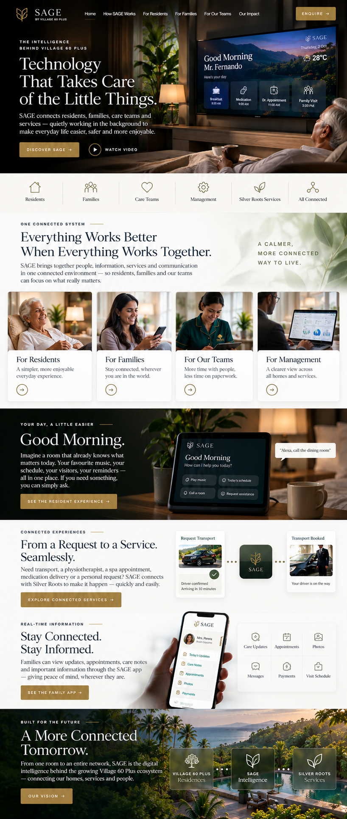
09 — OUR STORY
[Old photographs / early Village 60 Plus imagery transitioning into today's Oracle.]
ESTABLISHED 2008
Nearly Two Decades.
One Purpose.
Village 60 Plus didn't begin as a technology company or a lifestyle brand.
It began with care.
In 2008, we started with a simple purpose: to create a better environment for people growing older.
That purpose hasn't changed.
What has changed is how far it has taken us.
From residential homes to independent living.
From care inside our homes to support in people's own homes.
From traditional services to Silver Roots.
From individual residences to Oracle.
And now, from care alone to an entire connected ecosystem for later life.
The world has changed since 2008.
So have we.
[ DISCOVER OUR STORY ]

It should show that Village 60 Plus has been building, learning and evolving since 2008, and that Oracle, The Grove, Silver Roots, SAGE and Destination Retirement are the next chapter.
OUR STORY
VILLAGE 60 PLUS
We Didn't Start With
a Vision of an Ecosystem.
We started with something much simpler.
A home.
A place where people could grow older with dignity, feel safe, be treated as individuals and continue to feel that their life belonged to them.
That was the beginning of Village 60 Plus in 2008.
Nearly two decades later, the world around us has changed.
So have we.
What began with residential care has grown into a much bigger idea — connecting homes, independent living, care, recovery, wellbeing, technology, services and new ways to experience later life.
And we're still building.

SINCE 2008
Nearly Two Decades
of Learning What Matters.
You learn a lot when you spend years caring for people.
You learn that everyone ages differently.
That independence matters.
That dignity is found in small things.
That families need reassurance as much as residents need support.
That good care isn't only about what happens when something goes wrong.
And perhaps most importantly:
People don't stop wanting a good life because they get older.
That belief has shaped everything Village 60 Plus has become.

OUR JOURNEY
2008
WHERE IT BEGAN
Village 60 Plus begins its journey in Sri Lanka.
The idea was simple: create a better environment for later life — one built around dignity, comfort, safety and human connection.
One home became the beginning of something much larger.

2014
A NEW GENERATION
A new generation became increasingly involved in the direction and development of Village 60 Plus.
The focus began expanding beyond traditional residential care.
The question changed from:
“How do we care for someone?”
to:
“How do we help someone continue living well?”
That question would eventually shape the next generation of Village 60 Plus.

2016
DEVELOPING PEOPLE
Care is only as good as the people delivering it.
Our work expanded into education and training through the Colombo Institute of Life Sciences — CILS, developing skills across care and related professional fields.
It strengthened something we had already learned:
Better people create better care.

2018
HEALTH & WELLBEING
Our thinking continued to move beyond accommodation and traditional care.
Nutrition, wellbeing and healthier living became part of the wider conversation around how people can live better for longer.
The Village 60 Plus philosophy was beginning to extend beyond the walls of our homes.

2020
CARE BEYOND THE HOME
Not everyone wants to move into residential care.
And they shouldn't have to.
Our services expanded towards supporting people within their own homes and everyday lives.
Transport.
Appointments.
Personal assistance.
Household support.
Lifestyle services.
Companionship.
The idea was simple:
Bring the support to the person — wherever they choose to live.
That thinking would later become an important foundation for Silver Roots.

2022
RAISING THE STANDARD
Training, international standards and professional development became an increasingly important part of our work.
We continued looking beyond Sri Lanka for ideas, systems and standards that could strengthen the way our organisations operate.
Our ambition was no longer simply to operate care homes.
It was to help raise expectations of what later-life services could become.

2023
LOOKING BEYOND BORDERS
Our work in training and professional development expanded internationally.
New relationships, international opportunities and experience outside Sri Lanka gave us a wider perspective on care, workforce development and service standards.
We brought those lessons home.

2026
THE NEXT GENERATION
Nearly two decades after Village 60 Plus began, we asked ourselves another question.
If we could rethink later life from the beginning, what would we build?
The answer wasn't another traditional elders' home.
It was an ecosystem.

ORACLE
A NEW STANDARD OF LIVING
Oracle represents a new generation of Village 60 Plus.
A home created primarily for independent adults who want privacy, comfort and freedom — while knowing support is nearby when they need it.
Ten individually designed rooms.
Beautiful shared spaces.
Everyday services.
Technology working quietly behind the scenes.
Not an elders' home.
A home designed around you.
[ DISCOVER ORACLE ]

THE GROVE
SOMETHING BIGGER IS GROWING.
The Grove represents the next stage of our residential expansion.
A purpose-designed community bringing together private living, landscaped spaces, social areas, wellbeing and the experience Village 60 Plus has developed since 2008.
The Grove forms part of our wider expansion programme introducing 80 new rooms and significantly increasing the choice available within the Village 60 Plus network.
A new chapter is taking shape.
[ DISCOVER THE GROVE ]

SILVER ROOTS
CARE. CONNECTED.
Years of working with families showed us another problem.
Finding care is difficult.
Finding trusted services is difficult.
Comparing options is difficult.
And coordinating everything can become a job of its own.
So we began building Silver Roots.
A platform designed to connect older adults and families with care homes, home care, health and wellbeing services, transport, personal assistance and trusted providers across Sri Lanka.
Not only Village 60 Plus.
A wider network.
Because sometimes the best option for someone isn't ours.
The important thing is helping them find it.
[ DISCOVER SILVER ROOTS ]

SAGE
TECHNOLOGY IN THE BACKGROUND.
LIFE IN THE FOREGROUND.
As our homes, services and network grew, another challenge became obvious.
Everything needed to connect.
Residents.
Families.
Care teams.
Management.
Appointments.
Services.
Communication.
Information.
So we began developing SAGE — the intelligent system behind the next generation of Village 60 Plus.
Technology designed not to replace people, but to make everyday life simpler for them.
The right information.
The right person.
The right moment.
[ DISCOVER SAGE ]

DESTINATION RETIREMENT
RETIREMENT DOESN'T HAVE TO MEAN STAYING PUT.
Later life isn't only about care.
It's also about everything you finally have time to do.
Travel.
Rest.
Explore.
Experience something different.
Destination Retirement grew from that idea — bringing together longer stays, beautiful destinations, wellness experiences, retreats and seamless services.
From accommodation and transport to spa days, Ayurveda, wellbeing, excursions and everyday assistance.
Don't just retire.
Go somewhere.
[ DISCOVER DESTINATION RETIREMENT ]

ONE IDEA CONNECTS IT ALL.
Oracle may look different from Silver Roots.
SAGE may do something completely different from Destination Retirement.
The Grove may be very different from the homes where our story began.
But underneath everything is the same belief we've carried since 2008.
People deserve to live well as they grow older.
Sometimes that means care.
Sometimes it means independence.
Sometimes it means recovery.
Sometimes it means having someone drive you to an appointment.
Sometimes it means finding the right home.
And sometimes it means sitting beside the ocean with absolutely nowhere you need to be.
That's why Village 60 Plus is becoming more than a collection of care homes.

THE VILLAGE 60 PLUS ECOSYSTEM
LIVE
Beautiful homes and communities designed for different stages of later life.
CARE
The right level of support, from independent living to residential care, respite and recovery.
CONNECT
Silver Roots connects people, families, care providers and everyday services.
SIMPLIFY
SAGE helps bring information, communication and services together.
EXPERIENCE
Destination Retirement creates new possibilities for travel, wellness and enjoying later life.

WHAT HASN'T CHANGED
Homes Change.
Technology Changes.
People Don't.
Behind every new building, service, platform and idea is still a person.
Someone's mother.
Someone's father.
Someone's partner.
Someone's friend.
Someone who has lived an entire life before walking through our door.
They deserve to be known as more than a room number, diagnosis or care plan.
They deserve choices.
Privacy.
Respect.
Good food.
Conversation.
Laughter.
Family.
Purpose.
And the freedom to remain themselves.
That hasn't changed since 2008.
And it never will.

WE'RE STILL WRITING
THE STORY.
Village 60 Plus began with one idea.
Create a better place to grow older.
Today, that idea is becoming something much larger.
More homes.
More choice.
Better connections.
Smarter technology.
New experiences.
And new possibilities for later life.
The next chapter is already beginning.
[ EXPLORE VILLAGE 60 PLUS ]
[ DISCOVER OUR HOMES ]
[ ENQUIRE ]
VILLAGE 60 PLUS
Since 2008.
Built around life.
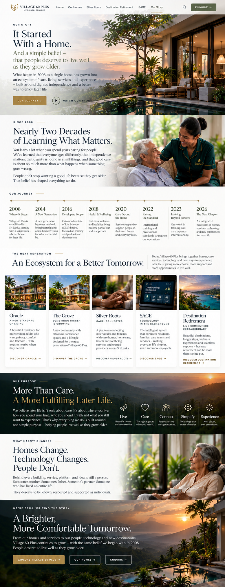
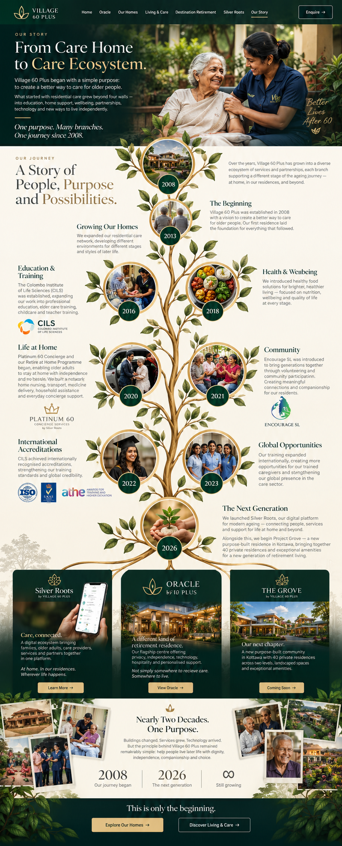

10 — THE CLOSING STATEMENT
[Full-width photograph/video — preferably a genuine human moment rather than a posed stock image.]
MORE THAN CARE.
A WAY OF LIFE.
There is no single way to grow older.
Some people need care.
Some need company.
Some want independence.
Some want adventure.
And sometimes, all someone really wants is the reassurance that if they need something, somebody will be there.
That's what Village 60 Plus is becoming.
A place to live.
A network to rely on.
And a better way to approach the years ahead.

11 — FINAL CTA
Your Next Chapter
Can Start Here.
Whether you're looking for yourself, someone you love, a short-term stay or simply planning ahead, we'd be happy to show you what Village 60 Plus can offer.
[ ARRANGE A PRIVATE VISIT ]
[ TALK TO OUR TEAM ]

FOOTER
VILLAGE 60 PLUS
Live Well. Age Exceptionally.
Established 2008 · Sri Lanka
Oracle · Our Homes · Living & Care · Destination Retirement · Silver Roots · SAGE · Our Story · Contact
© Village 60 Plus





The writing above gives the web designer the material, but visually the site should breathe.
The opening should be one full-screen video. Logo. LIVE WELL. AGE EXCEPTIONALLY. One sentence. Two buttons. That's it.
Then I want the visitor to scroll straight into “A More Meaningful Tomorrow” → Oracle. Oracle gets huge imagery because it's your flagship and shows immediately that this isn't some dated care-home operation.
Then the story flows naturally:
Oracle → Our Homes → Living & Care → Silver Roots → Destination Retirement → SAGE → Our Story → Enquire.
And there is one important brand decision here: SAGE should not dominate the homepage. You're selling living, not AI software. SAGE becomes impressive because visitors discover that all this technology exists quietly underneath the service.
Likewise, Silver Roots now owns the service ecosystem. No Platinum 60. No duplicated concierge brand confusing clients. Silver Roots = transport, escorts, grooming, appointments, physio coordination, home/lifestyle assistance, providers, bookings and the digital service ecosystem.
This finally makes Village 60 Plus understandable as one brand with several very clear branches, instead of looking like twelve businesses taped together.

