CONSOLIDATED SECURITY ASSESSMENT REPORT
Amazon ECS Fullstack App (Terraform Demo)
Date: 2026-02-18
Classification: CONFIDENTIAL
Methodology: STRIDE-LM + PASTA + OWASP Risk Rating | CVSS v3.1 | LINDDUN

Table of Contents
- I. Executive Summary
- II. System Overview
- III. Architecture Diagram
- IV. Risk Overlay Diagram
- V. Asset Inventory
- VI. Threat Actor Profiles
- VII. Findings
- VIII. Remediation Roadmap
- IX. Networking & Infrastructure
- X. Compliance Mapping
- XI. Privacy Assessment
- XII. Positive Observations
- XIII. Assumptions & Limitations
- XIV. Appendices

I. Executive Summary
Overall Security Posture: CONCERNING
This AWS ECS demo/reference architecture contains significant security gaps that make it unsuitable for production use without substantial hardening. The assessment identified 26 unique findings across four specialist domains, with two CRITICAL-severity issues enabling full AWS account compromise via the CI/CD pipeline.
Severity | Count | Scoring System
CRITICAL | 2 | OWASP Risk Rating
HIGH | 10 | OWASP Risk Rating
MEDIUM | 11 | OWASP Risk Rating
LOW | 3 | OWASP Risk Rating
Total | 26

Top 3 Risks
1. Repository-Sourced Buildspec with Broad IAM (TM-004, CRITICAL, Score 25): Any developer with GitHub push access can execute arbitrary commands with near-admin AWS permissions.
2. IAM PassRole on Wildcard Resource (TM-003, CRITICAL, Score 20): Both DevOps and ECS task roles can pass any IAM role, enabling privilege escalation.
3. No TLS on Public-Facing ALBs (TM-001, HIGH, Score 15): All user traffic traverses the internet in plaintext.
Metric | Value
Components Assessed | 26
Data Flows Mapped | 25+
Trust Boundaries Identified | 8
Threat Actors Modeled | 5
Unique Findings | 26

Quick Wins
- Set ECR image_tag_mutability = IMMUTABLE
- Add aws_s3_bucket_public_access_block to both buckets
- Enable DynamoDB PITR
- Replace npm install with npm ci in Dockerfiles
- Create AWS billing alarm ($50 threshold)

II. System Overview
System Purpose: AWS ECS Fargate-based fullstack web application serving a product catalog, deployed via Terraform. Designed as a demo/reference architecture demonstrating ECS + DevOps patterns.
Scope: Full system including 14 Terraform modules, Node.js/Express backend, Vue.js frontend, AWS CI/CD pipeline, networking, IAM roles, and data stores.
Layer | Technology | Version | Notes
Frontend | Vue.js + Bootstrap-Vue | 2.6.11 | SPA served by Nginx
Backend | Node.js + Express | 4.16.4 | API server with Swagger
Container | AWS Fargate | LATEST | awsvpc network mode
Data Store | DynamoDB | PAY_PER_REQUEST | Product catalog
CI/CD | CodePipeline + CodeBuild + CodeDeploy | V1 | Blue/Green
IaC | Terraform | >= 0.13 | AWS provider ~> 3.38
Deployment Model: Single AWS region, single VPC (10.120.0.0/16), public + private subnets across 2 AZs. Fargate launch type with Blue/Green deployment.

III. Architecture Diagram
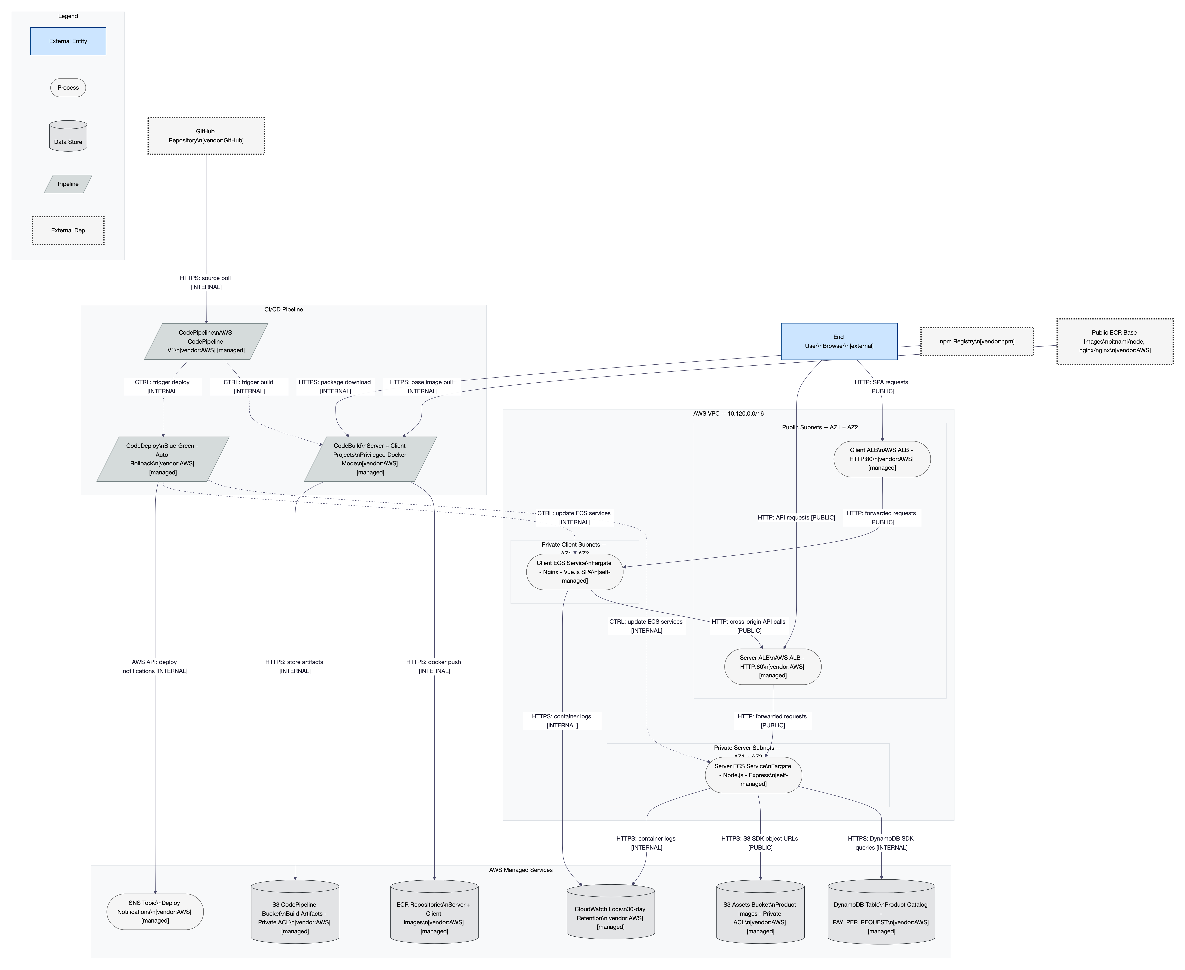
Figure 1: L1 Structural Architecture Diagram

IV. Risk Overlay Diagram

Figure 2: L4 Risk Overlay Diagram with Kill Chain Overlays

V. Asset Inventory
Asset | Classification | Storage | Encryption at Rest | In Transit | Access Controls | Retention
Product catalog | PUBLIC | DynamoDB | AWS-owned key | HTTPS | IAM | Indefinite
Product images | PUBLIC | S3 Assets | Default SSE-S3 | HTTP | ACL private | Indefinite
CI/CD artifacts | INTERNAL | S3 Pipeline | Default SSE-S3 | HTTPS | IAM | Indefinite
Docker images | INTERNAL | ECR | Default | HTTPS | IAM | Indefinite
Application logs | INTERNAL | CloudWatch | Default | HTTPS | IAM | 30 days
GitHub OAuth token | RESTRICTED | TF state + CodePipeline | Plaintext | CLI/API | Filesystem | Indefinite
Terraform state | RESTRICTED | Local filesystem | None | N/A | Filesystem | Indefinite

VI. Threat Actor Profiles

TA-1: Opportunistic Attacker
Attribute | Value
Type | External
Motivation | Curiosity, notoriety
Capability | 2/5
Access Level | Unauthenticated
Linked Findings | TM-001, TM-002, TM-007, TM-008, TM-012, TM-015, TM-016

TA-2: Malicious Insider
Attribute | Value
Type | Internal
Motivation | Revenge, financial gain
Capability | 3/5
Access Level | GitHub + AWS
Linked Findings | TM-003, TM-004, TM-005, TM-013, TM-014, TM-023

TA-3: Supply Chain Attacker
Attribute | Value
Type | External (indirect)
Motivation | Financial, espionage
Capability | 4/5
Access Level | npm/Docker
Linked Findings | TM-006, TM-015, TM-017, TM-025

TA-4: Network-Position (MitM)
Attribute | Value
Type | External
Motivation | Data interception
Capability | 3/5
Access Level | Network position
Linked Findings | TM-001

TA-5: Negligent Insider
Attribute | Value
Type | Internal
Motivation | Unintentional
Capability | 1/5
Access Level | Developer/DevOps
Linked Findings | TM-005, TM-009

VII. Findings
[CRITICAL] TM-004: Repository-Sourced Buildspec with Broad IAM
Field | Value
Affected Component(s) | CodeBuild, CodePipeline, DevOpsRole, GitHub
STRIDE-LM | T, E, LM
MITRE ATT&CK | T1195
CWE | CWE-269
CIA Impact | C:H I:H A:H
OWASP Risk Rating | 5x5=25
Confidence | HIGH
Remediation | R-012, R-013, R-014
[CRITICAL] TM-003: Overly Broad IAM PassRole (*)
Field | Value
Affected Component(s) | DevOpsRole, ECSTaskRole, CodeBuild, ServerECS
STRIDE-LM | E, LM
MITRE ATT&CK | T1078
CWE | CWE-269
CIA Impact | C:H I:H A:H
OWASP Risk Rating | 4x5=20
Confidence | HIGH
Remediation | R-011
[HIGH] TM-023: No Branch Protection on Repository
Field | Value
Affected Component(s) | GitHub, CodePipeline
STRIDE-LM | T, R
MITRE ATT&CK | T1195
CWE | CWE-862
CIA Impact | C:M I:H A:M
OWASP Risk Rating | 4x4=16
Confidence | MEDIUM
Remediation | R-013
[HIGH] TM-013: CodeBuild Privileged Docker Mode
Field | Value
Affected Component(s) | CodeBuild
STRIDE-LM | E, LM
MITRE ATT&CK | T1068
CWE | CWE-269
CIA Impact | C:H I:H A:M
OWASP Risk Rating | 4x4=16
Confidence | HIGH
Remediation | R-012
[HIGH] TM-014: No Pipeline Approval Gates / Scanning
Field | Value
Affected Component(s) | CodePipeline, CodeBuild, CodeDeploy
STRIDE-LM | T, R
MITRE ATT&CK | T1195
CWE | CWE-862
CIA Impact | C:H I:H A:M
OWASP Risk Rating | 4x4=16
Confidence | HIGH
Remediation | R-014, R-024
[HIGH] TM-001: No TLS/HTTPS on Public ALBs
Field | Value
Affected Component(s) | ClientALB, ServerALB
STRIDE-LM | I, T
MITRE ATT&CK | N/A
CWE | CWE-311
CIA Impact | C:H I:M A:L
OWASP Risk Rating | 5x3=15
Confidence | HIGH
Remediation | R-015
[HIGH] TM-002: No Authentication or Authorization
Field | Value
Affected Component(s) | ServerALB, ServerECS, ClientALB, ClientECS
STRIDE-LM | S, E
MITRE ATT&CK | T1190
CWE | CWE-306
CIA Impact | C:M I:M A:L
OWASP Risk Rating | 5x3=15
Confidence | HIGH
Remediation | R-028
[HIGH] TM-005: GitHub Token in Terraform State
Field | Value
Affected Component(s) | TFState, GitHubToken, CodePipeline
STRIDE-LM | I, S
MITRE ATT&CK | T1552
CWE | CWE-312
CIA Impact | C:H I:H A:L
OWASP Risk Rating | 3x5=15
Confidence | HIGH
Remediation | R-016, R-017
[HIGH] TM-006: Mutable ECR Tags + Latest Pattern
Field | Value
Affected Component(s) | ECR, CodeBuild, ServerECS, ClientECS
STRIDE-LM | T
MITRE ATT&CK | T1195
CWE | N/A
CIA Impact | C:L I:H A:M
OWASP Risk Rating | 3x5=15
Confidence | HIGH
Remediation | R-001, R-030
[HIGH] TM-007: No WAF or Rate Limiting
Field | Value
Affected Component(s) | ClientALB, ServerALB
STRIDE-LM | D
MITRE ATT&CK | T1498
CWE | CWE-770
CIA Impact | C:L I:L A:H
OWASP Risk Rating | 4x3=12
Confidence | HIGH
Remediation | R-018
[HIGH] TM-022: Unrestricted Egress from ECS Tasks
Field | Value
Affected Component(s) | ServerECS, ClientECS, SG_ECS
STRIDE-LM | I, LM
MITRE ATT&CK | T1048
CWE | CWE-269
CIA Impact | C:H I:M A:L
OWASP Risk Rating | 3x4=12
Confidence | HIGH
Remediation | R-019
[HIGH] TM-024: No Billing Alarm / Cost Detection
Field | Value
Affected Component(s) | DynamoDB, ServerECS
STRIDE-LM | D
MITRE ATT&CK | T1498
CWE | CWE-770
CIA Impact | C:L I:L A:H
OWASP Risk Rating | 4x3=12
Confidence | HIGH
Remediation | R-005
[MEDIUM] TM-009: S3 Buckets Missing Security Controls
Field | Value
Affected Component(s) | S3Assets, S3Pipeline
STRIDE-LM | I, T
MITRE ATT&CK | T1530
CWE | CWE-732
CIA Impact | C:M I:M A:L
OWASP Risk Rating | 3x3=9
Confidence | HIGH
Remediation | R-002, R-031, R-032
[MEDIUM] TM-011: No VPC Flow Logs
Field | Value
Affected Component(s) | VPC
STRIDE-LM | R
MITRE ATT&CK | T1562
CWE | CWE-390
CIA Impact | C:L I:L A:L
OWASP Risk Rating | 3x3=9
Confidence | HIGH
Remediation | R-020
[MEDIUM] TM-015: Outdated Dependencies
Field | Value
Affected Component(s) | ServerECS, ClientECS, CodeBuild
STRIDE-LM | T, E
MITRE ATT&CK | T1195
CWE | N/A
CIA Impact | C:M I:M A:M
OWASP Risk Rating | 3x3=9
Confidence | HIGH
Remediation | R-025
[MEDIUM] TM-017: Container Hardening Deficiencies
Field | Value
Affected Component(s) | ServerECS, ClientECS
STRIDE-LM | E, LM
MITRE ATT&CK | T1068
CWE | CWE-269
CIA Impact | C:M I:M A:L
OWASP Risk Rating | 3x3=9
Confidence | HIGH
Remediation | R-022
[MEDIUM] TM-012: Error Handler Info Leakage + Bug
Field | Value
Affected Component(s) | ServerECS
STRIDE-LM | I
MITRE ATT&CK | T1190
CWE | CWE-209
CIA Impact | C:M I:L A:L
OWASP Risk Rating | 4x2=8
Confidence | HIGH
Remediation | R-009
[MEDIUM] TM-025: npm install vs npm ci
Field | Value
Affected Component(s) | CodeBuild, ServerECS, ClientECS
STRIDE-LM | T
MITRE ATT&CK | T1195
CWE | N/A
CIA Impact | C:L I:H A:L
OWASP Risk Rating | 2x4=8
Confidence | HIGH
Remediation | R-004
[MEDIUM] TM-008: Unrestricted CORS
Field | Value
Affected Component(s) | ServerECS
STRIDE-LM | S
MITRE ATT&CK | T1190
CWE | CWE-732
CIA Impact | C:L I:L A:L
OWASP Risk Rating | 3x2=6
Confidence | HIGH
Remediation | R-010
[MEDIUM] TM-018: Single NAT Gateway (SPOF)
Field | Value
Affected Component(s) | VPC, ServerECS, ClientECS
STRIDE-LM | D
MITRE ATT&CK | T1498
CWE | CWE-400
CIA Impact | C:L I:L A:H
OWASP Risk Rating | 2x3=6
Confidence | HIGH
Remediation | R-007, R-027
[MEDIUM] TM-021: No Container Insights / Monitoring
Field | Value
Affected Component(s) | CloudWatch, ServerECS, ClientECS
STRIDE-LM | R
MITRE ATT&CK | T1562
CWE | CWE-390
CIA Impact | C:L I:L A:L
OWASP Risk Rating | 3x2=6
Confidence | HIGH
Remediation | R-021
[MEDIUM] TM-026: No CloudTrail Data Events
Field | Value
Affected Component(s) | DynamoDB, S3Assets, S3Pipeline
STRIDE-LM | R
MITRE ATT&CK | T1562
CWE | CWE-390
CIA Impact | C:L I:L A:L
OWASP Risk Rating | 3x2=6
Confidence | HIGH
Remediation | R-023
[MEDIUM] TM-016: Swagger Docs Publicly Exposed
Field | Value
Affected Component(s) | ServerECS, ServerALB
STRIDE-LM | I
MITRE ATT&CK | T1595
CWE | CWE-200
CIA Impact | C:L I:L A:L
OWASP Risk Rating | 5x1=5
Confidence | HIGH
Remediation | R-026
[LOW] TM-010: DynamoDB Missing PITR + CMK
Field | Value
Affected Component(s) | DynamoDB
STRIDE-LM | I, T
MITRE ATT&CK | T1485
CWE | CWE-311
CIA Impact | C:L I:L A:L
OWASP Risk Rating | 2x2=4
Confidence | HIGH
Remediation | R-003
[LOW] TM-019: No VPC Endpoints
Field | Value
Affected Component(s) | ServerECS, ClientECS
STRIDE-LM | I, D
MITRE ATT&CK | N/A
CWE | CWE-311
CIA Impact | C:L I:L A:L
OWASP Risk Rating | 2x2=4
Confidence | HIGH
Remediation | R-007, R-029
[LOW] TM-020: SNS No Subscribers / Encryption
Field | Value
Affected Component(s) | SNS
STRIDE-LM | R, I
MITRE ATT&CK | T1562
CWE | CWE-311
CIA Impact | C:L I:L A:L
OWASP Risk Rating | 3x1=3
Confidence | HIGH
Remediation | R-008, R-033
Total: 26 findings (2 critical, 10 high, 11 medium, 3 low)

VIII. Remediation Roadmap

Wave 1: Quick Wins (1-2 days)
R-ID | Recommendation | Addresses | Effort
R-001 | Set ECR immutable tags | TM-006 | LOW
R-002 | Add S3 public_access_block | TM-009 | LOW
R-003 | Enable DynamoDB PITR | TM-010 | LOW
R-004 | Replace npm install with npm ci | TM-025 | LOW
R-005 | Create billing alarm ($50) | TM-024 | LOW
R-006 | Enable ECR scan-on-push | TM-006, TM-014 | LOW
R-007 | Add VPC gateway endpoints | TM-019, TM-018 | LOW
R-008 | Add SNS subscription | TM-020 | LOW
R-009 | Fix error handler | TM-012 | LOW
R-010 | Configure CORS origin | TM-008 | LOW

Wave 2: Critical Fixes (1-2 sprints)
R-ID | Recommendation | Addresses | Effort
R-011 | Scope IAM PassRole to specific ARNs | TM-003 | MEDIUM
R-012 | Secure buildspec (inline or restricted repo) | TM-004 | MEDIUM
R-013 | Enable GitHub branch protection | TM-023 | MEDIUM
R-014 | Add pipeline approval gate | TM-014 | MEDIUM
R-015 | Enable HTTPS on ALBs | TM-001 | MEDIUM
R-016 | Migrate to CodeStar Connections | TM-005 | MEDIUM
R-017 | Remote Terraform backend | TM-005 | MEDIUM
R-018 | Associate WAF with ALBs | TM-007 | MEDIUM
R-019 | Restrict SG egress | TM-022 | MEDIUM

Wave 3: Hardening (2-4 sprints)
R-ID | Recommendation | Addresses | Effort
R-020 | Enable VPC Flow Logs | TM-011 | MEDIUM
R-021 | Enable Container Insights | TM-021 | LOW
R-022 | Container hardening | TM-017 | MEDIUM
R-023 | Enable CloudTrail data events | TM-026 | MEDIUM
R-024 | Add pipeline scanning stage | TM-014, TM-015 | MEDIUM
R-025 | Update dependencies | TM-015 | HIGH
R-026 | Disable Swagger in production | TM-016 | LOW
R-027 | Deploy NAT GW per AZ | TM-018 | MEDIUM

Wave 4: Production Readiness
R-ID | Recommendation | Addresses | Effort
R-028 | Implement authentication | TM-002 | HIGH
R-029 | VPC interface endpoints | TM-019 | MEDIUM
R-030 | Git SHA image tags | TM-006 | LOW
R-031 | Remove force_destroy | TM-009 | LOW
R-032 | S3 versioning | TM-009 | LOW
R-033 | SNS encryption | TM-020 | LOW

IX. Networking & Infrastructure Data
VPC: 10.120.0.0/16, single region, 2 AZs. See HTML report for full details.
SG Name | Direction | Protocol | Port | Source/Dest | Description
ALB SGs | Ingress | TCP | 80 | 0.0.0.0/0 | HTTP from internet
ECS Client SG | Ingress | TCP | 80 | Client ALB SG | HTTP from Client ALB
ECS Server SG | Ingress | TCP | 3001 | Server ALB SG | HTTP from Server ALB
All ECS SGs | Egress | ALL | ALL | 0.0.0.0/0 | Unrestricted egress

X. Compliance Mapping
Framework | Total | Compliant | Partial | Non-Compliant | N/A | Coverage
SOC 2 | 33 | 3 | 6 | 22 | 2 | 9%
ISO 27001 | 93 | 5 | 8 | 41 | 39 | 10%
NIST CSF 2.0 | 106 | 4 | 9 | 38 | 55 | 8%
PCI-DSS v4.0 | 64 | 1 | 3 | 48 | 12 | 2%

XI. Privacy Assessment
10 privacy findings identified (2 critical, 3 high, 3 medium, 2 low). Key issues: no TLS on personal data transmission, deceptive login form, no privacy notice, developer PII in Swagger. See HTML report for full LINDDUN analysis.

XII. Positive Observations
- Private subnets for ECS tasks with security group segmentation
- Fargate launch type (AWS-managed infrastructure isolation)
- Blue/Green deployment with auto-rollback on failure
- Read-only DynamoDB access from application (least privilege for data operations)
- awsvpc network mode enabling per-task SG enforcement
- Infrastructure as Code (Terraform) for reproducibility

XIII. Assumptions & Limitations
Single AWS account deployment assumed. No pre-existing security services. Demo context.
Not analyzed: npm audit, Docker image scans, penetration testing, Terraform plan execution.

XIV. Appendices

A. Methodology
OWASP Risk Rating bands: CRITICAL (20-25), HIGH (12-19), MEDIUM (6-11), LOW (1-5)
CVSS v3.1: CRITICAL (9.0-10.0), HIGH (7.0-8.9), MEDIUM (4.0-6.9), LOW (0.1-3.9)

B. Framework Reference
See HTML report Appendix B for complete MITRE ATT&CK and CWE reference tables.

C. QA Corrections Log
HIGH count corrected from 9 to 10. Confidence escalations applied for TM-006, TM-009, TM-015. 14 cross-agent duplicates deduplicated.

D. Glossary
ALB=Application Load Balancer, CORS=Cross-Origin Resource Sharing, CVSS=Common Vulnerability Scoring System, CWE=Common Weakness Enumeration, ECR=Elastic Container Registry, ECS=Elastic Container Service, IAM=Identity and Access Management, LINDDUN=Linkability/Identifiability/Non-repudiation/Detectability/Disclosure/Unawareness/Non-compliance, OWASP=Open Worldwide Application Security Project, PASTA=Process for Attack Simulation and Threat Analysis, STRIDE-LM=Spoofing/Tampering/Repudiation/Information Disclosure/Denial of Service/Elevation of Privilege/Lateral Movement, VPC=Virtual Private Cloud, WAF=Web Application Firewall

E. Threat Model Lifecycle Triggers
- Authentication or authorization is added
- Application handles user data or PII
- New API endpoints are added
- System deployed to production AWS account
- CI/CD pipeline structure changes

