Mushroom Green — 1865 Occupants
Book of Weaver · 59 households · c.1860
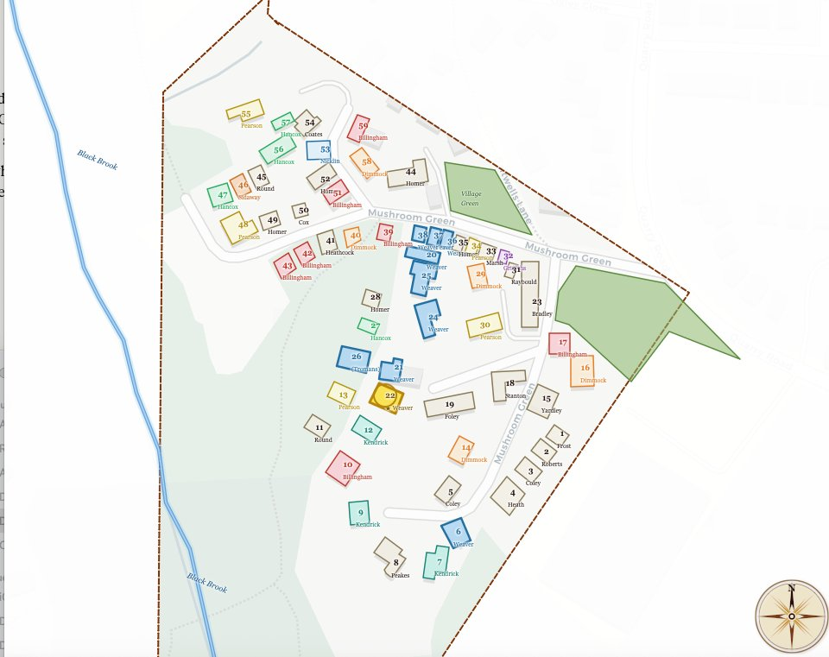
Mushroom Green c.1860 — household map based on 1861 census returns
This map is also available as a fully interactive version. Keep both files in the same folder, then open: mushroom_green_1865_v10_9.html
Hover over any house to see the household name and occupant count.

