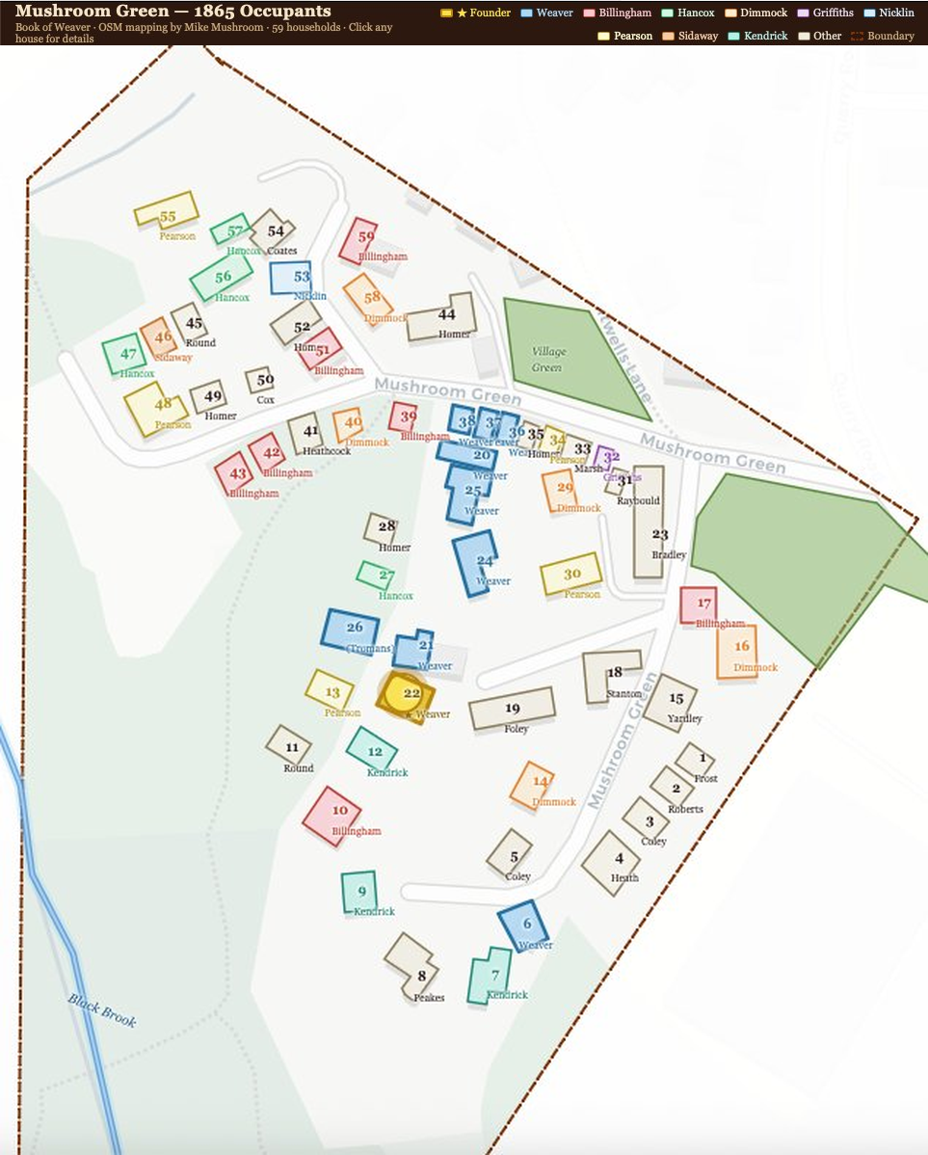
Mushroom Green c.1860 — household map based on 1861 census returns
Interactive version (keep both files in the same folder): mushroom_green_1865_v10_10.html

