|  |
| --- |
| UAH Fit Vault Detailed Design |
| CPE 656/658 Software Studio |
| Timothy R. Wilkins  Whit J. Sisulak  Glen L. Riden  James J. Duggan IV |

11/13/2015

Table of Contents

1. DETAILED DESIGN OVERVIEW i

1.1 Controllers i

1.1.1 AdminHomeController i

1.1.2 AdminLookupController ii

1.1.3 AdminEditController ii

1.2 Sequence Diagrams iii

## DETAILED DESIGN OVERVIEW

### Controllers

#### AdminHomeController

This class is responsible for accepting or rejecting a user account request. This class provides the backend for the **AdminHomeView**. The AdminHomeView has a link to navigate to look-up a user in order to delete, enable, or disable their account. See Figure 1 sequence diagram for this controller.

**<<Task>>**

**Attributes:**

* **Private Collection<String>** UserNames
  + Collection of usernames of accounts to be approved or rejected.

**Operations:**

* Sets and gets for all attributes.
* **Public ActionResult** btnAcceptClick()
  + When the accept button is clicked the user account request is approved.
  + The results are returned to the **AdminHomeView.**
* **Public ActionResult** btnRejectClick()
  + When the reject button is clicked the user account request is denied.
  + The results are returned to the **AdminHomeView.**

#### AdminLookupController

This class is responsible for allowing the system administrator to search for user accounts to modify. This class provides the backend for the **AdminLookupView**. See Figure 2 sequence diagram for this controller.

**<<Task>>**

**Attributes:**

* **Private String** Username
  + The username of the account to modify.

**Operations:**

* Sets and gets for all attributes.
* **Public ActionResult** btnSubmit()
  + A query by username is sent to the database and the user account information is returned.
  + The user account information is passed to the **AdminEditController.**

#### AdminEditController

This class is responsible for allowing the system administrator to enable, disable, or delete a user account. This class provides the backend for the **AdminEditView**. See Figure 2 sequence diagram for this controller.

**<<Task>>**

**Attributes:**

* **Private String** Username
  + The username of the account to modify.

**Operations:**

* Sets and gets for all attributes.
* **Public ActionResult** btnUpdate()
  + An update is sent to the database based on the selected option:
    - Enable
    - Disable
    - Delete
  + The results are returned to the **AdminEditView.**

### Sequence Diagrams

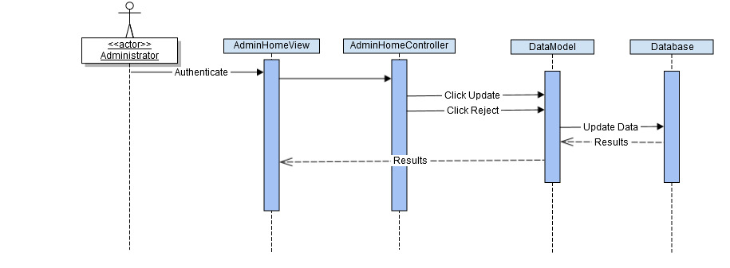

Figure : Approve Reject Account Sequence Diagram

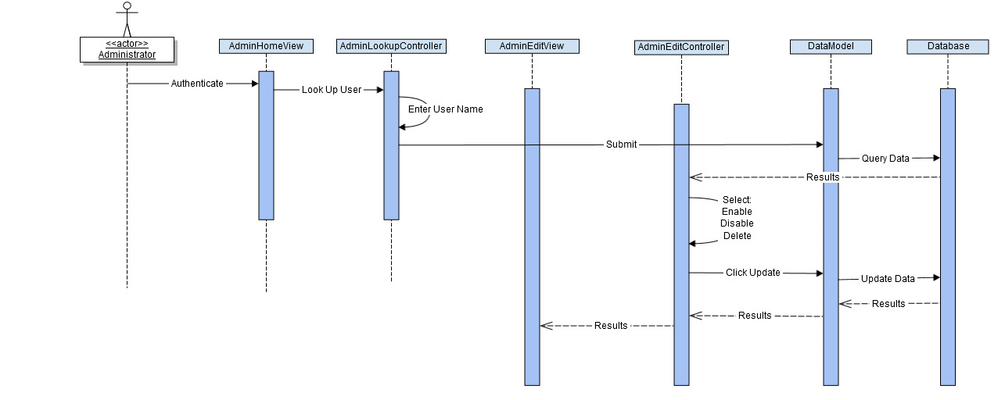

Figure : Enable, Disable, Delete Account Sequence