UAH Fit Vault

Prototypes

Contents

Main Screen 4

Forgot Password 1 5

Forgot Password 2 6

Forgot Password 3 7

Forgot Password 4 8

Request Account 1 9

Request Account 2 10

Logout 11

Patient: Welcome Screen 12

Patient: Welcome Screen 2 13

Patient: View Data 14

Patient: View Session 15

Patient: Edit Account Settings 16

Patient: Edit Account Settings Confirm 17

Patient: Upload Data 18

Patient: Upload Data Confirm 19

Patient: Upload Data Final 20

Physician: Welcome Screen 21

Physician: Edit Account Settings 22

Physician: Edit Account Settings Confirm 23

Physician: Create Patient 24

Physician: Create Patient Confirm 25

Physician: View Patient Data 26

Physician: Select Session 27

Physician: View Session 28

Experimenter: Welcome Screen 29

Experimenter: Create Experiment 30

Experimenter: Edit Account Settings 31

Experimenter: View Experiments 32

Experimenter: View Results 33

System Admin: Welcome Screen 34

System Admin: Edit Account Settings 35

System Admin: Look-up User 1 36

System Admin: Look-up User 2 37

System Admin: Jsmith1 Patients 38

System Admin: Smith0001 User 39

# Main Screen

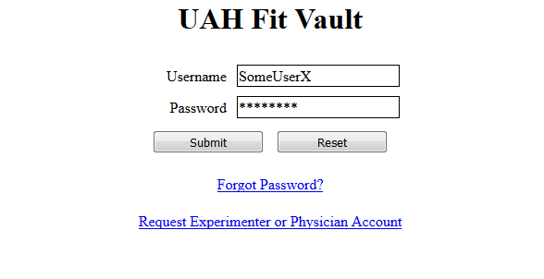

*Description: This is the main screen for the UAH Fit Vault system.*

# Forgot Password 1

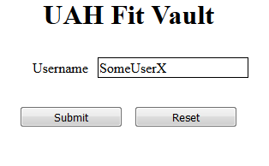

*Description: This is the screen displayed when a user clicks on the Forgot Password link on the “Main Screen”.*

# Forgot Password 2

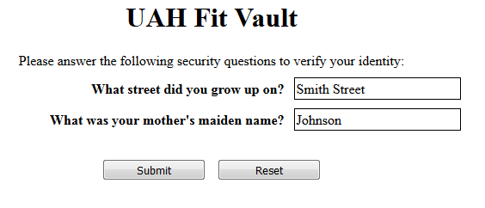

*Description: This screen is displayed after the user fills in their username and clicks on the Submit button on the “Forgot Password 1” screen.*

# Forgot Password 3

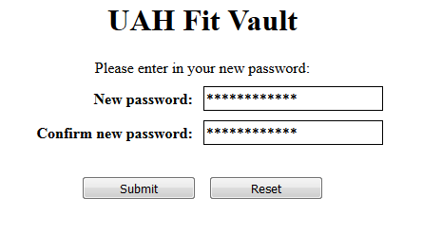

*Description: This screen appears after the user clicks Submit on the “Forgot Password 2” screen.*

# Forgot Password 4

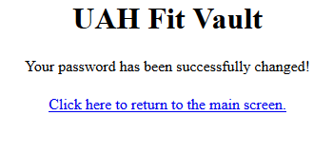

*Description: This screen is displayed after the user clicks Submit on “Forgot Password 3”.*

# Request Account 1

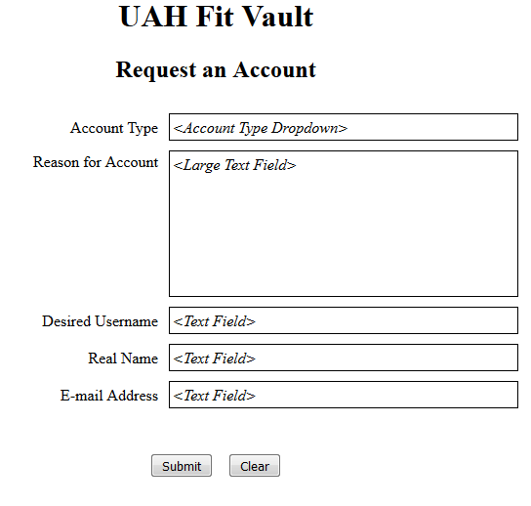

*Description: This is the screen that will be used for a new user to request a physician or experiment administrator account.*

# Request Account 2

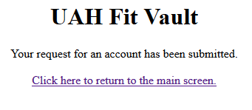

*Description: This screen will be displayed after the user clicks on the Submit button of the “Request Account 1” screen.*

# Logout

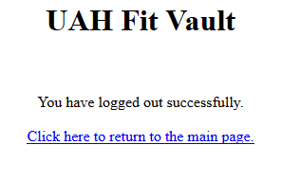

*Description: This screen will be displayed after a user clicks on the Logout button.*

# Patient: Welcome Screen

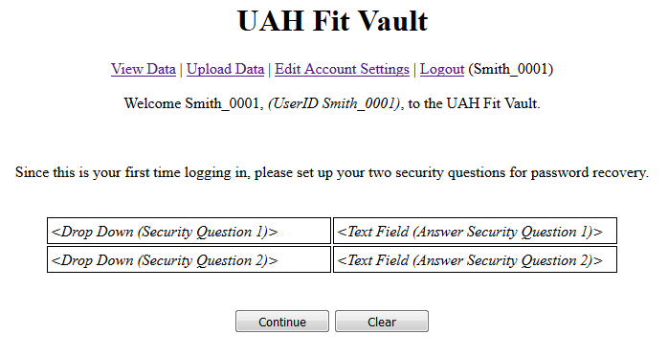

*Description: This is the screen the patient will see after logging in.*

*\*On the first log-in, the patient will be prompted to specify their security questions for password recovery.*

# Patient: Welcome Screen 2

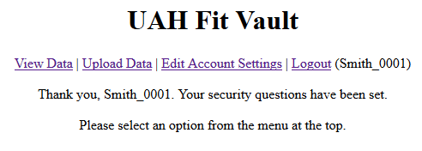

*Description: This is the screen after setting up security questions.*

# Patient: View Data

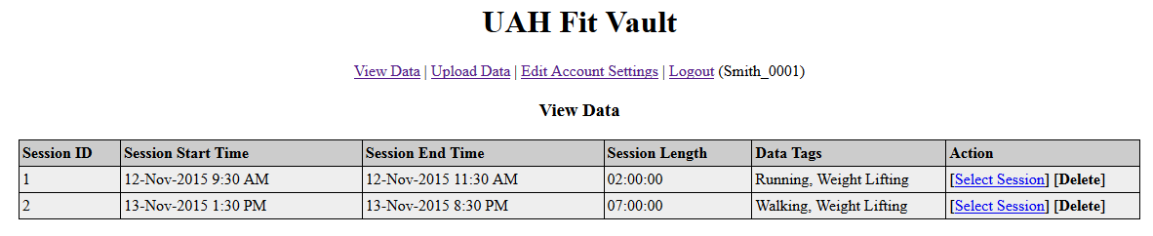

*Description: This screen shows the data previously uploaded by the patient.*

# Patient: View Session

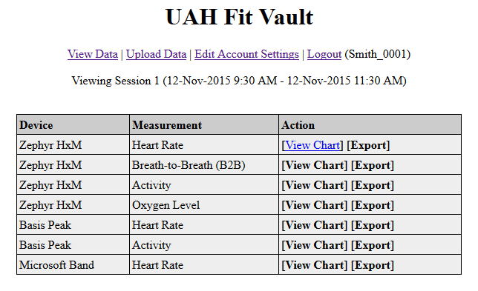

*Description: This is the screen that the patient will see after selected a session from the “Patient: View Data” screen.*

# Patient: Edit Account Settings

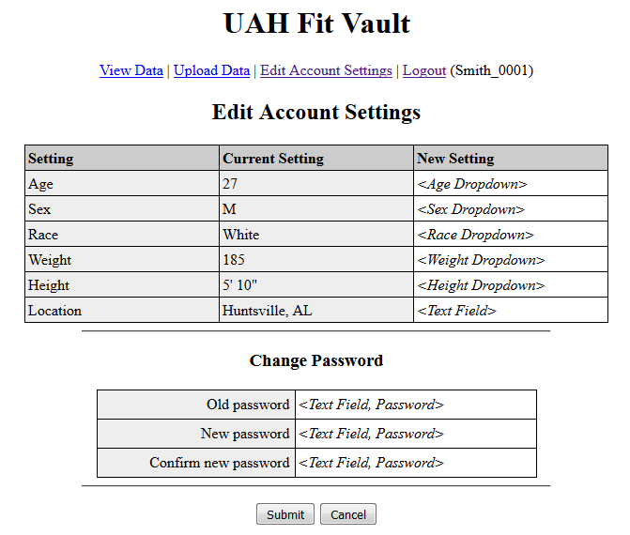

*Description: This is the screen that the patient will see when editing their account settings.*

# Patient: Edit Account Settings Confirm

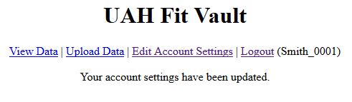

*Description: This screen will be shown after the patient clicks the submit button on the “Patient: Edit Account Settings” screen.*

# Patient: Upload Data

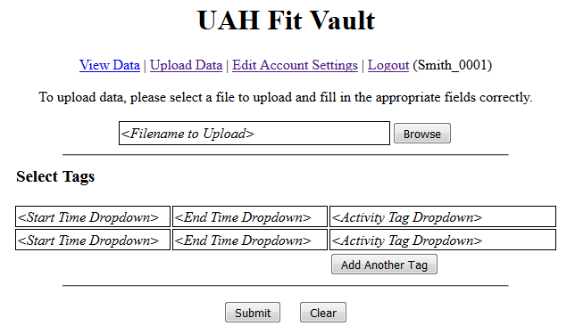

*Description: This is the screen that will be shown when the patient clicks on Upload Data.*

# Patient: Upload Data Confirm

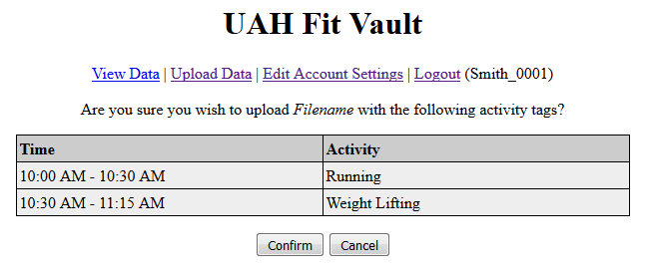

*Description: This screen appears after a patient clicks on the Submit button on the “Patient: Upload Data” screen. After clicking Confirm, the data will be uploaded to the system or display an error.*

# Patient: Upload Data Final

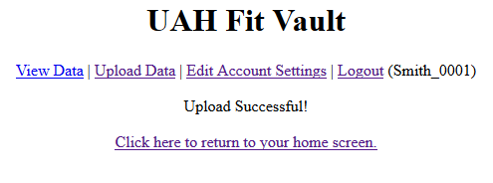

*Description: This screen should appear after the user clicks on the Confirm button on the “Patient: Upload Data Confirm” screen.*

# Physician: Welcome Screen

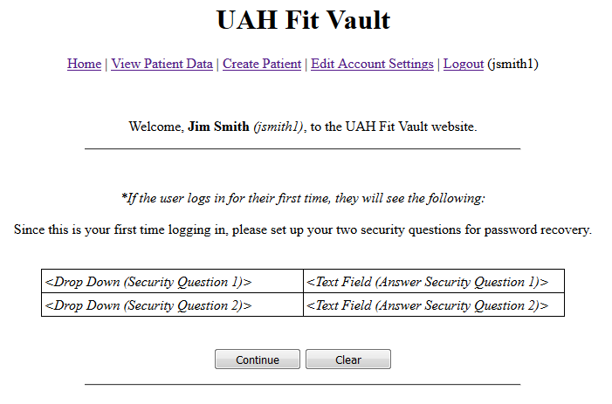

*Description: This is the screen that will be displayed after a physician logs in to the system. If it is the first time logging in, the system will ask the physician to provide two security questions for password recovery.*

# Physician: Edit Account Settings

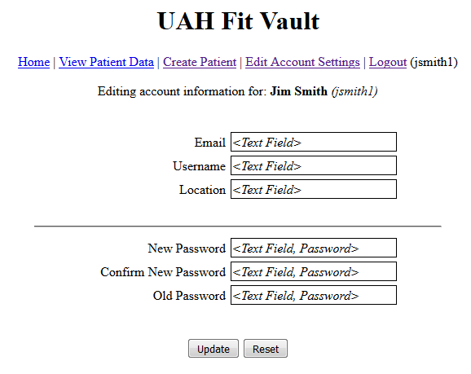

*Description: The screen will be displayed when the physician clicks on the Edit Account Settings link.*

# Physician: Edit Account Settings Confirm

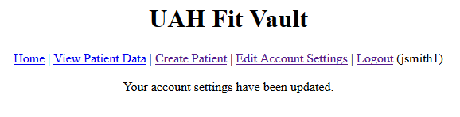

*Description: This screen will be shown when the physician clicks Submit on the “Physician: Edit Account Settings” screen.*

# Physician: Create Patient

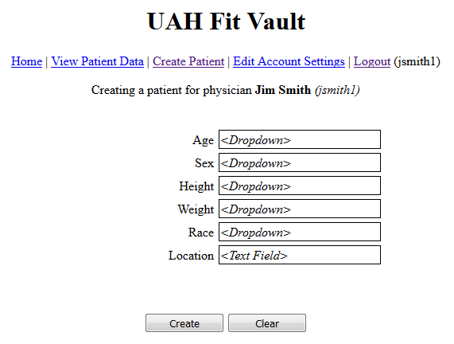

*Description: This screen will be displayed when the physician clicks on the Create Patient link.*

# Physician: Create Patient Confirm

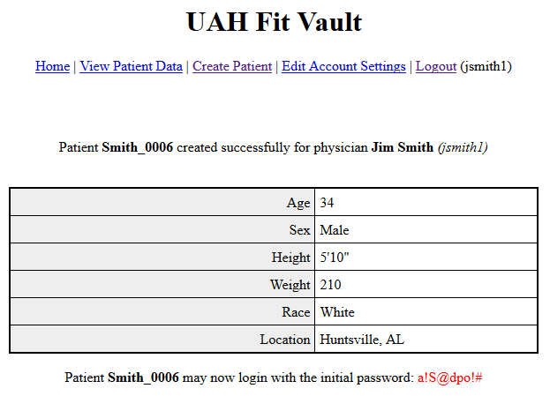

*Description: This screen will be displayed when the physician clicks the Create button on the “Physician: Create Patient” screen.*

# Physician: View Patient Data

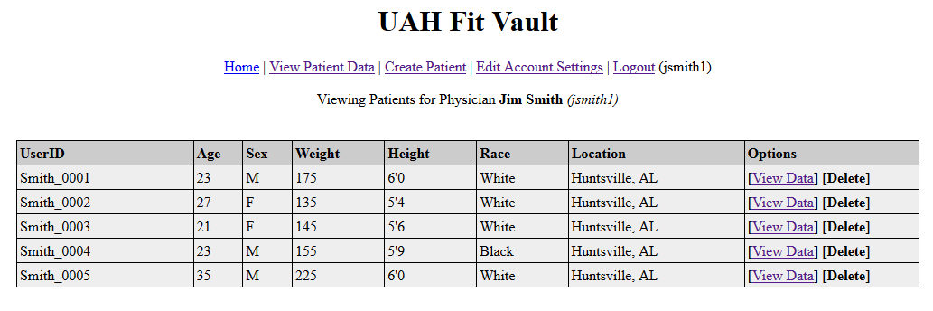

*Description: This screen will be displayed when the physician clicks on the View Patient Data link.*

# Physician: Select Session

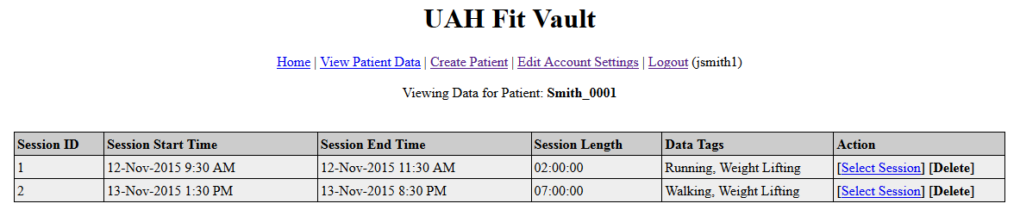

*Description: This screen will be displayed after the physician clicks on the View Data link for a patient on the “Physician: View Patient Data” screen.*

# Physician: View Session

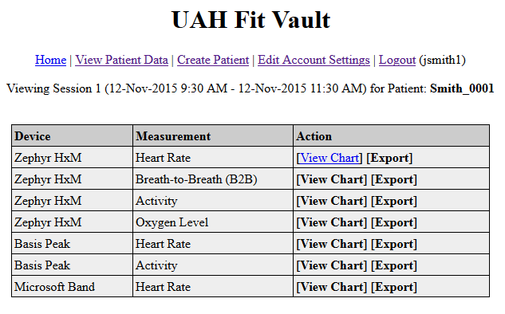

*Description: This screen will be displayed after the physician clicks on the Select Session link from the “Physician: Select Session” screen.*

# Experimenter: Welcome Screen

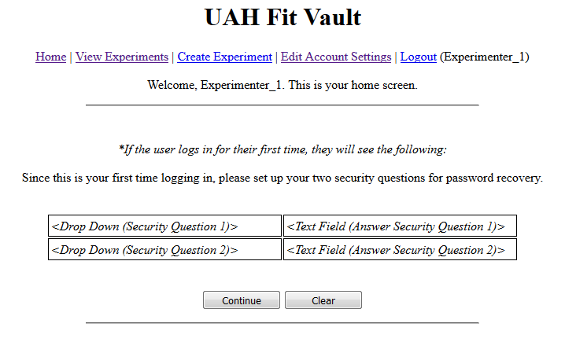

*Description: This is the screen that will appear when the experimenter first logs in. If this is the first time logging in, the system will ask the experimenter to provide security questions for password recovery.*

# Experimenter: Create Experiment

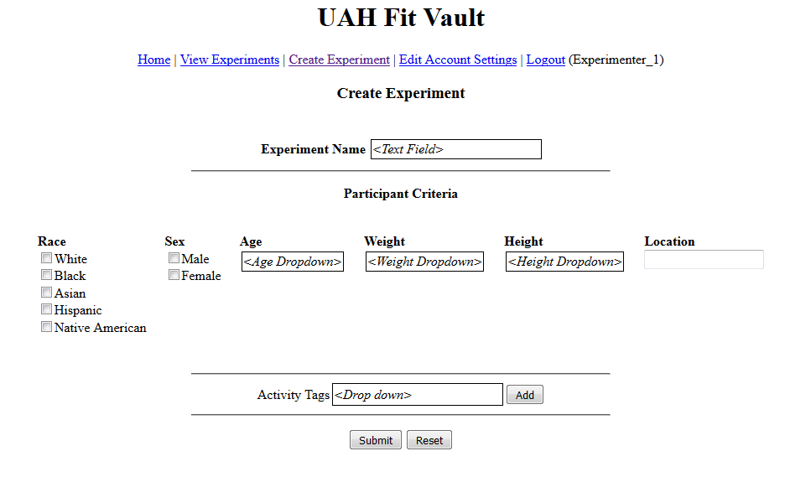

*Description: This is the screen that will appear after clicking on the Create Experiment link.*

# Experimenter: Edit Account Settings

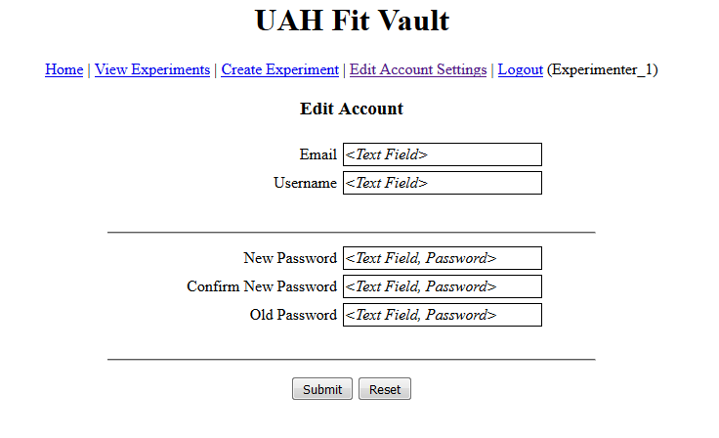

*Description: This is the screen that will be seen when the experimenter clicks on Edit Account Settings.*

# Experimenter: View Experiments

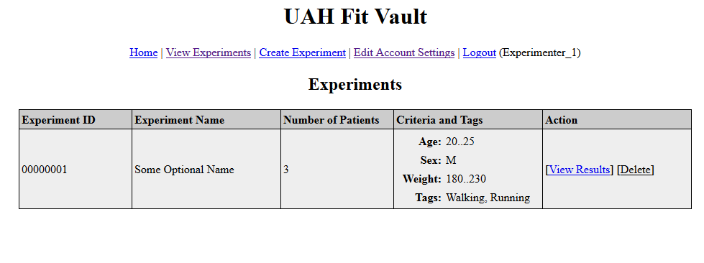

*Description: This is the screen that will be displayed when the experimenter clicks on the View Experiments link.*

# Experimenter: View Results

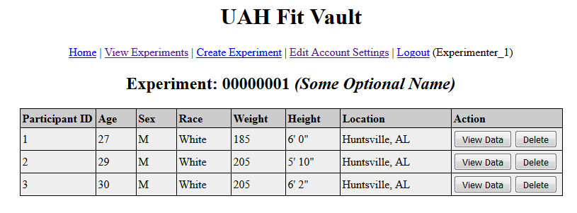

*Description: This screen will be displayed when the experimenter clicks on the View Results link of an experiment on the “Experimenter: View Experiments” screen.*

# System Admin: Welcome Screen

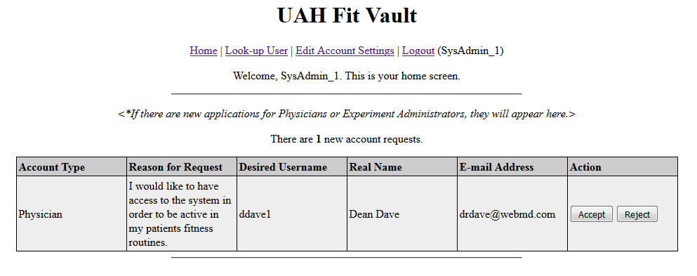

*Description: This screen will be displayed after the system administrator logs in.*

# System Admin: Edit Account Settings

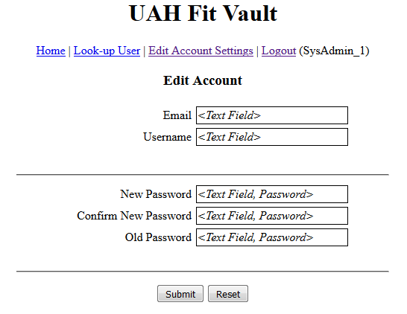

*Description: This screen will be displayed when the system administrator clicks on the Edit Account Settings click.*

# System Admin: Look-up User 1

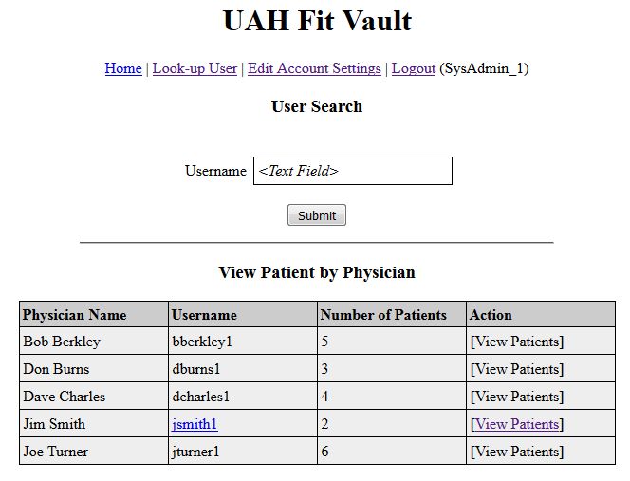

*Description: This screen will be displayed after the system administrator clicks on the Look-up User link at the top of the page. This page allows for a user search or a patient view by physician.*

# System Admin: Look-up User 2

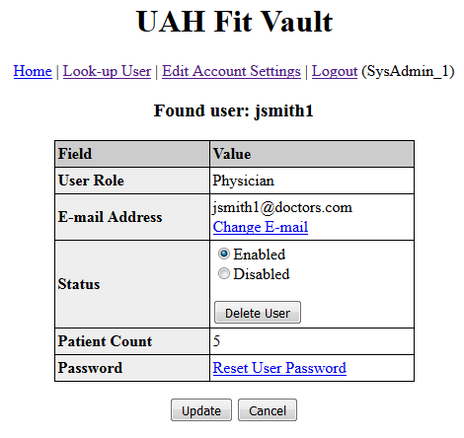

*Description: This screen is displayed after the system administrator enters a username in the “System Admin: Look-up User 1” screen and clicks Submit.*

# System Admin: Jsmith1 Patients

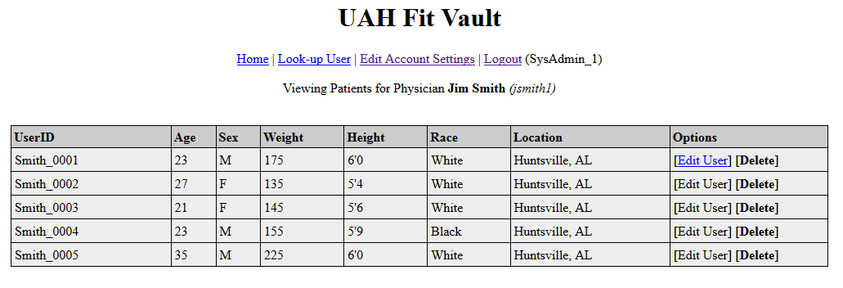

*Description: This screen is displayed after a system administrator clicks on the View Patients link in the “System Admin: Look-up User 1” screen.*

# System Admin: Smith0001 User

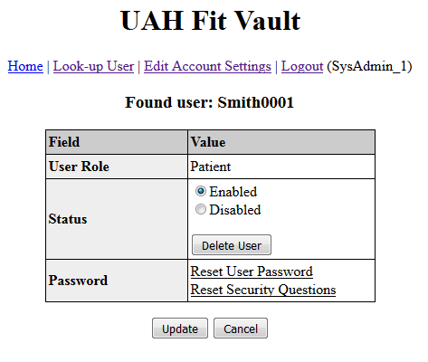

*Description: This screen is displayed after the system admin clicks on the Edit User link on the “System Admin: Jsmith1 Patients” screen.*