|  |
| --- |
| Information System Design |
| TOUR BANGLA |
| * AN ONLINE TOURIST COMMUNITY |

SUBMITTED BY :

1. MUSTAHSINUL MOULA (1005064 )
2. MD. ABDULLAH-AL- MARUF (1005066)
3. MD. HASAN JAWAD (1005069 )
4. MD. JAWAD NOOR ASIF ( 1005080)
5. MD. MONZURUL AMIN ( 1005085 )

**Contents:**

* Subsystems
* Actors
* According to each subsystems
  + Use-case Glossary
  + Use-case Diagram
  + Use-case Narrative with
    - High level table version &
    - Documentation

**Subsystems:**

* Admin
* User subsystem
* Group activities
* General interaction
* Commercial client management

1. Admin

# Actor:

1. Admin

2. General user

3. Registered user

4. Hotel companies

5. Travel agencies

6. Transport companies

# Actor Glossary:

|  |  |
| --- | --- |
| **Actor** | **Activity Scope** |
| Admin | Approval, verification, edition, modification, moderation, communication |
| General user | Voting and contact |
| Registered user | Voting , suggestion, sharing and communication |
| Hotel company | Advertisement and communication |
| Travel agencies | Advertisement and communication |
| Transport companies | Advertisement and communication |

# Use-Case Glossary:

# 1.1 Approval

|  |  |
| --- | --- |
| **Use Case Name** | **Define Route & Price** |
| Use Case Id | 1.1 |
| Priority | high |
| Primary Business Actor | ADM |
| Other participating actor | RU,GU,TCM , HCM,TA |
| Description | Sending requests and approving them |
| Trigger | Admin (ADM) |

# 1.2 Verification

|  |  |
| --- | --- |
| **Use Case Name** | **Define Route & Price** |
| Use Case Id | 1.2 |
| Priority | high |
| Primary Business Actor | ADM |
| Other participating actor | RU,GU, TCM , HCM,TA |
| Description | Sending requests and verifying them |
| Trigger | Admin (ADM) |

# 1.3 modification & moderation

|  |  |
| --- | --- |
| **Use Case Name** | **Define Route & Price** |
| Use Case Id | 1.3 |
| Priority | medium |
| Primary Business Actor | ADM |
| Other participating actor | RU,GU |
| Description | Modifying & moderating offensive contents |
| Trigger | Admin (ADM) |

# 1.4 communication

|  |  |
| --- | --- |
| **Use Case Name** | **Define Route & Price** |
| Use Case Id | 1.4 |
| Priority | medium |
| Primary Business Actor | ADM |
| Other participating actor | RU,GU,HCM,TCM,TA |
| Description | Taking feedbacks and communicate with clients |
| Trigger | Admin (ADM) |

# 1.5 polling

|  |  |
| --- | --- |
| **Use Case Name** | **Define Route & Price** |
| Use Case Id | 1.5 |
| Priority | medium |
| Primary Business Actor | ADM |
| Other participating actor | RU,GU |
| Description | Creating poll, voting & counting votes |
| Trigger | Admin (ADM) |

# Use-Case Diagram:

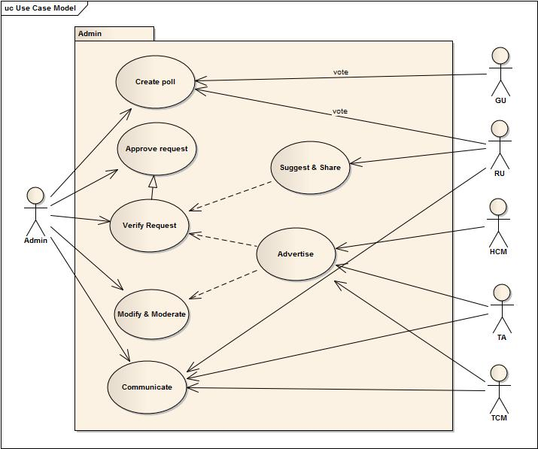

1. User subsystem

# Actor:

1. Admin

2. Registered user

3. General user

# Actor Glossary:

|  |  |
| --- | --- |
| **Actor** | **Activity Scope** |
| Admin | Verify , modify, approve, moderate data |
| Registered user | Sign up, place suggestion, review & rating, photo sharing and write blog |
| General user | Searching information |

# Use-Case Glossary:

# 2.1 creating profile

|  |  |
| --- | --- |
| **Use Case Name** | **Define Route & Price** |
| Use Case Id | 2.1 |
| Priority | High |
| Primary Business Actor | GU,TCM,HCM,TA |
| Other participating actor | ADM |
| Description | Creating profiles with detail info & updating |
| Trigger | GU,TCM,HCM,TA |

# 2.2 photo sharing

|  |  |
| --- | --- |
| **Use Case Name** | **Define Route & Price** |
| Use Case Id | 2.2 |
| Priority | low |
| Primary Business Actor | RU |
| Other participating actor | ADM |
| Description | Sharing photos & tagging users and places |
| Trigger | RU |

# 2.3 polling

|  |  |
| --- | --- |
| **Use Case Name** | **Define Route & Price** |
| Use Case Id | 2.3 |
| Priority | low |
| Primary Business Actor | RU,GU |
| Other participating actor | ADM |
| Description | Voting to take decisions |
| Trigger | RU,GU |

# 2.4 review writing

|  |  |
| --- | --- |
| **Use Case Name** | **Define Route & Price** |
| Use Case Id | 2.4 |
| Priority | medium |
| Primary Business Actor | RU |
| Other participating actor | ADM |
| Description | Writes reviews on places, hotels, transports |
| Trigger | RU |

# 2.5 rating

|  |  |
| --- | --- |
| **Use Case Name** | **Define Route & Price** |
| Use Case Id | 2.5 |
| Priority | medium |
| Primary Business Actor | RU |
| Other participating actor | GU |
| Description | Rates on places ,hotels , transports |
| Trigger | RU |

# 2.6 suggestion

|  |  |
| --- | --- |
| **Use Case Name** | **Define Route & Price** |
| Use Case Id | 2.6 |
| Priority | medium |
| Primary Business Actor | RU |
| Other participating actor | ADM |
| Description | Suggesting new places , verifies then approves |
| Trigger | RU |

# Use-Case Diagram:

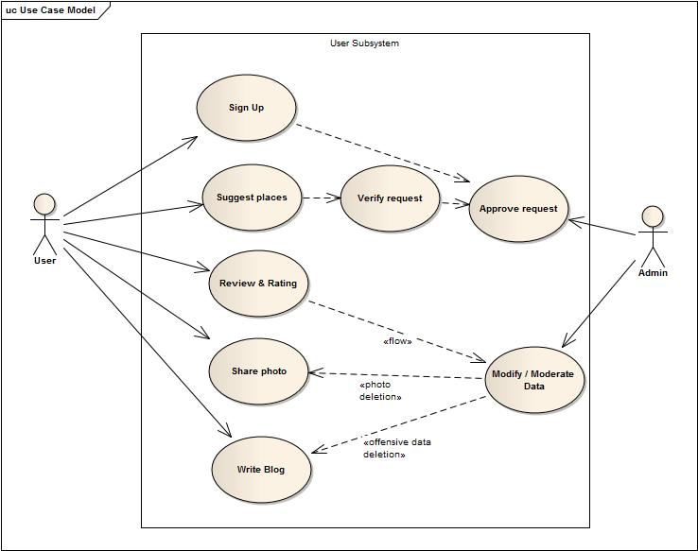

1. Group activities

# Actor:

1. Admin

2. Registered user

# Actor Glossary:

|  |  |
| --- | --- |
| **Actor** | **Activity Scope** |
| Admin | Verify and approve event management |
| Registered user | Group creation, invite member, add member, create and manage event |

# Use-Case Glossary:

# 3.1 group management

|  |  |
| --- | --- |
| **Use Case Name** | **Define Route & Price** |
| Use Case Id | 3.1 |
| Priority | Medium |
| Primary Business Actor | RU |
| Other participating actor |  |
| Description | Creating groups , adding , chatting |
| Trigger | RU |

# 3.2 event management

|  |  |
| --- | --- |
| **Use Case Name** | **Define Route & Price** |
| Use Case Id | 3.2 |
| Priority | Medium |
| Primary Business Actor | RU,TA |
| Other participating actor |  |
| Description | Creating & managing events |
| Trigger | RU,TA |

# Use-Case Diagram:

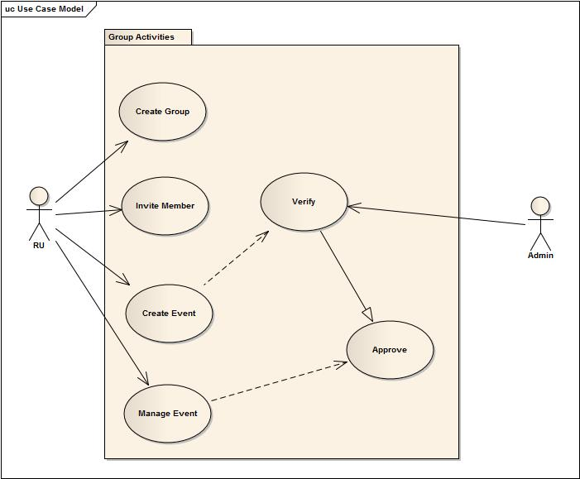

1. General interaction

# Actor:

1. Admin

2. Registered user

# Actor Glossary:

|  |  |
| --- | --- |
| **Actor** | **Activity Scope** |
| Admin | Notify changes and events |
| Registered user | Threading, discussion, chatting |

# Use-Case Glossary:

# 4.1 discussion

|  |  |
| --- | --- |
| **Use Case Name** | **Define Route & Price** |
| Use Case Id | 4.1 |
| Priority | Medium |
| Primary Business Actor | RU |
| Other participating actor | ADM |
| Description | Writing threads & posting comments |
| Trigger | RU |

# 4.2 shout-box activity

|  |  |
| --- | --- |
| **Use Case Name** | **Define Route & Price** |
| Use Case Id | 4.2 |
| Priority | Medium |
| Primary Business Actor | RU,ADM |
| Other participating actor |  |
| Description | Chatting & announcing notifications |
| Trigger | RU,ADM |

# Use-Case Diagram:

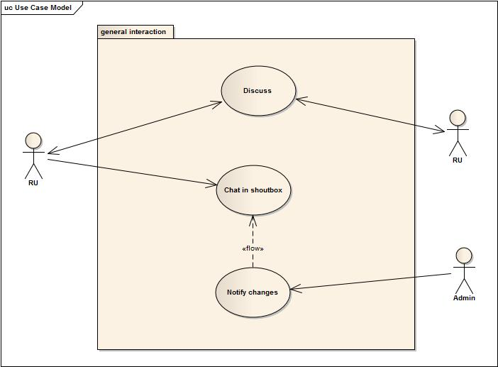

5. Commercial client management

# Actor:

1. Admin

2. Hotel companies

3. Transport companies

4. Travel agencies

# Actor Glossary:

|  |  |
| --- | --- |
| **Actor** | **Activity Scope** |
| Admin | Verify and approve request, advertisement |
| Hotel companies | Sign up, advertise and create package |
| Transport companies | Sign up, advertise and create package |
| Travel agencies | Sign up, advertise and create package |

# Use-Case Glossary:

# 5.1 creating premium accounts

|  |  |
| --- | --- |
| **Use Case Name** | **Define Route & Price** |
| Use Case Id | 5.1 |
| Priority | High |
| Primary Business Actor | TCM,HCM,TA |
| Other participating actor | ADM |
| Description | Creating premium accounts , approving accounts |
| Trigger | TCM,HCM,TA |

# 5.2 advertising

|  |  |
| --- | --- |
| **Use Case Name** | **Define Route & Price** |
| Use Case Id | 5.2 |
| Priority | Medium |
| Primary Business Actor | HCM,TCM,TA |
| Other participating actor | ADM |
| Description | Advertising features , verifying them |
| Trigger | TCM,HCM,TA |

# 5.3 offering packages

|  |  |
| --- | --- |
| **Use Case Name** | **Define Route & Price** |
| Use Case Id | 5.3 |
| Priority | Medium |
| Primary Business Actor | HCM,TCM,TA |
| Other participating actor | ADM |
| Description | Offering packages , verifying them |
| Trigger | HCM,TCM,TA |

# 5.4 serving guides

|  |  |
| --- | --- |
| **Use Case Name** | **Define Route & Price** |
| Use Case Id | 5.4 |
| Priority | Medium |
| Primary Business Actor | HCM,TA |
| Other participating actor |  |
| Description | Appointing guides to help |
| Trigger | HCM, TA |

# Use-Case Diagram:

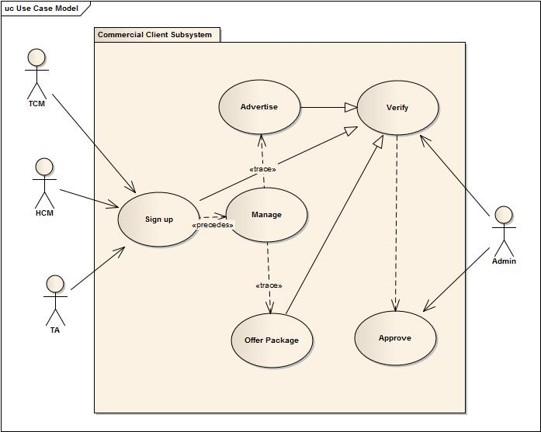

THE END