实验三 数据预处理
实验报告
- 分析新冠肺炎与地理位置间的相关关系
import numpy as np
import pandas as pd
import matplotlib.pyplot as plt
import requests

#请求地址
url = "http://dia.t.gdatacloud.com/api/diagnose/areacount/provinceCount"

params = {
'date':'2020-03-01'
}

#发送get请求
response = requests.get(url, params=params)

#获取返回的json数据
s = response.json()
data = pd.DataFrame(s['content'])

data.head()
import folium
import pandas as pd

# Instantiate a feature group for the incidents in the dataframe
incidents = folium.map.FeatureGroup()

# Loop through the 200 crimes and add each to the incidents feature group
for lat, lng, count, in zip(data.latitude, data.longitude, data.confirmedCount):
incidents.add_child(
folium.CircleMarker(
[lat, lng],
radius=7, # define how big you want the circle markers to be
color='yellow',
fill=True,
fill_color='red',
fill_opacity=0.4
)
)

# define the world map
world_map = folium.Map(location=[34.75, 113.62], zoom_start=5)

# display world map
world_map.add_child(incidents)

from folium.plugins import HeatMap

data = data.drop(['province', 'diaDate','deadCount','curedCount','suspectedCount','areaCode'], axis=1)
Heatdata = data[['latitude','longitude', 'confirmedCount']]
# let's start again with a clean copy of the map of China
china_map = folium.Map(location=[34.75, 113.62], zoom_start=4)

# add incidents to map
HeatMap(Heatdata).add_to(china_map)

china_map
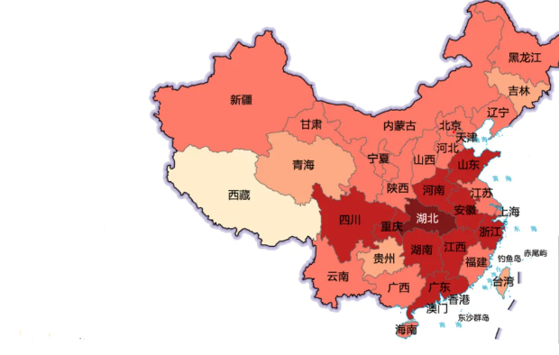
- 对一个省份的在某一天的感染人数进行概念分层，并给出各层的所对应的概念。
import matplotlib.pyplot
plt.rcParams['font.sans-serif'] = ['SimHei']
plt.rcParams['axes.unicode_minus'] = False
people=['10岁以下幼儿','10-20岁青年','20-40的家庭支柱','40-60中老年人','60-80已退休老人','80岁以后的耄耋长者']
year=[0,0,0,0,0,0]
for i in data.index:
if data.loc[i]['label'] in ['0-10']:
year[0]+=data.loc[i]['count']
if data.loc[i]['label'] in ['11-20']:
year[1]+=data.loc[i]['count']
if data.loc[i]['label'] in ['21-30','31-40']:
year[2]+=data.loc[i]['count']
if data.loc[i]['label'] in ['41-50','51-60']:
year[3]+=data.loc[i]['count']
if data.loc[i]['label'] in ['61-70','71-80']:
year[4]+=data.loc[i]['count']
if data.loc[i]['label'] in ['81-90','91-100']:
year[5]+=data.loc[i]['count']
plt.barh(people,year)
plt.show()
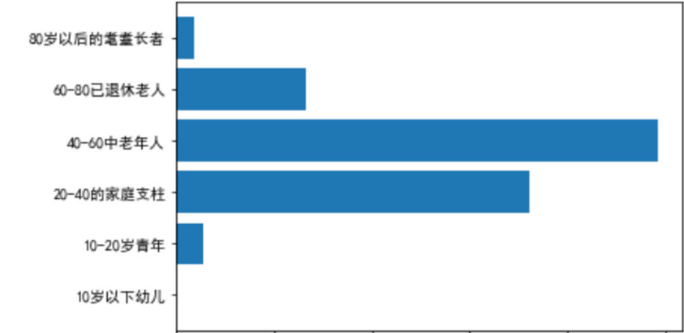
- 选择一个省份，分析感染人数、治愈人数随时间变化的趋势。
