实验五 关联规则-FP树
实验报告
3.1 使用Python实现FP树
from collections import OrderedDict
class treeNode:
def __init__(self, nameValue, numOccur, parentNode):
self.name = nameValue
self.count = numOccur
self.nodeLink = None
self.parent = parentNode
self.children = {}
def inc(self, numOccur):
self.count += numOccur
def disp(self, ind=1):
print(' ' * ind, self.name, ' ', self.count)
for child in self.children.values():
child.disp(ind + 1)

def loadSimpDat(a):
simpData = a
return simpData
def createInitSet(dataSet):
retDict=OrderedDict()
for trans in dataSet:
retDict[frozenset(trans)] = 1
return retDict

def createTree(dataSet, minSup=1):
headerTable = {}
for trans in dataSet:
for item in trans:
headerTable[item] = headerTable.get(item, 0) + dataSet[trans]
print("createTree 之前的 headerTable: ", headerTable)
print("之前的 headerTable's length: %s" % len(headerTable))

for k in list(headerTable.keys()):
if headerTable[k] < minSup:
del (headerTable[k])
print("createTree 删除不满足最小支持度的元素后 headerTable: ", headerTable)
print("删除不满足最小支持度的元素后 headerTable's length: %s" % len(headerTable))
freqItemSet = set(headerTable.keys())
if len(freqItemSet) == 0:
return None, None
for k in headerTable:
headerTable[k] = [headerTable[k], None]
retTree = treeNode('Null Set', 1, None) # create tree
for tranSet, count in dataSet.items():
print('tranSet, count=', tranSet, count)
localD = {}
for item in tranSet:
if item in freqItemSet:
localD[item] = headerTable[item][0]
if len(localD) > 0:
orderedItems = [v[0] for v in sorted(localD.items(), key=lambda p: p[1], reverse=True)]
updateTree(orderedItems, retTree, headerTable, count)
return retTree, headerTable

def updateTree(items, inTree, headerTable, count):
if items[0] in inTree.children:
inTree.children[items[0]].inc(count)
else:
inTree.children[items[0]] = treeNode(items[0], count, inTree)
if headerTable[items[0]][1] is None:
headerTable[items[0]][1] = inTree.children[items[0]]
else:
updateHeader(headerTable[items[0]][1], inTree.children[items[0]])
if len(items) > 1:
updateTree(items[1::], inTree.children[items[0]], headerTable, count)

def updateHeader(nodeToTest, targetNode):
while nodeToTest.nodeLink is not None:
nodeToTest = nodeToTest.nodeLink
nodeToTest.nodeLink = targetNode

def ascendTree(leafNode, prefixPath):
if leafNode.parent is not None:
prefixPath.append(leafNode.name)
ascendTree(leafNode.parent, prefixPath)

def findPrefixPath(basePat, treeNode):
condPats = {}
while treeNode is not None:
prefixPath = []
ascendTree(treeNode, prefixPath)
if len(prefixPath) > 1:
treeNode = treeNode.nodeLink
return condPats

def mineTree(inTree, headerTable, minSup, preFix, freqItemList):
bigL = [v[0] for v in sorted(headerTable.items(), key=lambda p: str(p[1]))]
print('-----', sorted(headerTable.items(), key=lambda p: p[1][0]))
print('bigL=', bigL)
for basePat in bigL:
newFreqSet = preFix.copy()
newFreqSet.add(basePat)
print('newFreqSet=', newFreqSet, preFix)

freqItemList.append(newFreqSet)
print('freqItemList=', freqItemList)

condPathBases = findPrefixPath(basePat, headerTable[basePat][1])
myCondTree, myHead = createTree(condPathBases, minSup)
print('myHead=', myHead)
if myHead is not None:
print('\n\n\n')
print('conditional tree for:', newFreqSet)
mineTree(myCondTree, myHead, minSup, newFreqSet, freqItemList)
print('\n\n\n')
3.2 选择其中三项挖掘频繁模式
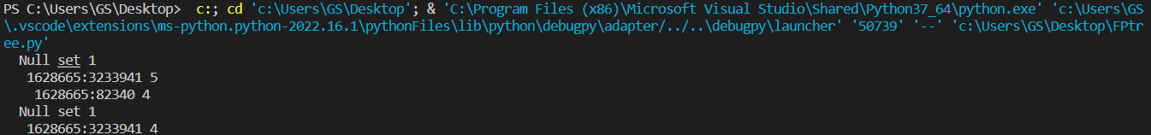
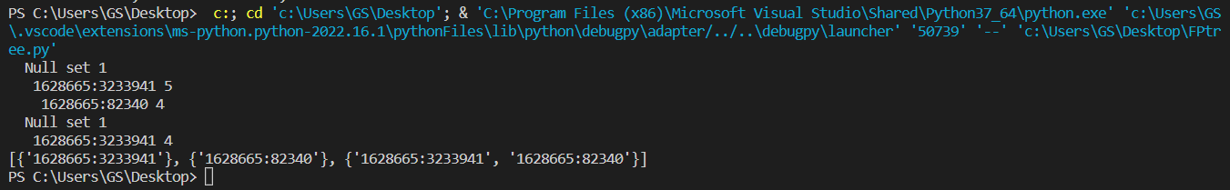
3.3 产生关联规则
{'1628665:3233941'}, {'1628665:82340'}, {'1628665:3233941', '1628665:82340'}
6.1、6.2 描述FP树的生成过程
第一次扫描数据，得到所有频繁一项集的的计数。然后删除支持度低于阈值的项，将频繁项集放入项头表，并按照支持度降序排列。接着第二次也是最后一次扫描数据，将读到的原始数据剔除非频繁项集，并按照支持度降序排列。
第二次扫描数据，对于每条数据剔除非频繁项集，并按照支持度降序排列。
通过两次扫描，项头表已经建立，排序后的数据集也已经得到了，开始FP树的建立。开始时FP树没有数据，建立FP树时我们一条条的读入排序后的数据集，插入FP树，插入时按照排序后的顺序，插入FP树中，排序靠前的节点是祖先节点，而靠后的是子孙节点。如果有共用的祖先，则对应的公用祖先节点计数加1。插入后，如果有新节点出现，则项头表对应的节点会通过节点链表链接上新节点。直到所有的数据都插入到FP树后，FP树的建立完成。

