实验六 决策树算法-ID3
实验报告
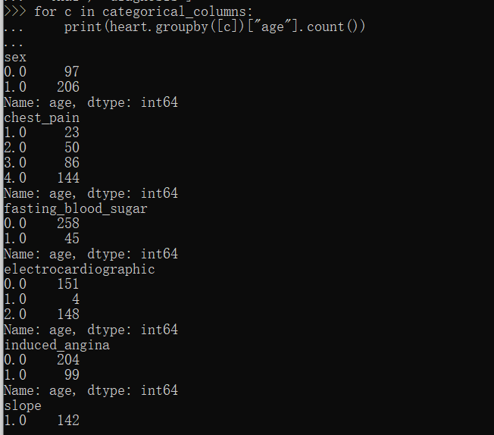
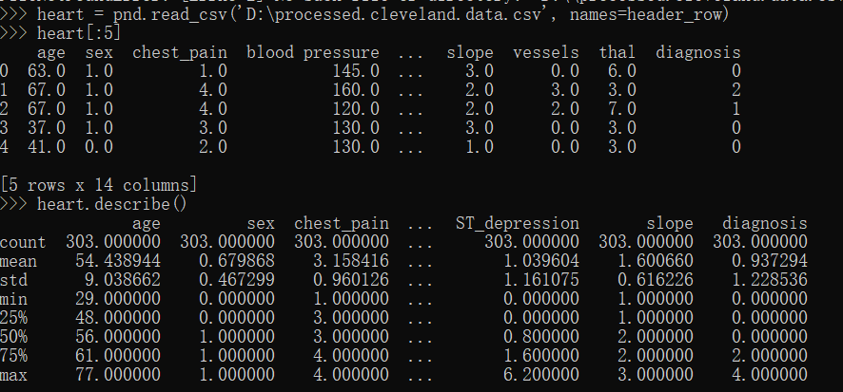
- 计算3个属性的信息增益

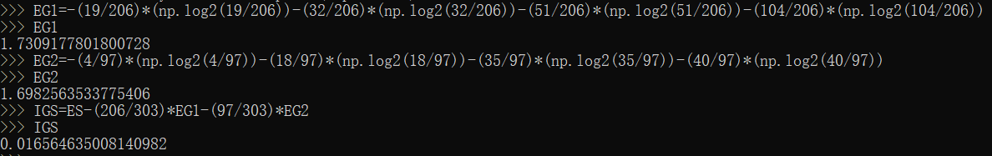
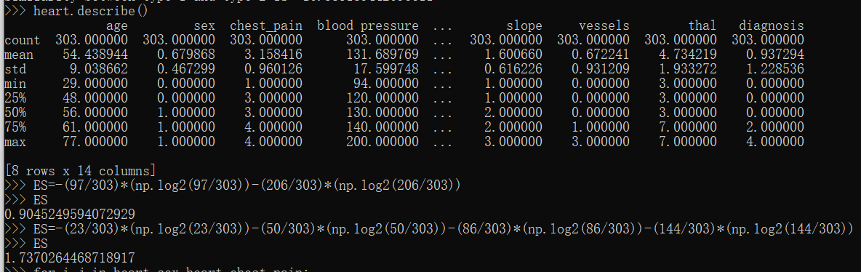
2. 描述ID3算法步骤
from math import log
import operator
import json
from utils.treeploter import *
def calcShannonEnt(dataSet):
numEntries = len(dataSet)
labelCounts = {}
for featVec in dataSet:
currentLabel = featVec[-1]
if currentLabel not in labelCounts.keys():
labelCounts[currentLabel] = 0
labelCounts[currentLabel] += 1
shannonEnt = 0.0
for key in labelCounts.keys():
prob = float(labelCounts[key]) / numEntries
shannonEnt = shannonEnt - prob * log(prob, 2)

return shannonEnt
def splitDataSet(dataSet, axis, value):
retDataSet = []
featVec = []
for featVec in dataSet:
if featVec[axis] == value:
reducedFeatVec = featVec[:axis]
reducedFeatVec.extend(featVec[axis + 1:])
retDataSet.append(reducedFeatVec)
return retDataSet
def chooseBestFeatureToSplit(dataSet):
numFeatures = len(dataSet[0]) - 1
baseEntropy = calcShannonEnt(dataSet)
bestInfoGain = 0.0
bestFeature = -1
for i in range(numFeatures):
featList = [example[i] for example in dataSet]
uniqueVals = set(featList)
newEntropy = 0.0
for value in uniqueVals:
subDataSet = splitDataSet(dataSet, i, value)
prob = len(subDataSet) / float(len(dataSet))
newEntropy += prob * calcShannonEnt(subDataSet)
infoGain = baseEntropy - newEntropy
if (infoGain > bestInfoGain):
bestInfoGain = infoGain
bestFeature = i
return bestFeature,bestInfoGain
def majorityCnt(classList):
classCount = {}
for vote in classList:
if vote not in classCount.keys(): classCount[vote] = 0
classCount[vote] += 1
sortedClassCount = sorted(classCount.iteritems(),
key=operator.itemgetter(1), reverse=True)
return sortedClassCount[0][0]

def createTree(dataSet, labels):
classList = [example[-1] for example in dataSet]
if classList.count(classList[0]) == len(classList):
return classList[0]
if len(dataSet[0]) == 1:
return majorityCnt(classList)
bestFeat,bestGain = chooseBestFeatureToSplit(dataSet)
bestFeatLabel = labels[bestFeat]
print("当前最佳属性%s,信息熵%f" % (bestFeatLabel,bestGain))
myTree = {bestFeatLabel: {}}
del (labels[bestFeat])
featValues = [example[bestFeat] for example in dataSet]
uniqueValue = set(featValues)
for value in uniqueValue:
subLabels = labels[:]
myTree[bestFeatLabel][value] = createTree(
splitDataSet(dataSet, bestFeat, value), subLabels)
return myTree

if __name__ == '__main__':

fr = open(r'data/text.txt')
listWm = [inst.strip().split(',')[1:] for inst in fr.readlines()[1:]]
# print(listWm)
fr.close()
fr = open(r'data/text.txt')
labels = fr.readlines()[0].split(',')[1:]
Trees = createTree(listWm, labels)
fr.close()
print(json.dumps(Trees, ensure_ascii=False))
createPlot(Trees)
3. 总结实验中遇到的问题及解决办法、心得、体会。
编写ID3算法构建决策树时，需要对各维度做汇总计数，计算各公式中出现的分母，同时为了构造最佳决策树，需要利用判断语句多次判别，采用递归法构建树枝，最终形成决策树。

