实验三：
RSA加密：
C++实现：
#include<iostream>
#include<typeinfo>
#include<sstream>
#include<cmath>
using namespace std;
typedef long long ll;

ll Quick_Multiply(ll a,ll b,ll c)
{
ll ans=0,res=a;
while(b)
{
if(b&1)
ans=(ans+res)%c;
res=(res+res)%c;
b>>=1;
}
return ans;
}

ll Quick_Power(ll a,ll b,ll c)
{
ll ans=1,res=a;
while(b)
{
if(b&1)
ans=Quick_Multiply(ans,res,c);
res=Quick_Multiply(res,res,c);
b>>=1;
}
return ans;
}

int main()
{
ll p,q,n,r,e,d = 1;
string plaintext,temp,hide,seek;
cout<<"请输入一个素数p:";
cin>>p;
cout<<"请输入另一个素数q:";
cin>>q;
n = p*q;
r = (p - 1)*(q - 1);
cout<<"r = (p - 1)*(q - 1) = "<<r<<endl;
cout<<"请输入和r互质的数e（e的范围是：1<e<r）:";
cin>>e;
cout<<"请输入一行英文文本作为plaintext:";
cin>>plaintext;
while(true)
{
d++;
if(Quick_Multiply(e,d,r)==1)
{
cout<<"d = "<<d<<endl;
break;
}
}
for(int i=0;i<plaintext.length();i++)
{
stringstream ss; //每次循环都需要初始化ss
int num = int(plaintext[i])-64;
//cout<<"num = "<<num<<endl;
ss<<num;
ss>>temp;
//cout<<"temp = "<<temp<<endl;
hide=hide+temp;
}
//cout<<"hide:"<<hide<<endl;
ll flag;
stringstream ss;
ss<<hide;
ss>>flag;
cout<<"plaintext:"<<flag<<endl;
//cout<<typeid(flag).name()<<endl;
ll encrypt = Quick_Power(flag,e,n);
cout<<"ciphertext:"<<encrypt<<endl;
ll decrypt = Quick_Power(encrypt,d,n);
cout<<"decrypt_ciphertext:"<<decrypt<<endl;
for(int i=0;i<hide.length();i++)
{
//cout<<hide[i]<<endl;
//cout<<int(hide[i])<<endl; 这里需要注意字符1的ASCII=49
stringstream ss;
int num = int(hide[i])+16;
//cout<<"num = "<<num<<endl;
char c = num;
//cout<<"temp = "<<temp<<endl;
seek=seek+c;
}
cout<<"decrypt_plaintext:"<<seek<<endl;
}
结果：
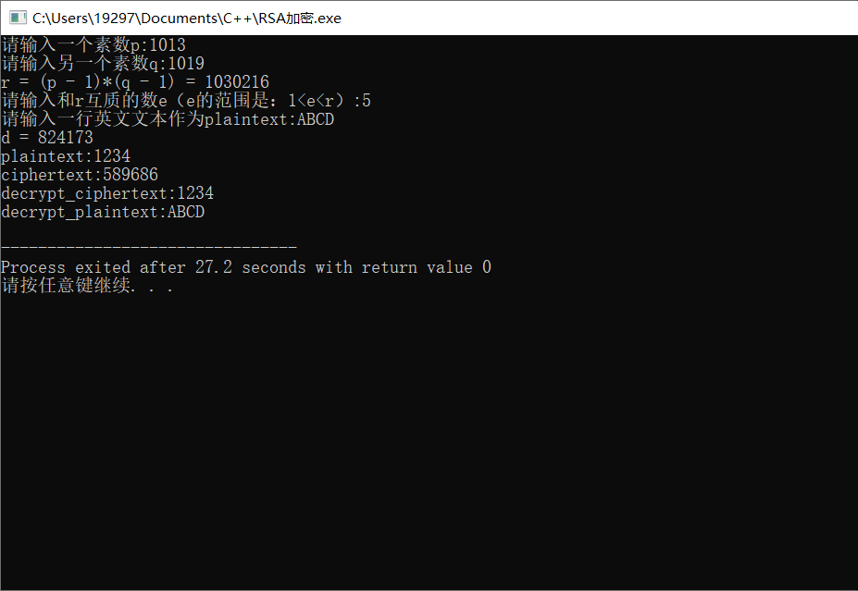
RSA解密：
Python实现：
import rsa

def rsa_encrypt(str):
(pubkey,privkey) = rsa.newkeys(512) # 最大加密长度
print("pubkey = ",pubkey)
print("privkey = ",privkey)
bytes = str.encode("utf-8") # str => bytes
ciphertext = rsa.encrypt(bytes, pubkey)
return (ciphertext, privkey)

def rsa_decrypt(bytes,privk):
plaintext = rsa.decrypt(bytes,privk)
plaintext = plaintext.decode("utf-8")
return plaintext

if __name__ == "__main__":
ciphertext,privk = rsa_encrypt("flag")
print("ciphertext:",ciphertext)
plaintext = rsa_decrypt(ciphertext,privk)
print("plaintext:",plaintext)
结果：
