## Задание 1

Console:

<==

joer@joer-VirtualBox:~/projects_eclipse/os_lab_2019/lab1/src$ ./background.sh &

[1] 9703

joer@joer-VirtualBox:~/projects_eclipse/os_lab_2019/lab1/src$ 1 sec

2 sec

3 sec

4 sec

5 sec

6 sec

7 sec

8 sec

9 sec

dasd10 sec

addaDone!

\dasdadda: command not found

[1]+ Done ./background.sh

==>

As you can see from the information in the console, the script was executed in a separate thread.

Console:

<==

joer@joer-VirtualBox:~/projects_eclipse/os_lab_2019/lab1$ mkdir my

joer@joer-VirtualBox:~/projects_eclipse/os_lab_2019/lab1$ cd my/

joer@joer-VirtualBox:~/projects_eclipse/os_lab_2019/lab1/my$ touch text

joer@joer-VirtualBox:~/projects_eclipse/os_lab_2019/lab1/my$ cat > text

First line

Second line

Upper spaces

And end of file

joer@joer-VirtualBox:~/projects_eclipse/os_lab_2019/lab1/my$ cat text

First line

Second line

Upper spaces

And end of file

==>

Console:

<==

joer@joer-VirtualBox:~/projects_eclipse/os_lab_2019/lab1/my$ wc text

6 10 58 text

==>

As we can see, text contains 10 worbs.

# Задание 2

Console:

<==

joer@joer-VirtualBox:~/projects_eclipse/os_lab_2019/lab1/src$ grep "cake" cake_rhymes.txt | cat > with_cake.txt

==>

For comparison:

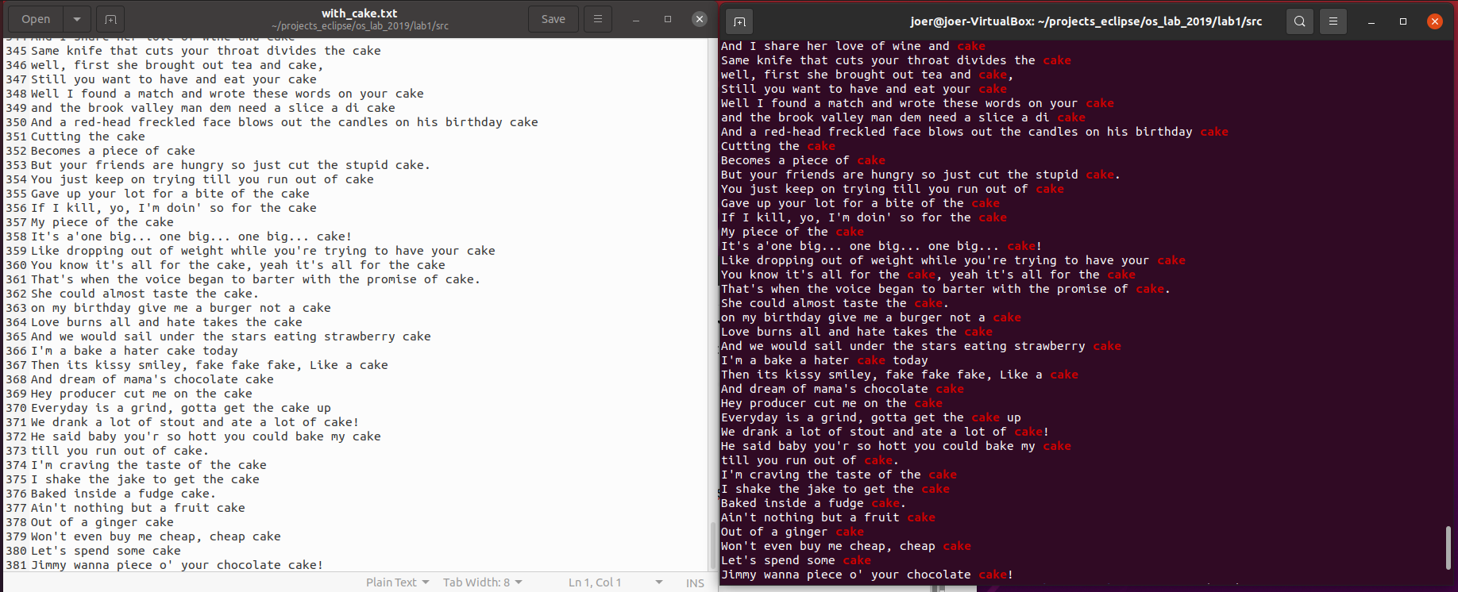

Console:

<==

joer@joer-VirtualBox:~/projects_eclipse/os_lab_2019/lab1/src$ rm file_for_delete > /dev/null

==>

We can move the threads of program in another threads like 2>&1 stderr to stdout 0 – stdin.

# Задание 3

Console: <==

joer@joer-VirtualBox:~/projects_eclipse/os_lab_2019/lab1/src$ chmod u+x hello.sh

joer@joer-VirtualBox:~/projects_eclipse/os_lab_2019/lab1/src$ ./hello.sh

Hello, world!

joer@joer-VirtualBox:~/projects_eclipse/os_lab_2019/lab1/src$ chmod u-x hello.sh

joer@joer-VirtualBox:~/projects_eclipse/os_lab_2019/lab1/src$ ./hello.sh

bash: ./hello.sh: Permission denied

==>

Set the execution flag and remove it.

Console: <==

joer@joer-VirtualBox:~/os_lab_2019/lab1/src$ touch script

joer@joer-VirtualBox:~/os_lab_2019/lab1/src$ chmod u+x script

joer@joer-VirtualBox:~/os_lab_2019/lab1/src$ cat > script

#!/bin/bash

echo "Current path: "

echo $PWD

echo "Current date: "

echo $(date)

echo $PATH

joer@joer-VirtualBox:~/os_lab_2019/lab1/src$ ./script

Current path:

/home/joer/os_lab_2019/lab1/src

Current date:

Пн 01 мар 2021 22:20:04 MSK

/usr/local/sbin:/usr/local/bin:/usr/sbin:/usr/bin:/sbin:/bin:/usr/games:/usr/local/games:/snap/bin

==>

# Задание 4*

average.sh:

<==

#!/bin/bash

cnt=0

sum=0

for num in $(cat $1)

do

sum=$(($sum + $num))

cnt=$(( $cnt + 1 ))

done

average=$(($sum/$cnt))

echo "Average is $average"

==>

<==

joer@joer-VirtualBox:~/os_lab_2019/lab1/src$ ./average.sh

12

12

12

Average is 12

joer@joer-VirtualBox:~/os_lab_2019/lab1/src$ ./average.sh

6

3

3

Average is 4

==>

<==

joer@joer-VirtualBox:~/os_lab_2019/lab1/src$ ./average.sh < numbers.txt

Average is 16401

==>