REGEX

Principles
Everything is essentially a character.
Writing patterns to match a specific sequence of characters.

Numbers and letters
\d in place of any digit from 0 to 9

Any character
. dot is a wildcard that can match any single character (letter, digit, whitespace).
\. to specifically match a period.

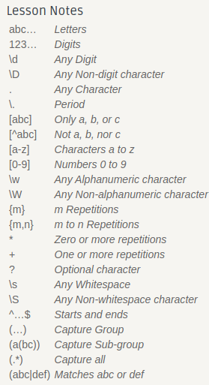
Match specifically
[] to match more specifically
[^] excluding specific characters

Ranges
[-] e [^-] ranges (specific upper or lower case)
\w any alphanumeric character

Repetitions
a{n} number n of repetitions for character a
a{n-n} range of repetitions for character a
ex: [wxy]{5} (five characters, each of which can be a w, x, or y)

Arbitrary number of characters
\d* to match any number of digits
\d+ which ensures at least one digit

Optional character
? ex: ab?c b is optional
\? to match real plain question mark

Whitespaces
space ␣ , tab \t , new line \n , carriage return \r
any whitespace \s

Starting and ending
^ (hat) for starting, $ (dollar sign) for ending sentence.

Groups () to capture any subpattern as a group
Nested groups (()) to extract multiple layers of information

All .*

Conditional
| (pipe) to denote different possible sets of characters.

Special characters
\D represents any non-digit character, \S any non-whitespace character,
\W any non-alphanumeric character (such as punctuation).
\b matches the boundary between a word and a non-word character.

