## AutoTrader

### Version 1.0

* **Requirements**

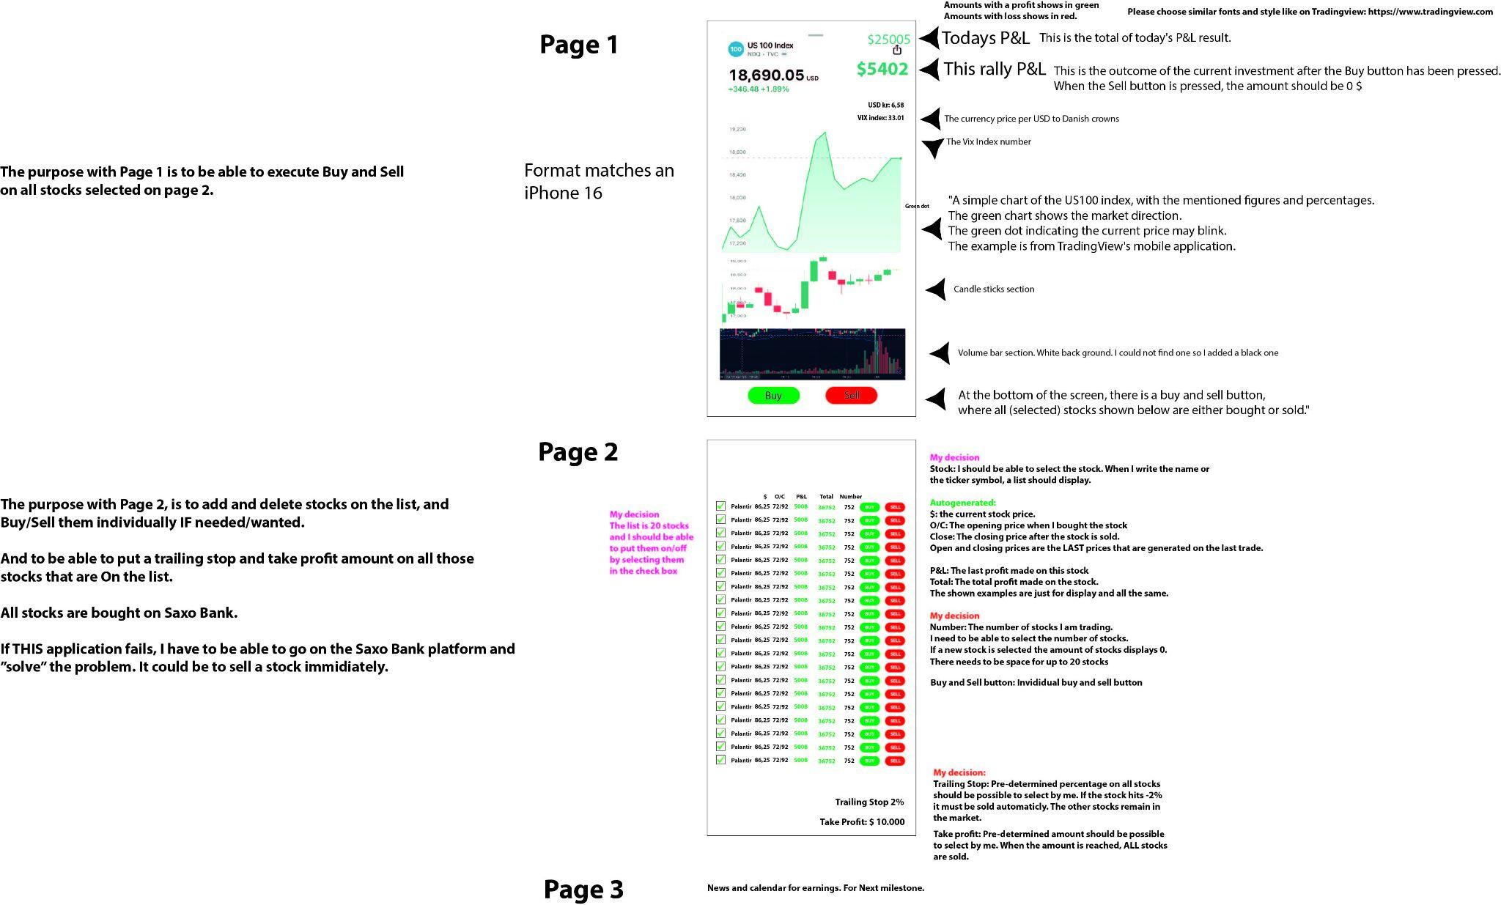

* It is important to me that I can easily pre-determine up to 20 stocks and sell and buy them with a few clicks. Which is the problem today on Saxo Bank and Interactive Brokers. I am using an iPhone 16 and I have made the layout in a way so it is easy for me to understand and operate

### Future Versions:

1. I would like if we somehow can set a general alarm with notice if a stock goes up or down more than ex 1 percent
2. There is one thing I need to add to the application. On each stock, the top and bottom traded price from the previous day. As a trader I need to be able to see when to buy and when to sell