Jubilee Marie Tantoy

Gabriel Angelo Guerrero

2ECE-D

**Machine Problem No. 1 – MATLAB**

CODE

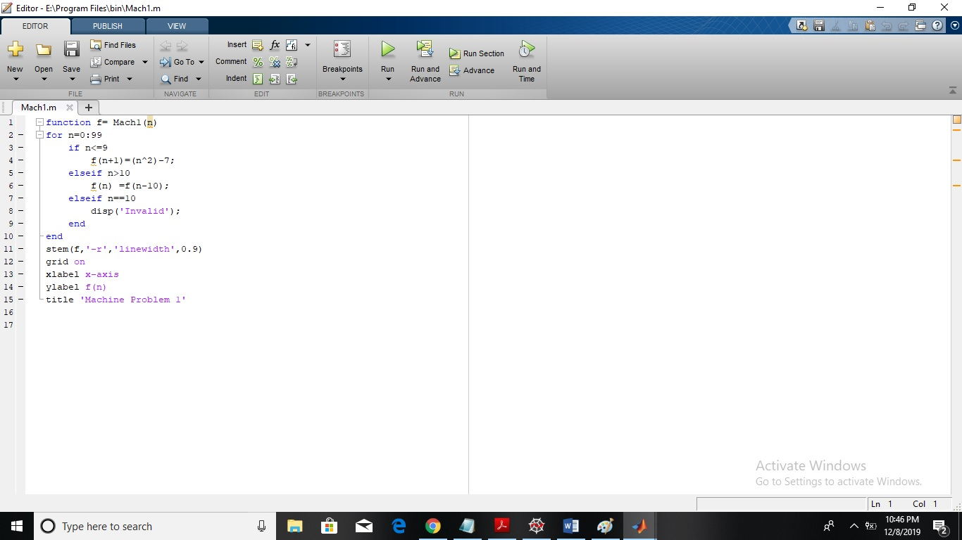

TRIAL: FIGURE

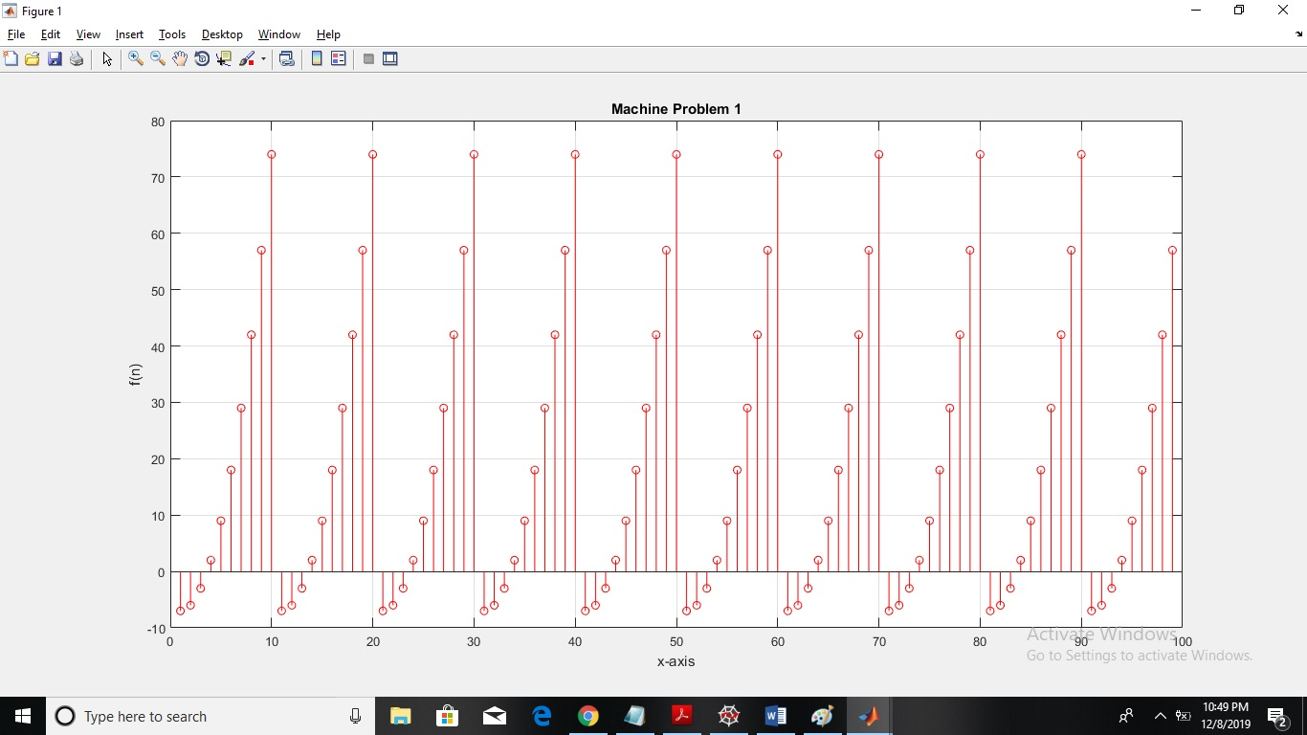

COMMENT:

In the piecewise function, the first equation is satisfied wherein the value n, ranges from 0 to 9. But as n equals to 10 or becomes greater than 10, the second equation is then satisfied. After that, as n having a new value, it goes back and is used in the first equation and will be used as a y value of that certain n.

Therefore, what is seen in the figure is the ten(10) points of each value from the range of n.