Jubilee Marie Tantoy

Gabriel Angelo Guerrero

2ECE-D

**Machine Problem No. 2 – MATLAB**

CODE

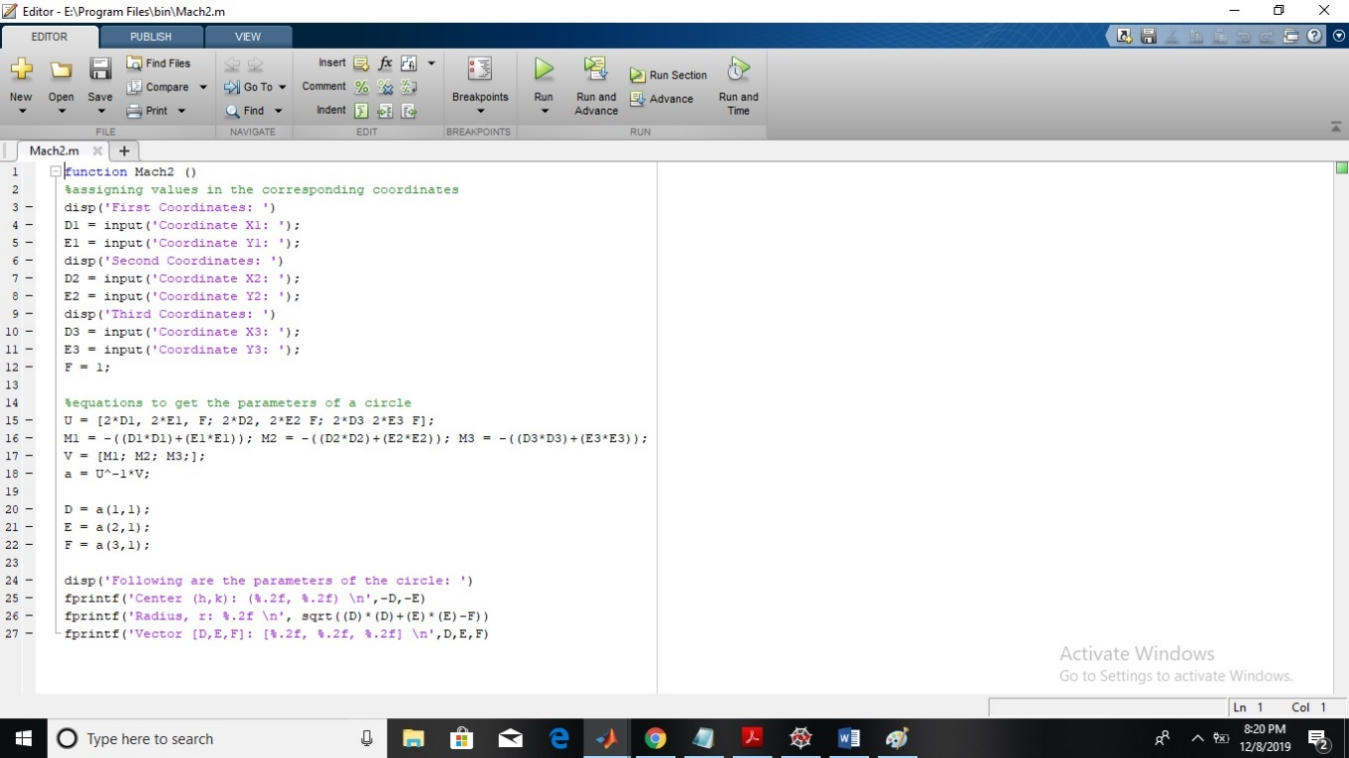

TRIAL

