Jubilee Marie Tantoy

Gabriel Angelo Guerrero

2ECE-D

**Machine Problem No. 2 – PYTHON**

CODE

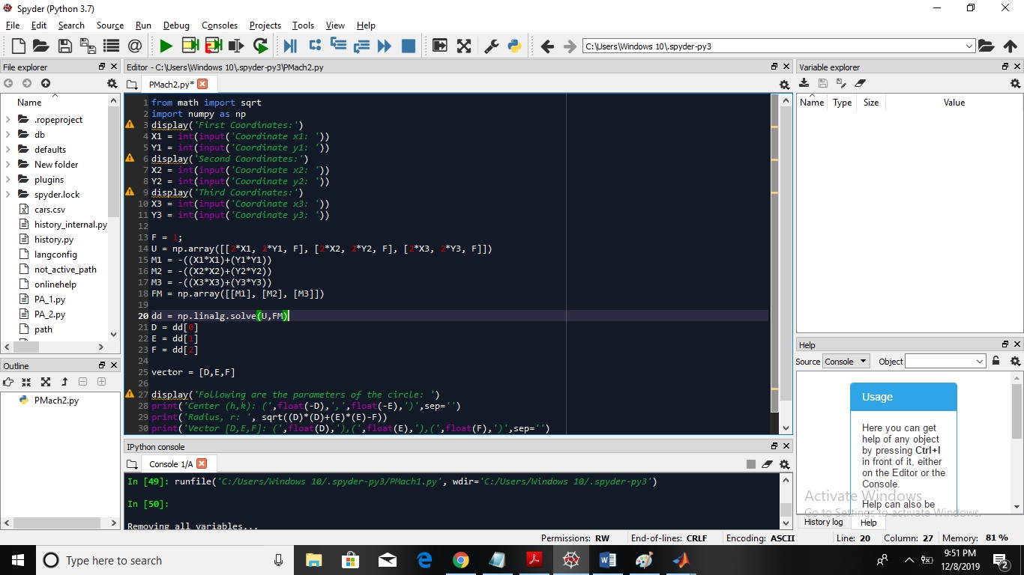

TRIAL

