Jubilee Marie Tantoy

Gabriel Angelo Guerrero

2ECE-D

**Machine Problem No. 3 – PYTHON**

CODE

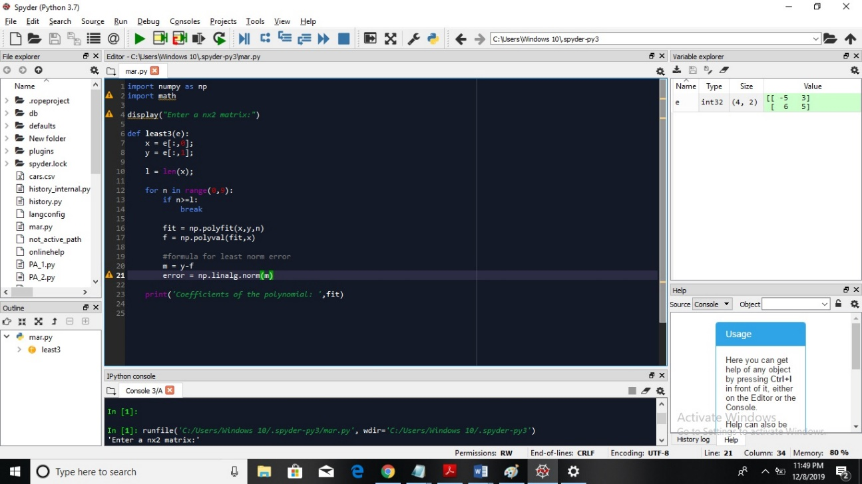

TRIAL:

