# EDA for Tel Aviv for Micro Mobility

* Check number of accidents per quarter
  + Compare to number of total accidents excluding micro mobility
  + Ratio of number accident
* Bicycle Path Length in relation to Quarter area.
  + Pearson Correlation between length of BP and number of accidents for each quarter
* Graph of number of accidents per quarter and total length of bicycle path in regards to time
  + Normalize by population in Tel Aviv
  + Scatter plot x is length of BP, y number of accidents.
    - One general scatter plot
    - Each quarter a specific plot
  + Scatter plot but with accidents that are severe
* Compare BP length to streets length

import matplotlib.pyplot as plt  
from shapely.geometry import Point  
import geopandas as gpd  
import pandas as pd  
import numpy as np  
from IPython.display import Image, display

### Loading Quarters Data

ta_q = gpd.read_file("./csv_tables/TA_Quaters_UTM/Quarters.shp")  
ta_q.oidrova = pd.to_numeric(ta_q.oidrova, downcast='integer')  
ta_q.krova = pd.to_numeric(ta_q.krova, downcast='integer')  
display(ta_q.crs)  
ta_q

<Projected CRS: EPSG:32636>  
Name: WGS 84 / UTM zone 36N  
Axis Info [cartesian]:  
- E[east]: Easting (metre)  
- N[north]: Northing (metre)  
Area of Use:  
- name: Between 30°E and 36°E, northern hemisphere between equator and 84°N, onshore and offshore. Belarus. Cyprus. Egypt. Ethiopia. Finland. Israel. Jordan. Kenya. Lebanon. Moldova. Norway. Russian Federation. Saudi Arabia. Sudan. Syria. Türkiye (Turkey). Uganda. Ukraine.  
- bounds: (30.0, 0.0, 36.0, 84.0)  
Coordinate Operation:  
- name: UTM zone 36N  
- method: Transverse Mercator  
Datum: World Geodetic System 1984 ensemble  
- Ellipsoid: WGS 84  
- Prime Meridian: Greenwich

oidrova krova dateimport ShapeArea \  
0 1 1 01/12/2015 02:28:14 1.301654e+07   
1 2 2 01/12/2015 02:28:14 8.013404e+06   
2 3 3 01/12/2015 02:28:14 3.380430e+06   
3 4 4 01/12/2015 02:28:14 4.510255e+06   
4 5 6 01/12/2015 02:28:14 2.089044e+06   
5 6 9 01/12/2015 02:28:14 7.879856e+06   
6 7 5 01/12/2015 02:28:14 3.024297e+06   
7 8 8 01/12/2015 02:28:14 3.420996e+06   
8 9 7 01/12/2015 02:28:14 6.343551e+06   
  
 geometry   
0 POLYGON ((670795.655 3555762.452, 670797.577 3...   
1 POLYGON ((672021.029 3553364.492, 672014.690 3...   
2 POLYGON ((668311.070 3552547.701, 668311.229 3...   
3 POLYGON ((670771.828 3552544.564, 670771.584 3...   
4 POLYGON ((668160.048 3550196.192, 668162.425 3...   
5 POLYGON ((668811.121 3546980.368, 668808.698 3...   
6 POLYGON ((666698.783 3550619.396, 666701.339 3...   
7 POLYGON ((667954.133 3548820.374, 667956.725 3...   
8 POLYGON ((665854.540 3548193.053, 665868.137 3...

#### Plotting Quarters

ta_q['index'] = ta_q.index  
  
# Define a list of colors  
color_map = {  
 1: 'red', 2: 'blue', 3: 'green', 4: 'purple',  
 5: 'orange', 6: 'yellow', 7: 'pink', 8: 'brown', 9: 'cyan'  
}  
  
# Basic plotting  
fig, ax = plt.subplots(figsize=(10, 10))  
  
# Plot each shape with a different color from the list  
for idx, row in ta_q.iterrows():  
 color = color_map[row['krova']] # Cycle through the colors list  
 gpd.GeoSeries([row['geometry']]).plot(ax=ax, color=color)  
  
 # Get the centroid of the polygon to place the text  
 centroid = row['geometry'].centroid  
 ax.annotate(text=row['krova'], xy=(centroid.x, centroid.y),   
 xytext=(3, 3), textcoords="offset points",  
 fontsize=24, color='black')  
  
plt.show()

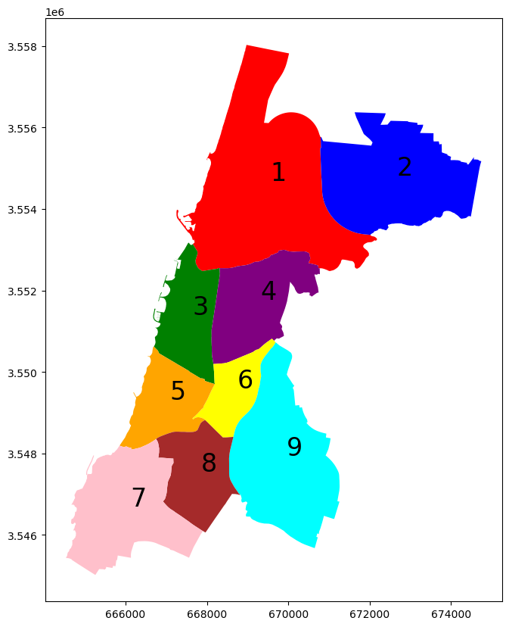

### Loading TA Accidents and TA Micro Mobility Accidents

# Exclude micro mobility  
BICYCLE = 15  
SCOOTER = 21  
E_BICYCLE = 23  
micro_m = [SCOOTER, E_BICYCLE, BICYCLE]

# Load original accident data  
i_m_h_ta_gdf = gpd.read_parquet('./csv_tables/i_m_h_ta_gdf.parquet')

# Accidents that are not MM  
i_m_h_ta_no_mm_gdf = i_m_h_ta_gdf[~(i_m_h_ta_gdf.involve_vehicle_type.isin(micro_m))].copy()

# Accidents that are just MM  
i_m_h_ta_mm_gdf = gpd.read_parquet('./csv_tables/i_m_h_ta_mm_gdf.parquet')  
display(i_m_h_ta_mm_gdf.crs)  
i_m_h_ta_mm_gdf.head(5)

<Projected CRS: EPSG:32636>  
Name: WGS 84 / UTM zone 36N  
Axis Info [cartesian]:  
- E[east]: Easting (metre)  
- N[north]: Northing (metre)  
Area of Use:  
- name: Between 30°E and 36°E, northern hemisphere between equator and 84°N, onshore and offshore. Belarus. Cyprus. Egypt. Ethiopia. Finland. Israel. Jordan. Kenya. Lebanon. Moldova. Norway. Russian Federation. Saudi Arabia. Sudan. Syria. Türkiye (Turkey). Uganda. Ukraine.  
- bounds: (30.0, 0.0, 36.0, 84.0)  
Coordinate Operation:  
- name: UTM zone 36N  
- method: Transverse Mercator  
Datum: World Geodetic System 1984 ensemble  
- Ellipsoid: WGS 84  
- Prime Meridian: Greenwich

accident_id provider_and_id provider_code file_type_police \  
41 2013001368 32013001368 3 3   
50 2013001742 32013001742 3 3   
131 2013001350 12013001350 1 1   
196 2013000147 12013000147 1 1   
197 2013000147 12013000147 1 1   
  
 involved_type involved_type_hebrew license_acquiring_date age_group \  
41 2 נהג נפגע 0 6   
50 2 נהג נפגע 0 7   
131 2 נהג נפגע 0 5   
196 2 נהג נפגע 0 8   
197 2 נהג נפגע 0 6   
  
 age_group_hebrew sex ... vehicle_attribution \  
41 25-29 1 ... 1.0   
50 30-34 2 ... 1.0   
131 20-24 1 ... 1.0   
196 35-39 1 ... 1.0   
197 25-29 1 ... 1.0   
  
 vehicle_attribution_hebrew seats total_weight total_weight_hebrew \  
41 ישראלי 99.0 0.0 לא ידוע   
50 ישראלי 99.0 0.0 לא ידוע   
131 ישראלי 99.0 0.0 לא ידוע   
196 ישראלי 99.0 0.0 לא ידוע   
197 ישראלי 99.0 0.0 לא ידוע   
  
 vehicle_damage vehicle_damage_hebrew urban_intersection \  
41 4.0 אין נזק NaN   
50 4.0 אין נזק NaN   
131 4.0 אין נזק NaN   
196 2.0 בינוני 9110323.0   
197 2.0 בינוני 9110323.0   
  
 accident_date geometry   
41 2013-07-27 01:00:00 POINT (667544.749 3549959.961)   
50 2013-10-07 01:30:00 POINT (667286.918 3548726.540)   
131 2013-08-25 01:00:00 POINT (667023.688 3548785.170)   
196 2013-09-19 00:00:00 POINT (668158.751 3551284.678)   
197 2013-09-19 00:00:00 POINT (668158.751 3551284.678)   
  
[5 rows x 162 columns]

#### Plotting accidents

fig, ax = plt.subplots(figsize=(10, 10))  
i_m_h_ta_mm_gdf.plot(ax=ax, color='red', marker='o', markersize=5 )  
plt.show()

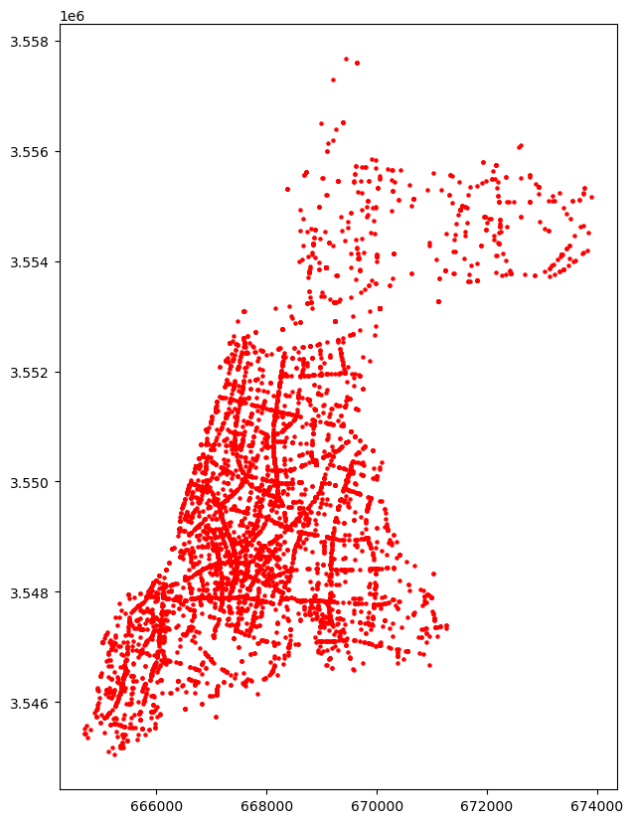

### Loading BP

bp_ta_bp_and_meta = gpd.read_parquet('./csv_tables/bp_ta_bp_and_meta.parquet')  
bp_ta_bp_and_meta.head(5)

oid_shvil msorech dateimport create_year \  
0 1 95.10 14/08/2024 02:30:05 2012   
1 2 201.14 14/08/2024 02:30:05 2013   
2 3 696.31 14/08/2024 02:30:05 2004   
3 4 659.20 14/08/2024 02:30:05 2018   
4 5 362.67 14/08/2024 02:30:05 2018   
  
 shemmikta create_date \  
0 נמיר מיוניצ'מן דרומה None   
1 פרופס מנמיר עד קדושי השואה None   
2 יאיר רוזנבלום מאורי צבי גרינברג עד פרופס None   
3 קק"ל מנמיר עד חיים לבנון None   
4 רקנאטי בגינה מקרן קיימת לישראל עד אחימאיר None   
  
 geometry width direction bitzua \  
0 LINESTRING (669823.985 3557373.860, 669855.549... 2.5 דו סטרי 2012   
1 LINESTRING (669232.834 3555478.027, 669169.381... 2.5 דו סטרי 2013   
2 LINESTRING (669232.637 3555478.023, 669249.025... 2.1 דו סטרי 2004   
3 LINESTRING (669354.261 3555417.055, 669410.178... 2.5 דו סטרי 2018   
4 LINESTRING (669946.350 3555344.516, 669962.261... 2.0 דו סטרי 2018   
  
 miflas date_created   
0 None None   
1 None None   
2 None None   
3 מדרכה None   
4 None 30/06/2018

#### Checking validity by lotting Quarters, Micro Mobility Accidents and BP

i_m_h_ta_mm_gdf.crs

<Projected CRS: EPSG:32636>  
Name: WGS 84 / UTM zone 36N  
Axis Info [cartesian]:  
- E[east]: Easting (metre)  
- N[north]: Northing (metre)  
Area of Use:  
- name: Between 30°E and 36°E, northern hemisphere between equator and 84°N, onshore and offshore. Belarus. Cyprus. Egypt. Ethiopia. Finland. Israel. Jordan. Kenya. Lebanon. Moldova. Norway. Russian Federation. Saudi Arabia. Sudan. Syria. Türkiye (Turkey). Uganda. Ukraine.  
- bounds: (30.0, 0.0, 36.0, 84.0)  
Coordinate Operation:  
- name: UTM zone 36N  
- method: Transverse Mercator  
Datum: World Geodetic System 1984 ensemble  
- Ellipsoid: WGS 84  
- Prime Meridian: Greenwich

#### Plotting accidents with BP and Quarters

fig, ax = plt.subplots(figsize=(10, 10))  
  
ta_q.plot(ax=ax, cmap='tab20', legend=True,)  
bp_ta_bp_and_meta.plot(ax=ax, color='blue', label='Specific Bicycle Path')  
i_m_h_ta_mm_gdf.plot(ax=ax, color='red', marker='o', markersize=5 )  
  
plt.legend()  
plt.show()

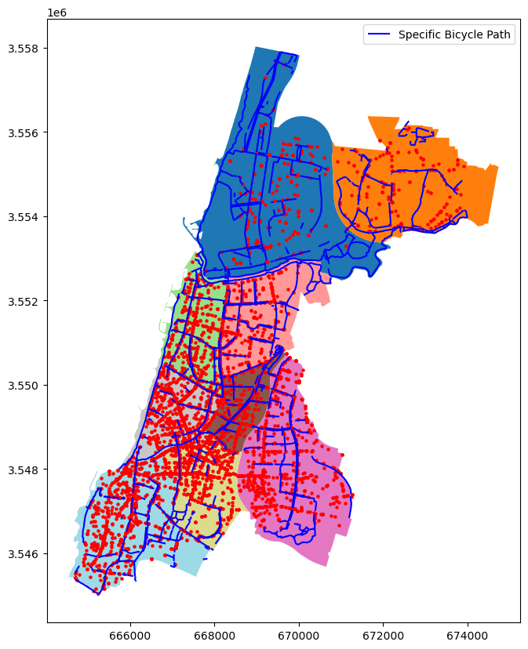

## Loading streets data

ta_streets = gpd.read_file('./csv_tables/TA_streets_20240724_031704/Streets.shp')  
ta_streets

oidrechov krechov trechov shemangli mslamas tsug \  
0 1.0 915.0 הרוגי מלכות HARUGEY MALKHOT 336.0 רחוב   
1 2.0 0.0 0 UKNOWN 0.0 רחוב   
2 3.0 265.0 אמסטרדם AMSTERDAM 516.0 רחוב   
3 4.0 644.0 אלון יגאל YIG'AL ALLON 2524.0 רחוב   
4 5.0 634.0 מרגולין MARGOLIN 2649.0 רחוב   
... ... ... ... ... ... ...   
8874 9851.0 3007.0 שבטי ישראל SHIVTEY YISRA'EL 1983.0 רחוב   
8875 9852.0 3058.0 אבינרי יצחק AVINERY 2027.0 רחוב   
8876 9853.0 3058.0 אבינרי יצחק AVINERY 2027.0 רחוב   
8877 9855.0 3907.0 3907 None 1703.0 רחוב   
8878 9857.0 34.0 מטלון MATALON 2327.0 רחוב   
  
 kkivun UniqueId shemarvit kreka \  
0 0.0 507-10001 قتل مملكة 100.0   
1 3.0 507-10002 None 100.0   
2 1.0 507-10003 أمستردام 100.0   
3 0.0 507-10004 ألون ييغال 200.0   
4 1.0 507-10005 مارغولين 100.0   
... ... ... ... ...   
8874 0.0 507-17843 قبائل إسرائيل 100.0   
8875 0.0 507-20562 Avinri Yitzhak 100.0   
8876 0.0 507-20563 Avinri Yitzhak 100.0   
8877 0.0 507-21960 3907 100.0   
8878 0.0 507-21966 ميتالون 100.0   
  
 geometry   
0 LINESTRING (672865.880 3554095.253, 672895.216...   
1 LINESTRING (666990.498 3551436.940, 667065.337...   
2 LINESTRING (667879.712 3551424.162, 667940.741...   
3 LINESTRING (669570.036 3550420.535, 669581.404...   
4 LINESTRING (669329.153 3548322.758, 669409.403...   
... ...   
8874 LINESTRING (665771.816 3547023.159, 665760.256...   
8875 LINESTRING (665585.719 3547178.152, 665627.936...   
8876 LINESTRING (665700.142 3547064.296, 665759.119...   
8877 LINESTRING (665087.059 3546677.092, 665075.120...   
8878 LINESTRING (666917.433 3548291.622, 666930.486...   
  
[8879 rows x 11 columns]

#### Checking street length validity with google maps

ta_streets[ta_streets.shemangli == 'MARGOLIN'].geometry.length.sum()

690.5226685950398

#### Plotting streets with BP and MM Accidents and Quarters

fig, ax = plt.subplots(figsize=(30, 30))  
  
ta_streets.plot(ax=ax, cmap='tab20', legend=True, label='Specific Bicycle Path')  
ta_q.plot(ax=ax, cmap='tab20', legend=True,)  
bp_ta_bp_and_meta.plot(ax=ax, color='blue', label='Specific Bicycle Path')  
i_m_h_ta_mm_gdf.plot(ax=ax, color='black', marker='o', markersize=15 )  
  
  
plt.legend()  
plt.show()

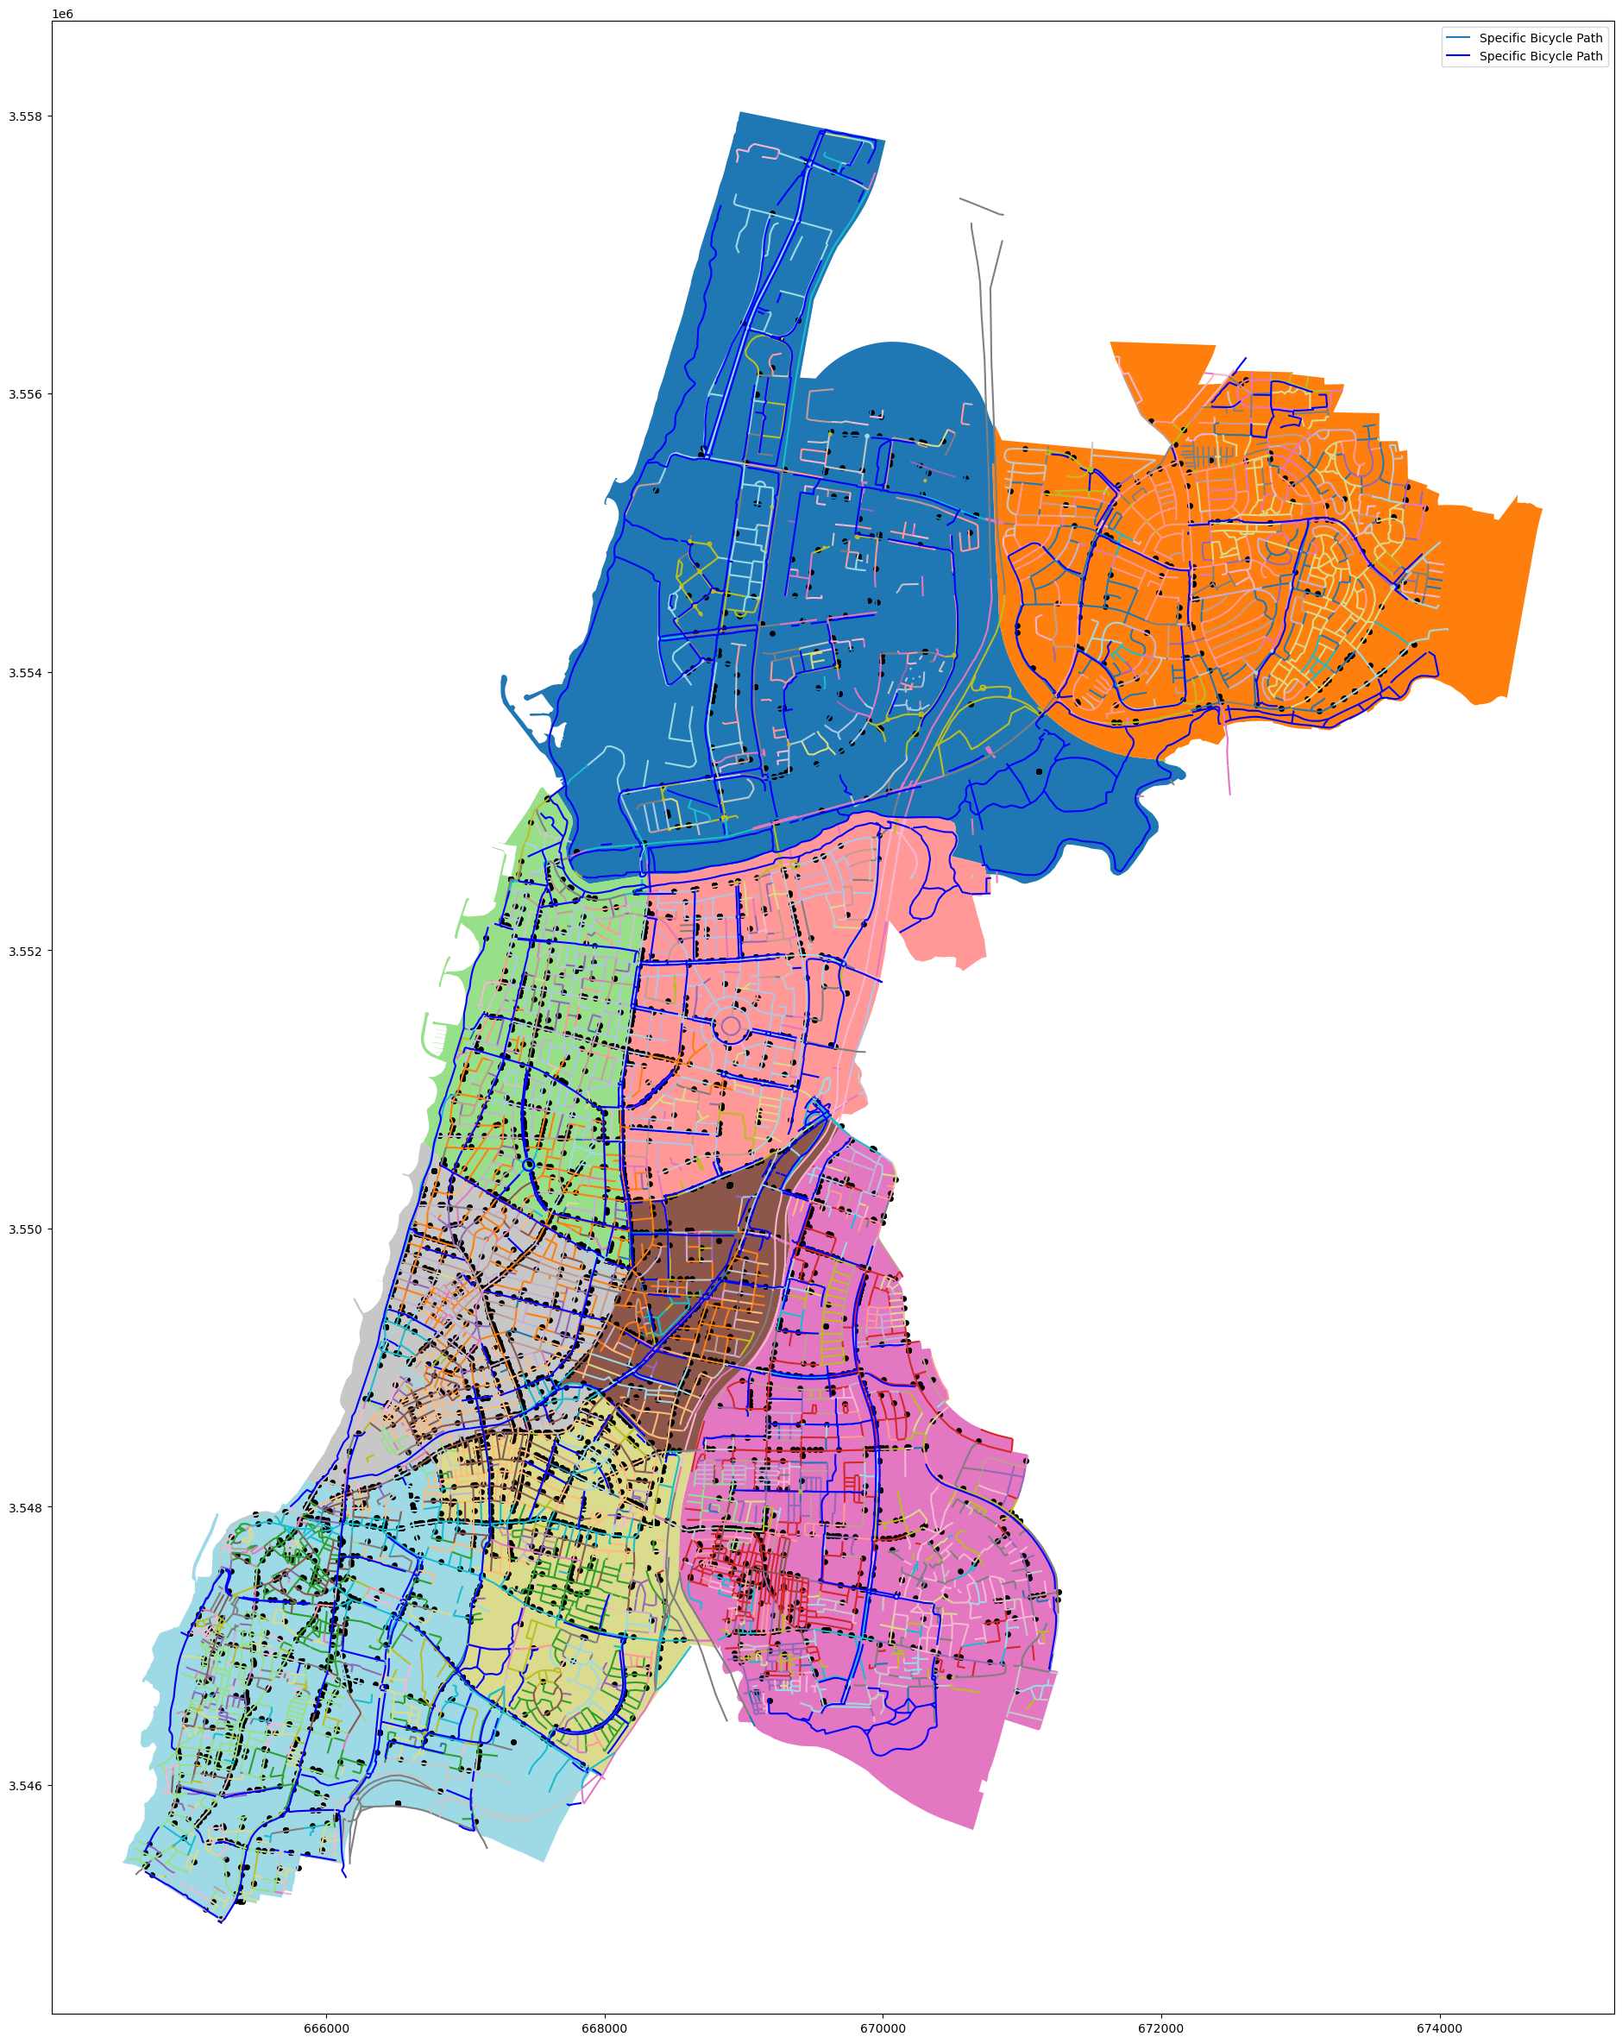

Length checks out OK

## Feature Engineering

**BP and Accidents**

Adding cumulative BP and Cumulative accidents for each quarter

for each quarter:

* Get the area of each quarter
* get the length of all the BP in the quarter
* get the length of all the streets in the quarter

**Streets**

Adding total streets length for each quarter

Side Note: I would do for each street but

* there is little data
* data regarding which street is open is missing I don't think plotting this will be beneficial

Pearson Correlation between length of BP and number of accidents for each quarter

bp_ta_bp_and_meta

oid_shvil msorech dateimport create_year \  
0 1 95.10 14/08/2024 02:30:05 2012   
1 2 201.14 14/08/2024 02:30:05 2013   
2 3 696.31 14/08/2024 02:30:05 2004   
3 4 659.20 14/08/2024 02:30:05 2018   
4 5 362.67 14/08/2024 02:30:05 2018   
.. ... ... ... ...   
866 462 197.41 14/08/2024 02:30:05 2014   
867 463 2112.94 14/08/2024 02:30:05 -1   
868 464 44.95 14/08/2024 02:30:05 -1   
869 465 112.12 14/08/2024 02:30:05 -1   
870 466 71.58 14/08/2024 02:30:05 -1   
  
 shemmikta create_date \  
0 נמיר מיוניצ'מן דרומה None   
1 פרופס מנמיר עד קדושי השואה None   
2 יאיר רוזנבלום מאורי צבי גרינברג עד פרופס None   
3 קק"ל מנמיר עד חיים לבנון None   
4 רקנאטי בגינה מקרן קיימת לישראל עד אחימאיר None   
.. ... ...   
866 שביל המוביל למרכז יצחק רבין None   
867 None None   
868 None None   
869 None None   
870 None None   
  
 geometry width direction \  
0 LINESTRING (669823.985 3557373.860, 669855.549... 2.5 דו סטרי   
1 LINESTRING (669232.834 3555478.027, 669169.381... 2.5 דו סטרי   
2 LINESTRING (669232.637 3555478.023, 669249.025... 2.1 דו סטרי   
3 LINESTRING (669354.261 3555417.055, 669410.178... 2.5 דו סטרי   
4 LINESTRING (669946.350 3555344.516, 669962.261... 2.0 דו סטרי   
.. ... ... ...   
866 LINESTRING (669777.502 3553114.882, 669733.916... NaN None   
867 LINESTRING (670193.904 3552876.389, 670151.903... NaN None   
868 LINESTRING (669398.890 3552674.103, 669398.284... NaN None   
869 LINESTRING (668324.626 3551551.690, 668319.918... NaN None   
870 LINESTRING (668433.941 3550240.154, 668441.188... NaN None   
  
 bitzua miflas date_created   
0 2012 None None   
1 2013 None None   
2 2004 None None   
3 2018 מדרכה None   
4 2018 None 30/06/2018   
.. ... ... ...   
866 2014 None None   
867 -1 None None   
868 -1 None None   
869 -1 None None   
870 -1 None None   
  
[871 rows x 12 columns]

### BP Feature Engineering

#### Creating Cumulative BP with Accidents and Quarter

bp_ta_bp_and_meta['bp_length'] = bp_ta_bp_and_meta.geometry.length

# get all the bp in a quarter  
bp_in_q = gpd.sjoin(bp_ta_bp_and_meta[['oid_shvil','shemmikta','bp_length','geometry','bitzua']], ta_q[['krova', 'geometry']], how='inner', predicate='intersects')  
  
# We have more rows then original bp_ta_bp_and_meta since we have duplication and since  
# since there are 47 duplicates(a bit ore then 5%) and most of them are on the same q, we can drop them  
bp_in_q = bp_in_q.drop_duplicates(subset=['bp_length'])  
bp_in_q

oid_shvil shemmikta bp_length \  
0 1 נמיר מיוניצ'מן דרומה 95.089688   
1 2 פרופס מנמיר עד קדושי השואה 201.128828   
2 3 יאיר רוזנבלום מאורי צבי גרינברג עד פרופס 696.261026   
3 4 קק"ל מנמיר עד חיים לבנון 659.153296   
4 5 רקנאטי בגינה מקרן קיימת לישראל עד אחימאיר 362.644518   
.. ... ... ...   
866 462 שביל המוביל למרכז יצחק רבין 197.392781   
867 463 None 2112.772412   
868 464 None 44.950912   
869 465 None 112.108111   
870 466 None 71.575372   
  
 geometry bitzua index_right \  
0 LINESTRING (669823.985 3557373.860, 669855.549... 2012 0   
1 LINESTRING (669232.834 3555478.027, 669169.381... 2013 0   
2 LINESTRING (669232.637 3555478.023, 669249.025... 2004 0   
3 LINESTRING (669354.261 3555417.055, 669410.178... 2018 0   
4 LINESTRING (669946.350 3555344.516, 669962.261... 2018 0   
.. ... ... ...   
866 LINESTRING (669777.502 3553114.882, 669733.916... 2014 0   
867 LINESTRING (670193.904 3552876.389, 670151.903... -1 3   
868 LINESTRING (669398.890 3552674.103, 669398.284... -1 3   
869 LINESTRING (668324.626 3551551.690, 668319.918... -1 3   
870 LINESTRING (668433.941 3550240.154, 668441.188... -1 4   
  
 krova   
0 1   
1 1   
2 1   
3 1   
4 1   
.. ...   
866 1   
867 4   
868 4   
869 4   
870 6   
  
[869 rows x 7 columns]

Making sure that BP that have no year of creation (bitzua) are unique and not actually related to other BP If they are unique, drop them.

bp_in_q[bp_in_q.oid_shvil.isin(bp_in_q[bp_in_q.bitzua == -1].oid_shvil)]

oid_shvil shemmikta bp_length \  
818 419 None 7.148114   
819 420 None 235.178823   
820 421 None 110.085315   
821 422 None 135.646550   
825 426 אינשטיין מלישנסקי עד הגשר 319.429381   
828 429 None 74.291330   
829 430 None 28.706871   
830 431 None 5.463124   
831 432 None 19.641170   
832 433 None 29.649964   
833 434 None 7.408510   
835 436 None 17.048499   
836 437 שניצר 435.287728   
837 438 None 55.722874   
838 439 קדושי השואה 554.091195   
839 440 None 9.411587   
840 441 None 7.802132   
841 442 None 6.917799   
842 443 None 7.652299   
849 449 None 24.925195   
851 451 None 237.200398   
858 456 הגדוד העברי מצ'לנוב עד הר ציון 172.749519   
862 458 None 157.466420   
864 460 חנה רובינא גדה דרומית 235.462831   
867 463 None 2112.772412   
868 464 None 44.950912   
869 465 None 112.108111   
870 466 None 71.575372   
  
 geometry bitzua index_right \  
818 LINESTRING (668405.407 3554224.806, 668398.271... -1 0   
819 LINESTRING (668328.569 3552403.104, 668215.470... -1 2   
820 LINESTRING (669671.803 3553011.534, 669678.363... -1 3   
821 LINESTRING (670743.348 3552413.244, 670743.408... -1 3   
825 LINESTRING (668722.847 3554258.059, 668645.585... -1 0   
828 LINESTRING (669114.211 3553307.829, 669119.029... -1 0   
829 LINESTRING (669139.697 3553260.352, 669168.290... -1 0   
830 LINESTRING (669177.650 3553267.796, 669173.921... -1 0   
831 LINESTRING (669171.699 3553253.385, 669172.367... -1 0   
832 LINESTRING (669174.747 3553223.387, 669162.198... -1 0   
833 LINESTRING (669138.878 3553222.759, 669133.694... -1 0   
835 LINESTRING (668727.210 3555599.430, 668722.695... -1 0   
836 LINESTRING (669177.008 3556117.864, 669172.205... -1 0   
837 LINESTRING (669137.693 3555857.832, 669096.634... -1 0   
838 LINESTRING (669077.515 3556061.715, 669071.257... -1 0   
839 LINESTRING (669006.054 3556456.529, 669014.758... -1 0   
840 LINESTRING (669026.431 3556449.754, 669034.124... -1 0   
841 LINESTRING (669018.101 3556491.192, 669024.660... -1 0   
842 LINESTRING (669037.420 3556484.549, 669044.631... -1 0   
849 LINESTRING (667330.906 3551499.313, 667306.793... -1 2   
851 LINESTRING (667372.545 3552078.483, 667454.736... -1 2   
858 LINESTRING (667661.811 3548450.710, 667698.700... -1 7   
862 LINESTRING (668569.064 3553991.289, 668557.508... -1 0   
864 LINESTRING (671517.200 3555437.604, 671521.514... -1 1   
867 LINESTRING (670193.904 3552876.389, 670151.903... -1 3   
868 LINESTRING (669398.890 3552674.103, 669398.284... -1 3   
869 LINESTRING (668324.626 3551551.690, 668319.918... -1 3   
870 LINESTRING (668433.941 3550240.154, 668441.188... -1 4   
  
 krova   
818 1   
819 3   
820 4   
821 4   
825 1   
828 1   
829 1   
830 1   
831 1   
832 1   
833 1   
835 1   
836 1   
837 1   
838 1   
839 1   
840 1   
841 1   
842 1   
849 3   
851 3   
858 8   
862 1   
864 2   
867 4   
868 4   
869 4   
870 6

# Making sure that not just oid is unique also name of bp  
bp_in_q[bp_in_q.shemmikta.isin(bp_in_q[bp_in_q.bitzua == -1].dropna().shemmikta)]

oid_shvil shemmikta bp_length \  
825 426 אינשטיין מלישנסקי עד הגשר 319.429381   
836 437 שניצר 435.287728   
838 439 קדושי השואה 554.091195   
858 456 הגדוד העברי מצ'לנוב עד הר ציון 172.749519   
864 460 חנה רובינא גדה דרומית 235.462831   
  
 geometry bitzua index_right \  
825 LINESTRING (668722.847 3554258.059, 668645.585... -1 0   
836 LINESTRING (669177.008 3556117.864, 669172.205... -1 0   
838 LINESTRING (669077.515 3556061.715, 669071.257... -1 0   
858 LINESTRING (667661.811 3548450.710, 667698.700... -1 7   
864 LINESTRING (671517.200 3555437.604, 671521.514... -1 1   
  
 krova   
825 1   
836 1   
838 1   
858 8   
864 2

Bitzua with -1 is unique so I drop them all.

bp_in_q_bitzua_no_na = bp_in_q[~bp_in_q.oid_shvil.isin(bp_in_q[bp_in_q.bitzua == -1].oid_shvil)].copy()  
bp_in_q_bitzua_no_na

oid_shvil shemmikta bp_length \  
0 1 נמיר מיוניצ'מן דרומה 95.089688   
1 2 פרופס מנמיר עד קדושי השואה 201.128828   
2 3 יאיר רוזנבלום מאורי צבי גרינברג עד פרופס 696.261026   
3 4 קק"ל מנמיר עד חיים לבנון 659.153296   
4 5 רקנאטי בגינה מקרן קיימת לישראל עד אחימאיר 362.644518   
.. ... ... ...   
860 457 יובל נאמן מלוי אשכול עד אייזיק שטרן 19.522751   
861 457 יובל נאמן מלוי אשכול עד אייזיק שטרן 135.518261   
863 459 יהודה עמיחי מיובל נאמן עד אייזיק שטרן 146.910140   
865 461 פארק גני יהושוע (רוקח) 325.943424   
866 462 שביל המוביל למרכז יצחק רבין 197.392781   
  
 geometry bitzua index_right \  
0 LINESTRING (669823.985 3557373.860, 669855.549... 2012 0   
1 LINESTRING (669232.834 3555478.027, 669169.381... 2013 0   
2 LINESTRING (669232.637 3555478.023, 669249.025... 2004 0   
3 LINESTRING (669354.261 3555417.055, 669410.178... 2018 0   
4 LINESTRING (669946.350 3555344.516, 669962.261... 2018 0   
.. ... ... ...   
860 LINESTRING (668688.687 3554091.847, 668685.107... 2024 0   
861 LINESTRING (668612.378 3554202.585, 668617.080... 2024 0   
863 LINESTRING (668685.107 3554072.655, 668682.157... 2024 0   
865 LINESTRING (670629.535 3553186.344, 670669.513... 2024 0   
866 LINESTRING (669777.502 3553114.882, 669733.916... 2014 0   
  
 krova   
0 1   
1 1   
2 1   
3 1   
4 1   
.. ...   
860 1   
861 1   
863 1   
865 1   
866 1   
  
[841 rows x 7 columns]

# Define the range for krova and bitzua  
krova_range = range(1, 10) # 1 to 9 inclusive  
bitzua_range = range(2000, 2025) # 2014 to 2023 inclusive  
  
# Create a MultiIndex  
index = pd.MultiIndex.from_product([krova_range, bitzua_range], names=['krova', 'bitzua'])  
  
# Create a DataFrame with the MultiIndex  
# Initialize with random data or zeros  
bp_krova = pd.DataFrame( index=index)  
bp_krova['bp_length'] = 0  
# Display the DataFrame  
bp_krova

bp_length  
krova bitzua   
1 2000 0  
 2001 0  
 2002 0  
 2003 0  
 2004 0  
... ...  
9 2020 0  
 2021 0  
 2022 0  
 2023 0  
 2024 0  
  
[225 rows x 1 columns]

# Ensure the DataFrame is sorted by 'krova' and 'year'  
bp_in_q_bitzua_no_na_sort = bp_in_q_bitzua_no_na.sort_values(by=['krova', 'bitzua'])  
  
# Calculate the cumulative sum  
bp_krova['bp_length'] = bp_in_q_bitzua_no_na_sort.groupby(['krova', 'bitzua'])['bp_length'].sum()  
  
bp_krova

bp_length  
krova bitzua   
1 2000 1431.567191  
 2001 NaN  
 2002 NaN  
 2003 NaN  
 2004 4713.852363  
... ...  
9 2020 2081.540059  
 2021 1509.641511  
 2022 537.031651  
 2023 171.426575  
 2024 NaN  
  
[225 rows x 1 columns]

bp_krova['cum_bp_length'] = bp_krova.groupby('krova')['bp_length'].cumsum()  
bp_krova

bp_length cum_bp_length  
krova bitzua   
1 2000 1431.567191 1431.567191  
 2001 NaN NaN  
 2002 NaN NaN  
 2003 NaN NaN  
 2004 4713.852363 6145.419554  
... ... ...  
9 2020 2081.540059 20832.869564  
 2021 1509.641511 22342.511075  
 2022 537.031651 22879.542727  
 2023 171.426575 23050.969302  
 2024 NaN NaN  
  
[225 rows x 2 columns]

# Forward fill NaN values with the previous non-NaN value for both columns  
bp_krova['bp_length'] = bp_krova['bp_length'].ffill()  
bp_krova['cum_bp_length'] = bp_krova['cum_bp_length'].ffill()  
  
# Display the updated DataFrame  
bp_krova

bp_length cum_bp_length  
krova bitzua   
1 2000 1431.567191 1431.567191  
 2001 1431.567191 1431.567191  
 2002 1431.567191 1431.567191  
 2003 1431.567191 1431.567191  
 2004 4713.852363 6145.419554  
... ... ...  
9 2020 2081.540059 20832.869564  
 2021 1509.641511 22342.511075  
 2022 537.031651 22879.542727  
 2023 171.426575 23050.969302  
 2024 171.426575 23050.969302  
  
[225 rows x 2 columns]

bp_krova.xs(4, level='krova')

bp_length cum_bp_length  
bitzua   
2000 3652.646051 3652.646051  
2001 3652.646051 3652.646051  
2002 904.620455 4557.266506  
2003 904.620455 4557.266506  
2004 5954.678368 10511.944875  
2005 5954.678368 10511.944875  
2006 5954.678368 10511.944875  
2007 5954.678368 10511.944875  
2008 5954.678368 10511.944875  
2009 5954.678368 10511.944875  
2010 5954.678368 10511.944875  
2011 5954.678368 10511.944875  
2012 1045.363666 11557.308541  
2013 502.869287 12060.177828  
2014 308.988817 12369.166646  
2015 308.988817 12369.166646  
2016 1701.036386 14070.203032  
2017 303.627379 14373.830411  
2018 1196.270724 15570.101135  
2019 451.048317 16021.149452  
2020 1264.659531 17285.808984  
2021 4489.535020 21775.344004  
2022 3023.563053 24798.907057  
2023 3023.563053 24798.907057  
2024 3023.563053 24798.907057

So we have

* bp length in each q over the years
* bp length cumulative in each q over the years
* q area

We also want number of accidents for each q over the years. For that I need:

* get the years of accidents in each q
* get the years of accidents for mm in in each q
* get the number of accidents in each q over the years
* get the number of mm accident in each q over the years

Then filter the bp_krova with the years.

Making sure we are not missing something in regards of years

# Spatial join of TA accidents and Quarters  
i_m_h_ta_quarters_gdf = gpd.sjoin(i_m_h_ta_gdf, ta_q[['krova', 'geometry']], how='inner', predicate='intersects')  
i_m_h_ta_no_mm_quarters_gdf = gpd.sjoin(i_m_h_ta_no_mm_gdf, ta_q[['krova', 'geometry']], how='inner', predicate='intersects')  
i_m_h_ta_mm_quarters_gdf = gpd.sjoin(i_m_h_ta_mm_gdf, ta_q[['krova', 'geometry']], how='inner', predicate='intersects')

#   
i_m_h_ta_q_gb_krova = pd.DataFrame(i_m_h_ta_quarters_gdf.groupby(['krova', 'accident_year']).size(), columns=['all_accident_cnt'])  
i_m_h_ta_no_mm_q_gb_krova = pd.DataFrame(i_m_h_ta_no_mm_quarters_gdf.groupby(['krova', 'accident_year']).size(),columns=['no_mm_accident_cnt'])  
i_m_h_ta_mm_q_gb_krova = pd.DataFrame(i_m_h_ta_mm_quarters_gdf.groupby(['krova', 'accident_year']).size(),columns=['mm_accident_cnt'])  
i_m_h_ta_q_gb_krova

all_accident_cnt  
krova accident_year   
1 2013 1399  
 2014 1109  
 2015 1289  
 2016 1159  
 2017 1108  
... ...  
9 2020 1094  
 2021 1157  
 2022 1187  
 2023 1088  
 2024 422  
  
[108 rows x 1 columns]

# trying to assign the accident_cnt to bp_krova  
bp_krova['all_acc_cnt'] = 0  
bp_krova['no_mm_acc_cnt'] = 0  
bp_krova['mm_acc_cnt'] = 0  
  
bp_krova['all_acc_cnt'] = i_m_h_ta_q_gb_krova['all_accident_cnt']  
bp_krova['no_mm_acc_cnt'] = i_m_h_ta_no_mm_q_gb_krova['no_mm_accident_cnt']  
bp_krova['mm_acc_cnt'] = i_m_h_ta_mm_q_gb_krova['mm_accident_cnt']  
bp_krova

bp_length cum_bp_length all_acc_cnt no_mm_acc_cnt \  
krova bitzua   
1 2000 1431.567191 1431.567191 NaN NaN   
 2001 1431.567191 1431.567191 NaN NaN   
 2002 1431.567191 1431.567191 NaN NaN   
 2003 1431.567191 1431.567191 NaN NaN   
 2004 4713.852363 6145.419554 NaN NaN   
... ... ... ... ...   
9 2020 2081.540059 20832.869564 1094.0 990.0   
 2021 1509.641511 22342.511075 1157.0 1042.0   
 2022 537.031651 22879.542727 1187.0 1067.0   
 2023 171.426575 23050.969302 1088.0 981.0   
 2024 171.426575 23050.969302 422.0 383.0   
  
 mm_acc_cnt   
krova bitzua   
1 2000 NaN   
 2001 NaN   
 2002 NaN   
 2003 NaN   
 2004 NaN   
... ...   
9 2020 104.0   
 2021 115.0   
 2022 120.0   
 2023 107.0   
 2024 39.0   
  
[225 rows x 5 columns]

bp_krova.xs(3, level='krova')

bp_length cum_bp_length all_acc_cnt no_mm_acc_cnt mm_acc_cnt  
bitzua   
2000 2393.581055 2393.581055 NaN NaN NaN  
2001 2393.581055 2393.581055 NaN NaN NaN  
2002 914.986474 3308.567529 NaN NaN NaN  
2003 914.986474 3308.567529 NaN NaN NaN  
2004 2527.949327 5836.516856 NaN NaN NaN  
2005 2527.949327 5836.516856 NaN NaN NaN  
2006 2527.949327 5836.516856 NaN NaN NaN  
2007 2527.949327 5836.516856 NaN NaN NaN  
2008 2527.949327 5836.516856 NaN NaN NaN  
2009 2527.949327 5836.516856 NaN NaN NaN  
2010 2527.949327 5836.516856 NaN NaN NaN  
2011 2527.949327 5836.516856 NaN NaN NaN  
2012 2608.205283 8444.722139 NaN NaN NaN  
2013 2608.205283 8444.722139 1153.0 1112.0 41.0  
2014 2608.205283 8444.722139 1050.0 971.0 79.0  
2015 2608.205283 8444.722139 1009.0 956.0 53.0  
2016 2608.205283 8444.722139 1077.0 986.0 91.0  
2017 2608.205283 8444.722139 944.0 856.0 88.0  
2018 257.426020 8702.148159 864.0 780.0 84.0  
2019 257.426020 8702.148159 726.0 631.0 95.0  
2020 1176.904473 9879.052632 636.0 552.0 84.0  
2021 4378.072371 14257.125003 654.0 550.0 104.0  
2022 1171.167498 15428.292501 600.0 521.0 79.0  
2023 1171.167498 15428.292501 506.0 441.0 65.0  
2024 1171.167498 15428.292501 211.0 180.0 31.0

# Filter the DataFrame to keep only rows where bitzua is 2013 or greater  
bp_krova_filtered = bp_krova.loc[bp_krova.index.get_level_values('bitzua') >= 2013].copy()  
  
# Display the filtered DataFrame  
bp_krova_filtered  
bp_krova_filtered.xs(3, level='krova')

bp_length cum_bp_length all_acc_cnt no_mm_acc_cnt mm_acc_cnt  
bitzua   
2013 2608.205283 8444.722139 1153.0 1112.0 41.0  
2014 2608.205283 8444.722139 1050.0 971.0 79.0  
2015 2608.205283 8444.722139 1009.0 956.0 53.0  
2016 2608.205283 8444.722139 1077.0 986.0 91.0  
2017 2608.205283 8444.722139 944.0 856.0 88.0  
2018 257.426020 8702.148159 864.0 780.0 84.0  
2019 257.426020 8702.148159 726.0 631.0 95.0  
2020 1176.904473 9879.052632 636.0 552.0 84.0  
2021 4378.072371 14257.125003 654.0 550.0 104.0  
2022 1171.167498 15428.292501 600.0 521.0 79.0  
2023 1171.167498 15428.292501 506.0 441.0 65.0  
2024 1171.167498 15428.292501 211.0 180.0 31.0

# Calculating Cum Sum  
bp_krova_filtered['cum_all_acc_cnt'] = bp_krova_filtered.groupby('krova')['all_acc_cnt'].cumsum()  
bp_krova_filtered['cum_no_mm_acc_cnt'] = bp_krova_filtered.groupby('krova')['no_mm_acc_cnt'].cumsum()  
bp_krova_filtered['cum_mm_acc_cnt'] = bp_krova_filtered.groupby('krova')['mm_acc_cnt'].cumsum()  
  
  
bp_krova_filtered

bp_length cum_bp_length all_acc_cnt no_mm_acc_cnt \  
krova bitzua   
1 2013 4613.175246 15716.611624 1399.0 1360.0   
 2014 758.026089 16474.637713 1109.0 1074.0   
 2015 2335.205547 18809.843260 1289.0 1244.0   
 2016 498.878369 19308.721628 1159.0 1114.0   
 2017 4680.392487 23989.114115 1108.0 1048.0   
... ... ... ... ...   
9 2020 2081.540059 20832.869564 1094.0 990.0   
 2021 1509.641511 22342.511075 1157.0 1042.0   
 2022 537.031651 22879.542727 1187.0 1067.0   
 2023 171.426575 23050.969302 1088.0 981.0   
 2024 171.426575 23050.969302 422.0 383.0   
  
 mm_acc_cnt cum_all_acc_cnt cum_no_mm_acc_cnt cum_mm_acc_cnt   
krova bitzua   
1 2013 39.0 1399.0 1360.0 39.0   
 2014 35.0 2508.0 2434.0 74.0   
 2015 45.0 3797.0 3678.0 119.0   
 2016 45.0 4956.0 4792.0 164.0   
 2017 60.0 6064.0 5840.0 224.0   
... ... ... ... ...   
9 2020 104.0 12306.0 11451.0 855.0   
 2021 115.0 13463.0 12493.0 970.0   
 2022 120.0 14650.0 13560.0 1090.0   
 2023 107.0 15738.0 14541.0 1197.0   
 2024 39.0 16160.0 14924.0 1236.0   
  
[108 rows x 8 columns]

# Calculating Ratio  
bp_krova_filtered['r_all_acc_bp_len'] = bp_krova_filtered['cum_all_acc_cnt'] / bp_krova_filtered['cum_bp_length']  
bp_krova_filtered['r_no_mm_acc_bp_len'] = bp_krova_filtered['cum_no_mm_acc_cnt'] / bp_krova_filtered['cum_bp_length']  
bp_krova_filtered['r_mm_acc_bp_len'] = bp_krova_filtered['cum_mm_acc_cnt'] / bp_krova_filtered['cum_bp_length']  
  
bp_krova_filtered

bp_length cum_bp_length all_acc_cnt no_mm_acc_cnt \  
krova bitzua   
1 2013 4613.175246 15716.611624 1399.0 1360.0   
 2014 758.026089 16474.637713 1109.0 1074.0   
 2015 2335.205547 18809.843260 1289.0 1244.0   
 2016 498.878369 19308.721628 1159.0 1114.0   
 2017 4680.392487 23989.114115 1108.0 1048.0   
... ... ... ... ...   
9 2020 2081.540059 20832.869564 1094.0 990.0   
 2021 1509.641511 22342.511075 1157.0 1042.0   
 2022 537.031651 22879.542727 1187.0 1067.0   
 2023 171.426575 23050.969302 1088.0 981.0   
 2024 171.426575 23050.969302 422.0 383.0   
  
 mm_acc_cnt cum_all_acc_cnt cum_no_mm_acc_cnt cum_mm_acc_cnt \  
krova bitzua   
1 2013 39.0 1399.0 1360.0 39.0   
 2014 35.0 2508.0 2434.0 74.0   
 2015 45.0 3797.0 3678.0 119.0   
 2016 45.0 4956.0 4792.0 164.0   
 2017 60.0 6064.0 5840.0 224.0   
... ... ... ... ...   
9 2020 104.0 12306.0 11451.0 855.0   
 2021 115.0 13463.0 12493.0 970.0   
 2022 120.0 14650.0 13560.0 1090.0   
 2023 107.0 15738.0 14541.0 1197.0   
 2024 39.0 16160.0 14924.0 1236.0   
  
 r_all_acc_bp_len r_no_mm_acc_bp_len r_mm_acc_bp_len   
krova bitzua   
1 2013 0.089014 0.086533 0.002481   
 2014 0.152234 0.147742 0.004492   
 2015 0.201862 0.195536 0.006326   
 2016 0.256672 0.248178 0.008494   
 2017 0.252781 0.243444 0.009338   
... ... ... ...   
9 2020 0.590701 0.549660 0.041041   
 2021 0.602573 0.559158 0.043415   
 2022 0.640310 0.592669 0.047641   
 2023 0.682748 0.630819 0.051928   
 2024 0.701055 0.647435 0.053620   
  
[108 rows x 11 columns]

### Quarters Feature Engineering

#### Polygone Area

# area of each quarter  
ta_q['area'] = ta_q.geometry.area  
ta_q

oidrova krova dateimport ShapeArea \  
0 1 1 01/12/2015 02:28:14 1.301654e+07   
1 2 2 01/12/2015 02:28:14 8.013404e+06   
2 3 3 01/12/2015 02:28:14 3.380430e+06   
3 4 4 01/12/2015 02:28:14 4.510255e+06   
4 5 6 01/12/2015 02:28:14 2.089044e+06   
5 6 9 01/12/2015 02:28:14 7.879856e+06   
6 7 5 01/12/2015 02:28:14 3.024297e+06   
7 8 8 01/12/2015 02:28:14 3.420996e+06   
8 9 7 01/12/2015 02:28:14 6.343551e+06   
  
 geometry index area   
0 POLYGON ((670795.655 3555762.452, 670797.577 3... 0 1.301456e+07   
1 POLYGON ((672021.029 3553364.492, 672014.690 3... 1 8.012438e+06   
2 POLYGON ((668311.070 3552547.701, 668311.229 3... 2 3.379848e+06   
3 POLYGON ((670771.828 3552544.564, 670771.584 3... 3 4.509556e+06   
4 POLYGON ((668160.048 3550196.192, 668162.425 3... 4 2.088708e+06   
5 POLYGON ((668811.121 3546980.368, 668808.698 3... 5 7.878684e+06   
6 POLYGON ((666698.783 3550619.396, 666701.339 3... 6 3.023758e+06   
7 POLYGON ((667954.133 3548820.374, 667956.725 3... 7 3.420414e+06   
8 POLYGON ((665854.540 3548193.053, 665868.137 3... 8 6.342357e+06

### Streets Feature Engineering

#### Getting Streets Length and Cumulative Length

ta_streets['street_length'] = ta_streets.geometry.length  
ta_streets

oidrechov krechov trechov shemangli mslamas tsug \  
0 1.0 915.0 הרוגי מלכות HARUGEY MALKHOT 336.0 רחוב   
1 2.0 0.0 0 UKNOWN 0.0 רחוב   
2 3.0 265.0 אמסטרדם AMSTERDAM 516.0 רחוב   
3 4.0 644.0 אלון יגאל YIG'AL ALLON 2524.0 רחוב   
4 5.0 634.0 מרגולין MARGOLIN 2649.0 רחוב   
... ... ... ... ... ... ...   
8874 9851.0 3007.0 שבטי ישראל SHIVTEY YISRA'EL 1983.0 רחוב   
8875 9852.0 3058.0 אבינרי יצחק AVINERY 2027.0 רחוב   
8876 9853.0 3058.0 אבינרי יצחק AVINERY 2027.0 רחוב   
8877 9855.0 3907.0 3907 None 1703.0 רחוב   
8878 9857.0 34.0 מטלון MATALON 2327.0 רחוב   
  
 kkivun UniqueId shemarvit kreka \  
0 0.0 507-10001 قتل مملكة 100.0   
1 3.0 507-10002 None 100.0   
2 1.0 507-10003 أمستردام 100.0   
3 0.0 507-10004 ألون ييغال 200.0   
4 1.0 507-10005 مارغولين 100.0   
... ... ... ... ...   
8874 0.0 507-17843 قبائل إسرائيل 100.0   
8875 0.0 507-20562 Avinri Yitzhak 100.0   
8876 0.0 507-20563 Avinri Yitzhak 100.0   
8877 0.0 507-21960 3907 100.0   
8878 0.0 507-21966 ميتالون 100.0   
  
 geometry street_length   
0 LINESTRING (672865.880 3554095.253, 672895.216... 32.805562   
1 LINESTRING (666990.498 3551436.940, 667065.337... 75.559350   
2 LINESTRING (667879.712 3551424.162, 667940.741... 63.283401   
3 LINESTRING (669570.036 3550420.535, 669581.404... 25.979540   
4 LINESTRING (669329.153 3548322.758, 669409.403... 80.262574   
... ... ...   
8874 LINESTRING (665771.816 3547023.159, 665760.256... 29.466544   
8875 LINESTRING (665585.719 3547178.152, 665627.936... 164.959426   
8876 LINESTRING (665700.142 3547064.296, 665759.119... 82.717053   
8877 LINESTRING (665087.059 3546677.092, 665075.120... 31.021221   
8878 LINESTRING (666917.433 3548291.622, 666930.486... 43.847359   
  
[8879 rows x 12 columns]

ta_streets.length.value_counts()

32.805562 1  
20.102087 1  
63.825799 1  
31.448977 1  
46.092444 1  
 ..  
90.687522 1  
102.406872 1  
107.858034 1  
120.822715 1  
43.847359 1  
Name: count, Length: 8879, dtype: int64

Since each length is unique we will use it to drop any duplicates

Getting streets in each Quarter

streets_in_q = gpd.sjoin(ta_streets[['oidrechov','trechov','shemangli','kkivun', 'geometry','street_length']], ta_q[['krova', 'geometry']], how='inner', predicate='intersects')  
streets_in_q

oidrechov trechov shemangli kkivun \  
0 1.0 הרוגי מלכות HARUGEY MALKHOT 0.0   
1 2.0 0 UKNOWN 3.0   
2 3.0 אמסטרדם AMSTERDAM 1.0   
3 4.0 אלון יגאל YIG'AL ALLON 0.0   
4 5.0 מרגולין MARGOLIN 1.0   
... ... ... ... ...   
8874 9851.0 שבטי ישראל SHIVTEY YISRA'EL 0.0   
8875 9852.0 אבינרי יצחק AVINERY 0.0   
8876 9853.0 אבינרי יצחק AVINERY 0.0   
8877 9855.0 3907 None 0.0   
8878 9857.0 מטלון MATALON 0.0   
  
 geometry street_length \  
0 LINESTRING (672865.880 3554095.253, 672895.216... 32.805562   
1 LINESTRING (666990.498 3551436.940, 667065.337... 75.559350   
2 LINESTRING (667879.712 3551424.162, 667940.741... 63.283401   
3 LINESTRING (669570.036 3550420.535, 669581.404... 25.979540   
4 LINESTRING (669329.153 3548322.758, 669409.403... 80.262574   
... ... ...   
8874 LINESTRING (665771.816 3547023.159, 665760.256... 29.466544   
8875 LINESTRING (665585.719 3547178.152, 665627.936... 164.959426   
8876 LINESTRING (665700.142 3547064.296, 665759.119... 82.717053   
8877 LINESTRING (665087.059 3546677.092, 665075.120... 31.021221   
8878 LINESTRING (666917.433 3548291.622, 666930.486... 43.847359   
  
 index_right krova   
0 1 2   
1 2 3   
2 2 3   
3 5 9   
4 5 9   
... ... ...   
8874 8 7   
8875 8 7   
8876 8 7   
8877 8 7   
8878 7 8   
  
[9100 rows x 8 columns]

# Dropping duplicates  
streets_in_q = streets_in_q.drop_duplicates(subset=['street_length'])  
streets_in_q

oidrechov trechov shemangli kkivun \  
0 1.0 הרוגי מלכות HARUGEY MALKHOT 0.0   
1 2.0 0 UKNOWN 3.0   
2 3.0 אמסטרדם AMSTERDAM 1.0   
3 4.0 אלון יגאל YIG'AL ALLON 0.0   
4 5.0 מרגולין MARGOLIN 1.0   
... ... ... ... ...   
8874 9851.0 שבטי ישראל SHIVTEY YISRA'EL 0.0   
8875 9852.0 אבינרי יצחק AVINERY 0.0   
8876 9853.0 אבינרי יצחק AVINERY 0.0   
8877 9855.0 3907 None 0.0   
8878 9857.0 מטלון MATALON 0.0   
  
 geometry street_length \  
0 LINESTRING (672865.880 3554095.253, 672895.216... 32.805562   
1 LINESTRING (666990.498 3551436.940, 667065.337... 75.559350   
2 LINESTRING (667879.712 3551424.162, 667940.741... 63.283401   
3 LINESTRING (669570.036 3550420.535, 669581.404... 25.979540   
4 LINESTRING (669329.153 3548322.758, 669409.403... 80.262574   
... ... ...   
8874 LINESTRING (665771.816 3547023.159, 665760.256... 29.466544   
8875 LINESTRING (665585.719 3547178.152, 665627.936... 164.959426   
8876 LINESTRING (665700.142 3547064.296, 665759.119... 82.717053   
8877 LINESTRING (665087.059 3546677.092, 665075.120... 31.021221   
8878 LINESTRING (666917.433 3548291.622, 666930.486... 43.847359   
  
 index_right krova   
0 1 2   
1 2 3   
2 2 3   
3 5 9   
4 5 9   
... ... ...   
8874 8 7   
8875 8 7   
8876 8 7   
8877 8 7   
8878 7 8   
  
[8860 rows x 8 columns]

Getting total street length in each Quarter

street_length_in_q = pd.DataFrame(streets_in_q.groupby('krova').street_length.sum())  
street_length_in_q

street_length  
krova   
1 98179.376498  
2 110005.705942  
3 64029.796480  
4 58038.417663  
5 67338.855129  
6 34954.056247  
7 119412.634977  
8 76179.594682  
9 133933.606790

## Exploration that should be done before diving deep into analyzing

### Quarter Comparison Analysis

#### 1. **Compare Quarter Area:**

* **With Bike Path (BP) Length:**
  + Identify which quarters have more BP infrastructure.by number of BP and or total length.
* **With Number of BPs:**
  + Compare against accident counts.
* **With Street Length:**
  + Plotting number of streets in each Quarter
  + **Against BP Length and Number of BPs:**
    - Assess infrastructure investment relative to BP coverage.
  + **Against Number of Accidents:**
    - Evaluate the effectiveness of BP infrastructure in reducing accidents.
    - **Including Accident Severity:**
      * Identify quarters that are more hazardous beyond just accident frequency.

#### 2. **Compare Number of Accidents:**

* Determine which quarters are most hazardous.
* **Including Accident Severity:**
  + Identify quarters that are more hazardous beyond just accident frequency.

### Additional Analyses

* **Street Density:**
  + Investigate quarters with high street density and proximity of streets.
  + Examine correlation with accident frequency.

This version keeps all the details but streamlines the structure for clarity.

* Absolute numbers of total accidents in districts compared to absolute numbers of micromobility accidents.
* Normalization: Number of micromobility accidents compared to the length of bike paths.
* Ratio of micromobility accidents to the total number of accidents (to understand whether the trend in each district is specific to micromobility).
* In each district: Ratio of the length of bike paths relative to the area (over time).

1. ☐ Check Pearson correlation between the length of bike paths and the number of accidents.
2. ☐ In each district, for each year - calculate the ratio of the number of accidents to the length of bike paths for each year, and present a histogram.
3. ☐ In each district, for each year, we have a data point for the number of accidents and the length of bike paths. Draw a scatter plot showing the length of the paths on the x-axis and the number of accidents on the y-axis.
   * It is possible to present one general scatter plot and one for each district.
4. ☐ Create a similar graph to point 3 but with the number of severe accidents (serious + fatal).
5. ☐ Download historical road network data from Open Street Maps (sample each year).

## Analyzing the data. plotting etc

### Identify which quarters have more BP infrastructure.by number of BP and or total length.

#### Which Quarter has a larger number of BP in it?

#### Plotting functions

def plot_bar_chart(x_data, y_data, title, x_label, y_label, decimal_places=2):  
 """  
 Plot a bar chart with the given data and labels.  
  
 Parameters:  
 - x_data (list or array): The data for the x-axis.  
 - y_data (list or array): The data for the y-axis.  
 - title (str): The title of the plot.  
 - x_label (str): The label for the x-axis.  
 - y_label (str): The label for the y-axis.  
 - decimal_places (int): The number of decimal places to round the y-values to. Default is 2.  
 """  
 # Create the bar plot  
 plt.figure(figsize=(8, 6))  
 bars = plt.bar(x_data, y_data, color='blue')  
 plt.xlabel(x_label)  
 plt.ylabel(y_label)  
 plt.title(title)  
  
 # Add the count above each bar, rounded to the specified number of decimal places  
 for bar in bars:  
 yval = round(bar.get_height(), decimal_places)  
 plt.text(bar.get_x() + bar.get_width()/2, bar.get_height(), str(yval), ha='center', va='bottom')  
  
 # Set x-ticks to match the 'krova' labels  
 plt.xticks(x_data)  
  
 plt.tight_layout()  
 plt.show()

# Grouping by 'krova' and counting occurrences  
bp_count_in_q = bp_in_q['krova'].value_counts().reset_index()  
bp_count_in_q.columns = ['krova', 'count']  
plot_bar_chart(bp_count_in_q['krova'], bp_count_in_q['count'], 'Number of BP in Each Quarter', 'Krova', 'Number of BP')

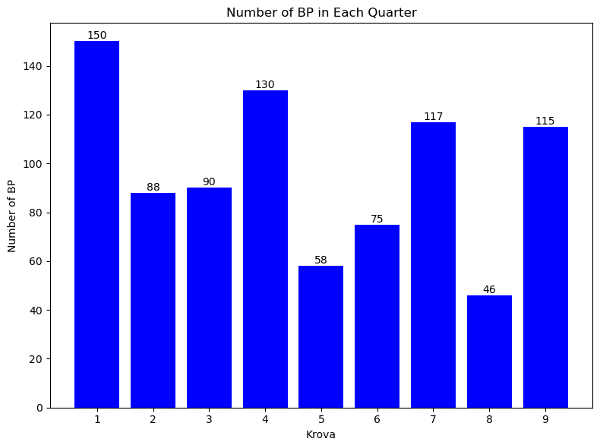

#### Which Quarter has more BP in total length

bp_sum_df = pd.DataFrame(bp_in_q.groupby('krova').bp_length.sum())  
bp_sum_df.bp_length = bp_sum_df.bp_length.astype('int32')  
  
plot_bar_chart(bp_sum_df.index, bp_sum_df['bp_length'], 'Total length of BP in each Quarter', 'Krova', 'Total length of BP')

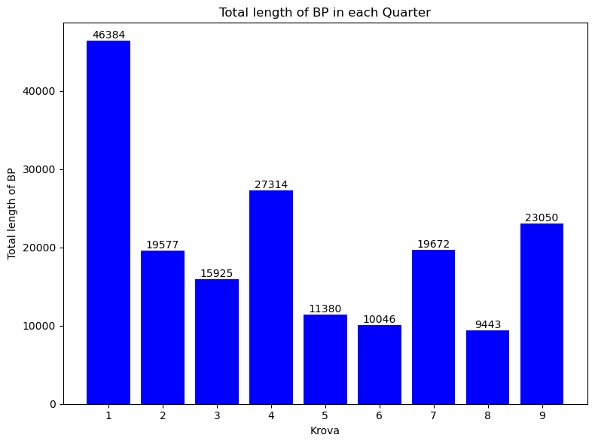

Conclusions:

Quarter 1 has the highest number of individual BP and the most BP length by more than twice the second place. Quarter 4 and 9 are second and third respectively.

I would expect to see Quarter 1 to have the least amount of accidents of all the quarters.

#### Plotting number of Micro Mobility accidents in each Quarter

mm_accidents_count_krova = i_m_h_ta_mm_quarters_gdf['krova'].value_counts().reset_index()  
plot_bar_chart(mm_accidents_count_krova['krova'], mm_accidents_count_krova['count'], 'Number of Micro Mobility accidents in Each Krova', 'Krova', 'Number of Micro Mobility accidents')

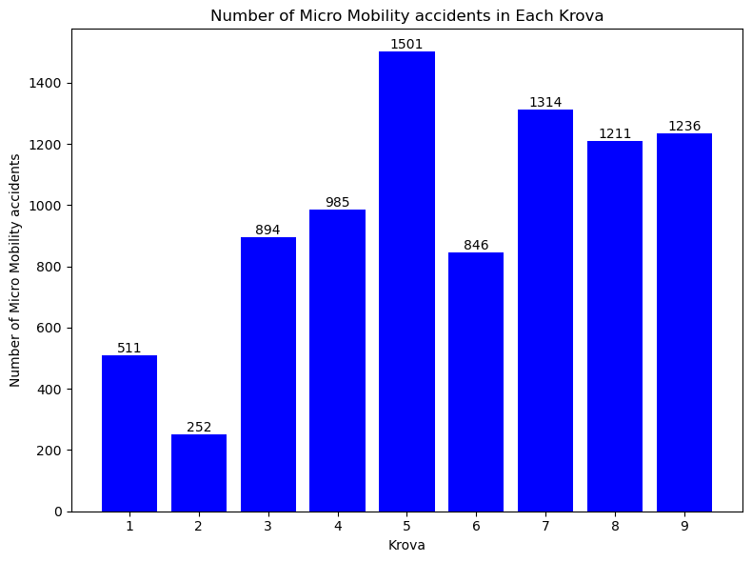

Conclusions:

We see that Quarter 1 does not have the lowest number of accidents, it is the second place. Quarter 2 has the lowest by a large margine

The quarter with the highest number of MM accidents is 5.

#### Plotting number of accidents that are not Micro Mobility in each quarter

no_mm_accidents_count_krova = i_m_h_ta_no_mm_quarters_gdf['krova'].value_counts().reset_index()  
plot_bar_chart(no_mm_accidents_count_krova['krova'], no_mm_accidents_count_krova['count'], 'Number of accidents that are not Micro Mobility in Each Krova', 'Krova', 'Number of accidents that are not Micro Mobility')

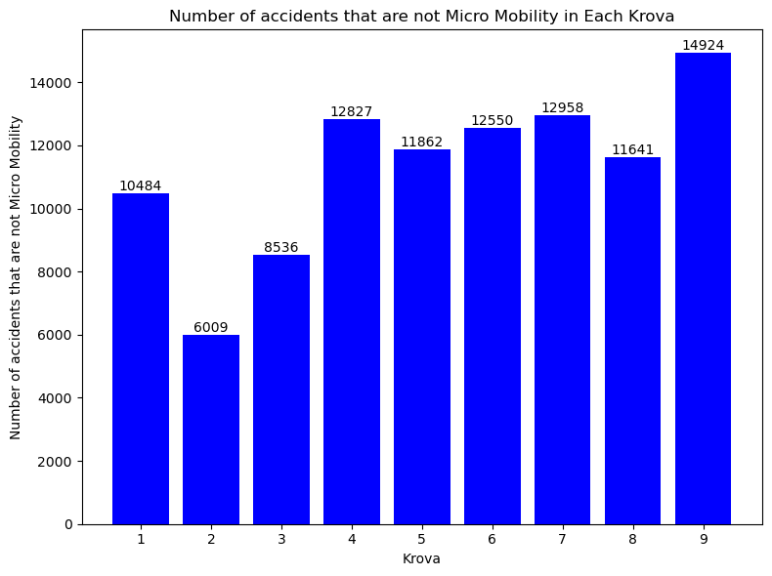

Conclusion:

Quarter 9 has the highest number of accidents that are not micro mobility

Quarter 1 has the 4th lowest.

The lowest is Quarter 2 by a large difference to the second place Q 3 by around 30%.

#### Plotting number of streets in each Quarter

streets_in_krova = streets_in_q['krova'].value_counts().reset_index()  
plot_bar_chart(streets_in_krova['krova'], streets_in_krova['count'], 'Number of streets in Each Krova', 'Krova', 'Number of streets')

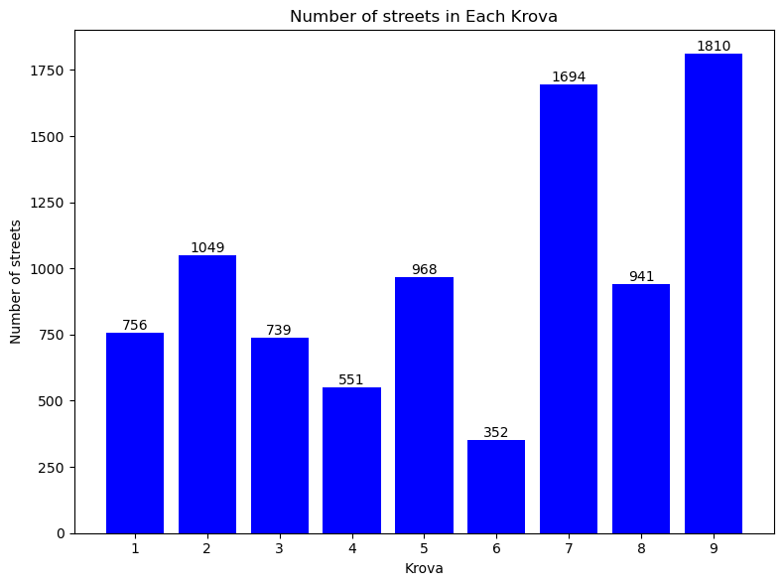

#### Plotting total length of streets in each Quarter

streets_length_sum_df = pd.DataFrame(streets_in_q.groupby('krova').street_length.sum())  
streets_length_sum_df.street_length = streets_length_sum_df.street_length.astype('int32')  
plot_bar_chart(streets_length_sum_df.index, streets_length_sum_df['street_length'], 'Total Streets Length in each Quarter', 'Krova', 'Streets Length Sum')

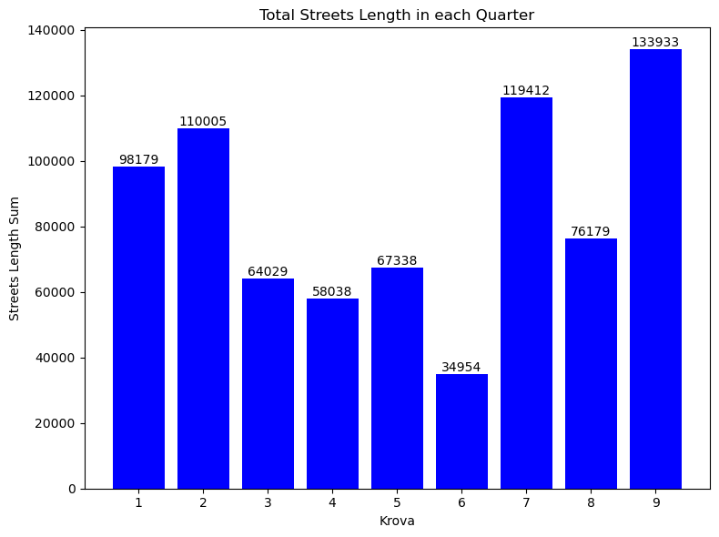

#### Plotting total streets length in relation to quarter area

krova_values = streets_in_krova.sort_values(by='krova')['krova'].values  
street_total_length_krova_area_ratio_ls = (streets_length_sum_df['street_length'].to_list()/ ta_q.sort_values(by='krova').area).to_list()  
total_length_streets_krova_share = pd.DataFrame(street_total_length_krova_area_ratio_ls,columns=['street_ln_share_in_q'], index=krova_values)  
  
plot_bar_chart(total_length_streets_krova_share.index, total_length_streets_krova_share['street_ln_share_in_q'], 'krova', 'Total Streets Length share in Quarter','Total Streets Length',6 )

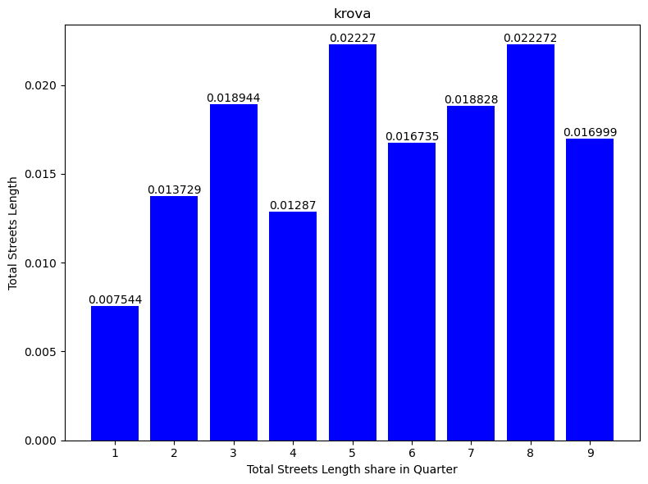

#### Plotting number of BP in relation to Quarter area

krova_values = streets_in_krova.sort_values(by='krova')['krova'].values  
bp_total_length_krova_area_ratio_ls = (bp_sum_df['bp_length'].to_list()/ ta_q.sort_values(by='krova').area).to_list()  
bp_total_length_krova_area_ratio_ls  
bp_total_length_krova_share = pd.DataFrame(bp_total_length_krova_area_ratio_ls,columns=['bp_ln_share_in_q'], index=krova_values)  
  
plot_bar_chart(bp_total_length_krova_share.index, bp_total_length_krova_share['bp_ln_share_in_q'], 'krova', 'Total BP Length share in Quarter','Total BP Length',6 )

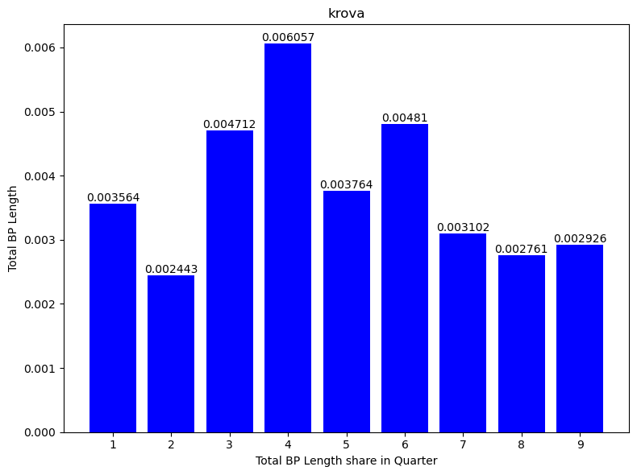

#### Plotting Number of BP in relation to number of streets in each quarter

#### Plotting BP total length in relation to Streets total length in each quarter

#### Plotting avg street width in each quarter

#### Plotting accidents severity for MM and no MM in each quarter.

#### Plotting number of accidents per quarter through the years.

#### **Compare Quarter Area:**

import pandas as pd  
import geopandas as gpd  
import matplotlib.pyplot as plt  
from matplotlib.ticker import MaxNLocator  
  
# Group data  
i_m_h_ta_q_gb_krova = i_m_h_ta_quarters_gdf.groupby(['krova', 'accident_year']).size().reset_index(name='counts')  
i_m_h_ta_no_mm_q_gb_krova = i_m_h_ta_no_mm_quarters_gdf.groupby(['krova', 'accident_year']).size().reset_index(name='counts')  
i_m_h_ta_mm_q_gb_krova = i_m_h_ta_mm_quarters_gdf.groupby(['krova', 'accident_year']).size().reset_index(name='counts')  
  
  
max_accidents_in_all_krova_and_year = i_m_h_ta_quarters_gdf.groupby(['krova','accident_year']).count().max().values[0]  
max_accidents_in_mm_krova_and_year = i_m_h_ta_mm_quarters_gdf.groupby(['krova', 'accident_year']).count().max().values[0]  
# Get unique krovas  
krovas = i_m_h_ta_mm_q_gb_krova['krova'].unique()  
  
# Determine the number of plots needed  
num_plots = len(krovas) * 2  
num_rows = 9  
num_cols = 2  
  
# Create subplots with adjusted margins  
fig, axes = plt.subplots(num_rows, num_cols, figsize=(15, 30), constrained_layout=True)  
axes = axes.flatten()  
  
# Plot each krova  
for idx, krova in enumerate(krovas):  
 if idx < num_plots:  
 # ax for plotting all lines  
 ax_all = axes[idx*2]  
  
 # ax for plotting just micro mobility  
 ax_mm = axes[idx*2 +1]  
   
 # Plot line for i_m_h_ta_mm_q_gb_krova  
 subset_mm = i_m_h_ta_mm_q_gb_krova[i_m_h_ta_mm_q_gb_krova['krova'] == krova]  
 ax_all.plot(subset_mm['accident_year'], subset_mm['counts'], marker='o', label='Micro Mobility')  
   
 # Plot line for i_m_h_ta_no_mm_q_gb_krova  
 subset_no_mm = i_m_h_ta_no_mm_q_gb_krova[i_m_h_ta_no_mm_q_gb_krova['krova'] == krova]  
 ax_all.plot(subset_no_mm['accident_year'], subset_no_mm['counts'], marker='x', label='Micro Mobility Excluded')  
   
 # Plot line for i_m_h_ta_gdf  
 subset_all = i_m_h_ta_q_gb_krova[i_m_h_ta_q_gb_krova['krova'] == krova]  
 ax_all.plot(subset_all['accident_year'], subset_all['counts'], marker='s', label='All Data')  
   
 ax_all.set_title(f'Krova {krova}', fontsize=10)  
 ax_all.set_xlabel('Accident Year')  
 ax_all.set_ylabel('Number of Accidents')  
 ax_all.set_ylim(0, max_accidents_in_all_krova_and_year + 200)  
 ax_all.grid(True)  
 ax_all.xaxis.set_major_locator(MaxNLocator(integer=True))  
  
 ax_mm.plot(subset_mm['accident_year'], subset_mm['counts'], marker='o', label='Micro Mobility')  
 ax_mm.set_title(f'Krova {krova}', fontsize=10)  
 ax_mm.set_xlabel('Accident Year')  
 ax_mm.set_ylabel('Number of Accidents for Micro Mobility')  
 ax_mm.set_ylim(0, max_accidents_in_mm_krova_and_year + 20)  
 ax_mm.grid(True)  
 ax_mm.xaxis.set_major_locator(MaxNLocator(integer=True))  
 else:  
 fig.delaxes(axes[idx])  
  
# Create a single legend outside of the subplots  
handles, labels = ax_all.get_legend_handles_labels()  
fig.legend(handles, labels, loc='upper center', ncol=3, bbox_to_anchor=(0.5, 1.05))  
  
plt.show()

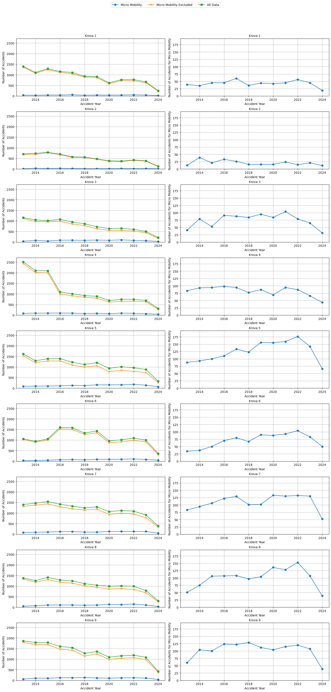

### Plotting number of accidents in relation to BP length

import matplotlib.pyplot as plt  
  
# Calculate maximum values for y-axis limits  
max_all_accidents = bp_krova_filtered['all_acc_cnt'].max()  
max_mm_accidents = bp_krova_filtered['mm_acc_cnt'].max()  
max_cum_bp_length = bp_krova_filtered['cum_bp_length'].max()  
  
# Prepare the figure with 9 rows and 2 columns  
fig, axs = plt.subplots(9, 2, figsize=(15, 36), constrained_layout=True)  
  
# Flatten the 2D grid of axs for easy iteration  
axs = axs.flatten()  
  
# Colors for different types of accidents  
colors = ['blue', 'orange', 'green']  
labels = ['All Accidents', 'No Micro Mobility Accidents', 'Micro Mobility Accidents']  
  
# Iterate over each unique city quarter  
for i, quarter in enumerate(bp_krova_filtered.index.get_level_values('krova').unique()):  
 if i < len(axs) // 2: # Ensure we don't exceed the number of available subplots  
 # Extract data for this city quarter  
 data = bp_krova_filtered.loc[quarter]  
   
 # First plot in the row  
 ax1 = axs[2 * i]  
 ax1.plot(data.index.get_level_values('bitzua'), data['all_acc_cnt'], 'o-', color=colors[0], label=labels[0])  
 ax1.plot(data.index.get_level_values('bitzua'), data['no_mm_acc_cnt'], 'o-', color=colors[1], label=labels[1])  
 ax1.plot(data.index.get_level_values('bitzua'), data['mm_acc_cnt'], 'o-', color=colors[2], label=labels[2])  
 ax1.set_title(f'Accident Counts for {quarter}')  
 ax1.set_xlabel('Year (Bitzua)')  
 ax1.set_ylabel('Number of Accidents')  
 ax1.set_ylim(0, max_all_accidents + 200)  
 ax1.legend(loc='upper left')  
 ax1.grid(True)  
 # Create a secondary y-axis for cum_bp_length  
 ax1_right = ax1.twinx()  
 ax1_right.plot(data.index.get_level_values('bitzua'), data['cum_bp_length'], 'o-', color='purple', label='Cumulative BP Length')  
 ax1_right.set_ylabel('Cumulative BP Length')  
 ax1_right.set_ylim(0, max_cum_bp_length + 500)  
 ax1_right.legend(loc='upper right')  
   
 # Second plot in the row  
 ax2 = axs[2 * i + 1]  
 ax2.plot(data.index.get_level_values('bitzua'), data['mm_acc_cnt'], 'o-', color=colors[2], label=labels[2])  
 ax2.set_title(f'MM Accident Counts for {quarter}')  
 ax2.set_xlabel('Year (Bitzua)')  
 ax2.set_ylabel('Number of MM Accidents')  
 ax2.set_ylim(0, max_mm_accidents + 20)  
 ax2.legend(loc='upper left')  
 ax2.grid(True)  
  
 # Create a secondary y-axis for cum_bp_length  
 ax2_right = ax2.twinx()  
 ax2_right.plot(data.index.get_level_values('bitzua'), data['cum_bp_length'], 'o-', color='purple', label='Cumulative BP Length')  
 ax2_right.set_ylabel('Cumulative BP Length')  
 ax2_right.set_ylim(0, max_cum_bp_length)  
 ax2_right.legend(loc='upper right')  
  
# Hide any unused subplots  
for j in range(2 * i + 2, len(axs)):  
 fig.delaxes(axs[j])  
  
# Display the plot  
plt.show()

