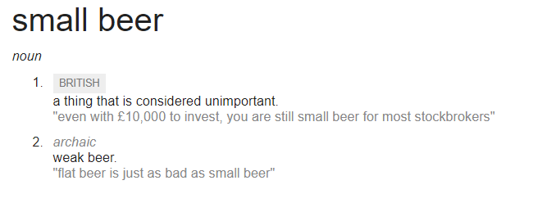

In medieval times, and on into the 19th century, having a drink of water was a risky thing to do. Water-borne diseases such as cholera and typhoid took the lives of both rich and poor alike. History books (<https://en.wikipedia.org/wiki/1854_Broad_Street_cholera_outbreak>) will tell you that we all thought the likes of cholera were carried by ‘bad air’ until the 1850s. There was, however, at least one very popular tradition that , there did exist one technique for the treatment of water

There was a lot of cholera and typhoid about in med

In medieval times and on into the 19th century, much of the water in the UK was unsafe to drink.