

NATIONAL OPEN UNIVERSITY OF NIGERIA
Plot 91, Cadastral Zone, Nnamdi Azikiwe Expressway, Jabi, Abuja.

FACULTY OF SCIENCES
DEPARTMENT OF MATHEMATICS
JULY 2017_1 EXAMINATION

Course Code: STT311
Course Title: Probability Distribution II
Credit Unit: 3
Time Allowed: 3 HOURS
Total: 70 Marks
INSTRUCTION: ATTEMPT NUMBER ONE (1) AND ANY OTHER FOUR (4) QUESTIONS

- (a) Write short notes on each of the following from probability and statistical point of view:
- Experiment, (ii) Sample Space, (iii) Events, (iv) Random Variable,
(v) Probability distribution function, (vi) Probability density function (6 Marks)

(b) If someone takes four shots at a target and we care only whether each shot is a hit or a miss,
Describe (i) a suitable sample space, (ii) the elements of the sample space that constitute event M that the person miss the target twice, (iii) the elements of event N that the person will hit the target once and miss trice. (6 Marks)

(c) The probabilities that the serviceability of a new Scanning machine will be rated very difficult,
difficult, average, easy, or very easy are, respectively, 0.12, 0.17, 0.34, 0.29 and 0.08.
find the probabilities that the serviceability of the machine will be rated
- Difficult or very difficult
- Neither very difficult or very easy;
- Average or worse
- Average or better (4 Marks)

(d) The joint probability function of two discrete random variables X and Y is given by
f(x,y) = c(2x + y), where x and y can assume all integers such that 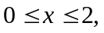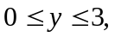and f(x,y) = 0 otherwise.
- Find the value of the constant c.
- Find P(X=2, Y=1).
- Find 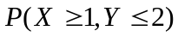 (6 Marks)

- (a) The distribution function of the random variable X is given by
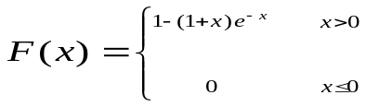

Find (i) 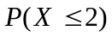 (ii) 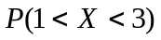 (iii) 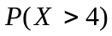 (6 Marks)

(b) Find the probability density function of the random variable X in 1(a) and use the pdf verify the solution of (i) (ii) (iii) (6 Marks)

- (a) A coin is tossed once. Then, if it comes up heads, a die is thrown once; if the coins comes up tails, it is tossed twice more. Using the notation in which (H,2), for example, denotes the event that the coin comes up heads and then the die comes up 2, and (T,T,T) denotes the event that the coin comes tails three times in a row: list
- The 10 element of the sample space S; (2 Marks)
- The elements of S corresponding to event A that exactly one head occurs (2 Marks)
STT311

- The elements of S corresponding to event B that at least two tails occurs or a number greater than 4 occurs. (2 Marks)
.
(b) If 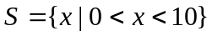, 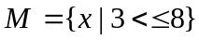, and 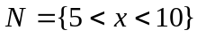
Find i) 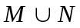; ii) 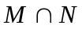;
iii) 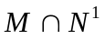 iv) 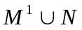 (6 Marks)

- (a) (i) Define the convergence of a random variables. (2 Marks)

- State and prove De’movre’s Theorem (6 Marks)

- What is a random variable? Give examples using the outcome from the toss of two dice.

A random variable X has E(x) =2, E(x²) = 8

Find Var (x) (ii) Standard deviation of x (4 Marks)

- (a) If the joint probability density of X and Y is given by.

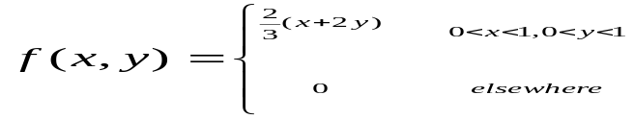
Find the conditional mean and conditional variance of X given Y = ½ (6 Marks)

(b) The joint density function of two continuous random variables X and Y is
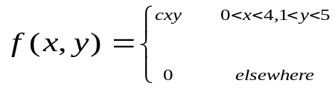

Find the value of the constant c.
Find P(1 < X <2, 2 < Y < 3). Find P(X+Y<3) (6 Marks)

6. (a) What is a moment generating function (3Marks)

(b) Find the moment generating function of the random variable whose probability density is given by. 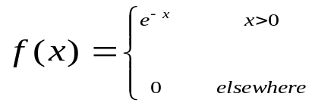 (9 Marks)

