CCC München - Comprehensive Cancer Center / Tumorzentrum München · Pettenkoferstraße 8a ∙ 80336 München

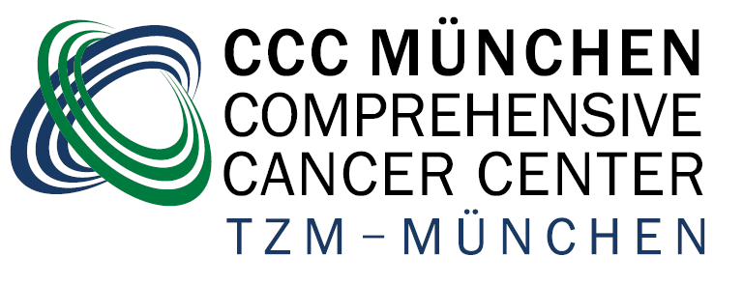

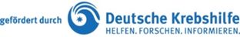

CCC München
Comprehensive Cancer Center

Direktoren
Prof. Dr. H. Algül
Prof. Dr. V. Heinemann

Zentrale Geschäftsstelle
Frau M. Schmid
Pettenkoferstraße 8a
80336 München

Tel.: 089-4400-57430
Fax: 089-4400-57432
Mail: ccc-muenchen@med.uni-muenchen.de
www.ccc-muenchen.de



Application form

Personal details:

Login name:
First name:
Last name:
Organizational Unit:
Phone:

Restriction of authorization (e.g. "C34", "operated", etc.):

By signing, the applicant accepts the OVIS user agreement and confirms that the authorizations mentioned above are based either on existing consents, a treatment relationship, or a research assignment pursuant to Article 27 (4) of the Bavarian Hospital Act.”

Signature of the authorized person

Signature(s) of the data-holding supervisor(s)
( multiple entries possible)

Signature after review of the CCC (Director or designated representative)

