Revision Log

Section: Dispatch / Delivery Orders

Edit #1: Auto-dispatch orders, and auto-reassign to the nearest driver if none is available
Client note: It should auto dispatch and if driver not available should send it to the nearest driver that will drop off his order automatically.
Requested change: When an order has no driver assigned (as shown: DRB-DWPH-0130, Al Dawaa Pharmacy, No Driver, SLA -7051:57), the system should automatically dispatch it rather than requiring manual assignment. If no driver is available at dispatch time, the system should automatically route the order to the nearest available driver so it is still delivered without manual intervention. The order detail view already exposes Reassign and Auto-redispatch actions manually — this should also happen automatically.
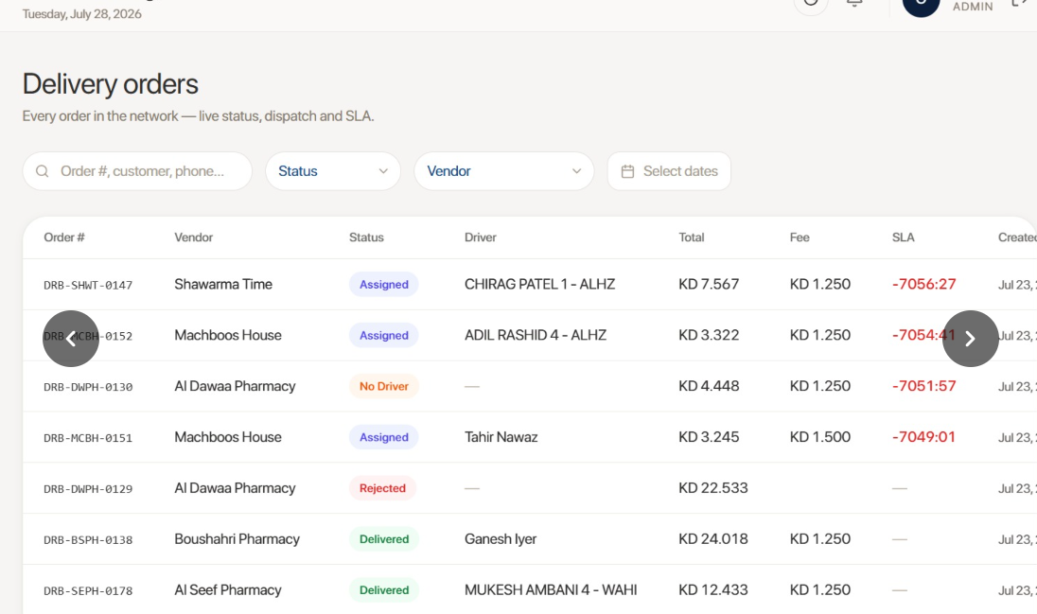

Edit #2: Auto-reassign to another driver when an order is rejected
Client note: And if the order is rejected from the driver it should be sent to another driver automatically.
Requested change: When a driver rejects an assigned order, the system should automatically reassign it to another available driver, using the same auto-dispatch/nearest-driver logic requested in Edit #1, instead of leaving it unassigned until a staff member manually reassigns it.
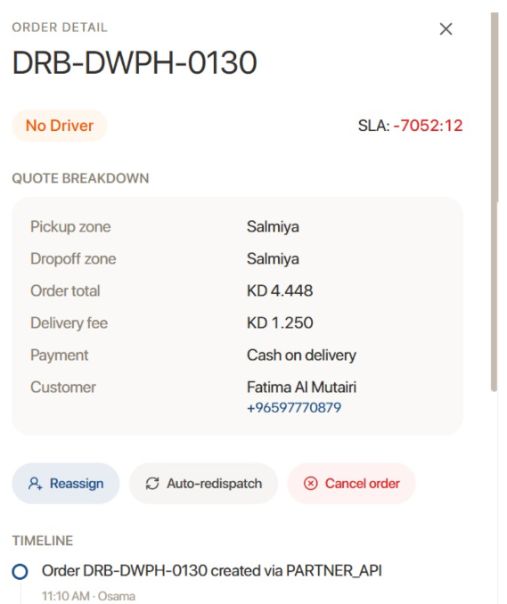

Section: Vendor Money / Cash & Statements

Edit #3: Move "Cash Handed In" to a separate portal for cash collection only
Client note: This page should be in a different portal for cash collection only (cash handed in).
Requested change: Split the Cash handed in tab (currently alongside Ledger / Shop statements / Nightly checks, with the "Record cash handed in" form and History table) out into its own dedicated portal focused solely on recording and viewing driver cash hand-ins, separate from the other Money tabs.
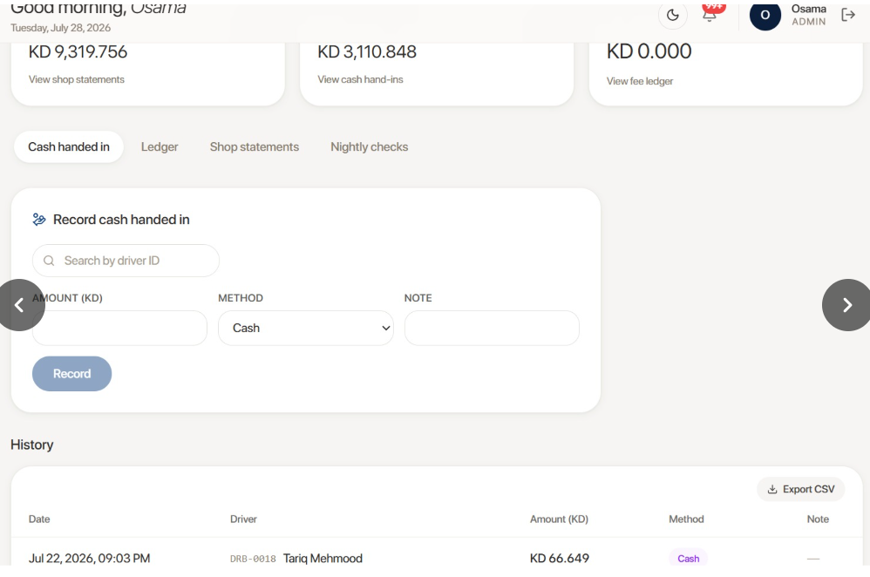
Cash handed in — Record cash handed in form + History table

Edit #4: Detailed per-transaction report for Shop Statements
Client note: This page should give a detailed report for each transaction for the shop statement.
Requested change: The Shop statements list (Shop / Period / COD net / Closing balance / Status) should support drilling into a detailed, per-transaction report for each shop's statement period, rather than only showing the summary row per shop per period.
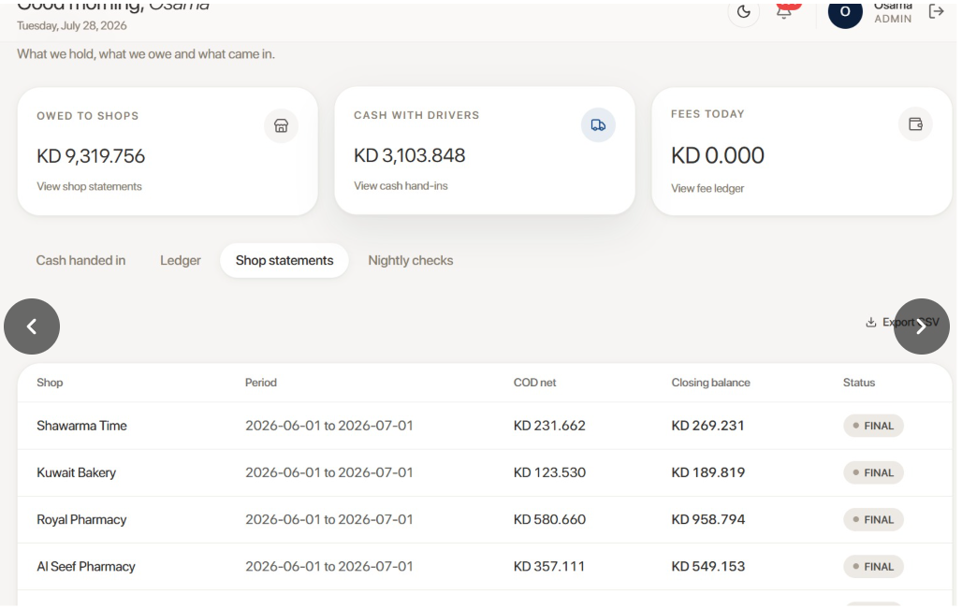
Shop statements — Shop/Period/COD net/Closing balance/Status list

Edit #5: Shop statement export should be per-shop detail, not all shops combined
Client note: And the downloaded file should be the same concept — detailed statement, not all shops together.
Requested change: The Export CSV on Shop statements currently produces one combined file with a summary row per shop per period (as shown: Shawarma Time, Kuwait Bakery, Royal Pharmacy, etc., each with Shop/Period/COD net/Closing balance/Status). Once Edit #4's detailed per-transaction report exists, the export should follow the same concept — a detailed, per-shop statement export — instead of one flat file mixing all shops together.

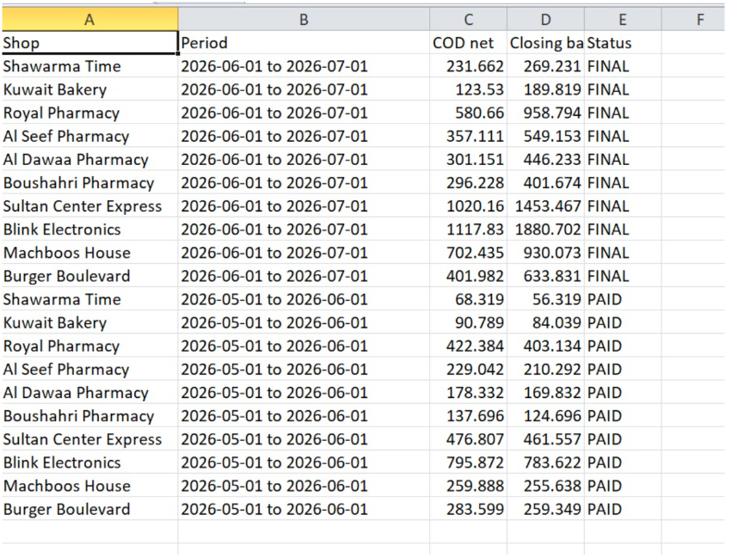
Shop statements CSV export — all shops combined in one flat file

Section: Delivery Zones & Pricing

Edit #6: Draw zones with pinpoints, like the Google Earth measure tool
Client note: For the zones, it's better to put pinpoints — after that the line will appear, same as the Google Earth measure feature.
Requested change: Change the zone drawing tool on the Areas we deliver to map so that staff place pinpoints one at a time, with connecting lines appearing automatically between them as they go (matching the interaction pattern of Google Earth's "measure distance" tool), rather than the current freehand polygon drawing.
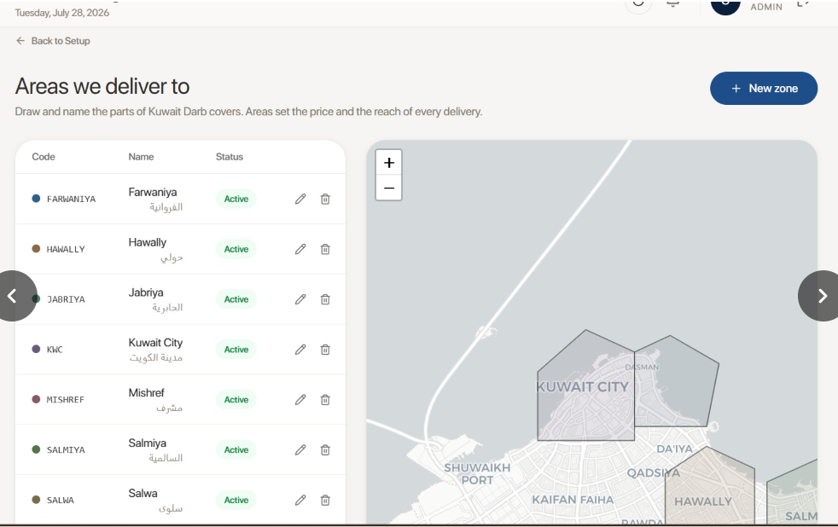
Areas we deliver to — zone map with drawn polygons

Edit #7: Vendor delivery pricing plans (by zone or by kilometer, custom-named, reusable)
Client note: For delivery prices it would be in the vendor profile as delivery plan. We will create a pricing plan, after that we will assign it to each vendor. As an example: delivery in the same zone = this price, per kilometer calculated from Google Maps (not the actual route the driver took) — so 12 km and less = this price, 12.1 to 14 km = this price, and 14+ km = this price. Prices may be adjusted any time and kilometers may be adjusted; keep the cell blank to mark a pair unserviceable. Each plan will have a custom name. To keep it simple, a plan is either by zone or by kilometers, and the screenshot above is one example (delivery plan) — we could create more than one plan for each category.
Requested change: Add a Delivery plan concept, managed independently of any single vendor, that can be created and then assigned to a vendor in that vendor's profile:
- Each plan has a custom name and is one of two types: by zone or by kilometer.
- By-zone plans work like the current pricing screen — an intra-zone flat fee plus a zone-to-zone surcharge grid (as shown: Farwaniya/Hawally/Jabriya/Kuwait City/etc.), with a blank cell marking that origin/destination pair unserviceable.
- By-kilometer plans define price tiers based on distance calculated from Google Maps routing distance (not the driver's actual traveled route) — e.g. 12 km and under = price A, 12.1–14 km = price B, 14+ km = price C. Both the prices and the km breakpoints must be editable at any time, and a blank tier likewise marks it unserviceable.
- Multiple plans of each type can exist (e.g. several different by-zone plans, several different by-kilometer plans), and each vendor is assigned one plan from vendor profile → Delivery plan.
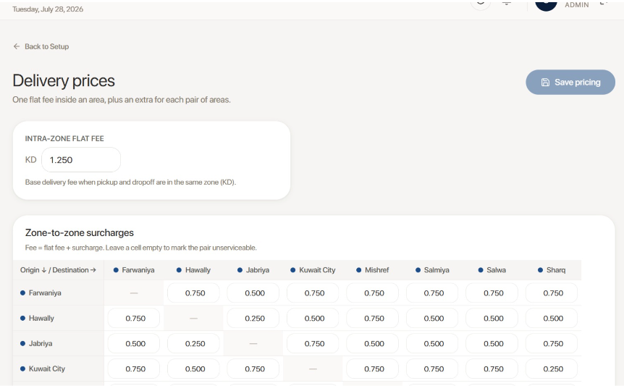
Delivery prices — intra-zone flat fee + zone-to-zone surcharge grid

Section: Vendor Management

Edit #8: Add a phone number column to the vendor branches table
Client note: Phone number for each branch should be included out here.
Requested change: Add a Phone number column to the vendor Branches table (currently: Branch name / Address / Zone / Latitude-Longitude), shown per branch — e.g. for Al Dawaa Pharmacy's Mishref and Salmiya branches.
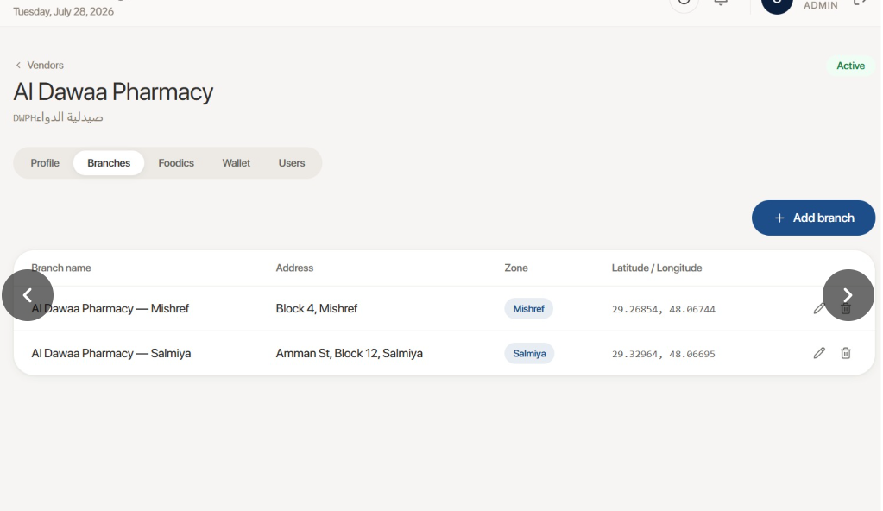
Al Dawaa Pharmacy — Branches tab, no phone number column

Edit #9: Add a phone number field to Create portal user
Client note: Should include phone number when creating a user.
Requested change: Add a Phone number field to the Create portal user form (currently: Full name / Email / Password / Portal role / Branch).
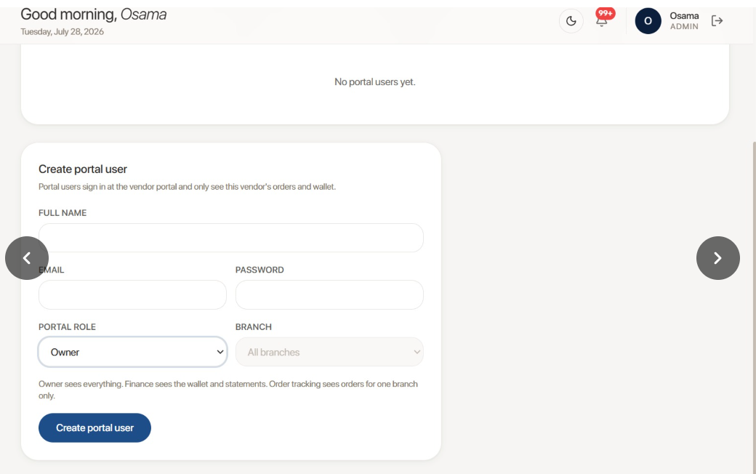
Create portal user — no phone number field

Section: Fleet / Fleet Partners

Edit #10: Include fleet detail (scorecard + payout statements) in the Excel export
Client note: Details should be shown when downloading in Excel.
Requested change: The current Fleet/Delivery companies Excel export only includes the summary columns (Fleet / Roster / Discipline / Fee-per-order / Status). It should also include the detail shown in the Fleet side panel when a fleet is opened — Performance scorecard (On-time rate, Acceptance rate, Utilisation, Delivered orders, Online hours, Contracted hours, Rating) and Payout statements (e.g. June 2026: 177 × KD 1.100 = KD 194.700, Final; May 2026: 105 × KD 1.100 = KD 115.500, Paid).
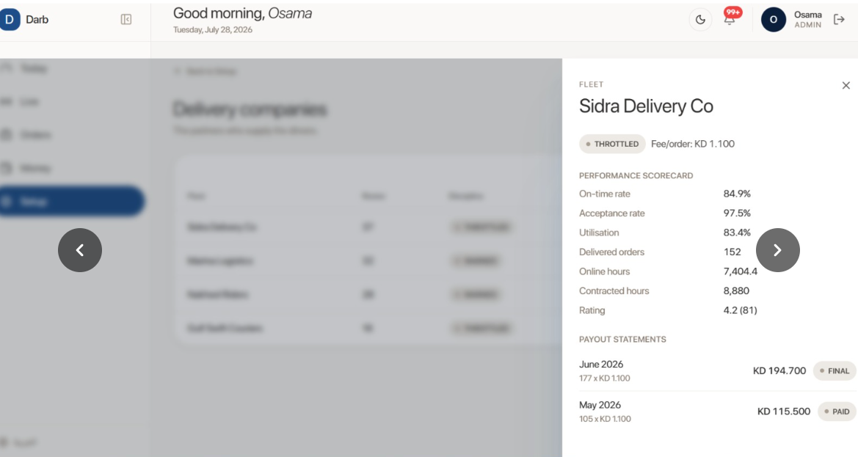
Fleet detail panel — Sidra Delivery Co performance scorecard and payout statements
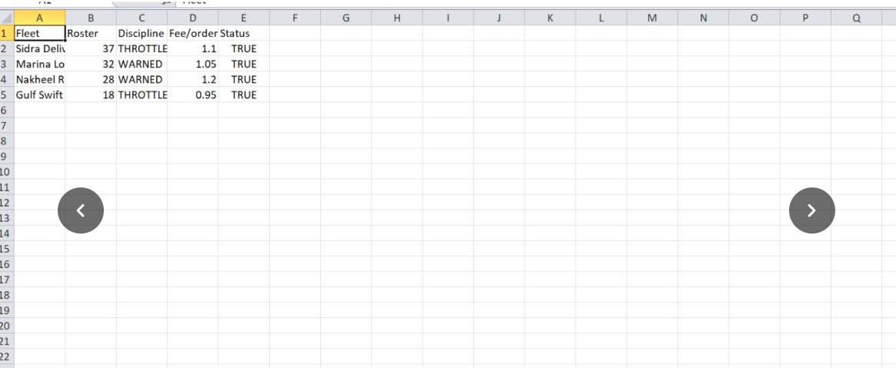
Current Excel export — summary columns only (Fleet/Roster/Discipline/Fee-per-order/Status)

Section: People & Access

Edit #11: Add Account Manager to the notifications matrix
Client note: There should be a user for account manager to send him notifications.
Requested change: Add an Account Manager role/column to the violation-notifications matrix (currently: Admin / Ops Manager / Supervisor / Accountant / Viewer, across violation types like Cash Threshold Exceeded, GPS Off, Out of Zone, Zone Mismatch, Selfie Fail), so account managers can be toggled on to receive relevant notifications.
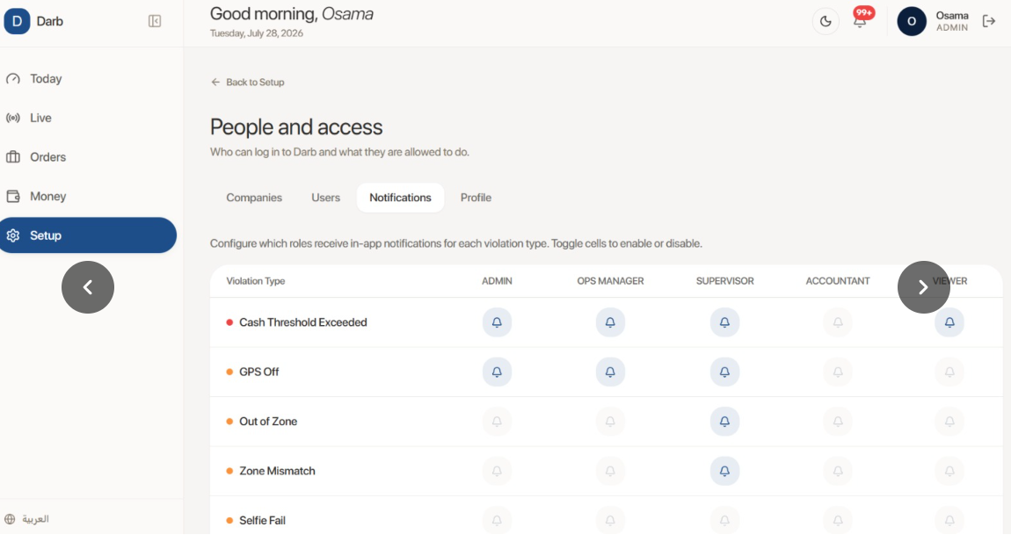
People and access — Notifications matrix by role, no Account Manager column

Edit #12: Self-service password on invite, plus a per-user permissions page
Client note: User should create his own password, and we need a page for restrictions for each user — what he can view or change — and for account managers, what companies they are handling.
Requested change:
- In the Invite User modal, remove the admin-entered Password field. Instead, the invited user should set their own password (e.g. via a link sent to their email), consistent with the Name / Email / Role / Phone fields staying as admin-entered.
- Add a new Permissions page where each user's view/edit access can be restricted individually (beyond the existing coarse Role dropdown of Owner/Finance/Order tracking-style roles).
- Specifically for Account Managers, this page should let staff assign which companies (vendors) each account manager is responsible for.
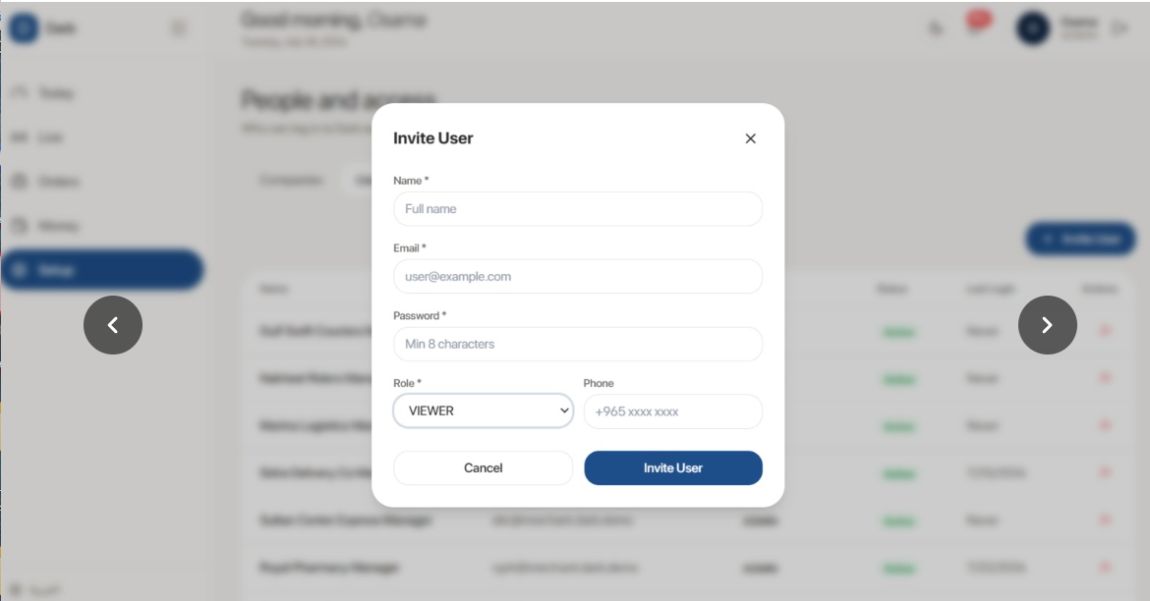
Invite User modal — admin-entered Password field, no permissions/company-assignment step

Section: Setup / Equipment

Edit #13: Platform Equipment should only list Darb, not other delivery platforms
Client note: The only platform there is Darb — should not show other platforms' equipment.
Requested change: In Add Platform Equipment, the Platform dropdown currently lists other delivery platforms (e.g. Talabat, as shown). Since Darb is the only platform in scope, this dropdown should not offer other platforms' equipment pools at all.
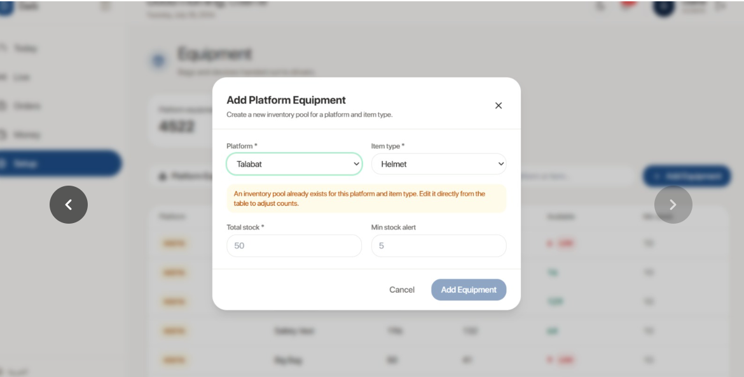
Add Platform Equipment — Platform dropdown includes Talabat

