Keeta Ops Console — Training Analysis
Darb Fleet Management — Feature Gap Review
Prepared 14 April 2026 • Tenant: kt_HQ_Sidra (Sidra → Kuwait City)

1. Executive Summary
On 14 April 2026 a 36-minute training session was recorded in which Supervisor Waho walked through the live Keeta operations console for the Sidra branch (Kuwait City). This document summarises every screen that was demonstrated, extracts the business logic behind Keeta's incentive and finance engines, and maps each observation to a concrete implementation item for the Darb Keeta module.
Darb already has overview, drivers, attendance, shifts, orders, performance, phones, vehicles and settings pages for Keeta. The recording exposes three major gaps not yet captured in CLAUDE.md: a full-screen live operations map, a tier-based Incentive Management module with formula-driven payouts, and a Financial Management module covering billing, tax invoices and system-auto-withdrawals.

2. Screen-by-Screen Walkthrough

2.1 Operation Centre — Live Map
Full-screen map of Kuwait City with every merchant, courier and active order plotted. Two toggles at the top let the supervisor switch between a By Order view and a By Courier view. The left rail lists filterable entities; selecting one zooms and highlights it on the map. This is Keeta's "mission control" view and is consulted continuously during the shift.
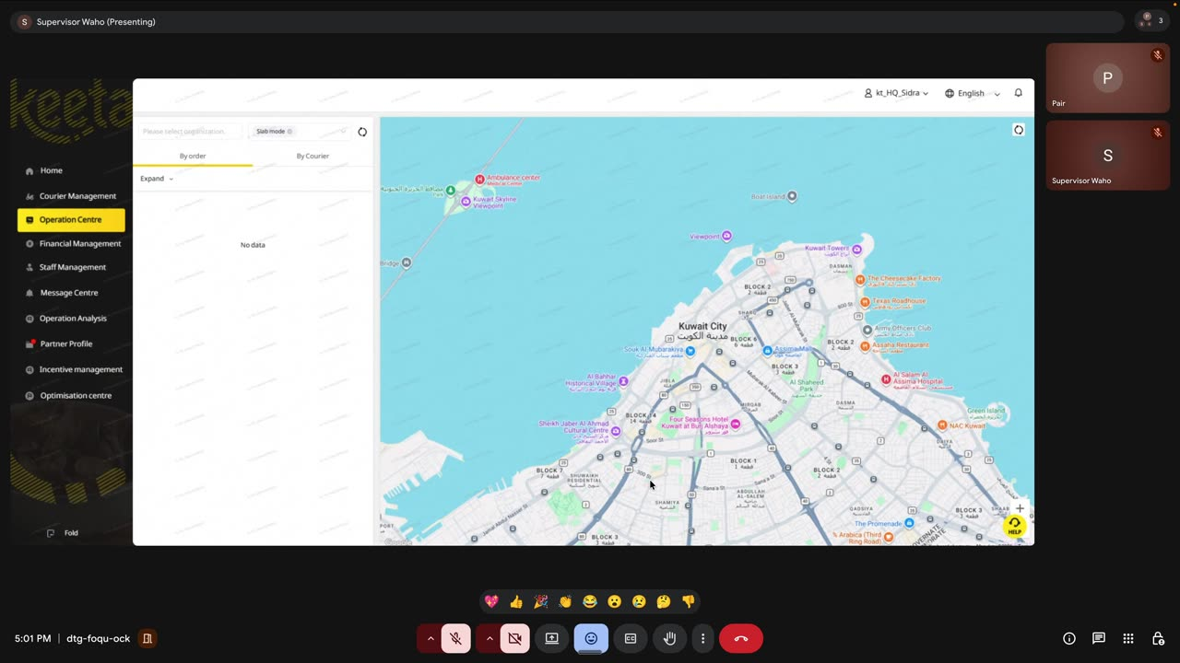
Screenshot 1 — Operation Centre: live map with By Order / By Courier toggle

2.2 Home — Core Metrics Dashboard
Six KPI cards with Day-over-Day (DoD) and Week-over-Week (WoW) deltas, followed by a trend chart with an accumulative / discrete toggle. Values observed on the demo day:
- Accepted Tasks: 493 (DoD +4.01%)
- Delivered Tasks: 425 (DoD −0.47%, WoW +14.02%)
- Couriers (Delivered Tasks) Proportion: 93.98%
- Cancelled Tasks: 50 (DoD +6.38%, WoW +100%)
- Online Couriers: 79
- On-time Rate (D): 99.06%
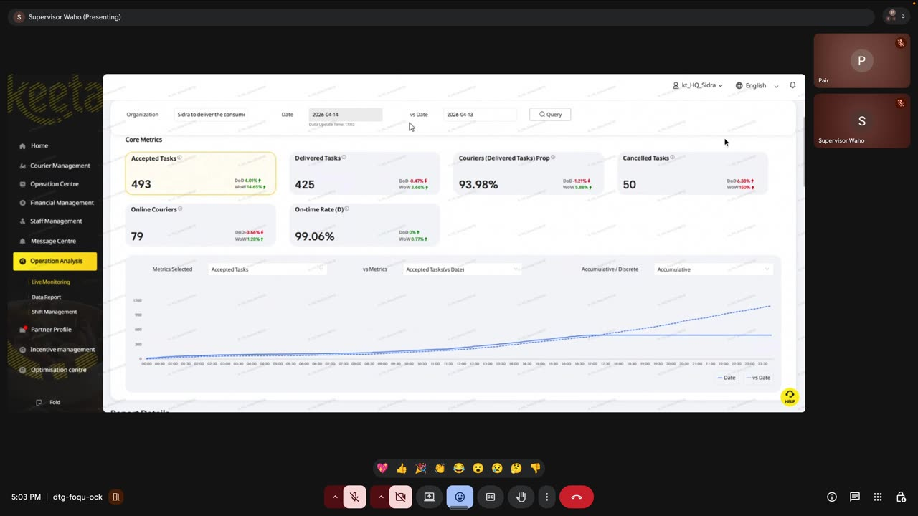
Screenshot 2 — Core metrics with DoD/WoW deltas and trend chart

2.3 Data Report — Task Volumes / Courier Capacity / Delivery Experience
Three sub-tabs, each surfacing headline KPI cards and a two-metric trend chart with a multi-day comparison date picker. "Download Data" is available on every table.
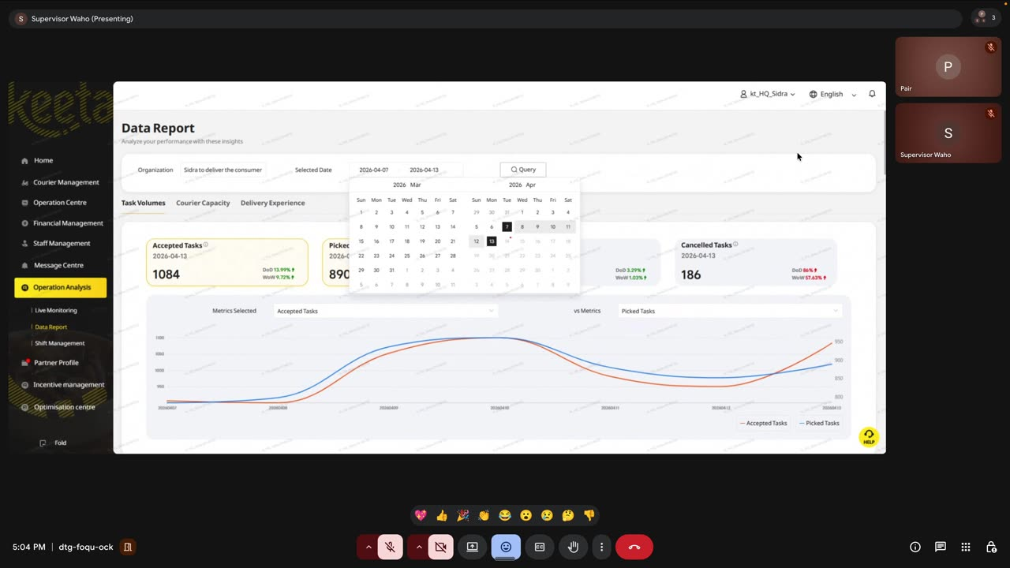
Screenshot 3 — Data Report with 7-day trend compare

2.4 Courier Details — By Date / By Period
Dense per-courier-per-day table with these columns: On-Shift?, Valid Day?, Courier App Online Time, Valid Online Time, Peak Online Hours, Accepted Tasks, Tasks with Restaurant Arrivals, Delivered Tasks, Large Order Tasks Completed, Cancelled Tasks. The adjacent Attendance Summary splits each day into eight 3-hour slots (00:00–03:00, 03:00–06:00, …, 21:00–00:00) and labels each slot either "On Shift X hr Y min" or "No Shift". Pagination: 10 rows × 109 pages.
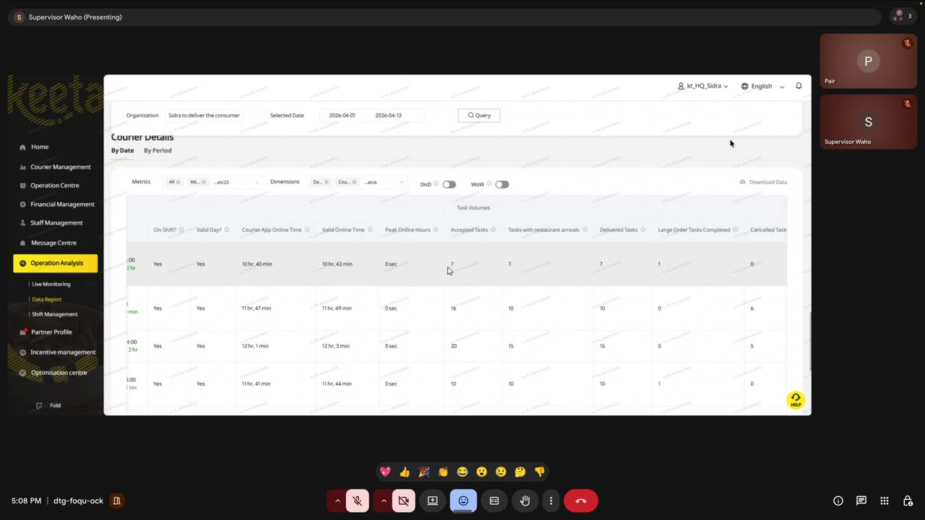
Screenshot 4 — Courier Details task-volume columns
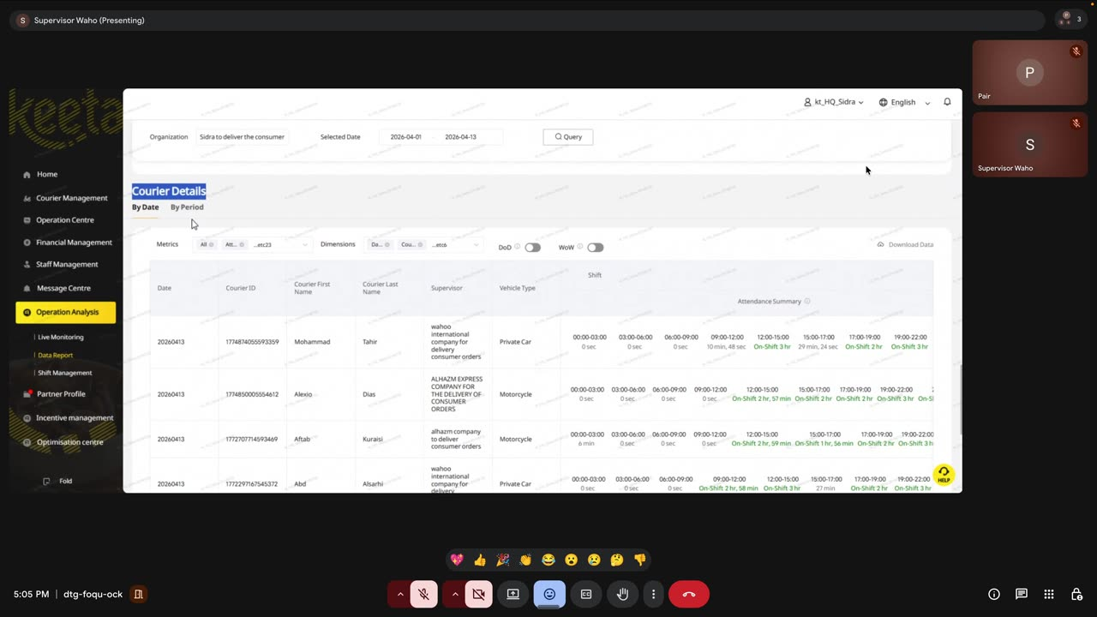
Screenshot 5 — Attendance summary broken into 3-hour slots

2.5 Shift Management — Live Monitor, Scheduling, Export
The Courier Schedule Live Monitor rolls up per branch: Total Registered Couriers, Scheduled, Not on shift, and Couriers with scheduled shifts ≥ 10 hours (a shift-compliance KPI). The Scheduling-by-shift page exposes each shift row with a Delivery Area (Al Khiran, Hawally, Avenues, Salmiya…) and a Vehicle Type. The Excel export uses yellow highlighting on any row where Total Shift Hours = 0.00 or the slot reads "No shift".
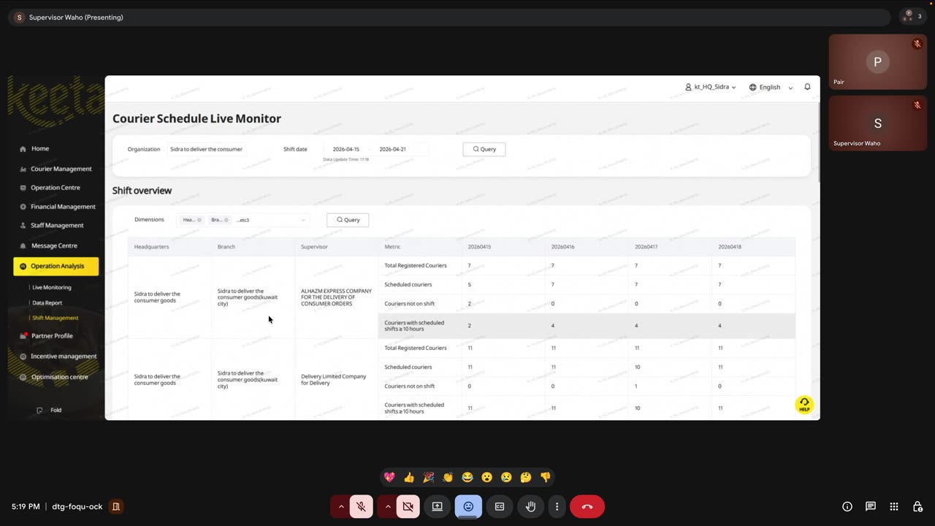
Screenshot 6 — Courier Schedule Live Monitor with ≥10h compliance metric
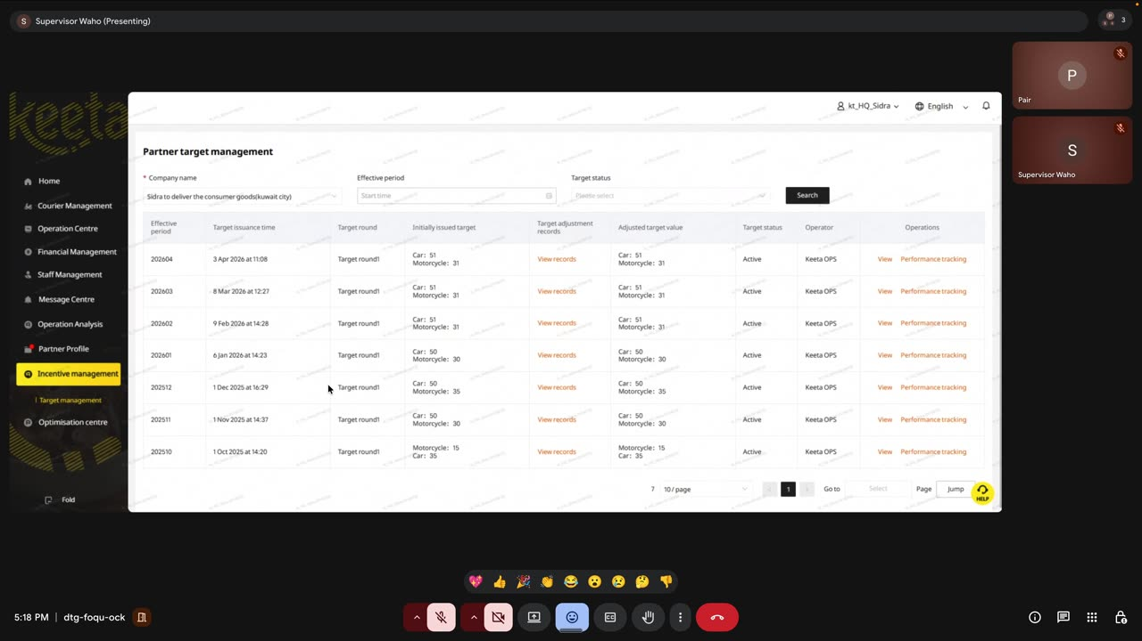
Screenshot 7 — Scheduling by shift with delivery area column
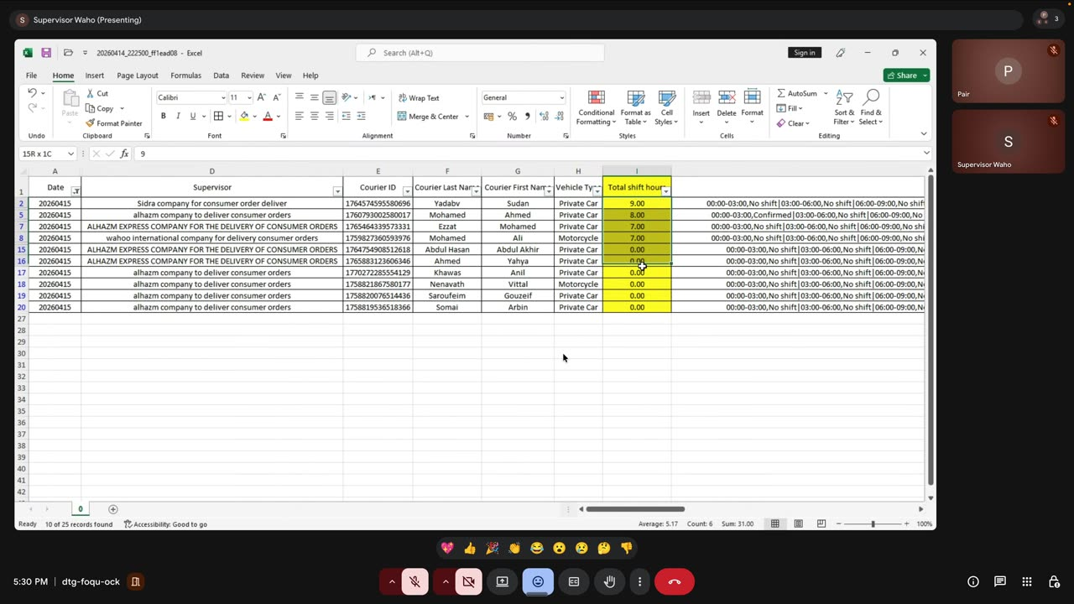
Screenshot 8 — Excel export: yellow-highlighted "No shift" rows

2.6 Incentive Management — Partner Target Management
A monthly "target round" is issued per partner per vehicle type. Rounds observed: 202604 (3 Apr 2026, Car 51 / Motorcycle 31), 202603, 202602, 202601, 202512, 202511, 202510. Each round has Effective Period, Target Issuance Time, Initially Issued Target, Adjusted Target Value, Target Status (Active), Operator (Keeta OPS), and a per-courier Performance Tracking view.
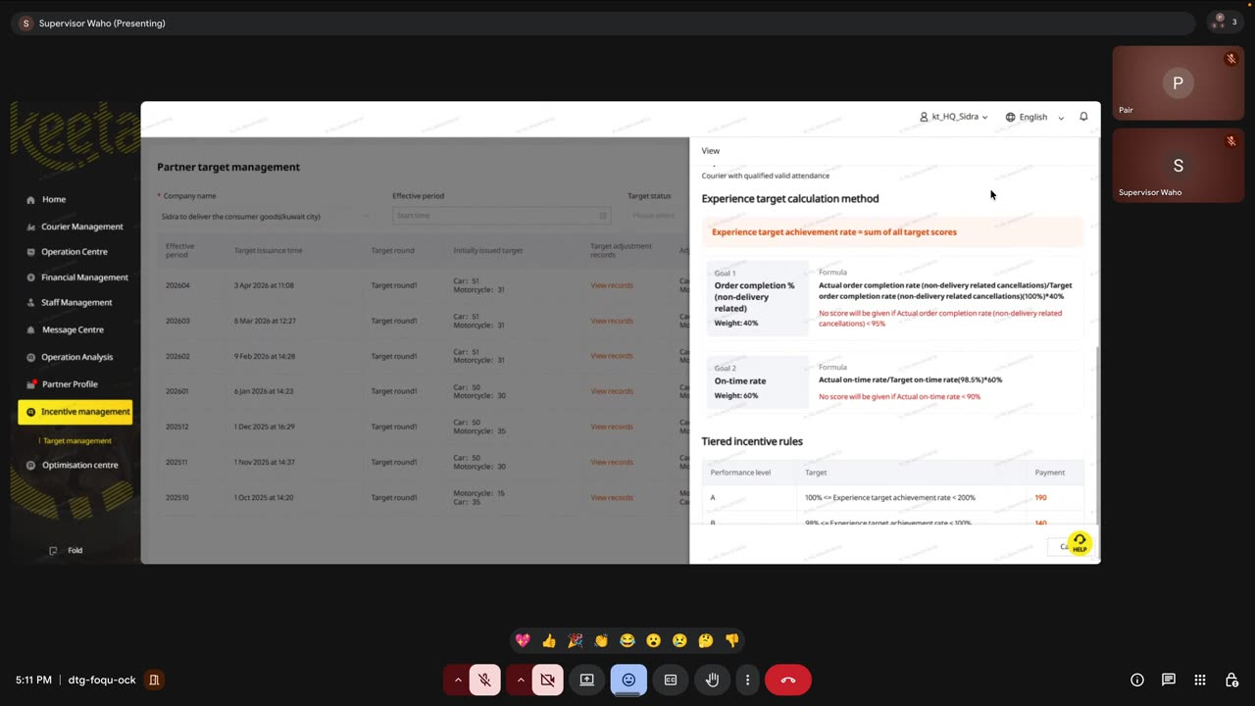
Screenshot 9 — Partner Target Management list

Experience Target Formula
The payout formula uses a weighted sum:
Experience target achievement rate = Σ(all target scores)
- Goal 1 — Order completion % (non-delivery related). Weight 40%. Formula: Actual / Target × 100% × 40%. No score if actual rate < 95%.
- Goal 2 — On-time rate. Weight 60%. Formula: Actual / Target (98.5%) × 100% × 60%. No score if actual on-time rate < 90%.
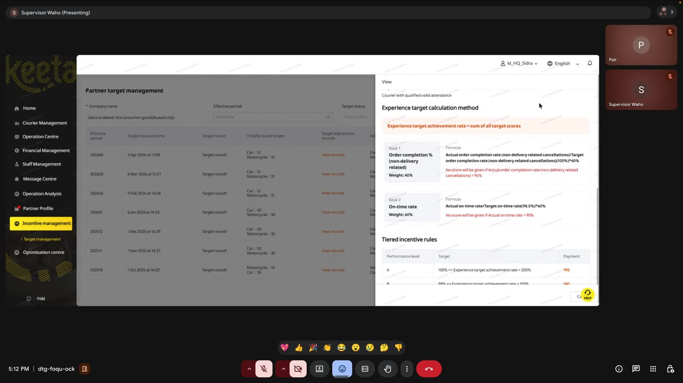
Screenshot 10 — Experience target formula with weighted goals
Tiered payout based on the achievement rate:
Level | Target | Payment (KWD)
A | 100% ≤ rate < 200% | 190
B | 98% ≤ rate < 100% | 140
C | 96% ≤ rate < 98% | 90
D | 0% ≤ rate < 96% | 0
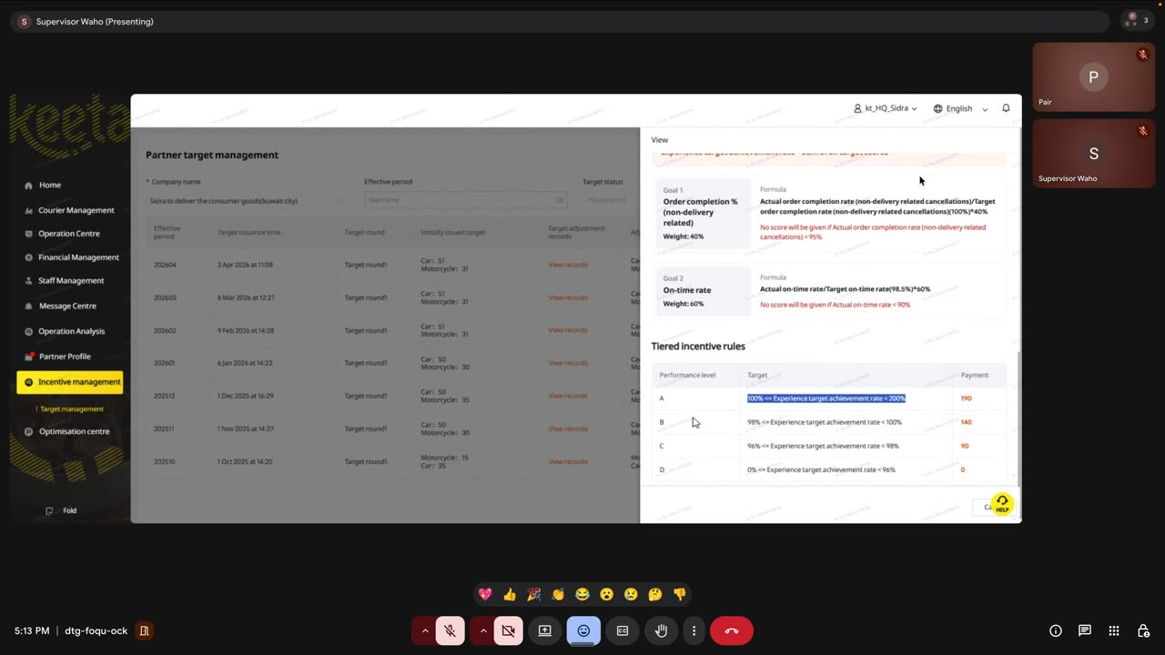
Screenshot 11 — Experience-target tiered payouts

Valid DA Assessment
A second, parallel incentive is keyed to the monthly count of Valid Delivery-Attendance days. Separate Car and Motorcycle tables. A courier can earn both the Experience Target payment and the Valid DA payment in the same month.
Level | Target (Valid DA count) | Payment (KWD)
A | 40 ≤ Valid DA ≤ 51 | 180
B | 30 ≤ Valid DA < 40 | 130
C | 25 ≤ Valid DA < 30 | 80
D | 0 ≤ Valid DA < 25 | 0
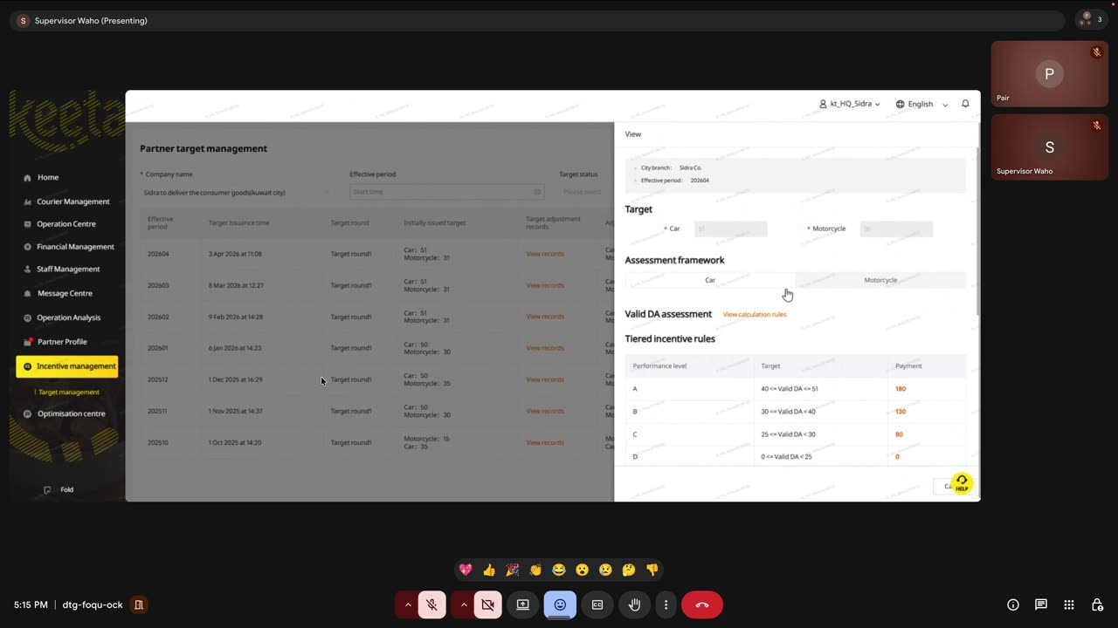
Screenshot 12 — Valid DA tiered payouts

2.7 Financial Management — Billings, Tax Invoices, Auto-Withdrawals
Three sub-pages governed by a strict flow: (1) Keeta issues a Billing each period; (2) the partner uploads a Tax Invoice against that billing; (3) once Keeta accepts the invoice, the withdrawable balance is released and a SYSTEM AUTO WITHDRAW record is created against the configured bank account (demo tail number 8172).
Auto-withdrawal records observed (account tail 8172):
Withdraw Time | Amount (KWD) | Status
7 Apr 2026 18:05:05 | 10,202.049 | Withdrawn
9 Mar 2026 09:05:05 | 10,179.467 | Withdrawn
10 Feb 2026 09:05:05 | 11,286.443 | Withdrawn
8 Jan 2026 21:05:05 | 11,032.576 | Withdrawn
9 Dec 2025 15:05:05 | 7,604.985 | Withdrawn
7 Nov 2025 12:05:05 | 6,202.747 | Withdrawn
21 Oct 2025 17:05:05 | 930.536 | Withdrawn
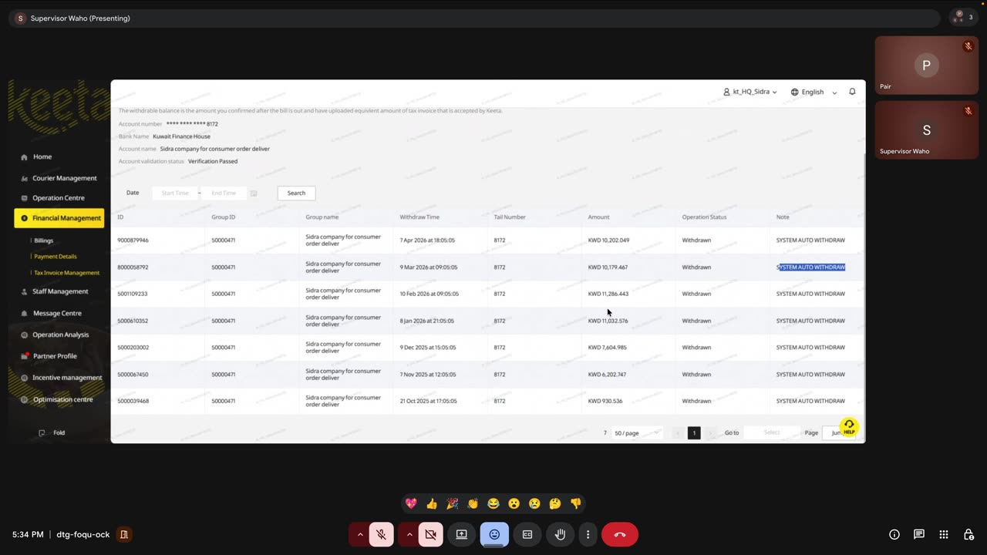
Screenshot 13 — Payment Details: SYSTEM AUTO WITHDRAW ledger
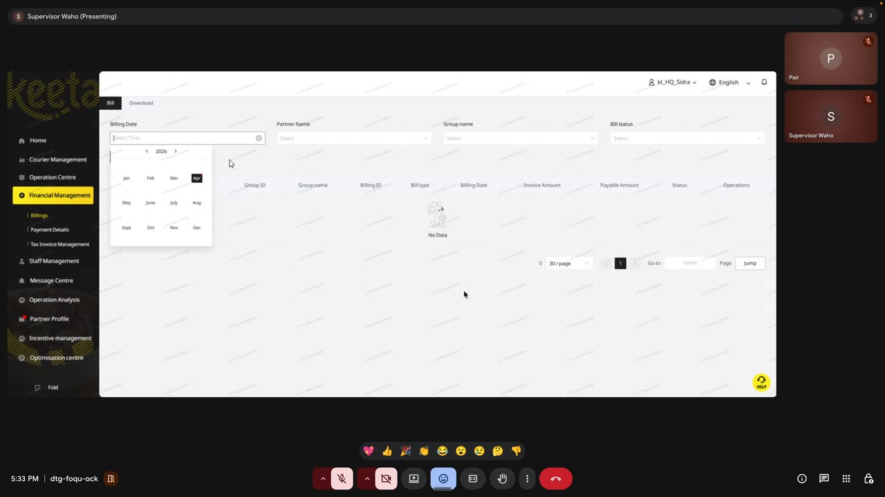
Screenshot 14 — Billings page with monthly period picker
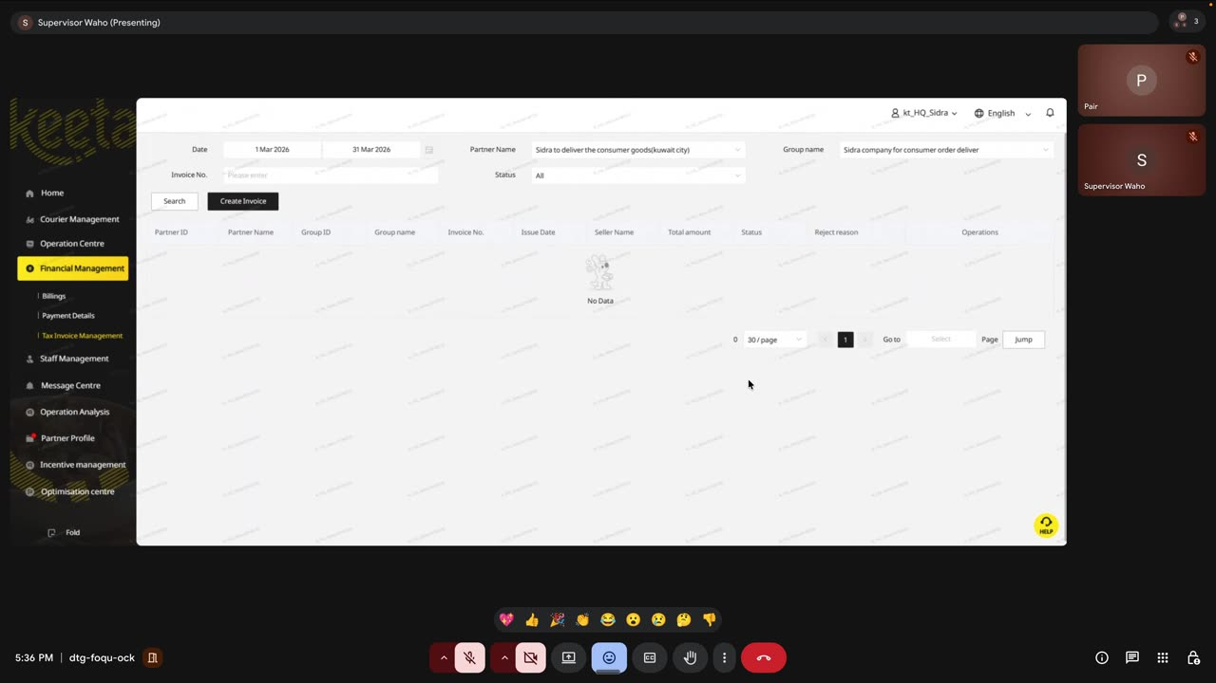
Screenshot 15 — Tax Invoice Management with Create Invoice action

3. Feature Gaps & Implementation Backlog for Darb
The following backlog layers on top of the six features already defined in CLAUDE.md (real-time monitor, violations, order flow, notifications, penalties, shift/area). Items are grouped by priority.

P0 — Operator-facing parity
- Full-screen Live Map at /keeta/operation-centre with By Order / By Courier toggle, left-rail selectable list and existing React Leaflet.
- Home KPI cards with DoD and WoW deltas, plus an accumulative / discrete trend toggle on /keeta/overview.
- Courier Details table with eight 3-hour attendance slots per day; new CourierAttendanceSlot model; XLSX export that yellow-highlights No-shift rows.
- Shift Live Monitor rollup per branch with a configurable under-shift threshold (default 10 hours); flag under-shift couriers to Notifications (category OPS_TODO).

P1 — Incentive & finance engine
- Partner Target Management module: IncentiveTargetRound, IncentiveGoal, IncentiveTierRule, CourierIncentivePayout. Monthly rounds per vehicle type with initial + adjusted targets.
- Experience Target calculator (Order Completion 40% + On-time Rate 60%, no-score gates at 95% / 90%) returning tier A/B/C/D and payment 190/140/90/0.
- Valid DA calculator counting valid delivery-attendance days per month and mapping to tier A/B/C/D with payment 180/130/80/0.
- Financial Management module with Billing, TaxInvoice and PaymentWithdrawal tables; nightly job that creates a SYSTEM AUTO WITHDRAW record once a tax invoice is accepted.

P2 — Reporting polish
- Data Report page /keeta/reports with three tabs (Task Volumes, Courier Capacity, Delivery Experience), each exposing headline KPI cards, a two-metric trend chart and a Download Data action.
- Pagination hardening: page-jump input, virtualization for 1,000+ row lists.

P3 — Nice-to-haves
- Bilingual columns: show Courier First Name, Last Name and numeric Courier ID on every table.
- Dark-sidebar theme on the Keeta module to match operator muscle memory (sidebar ~ #0F1115, yellow active-item accent).
- Elevate Delivery Area from Feature 6 P3 to P1 — it is surfaced on every shift row in the real console.

4. Coverage Matrix
Area | In CLAUDE.md? | Added by this review
Real-time monitor | Yes (F1) | Full-screen map + By Order / By Courier toggle
Violations | Yes (F2) | —
Order-flow timeline | Yes (F3) | —
Notifications | Yes (F4) | Under-shift + no-invoice notifications
Penalty management | Yes (F5) | —
Shift / Area | Yes (F6) | ≥10h compliance metric, 3-hour slot grid
Incentive / Target Mgmt | No | New P1 module with formulas & tiers
Financial Mgmt | No | New P1 module (billing, tax invoice, auto-withdraw)
Data Report (3 tabs) | No | New P2 page
Core-metrics DoD/WoW | Partial | Delta computation + accumulative toggle

5. Screenshot Index
- 01. Operation Centre — live map
- 02. Core metrics dashboard
- 03. Data Report — trend chart
- 04. Courier Details — task-volume columns
- 05. Courier Details — attendance summary (3-hour slots)
- 06. Partner Target Management list
- 07. Experience target formula
- 08. Tiered incentive rules (A/B/C/D)
- 09. Valid DA assessment tiers
- 10. Courier Schedule Live Monitor
- 11. Scheduling by shift (with delivery area)
- 12. Courier shift details filter
- 13. Shift export Excel — No-shift flags
- 14. Payment Details — SYSTEM AUTO WITHDRAW ledger
- 15. Billings filter page
- 16. Tax Invoice Management

