


Highlights
- Results of Hadoop enabled Genome Analysis on an IBM Power8 (40 Node) HPC Cluster.
- Performance results utilizing IBM SMT8, Simultaneous Multi-Threading.
- Use of the Spectrum Scale file system for data and compute intensive workloads
- De Bruijn graph construction .

Contents

Executive summary

Discussion of the science

Outline of the compute resources
- Description of the results.

.

IBM Power8® HPC System Accelerates Genomics Analysis.

Executive summary
Current compute technologies and scientific methods for Big Data analysis today are demanding more compute cycles per processor than ever before, with extreme I/O performance also required. The capabilities of traditional Intel Hyper-Threading that can only utilize 2 simultaneous treads per core are limiting the results of these recent Big Data analysis technique advances.

Despite multiple prior Hadoop Genome analysis attempts on an existing Intel based LSU HPC cluster, a large metagenome dataset could not be analyzed in a reasonable period of time on existing LSU resources. Therefore, the LSU Center for Computational Technologies staff and researchers turned to IBM for help.
The existing Hadoop based method was ported to an IBM Customer Center 40 Node Power8® cluster running Ubuntu 14.1 and Spectrum Scale GPFS file system. The result was astonishing: The 1st phase of the Hadoop analysis on the huge 3.2TB metagenome dataset was rendered in 6.25 hours, using only 40 nodes. LSU and IBM are excited to report on these promising advances in this data and compute intensive scientific use case of Hadoop.
Further research work is being done with IBM on the use of NOSQL key value stores for the graph analysis.
Introduction and Science Challenge:
The genome input data size has already outpaced Moore’s law and exceeded terabytes. The data size will continue to grow as sequencing technologies improve. This unprecedented volume of data and complex computational requirement creates a dire need for a scalable software solution, as well as, an efficient distributed cyber infrastructure that can handle this data and compute intensive workload. Recently, Hadoop has emerged as the big data analytics framework. Genome scientists are increasingly using Hadoop for their data and compute intensive scientific applications. In this work, we focus on evaluating underlying distributed cyber infrastructure to accelerate a Hadoop-based data- and compute- intensive genome assembly workload.
In particular, in this white paper, we evaluate the IBM Power8 processor with respect to our Hadoop-based benchmark genome assembler. On a cluster of 40 Power8 nodes, we analyze a 3.2TB of input metagenome data set with Hadoop producing results in 6 hours rendering 8.6TB of graph data structure (called de Bruijn graph).

Hadoop Programming model
Hadoop was originated as the open-source counterpart of Google’s MapReduce. It has two distinct modules: a distributed file system, and a MapReduce programming abstraction.
Hadoop reads the input data from the underlying distributed file system in the form of disjoint sets or partitions of records. Normally, Hadoop Distributed File System (HDFS) is used for this purpose. However, other parallel file systems (e.g., Lustre and GPFS) are frequently used for this purpose as well. In our IBM Power8 cluster evaluation, we used IBM Spectrum Scale (formerly known as General Parallel File System, or GPFS) as the underlying parallel file system.
Then, in the MapReduce programming abstraction, a user-defined map function is applied to each disjoint set concurrently to extract information from each record in the form of intermediate key-value pairs. These key-value pairs are then grouped by the unique keys and shuffled to the reducers. Finally, a user-defined reduce function is applied to the value-set of each key, and the final output is written to the HDFS. The MapReduce framework enables data-and compute-intensive applications to run large volume of distributed data sets over distributed compute nodes with local storage.

The Workload
De novo genome assembly refers to construction of an entire genome sequence from a large amount of short read sequences when no reference genome is available. The problem of de novo genome assembly can be interpreted as a simplified de Bruijn graph traversal problem. Construction of this simplified de Bruijn graph from huge volumes of genome sequence data is the central workload of the de novo genome assembly pipeline. The graph construction process is severely data- and compute-intensive. We use Hadoop for this purpose.

Hadoop-based De-Bruijn graph construction (Data and Compute intensive workload)
Figure 1: Hadoop-based de Bruijn graph construction job
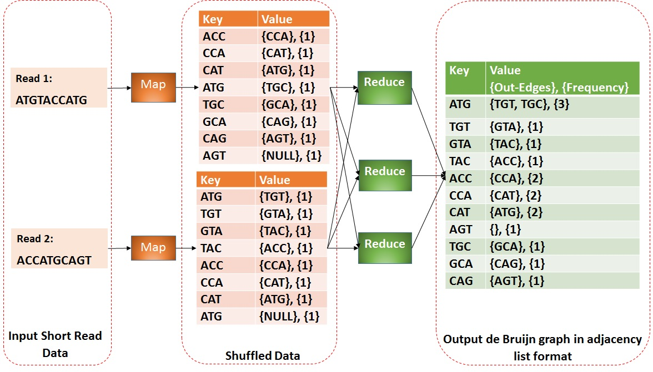

Figure 1 shows the overview of the MapReduce job. The map function scans through each line of the data file (written in fastq format) and filters out the lines containing only A, T, G, and C, i.e. , the nucleotide characters. These lines are called short reads, or simply reads, which represent a small fragment of the entire genome. Then the same map task divides each read into several short fragments of length k, known as k-mers. Two adjacent k-mers are emitted as an intermediate key-value pair that represents a vertex and an edge (emitted from that vertex) in the de Bruijn graph. The reduce function aggregates the edges (i.e., the value-list) of each vertex (i.e., the k-mer emitted as a key) and, finally, writes the graph structure in the file system in an adjacency-list format. Based upon the value of k (determined by biological characteristics of the species), the job produces huge amounts of shuffled data. For example, for a read-length of 100 and k of 31, the shuffled data size is more than 6-times than the original short read input.

Experimental Testbeds:
Table 1: Cluster configuration
System Type | IBM | LSU SuperMikeII
Processor | Two 10-core IBM Power8 | Two 8-core Intel SandyBridge Xeon
Maximum #Nodes used in various experiment | 40 | 120
#Physical cores/node | 20 (8 Simultaneous Multi-Thread) | 16 (Hyper threading disabled)
#vcores/node | 160 | 16
RAM/node (GB) | 256 | 32
#Disks/node | 5 | 3
#Disks/node used for shuffled data | 3 | 1
Total Storage space/node used for shuffled data | 1.8 | 0.5
Network | 56Gbps InfiniBand ( non-blocking) | 40Gbps InfiniBand (2:1 blockings)
Table 1 compares two different types of clusters that we used in our experiments. The first one is the IBM Power8 based HPC cluster. Each Power8 824L server was equipped with 20 IBM Power8 Cores, each with maximum 8 SMTs available. Each server had 5-HDDs for improved sequential I/O bandwidth. Each node had 256GB RAM. All the Power8 nodes are inter-connected with an InfiniBand connection. We used 40 nodes for this benchmark evaluation.
In contrast, each LSU SuperMikeII node is equipped with two 8-core Intel SandyBridge Xeon processor, 32GB of RAM,and 1 500GB-HDD. All the nodes of SuperMikeII are connected with a 40Gbps InfiniBand network with 2:1 blocking ratio. The hyper-threading was disabled, since we there was no noticeable performance gain for these workloads.

Physical Compute/Storage Cluster schematic
Figure 2: 40 Nodes IBM Power S824L, SMT8 enabled. IBM Spectrum Scale Elastic Storage, 512TB.
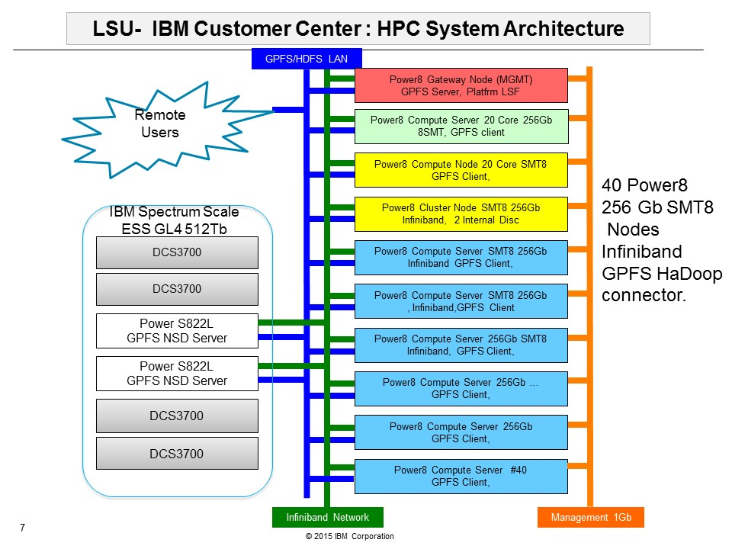

Processor
As mentioned in Table 1, each IBM Power8 node is equipped with 20 IBM Power8 cores operating at 3.42 GHz.. Each core can utilize 8 SMT threads (Simultaneous Multi-Threading), which equates to a total of 160 (20*8) virtual cores (vcores) visible to the OS. On the contrary, each SuperMikeII node has two 8-core Intel Sandy Bridge Xeon processors with 2.6GHz core speed, with hyper-threading disabled.
The high number of vcores enabled by the IBM Power8 SMT technology can accelerate data and compute-intensive scientific workloads tremendously, especially, when used in conjunction with YARN resource management. For example, a data-intensive Hadoop job can use a high number of concurrent YARN containers (mappers/reducer) while also using fewer vcores per container. On the other extreme, a severely constrained compute-intensive workload can launch fewer concurrent YARN containers while using more vcores per container. In our genome assembly workload, we optimized these numbers (i.e., the number of concurrent YARN containers, and the number of vcores per container) by observing prior job profiles.
Storage
To provide enough I/O bandwidth to each IBM Power8 node, we used 5 hard disc drives (HDDs) (1 x 300GB and 4 x 600GB) per node, which cumulatively provide almost ~500MBps I/O throughput (assuming ~100MBps per HDD). One 600GB drive was used for O/S and one 300GB HDD was configured as /scratch, where Apache Hadoop was installed. The other three 600GB drives were used for shuffle space (mounted as /shuffle1, /shuffle2, /shuffle3). This high I/O throughput is exactly in contrast with SuperMikeII, which only has available one HDD per node.
A system’s performance is always constrained by its slowest component, such as the I/O subsystem, or network, or both. A big data application, such as, our genome analytic application, on the other hand normally involves a huge number of I/O operations. In order to take advantage of the Power8 data processing capabilities, I/O throughput needs to also be maximized. The throughput of each compute node can be increased linearly by scaling up the I/O subsystem with more numbers of Direct Attached Storage (DAS) devices. However, it should be noted that after a certain threshold on I/O throughput, the disk controller can be saturated, i.e., adding more disks does not improve the application’s performance. We found that allowing three discs for shuffle space provided enough I/O throughput to optimize the performance.
Memory
Each IBM Power8 node had 256GB memory (RAM) as compared to only 32GB RAM in the LSU SuperMikeII system. The IBM node provides 16 independent, high bandwidth memory controllers, which allowed us to provide 16GB per memory controller. With the Intel system, due to the direct attached memory interface, adding more memory did not improve the memory bandwidth. Also, when using higher amounts of RAM in a server, we have seen smaller amounts of “garbage” collection frequency of a Java application (e.g., a Hadoop application). Utilizing higher amounts of memory may in fact improve the effect of caching. It is worthy to mention here, that the high computational speed of the Power8 processor eliminates the need for tuning Hadoop parameters related to memory buffer size (e.g., io.sort.mb, io.sort.factor, etc.) provided enough I/O bandwidth is available. These parameters are commonly increased for performance reasons.
For our Hadoop-based genome analytic workload, 256GB RAM per IBM Power8 node (with 20 IBM Power8 cores) was found to be a good balance between the high processing speed and the memory bandwidth required.
Network
The IBM customer center system uses two 108-port Mellanox SX6506 FDR 56Gbps InfiniBand switches with non-blocking I/O for a balanced architecture. The high network bandwidth (non-blocking 12.1Tbps) provided by the SX6506 switch enables the high throughput needed for the analysis and capabilities of IBM Power8 nodes. Comparatively, the LSU SuperMikeII cluster uses a 40Gbps InfiniBand network. Because the SuperMikeII cluster uses a 2:1 blocking factor, (a tradeoff between performance and price), the effective bandwidth between any two SuperMikeII:nodes is significantly reduced to only 950Mbps.
The choice of network architecture is critical to the performance of Hadoop. In particular, the shuffle phase of a Hadoop job involves a huge data movement across the cluster. At this point, the data network is a critical path, and its performance and latency directly impact the execution time of the entire job-flow. The choice of a high performance, low latency, InfiniBand network with non-blocking I/O successfully addresses the following issues:
- The current programming model, i.e., MapReduce,(in particular the shuffle phase) emphasizes bandwidth. Hence, the use of blocking is avoided.
- With the rapid evolution of processor and storage technologies, each host (or, compute node) is capable of processing data in multiple GB per sec. rates. Therefore, in order for a compute node to take the advantage of the increased I/O bandwidth and processing power, the network capacity should also be increased correspondingly.
Hadoop Configuration
In the entire benchmark evaluation, we used Apache Hadoop-2.5.2. The file system for the analysis was IBM Spectrum Scale 4.1.1 (GPFS with Hadoop connector) solution that has been on the market for many years. In this case we also used a new Hadoop GPFS connector. The GPFS Hadoop Connector provides a liaison between Hadoop MapReduce and the scalable parallel file system. The GPFS solution allows the system to utilize millions of high speed parallel files.

In this section, we briefly describe the most important Hadoop parameters that we configured to explore the application behavior atop IBM hardware.
Table 2 shows the Hadoop and YARN parameters that we used in the Power8 cluster and SuperMikeII for the most optimized performance in each of the clusters.
Table 2: Hadoop parameter.

Hadoop Parameters | IBM Power8 | SuperMikeII
Yarn.nodemanager.cpu.resource.vcore | 120 | 16
Yarn.nodemanager.memory.mb | 231000 | 29000
Mapreduce.map/reduce.cpu.vcore | 4 | 2
Mapreduce.map/reduce.memory.mb | 7000 | 3500
Mapreduce.map/reduce.java.opts | 6500m | 3000m

- Number of concurrent YARN containers: As Table 2 suggests, for our data- and compute-intensive genome analytic application, we launched 30 concurrent Yarn containers (mappers/reducers) per IBM Power8 node, where each container used 4 vcores. That amounts to a total of 120 vcores (out of 160) per node utilized, which was found to yield the most optimized performance. On the other hand, in SuperMikeII, we could only achieve the most optimized performance with 8 concurrent YARN containers per node with 2 vcores per container.
- Amount of memory and Java heap space per container: As it can be seen in Table 2, in each node of any cluster, we kept almost 10% of the memory for the system use. The rest of the memory was equally divided among the concurrently launched YARN containers. The Java heap space per worker is always set to lower than the memory per container, as per normal recommendation.

- Total number of reducers: Based on the observation of job profiles and prior experiences, we observed that 2-times the # of reducers than number of concurrent containers produced good performance in general cases.

Discussion: From the Hadoop configuration parameters, it is clear that the Power8 SMT technology helps increase the level of parallelism, both in the job, as well as, individual task level verses the Intel Xeon processor. Even though only 4 more cores exist in IBM Power 8 versus our Intel implementation, we found that turning on SMT8 thread capability accelerated the job significantly more.
Input Data
Table 3: Data set
Genome data set | Input size | Shuffle data size | Output size
Rice genome | 12GB | 70GB | 50GB
Bumble bee genome | 90GB | 600GB | 95GB
Metagenome | 3.2TB | 20TB | 8.6TB

Table 3 shows the details of the input data set that was used in the benchmark evaluation. We used three different data sets. The first one is a small size rice genome data set . The second one was a 90GB data set of a moderate size Bumble Bee genome data. We used this data set to make a comparative study between SuperMikeII and the IBM Power8 cluster. The data set is openly available on the public website of genome assembly gold standard evaluation (http://gage.cbcb.umd.edu/data/index.html).
The second dataset is a metagenome data set generated by the Joint Genome Institute (JGI). The huge volume of the data with complex computation make this analysis challenging. We were only able to analyze the second data set in a reasonable amount of time due to the availability of SMT8 technology.

Scalability Test of Hadoop atop Power8 SMT
Figure 3: Scalability of Hadoop with increasing SMT
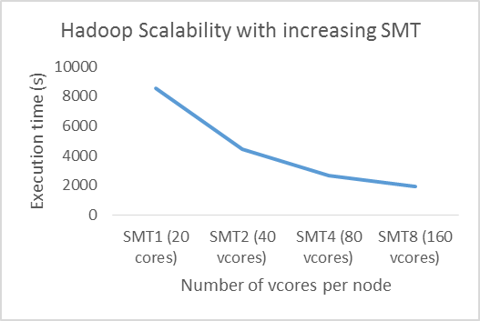
In this experiment, we tested the scalability of our Hadoop application with increasing SMT of Power8 processors. It is worthy to mention here that we performed this experiment on a 2-node IBM Power8 cluster with the smaller size (12GB) rice genome data set before the actual benchmark evaluation at the Poughkeepsie customer center took place. The motivation of this experiment was to analyze the job profiles of our genome assembler atop Power8 processor. In fact, we configured Hadoop (discussed earlier in this paper) based upon these experiments to get the most optimized performance.

Error: Reference source not found Shows the scalability of our Hadoop application with increasing the threads of each Power8 based node. We started with disabling SMT on all compute nodes. Then we increased it until SMT8, the maximum threading available per compute node. At the same time, we changed the number of concurrent Yarn containers (thus, number of mappers and reducers) according to the total number of vcores visible to the OS.

Evaluation of IBM Power8 Cluster for Hadoop
In this section, we compare the performance of IBM Power8-824L and Intel SandyBridge Xeon processor with respect to our benchmark genome assembler with varying size of data (shown in Table 3) atop two different clusters (shown in Table 1). For a fair comparison, the impact of I/O should be minimized. To do that we used the same number of disks in both of the clusters for each of the experiments, thus keeping the aggregated I/O throughput similar across both the clusters.
As shown in Table 1, each IBM node uses 3 disks and each SuperMikeII node uses 1 disk for shuffled data. Hence, for each of the experiments (which are all shuffle intensive as mentioned before), we used 3x more nodes in SuperMikeII than those used in the IBM Power8 cluster. Even though, this configuration always results in 2.4x fewer IBM Power8 physical cores than Intel Xeon physical cores, the Power8 cluster combined with SMT8 always showed 2.5x to 3x performance increase over SuperMikeII.
In summary, the IBM Power8 cluster combined with SMT8 rendered 7.5x to 9x speedup per compute server versus each Intel Xeon based LSU HPC cluster.
This high performance gain implies, even if HyperThreading (i.e., 2 threads/core) is enabled in SuperMikeII, and even if we assume Hadoop performance improves linearly with number of vcores (which is maximum and in most cases performance improves sublinearly), Power8 with SMT8 will show almost 3.75x to 4.5x speedup/server comparing to Intel Xeon.
Analyzing Small Size Rice Genome
Figure 4: Execution time of Rice genome
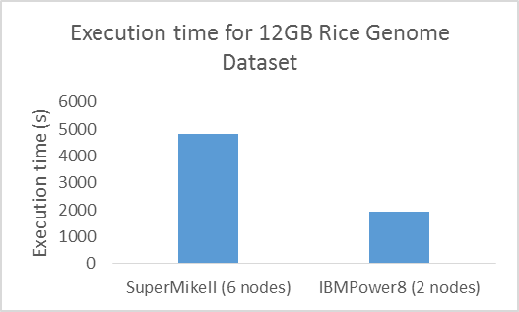
Figure 4 compares the execution time of the IBM Power8 cluster and Intel Xeon based SuperMikeII cluster for a small size (12GB) rice genome data set using 2 and 6 nodes respectively. The small size of data and small number of nodes minimizes the impact of network. On the other hand, 3x more SuperMikeII nodes than IBM Power8 nodes were required to keep the total I/O throughput similar across both the clusters. The IBM Power8 cluster rendered 2.5x performance improvement over the LSU SuperMikeII HPC cluster, while using 3x fewer nodes. In other words, the IBM cluster shows almost 7.5x improvement over SuperMikeII in terms of performance per server.
Analyzing Moderate Size Bumble Bee Genome
Figure 5: Execution time for 90GB Bumble Bee genome
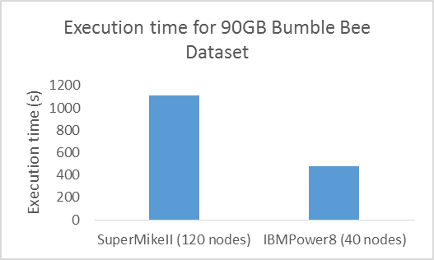

Figure 5 shows the execution time for graph construction in both IBM Power8 cluster and Intel Xeon based LSU HPC cluster (SupermikeII). We used 40 nodes in IBM Power8 cluster as opposed to 120 nodes in SuperMikeII. The IBM Power8 cluster combined with SMT8 rendered almost 3x performance improvement over the LSU SuperMikeII HPC cluster while using 3x fewer nodes and 2.4x fewer physical cores.

Analyzing Large Size 3.2TB Metagenome
Figure 6: Execution time for 3.2TB
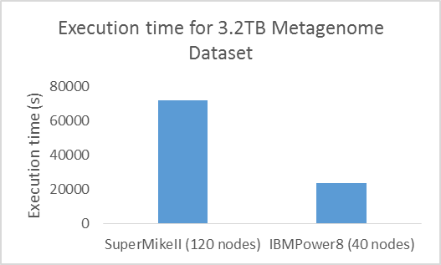
To explore the capability of IBM Power8 processor with large scale data, we analyzed a dataset size of 3.2TB of metagenome data. The process completed in 6 hours and 22 minutes on the IBM Power8 cluster using only 40 nodes. This same process takes more than 20 hours to complete on 120 Intel nodes available at LSU. That is, for this huge data set also the IBM cluster produced more than 3x performance improvement using 3x fewer nodes, thereby producing more than 9x improvement in terms of performance/server.

Evaluating GPFS for Hadoop
Benefit of IBM Spectrum Scale over HDFS
As mentioned earlier, we used IBM Spectrum Scale (formerly GPFS) as the underlying distributed file system. All Hadoop applications run as is or with very minimal changes if Spectrum Scale is used as the underlying file system instead of HDFS. Spectrum Scale is a global parallel file system and offers several features to benefit large scale big data clusters in terms of easy and cost effective data management. Some of the advantages of using GPFS over HDFS are as follows:

- Integrating Different Analytic Environment: IBM spectrum scale is POSIX compliant. It providess a seamless environment for Hadoop and other traditional HPC analytic environment. For example, the output of an MPI application can easily work as an input to a Hadoop application. And vice versa.
- Information Life-cycle Management (ILM): Spectrum Scale ILM policies can enable automatic archiving of unused or aging data to low performance disks. This is a major advantage over HDFS which minimizes the continually growing storage cost.in a big data analytic cluster.
- Fault tolerance: Spectrum Scale does not have any single points of failure, whereas HDFS has a single point of failure (i.e., the Hadoop NameNode).
- Storage Space: Furthermore, HDFS is mounted on local storage of compute nodes which may be limited in terms of storage capacity in an HPC cluster. GPFS uses dedicated I/O servers and normally provides a huge amount of storage space required in a big data HPC environment.

IBM Spectrum Scale as Temporary Shuffled Data Storage
Figure 7: GPFS I/O throughput
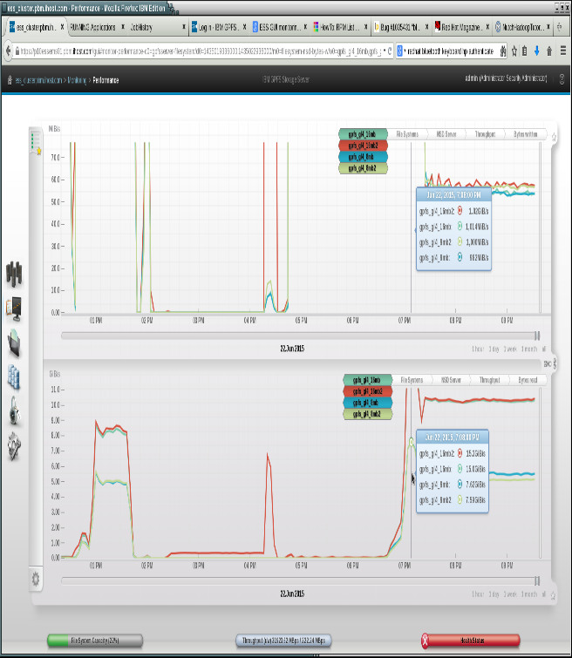

Figure 8: Performance comparison between local file system and GPFS as shuffle data storage
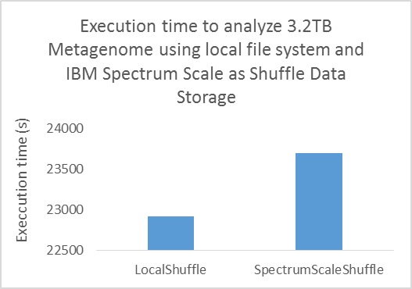

In this section, we explore the possibility of IBM Spectrum Scale as a storage space for temporary shuffled data. In general, Hadoop uses the local file system that is mounted on the DAS device of the compute node to keep the temporary shuffled data. As mentioned earlier, for a shuffle intensive Hadoop job, we observed the following two bottlenecks in an HPC cluster:
- Limited storage space: Traditionally the HPC cluster has a lower amount of storage space attached to compute nodes as compared to that in the dedicated I/O servers. This may be a bottleneck for shuffle intensive Hadoop jobs
- Limited sequential I/O throughput causes I/O wait: Because of lower number of DAS devices (normally HDD) the shuffle phase becomes I/O bound, resulting in a huge amount of I/O wait.
If GPFS can be configured properly to store this temporary shuffled data, then a shuffle intensive Hadoop job (such as, our Hadoop-based de Bruijn graph construction which produces more than 6 times shuffled data than the original input) can take advantage of the huge storage space and the optimized I/O throughput. We configured the Spectrum Scale file system to utilize one directory for each compute node, with 6 shuffle directories within each for that node's shuffle data. In both of the cases, we used the default round robin scheduling of YARN to spread the temporary shuffle data across multiple directories.
Error: Reference source not found shows GPFS yielding high I/O throughput (Peak 44GiB/s) during the shuffle phase of our Hadoop job when configured properly. Error: Reference source not found shows the execution time of the metagenome analysis executing in similar time scale for both the cases (6hrs35min for GPFS shuffle comparing to 6hrs22min for local shuffle).
.
What next?
Based on these results, LSU joined the OpenPower Foundation. This allowed IBM and LSU-CCT staff to have deeper technical collaboration and provide unique science innovations using even more technologies from IBM. The 2nd phase of the Genome analysis is being refined through the use of Key-Value-Store NOSQL analysis. This analysis will take advantage of the patented IBM CAPI® interface (Coherent Accelerator Processor Interface) attached to an IBM Flash Array system. This CAPI interface and the IBM Flash storage array effectively provide the Power8 processors with 40TB of main memory. This technology will advance the MetaData key value store calculations through a NOSQL database implementation. Preliminary results are already very promising with a 20TB Processor memory CAPI® extension.

Article authors and contributors:
LSU: Seung-Jong, Jay Park, Ph.D.
Arghya Kasum Das, PhD Student. Author
Richard Platania, PhD Student
Sayan Goswami, PhD Student

IBM: Frank Lee, PhD., Healthcare Life Sciences Industry Leader, IBM SDFS.
Ravi Arimilli, IBM Fellow, IBM Research
Terry Leatherland, Systems Architect, IBM Systems Group
JoAnna Wong, PhD. IBM Software Defined Infrastructure Architect.
John Simpson, IBM Power Systems Technical Computing Team lead, IBM Customer Center.
Grace Liu, IBM Client Technical Specialist
JinChun Wang, IBM Client Technical Specialist

© Copyright IBM Corporation
©Copyright Louisiana State University.

IBM, the IBM logo, and ibm.com are trademarks of International Business Machines Corp., registered in many jurisdictions worldwide. Other product and service names might be trademarks of IBM or other companies.
A current list of IBM trademarks is available on the web at “Copyright and trademark information” at ibm.com/legal/copytrade.shtml

THIS INFORMATION IS PROVIDED TO YOU 'AS IS' WITHOUT REPRESENTATIONS OR WARRANTIES OF ANY KIND EITHER EXPRESS OR IMPLIED. IBM CORPORATION (“IBM”) AND ITS SUPPLIER, ALINEAN INC., (“ALINEAN”) DISCLAIM ALL WARRANTIES PERTAINING TO THE INFORMATION PROVIDED, INCLUDING, BUT NOT LIMITED TO, IMPLIED WARRANTIES OF MERCHANTABILITY OR FITNESS FOR A PARTICULAR PURPOSE. IBM AND ALINEAN DO NOT WARRANT OR MAKE ANY REPRESENTATIONS REGARDING THE USE, VALIDITY, ACCURACY OR RELIABILITY OF THE INFORMATION, OR THE RESULTS OF THE USE OF THE INFORMATION. IN NO EVENT SHALL IBM NOR ALINEAN BE LIABLE FOR ANY DAMAGES, INCLUDING THOSE ARISING AS A RESULT OF IBM’S OR ALINEAN'S NEGLIGENCE. WHETHER THOSE DAMAGES ARE DIRECT, INDIRECT, CONSEQUENTIAL, INCIDENTAL, OR SPECIAL, RELATING TO THE INFORMATION PROVIDED HEREWITH EVEN IF IBM OR ALINEAN HAS BEEN ADVISED OF THE POSSIBILITY OF SUCH DAMAGES. THE INFORMATION IS PROVIDED FOR ILLUSTRATIVE PURPOSES ONLY, AND THE RESULTS YOU OBTAIN BY USING THE IBM PRODUCT MAY VARY.

IBM products are warranted according to the terms and conditions of the agreements under which they are provided. The client is responsible for ensuring compliance with laws and regulations applicable to it. IBM does not provide legal advice or represent or warrant that its services or products will ensure that the client is in compliance with any law or regulation.

