## Big Data and Hadoop Development

## Session1 Assignment 1

1. *Import Appliance*

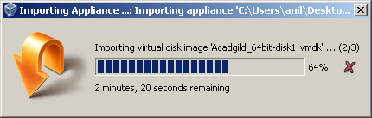

1. Successfully installation of Acadgild_64bit machine

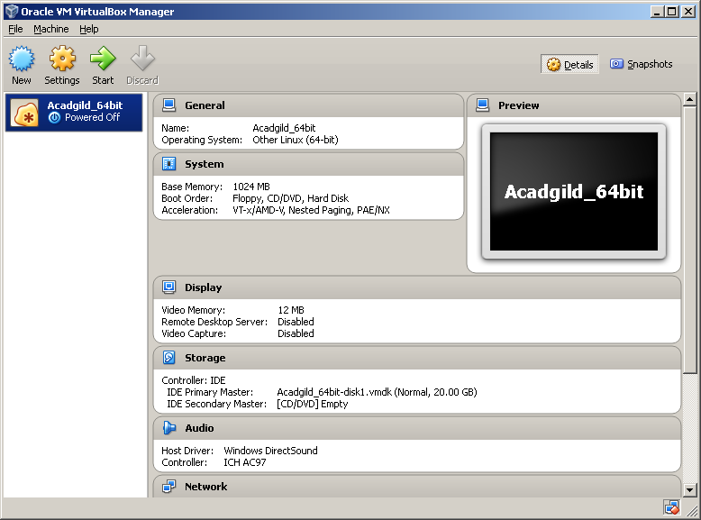

1. Current list of daemons



1. Starting ssh server



1. Starting all daemons

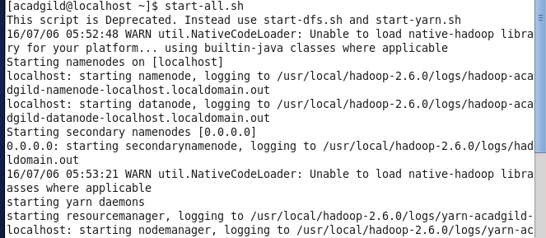

1. Starting history server



1. Start pig in hdfs mode

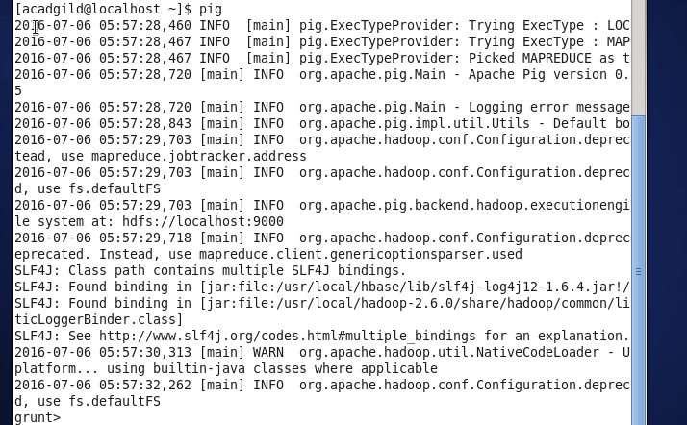

1. Starting mysql service



1. Starting hive

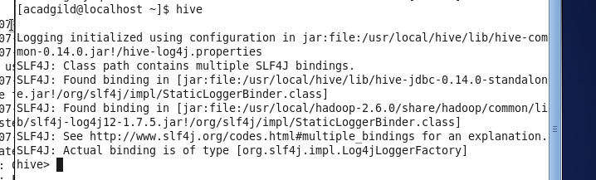

1. Starting hbase



1. View all service

