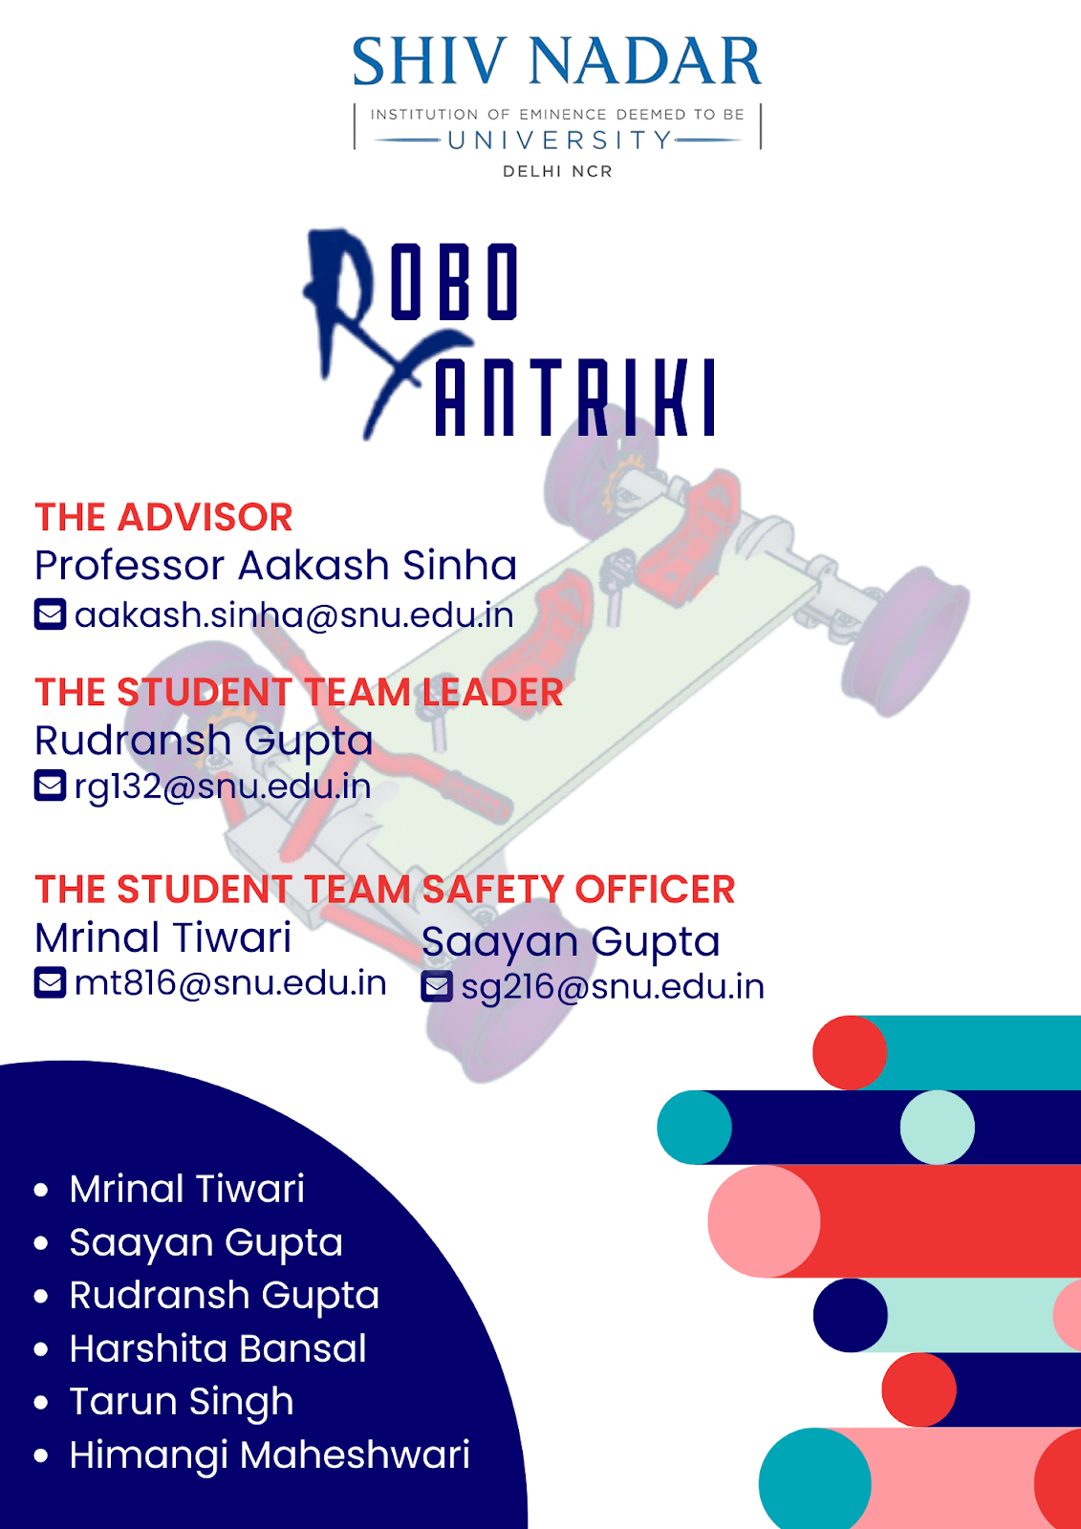

8th August 2022

**Facilities and Equipment**

 Our institution has a fully working and maintained Manufacturing Lab with Industry level heavy Machinery, which we intend to use to build our rover.

With a team of professional lab assistants, training to use industry-level heavy machinery will be given to every team member to ensure safety.

All safety protocols will be kept in mind and followed rigorously.

We plan on procuring all our supplies from Industry Websites and Locally available yet certified raw materials.

Our lab assistants will give a minimum of 72hours of extensive training to each team member to operate the machinery.

Manufacturing process machines

·       Milling machine

·       Semi-automatic lathe machine

·       Radial drilling machine

·       Bench grinder

·       Surface grinder

·       Automatic lathe machine

·       Power hacksaw machine

·       Slotting machine

·       Tig welding

Tool And Inventory Check List

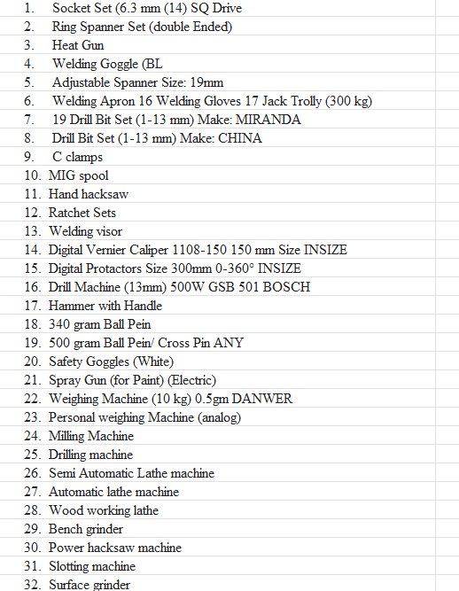

Supplier selection criteria

The materials will be selected keeping in mind the following points:

* Cost
* Quality & Safety
* Delivery
* Service
* Social Responsibility
* Convenience/Simplicity
* Risk
* Agility

Bill of Material

|  |  |
| --- | --- |
| Material | Price $ |
| ASIS 4130 | 90 |
| Raw Material for mounts | 188 |
| Rain guards | 10 |
| paint | 26 |
| seatbelts | 130 |
| helmets | 100 |
| Wide handlebars | 86 |
| Rack and Pinion system | 188 |
| Joints | 135 |
| Wishbones | 252 |
| H-arm | 125 |
| Camberlink | 10 |
| Ball joints | 65 |
| Shock absorber | 500 |
| Tires | 150 |
| Belt system | 400 |
| Paddles | 20 |
| Gearheads | 80 |
| Disc brakes | 125 |
| Rim | 30 |
| Lock, Nuts | 50 |
|  |  |

PFMEA

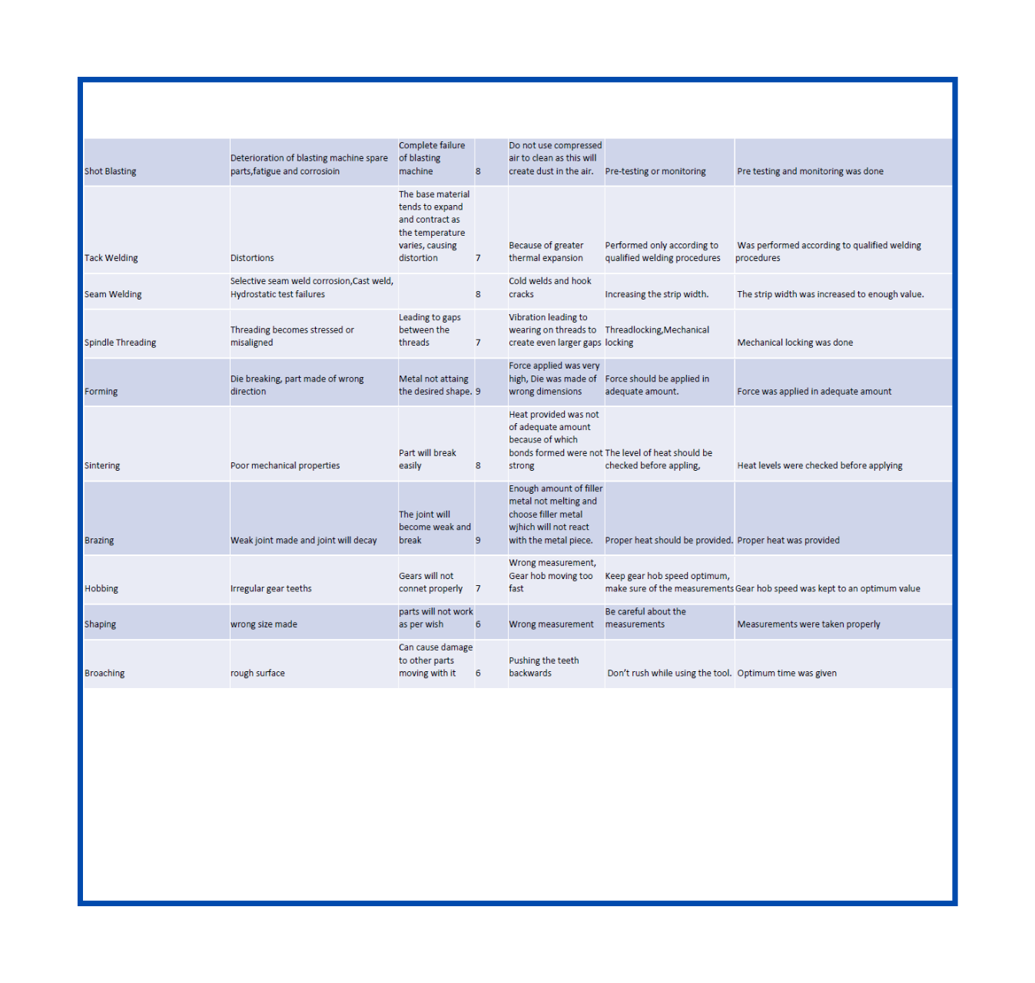

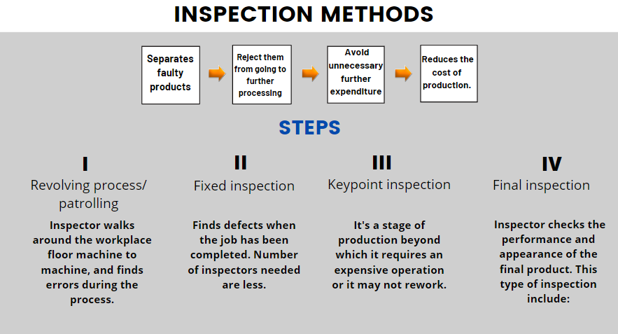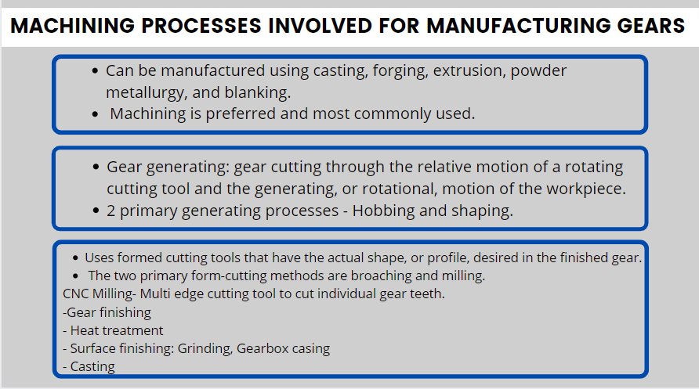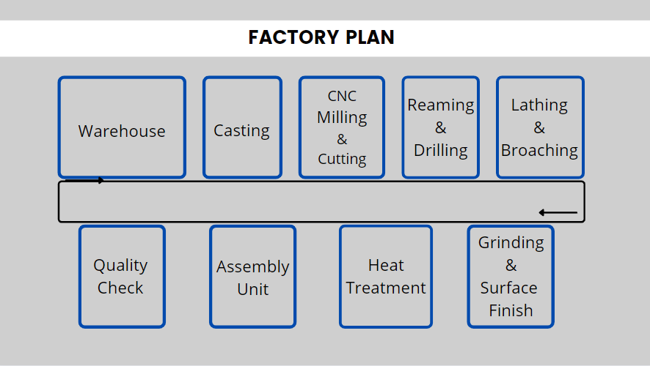

**Safety**

We will put a belt cover so that the pilot's body never encounters the running belt protecting the pilot. We will cover the pilot with a mudguard to protect the pilot from the rotating tires. All the rover's chassis edges will be rounded to protect the pilots from any injuries. We will keep the rover's centre of gravity (plus drivers) minimum, i.e., 12 inches, to prevent it from rolling over at slopes and greater angles. There are chances, while driving, some particles or debris from the tires may fly and hit the chassis and the pilots sitting inside, so we plan to use a V-shaped base in the front of the rover to prevent the same for the personal safety measures to be taken by the pilot. We will provide the pilots with helmets, gloves, arm-caps, kneecaps, and proper riding jackets.

**Technical Design**

Wheels

We intend to use cascading grip tires because they have a better grip than the regular treads and will aid us in quickly moving our rover, giving us extra torque for the 30-degree inclined plane ascend. Our Tire width profile will be moderate, keeping in mind the manoeuvrability of our rover for the entire course, especially the asteroid debris and mars terrain obstacle, where the width of tires will be very crucial.

Seat

We intend to put in rotating cushioned bucket seats. The main reason for using them is that drivers need to be able to seat themselves solidly to provide plenty of lower-back pushing power, and bucket seats have that quality of holding the driver tight. Additionally, bucket seats reduce vehicle weight. Aside from that, we planned to rotate the seats by providing a lever to control the rotation as per the course requirement.

Seat Belts

Seat belts play an essential role in all such activities, so we are planning to use a racing harness as Standard seat belts are attached to three points while racing harnesses have five or six points in total. Plus, harnesses are designed to keep the driver perfectly secure in the seat, whereas seat belts are designed to stretch and minimize momentum during a collision. Moreover, racing harnesses offer much more protection by helping the driver remain in their seat and protecting their head and neck. It is safer because racing harnesses are designed so that we can disengage quickly with just the push of a button.

Disc Brakes

In our rover, we are planning to use disk brakes for the purpose of stopping our vehicle. One of the reasons for using this is that they are quite less in weight and will help to lighten the weight of the vehicle.

Moreover, they give us better braking control over rim brakes. They allow us wider tire options. They give us a better stopping power and perform better in off-road conditions. Also, they last longer than brake pads. Braking performance is less likely to be affected by dust, debris, water or rust contamination.

Gears

For gears, we plan to use two gears of different sizes. We will be using one small and one larger one.

The smaller one rotates more with a lesser number of paddles, so it will help us to gain speed and cover up a larger distance in a lesser period. The bigger one rotates less if compared to the number of paddles we push, but it instead provides us with a stronger torque which will make it possible for the rover to tackle stronger angles and rocky surfaces.

Suspension

We will provide a separate suspension for each wheel of the rover. We are going to put Coil over (with adequate stiffness calculated using sound engineering). Suspension is one of the most important components required for a vehicle a rover helps the vehicle to make the most contact between the tires and the surface which is very much required on uneven ground to prevent it from getting stuck. Suspensions will provide us with consistent handling and breaking, more comfort for the passengers and will reduce the pressure on the chassis.

Drivetrain

Belt drives are simple, inexpensive, and do not require axially aligned shafts. They help protect machinery from overload, jams, and dampness and isolate noise and vibration. Load fluctuations are shock-absorbed (cushioned). Different speeds can be obtained utilizing step or tapered pulleys. They need no lubrication and minimal maintenance.

Sample Retrieval

For the task "Liquid Sample Retrieval from Cave," We will use a retractable hand-operated pump, long enough to go deep inside the cave to collect the sample.

For the "Underground Liquid Sample Retrieval" task, we are required to open and close the 15 pounds (6.8kgs) lid. To tackle this task, we will use an electromagnetic plate that will attach itself to the underground reservoir lid and use the hand-operated pump to receive the sample from the reservoir.

Chassis

We plan on using H-shaped chassis for optimum stability and sheer comfort. We will modify the chassis so that it is foldable, and its folded dimension comes under the 5x5x5 ft. guideline set by the organizers. We will ensure our machine has sufficient strength to handle the stresses experienced by those hinges or fold points once the rover is assembled or unfolded. Our rover will be fully equipped with essential components like a telemetry program and telemetry watches for the drivers, through which we would be able to track the rover's performance and the drivers' health data.

Manoeuvrability

The function of handlebar raisers is to make the rover more comfortable by altering the position of the handlebars, such as raising them or removing them from the rider based on the needs of the rider. Bar risers are used by most riders to make seating more natural and comfortable for their riding. While drop bars do excel on faster and longer rides, on taking an objective look at both handlebar designs, it's clear that riser bars are the best option for most people. The higher steering leverage allows for better bike control, both at high and low speeds.

Also, these are supportive as they provide us with enough confidence to manoeuvre the rover on a slanted surface because the body weight will be perpendicular which will make sure the driver position is optimal.

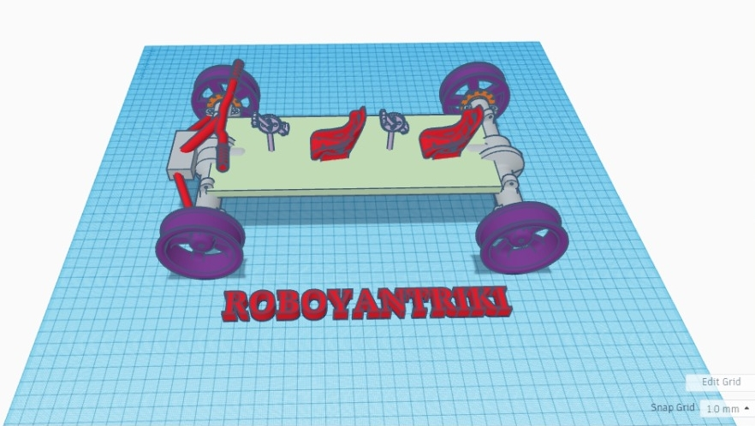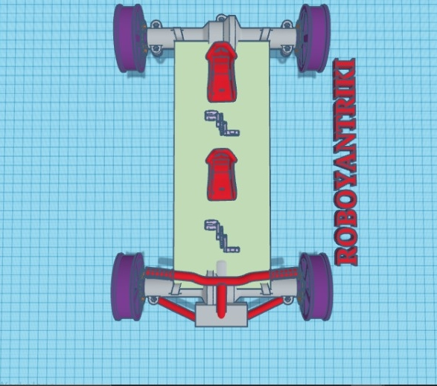

Assuming the weight of the Vehicle to be 80 Kg and the track to consists of Sand, Dirt, Debris and Soil

Rolling Resistance

RR = CWG * g * Crr

       = 80 * 9.81 * 0.12 (Crr = 0.12, Avg. of track resistance)

       = 94.17 N

Avg. grade Resistance

GR = CWG * g * sin(theta) (theta is the angle of inclination, 30deg)

      = 80 * 9.81 * 0.5

      = 39.24 N

Acceleration Force

FA = m*a

     = 80*1.5

     = 120 N

Total Tractive Effort

TTE = FA + GR + RR

        = 120 + 39.24 + 94.17

        = 253.41 N

Max Torque at Wheel

T = (static coefficient * Wrf * GVW * Rwheel /2)

   = (0.12 * 0.6 * 290 * 9.81 * .2921) / 2

   = 59.8 Nm

For Gradeability (Vertical dist. To horizontal distance covered)- tan (30°) *100 = 0.5773*100 = 57.73%

**Project Plan**

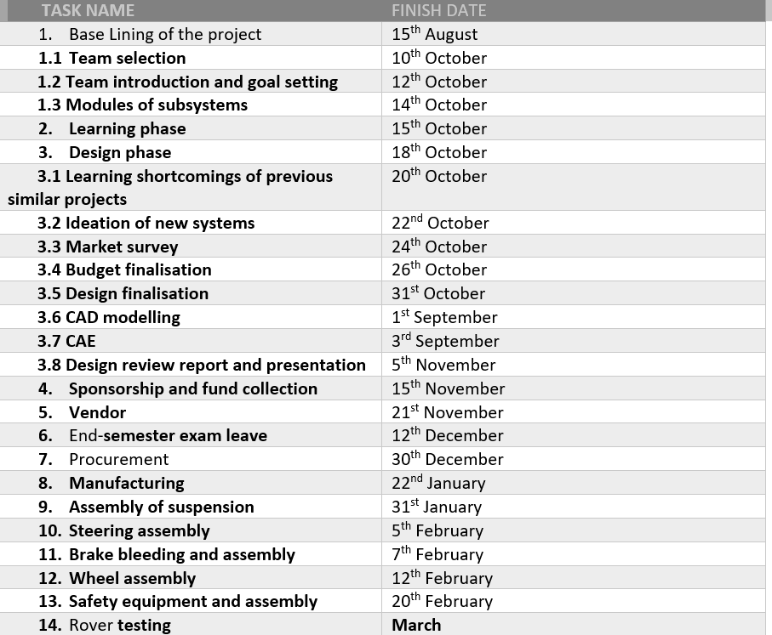

We plan to compete with a budget of 63 thousand dollars ($63,000), which covers all aspects necessary to complete the project successfully, including travel, accommodation, and transportation. The budget includes both materials and supplies the team already has on hand, and the team will need to purchase.

Our team is fully sponsored by our institution, Shiv Nadar Institutes Fund.