Tarun Singh

Researched on types to ways to power the vehicle.

In that:-

Our primary focus was *not to use chain and sprocket system* as they weren’t encouraged in the competition.

*Researched on belt drive systems.*

Its advantages and disadvantages.

Advantages of belt system

Cost-effective

Simple to use

No need for parallel shaft

Come with jam protection

Load fluctuations are shock absorbed

Reduce noise and vibrations

Disadvantages of belt System

Not compact

Greater wear and tear

Inflict heavy load on shafts

Angular velocity not constant

Operating temperature at -35° to 85°C

Velocity not constant due to V-belt slip

Types of belt systems.

--Round Belt

--Flat Belt

--V shaped belt

--Toothed belt

--Link belt

Researched on gear systems and types of them, their advantages, and disadvantages.

Advantages of Gearbox

They are non-slip drives

Mechanically strong

Deliver high transmission efficiency

Ideal for low, medium, and high-power transmission

More compact compared to belts and chains

They can transmit motion over small center distance of shafts

Disadvantages of Gearbox

Cannot be used for shafts with large center distances

Not ideal for large velocities

Need regular lubrication

Multiple gears raise machine overall weight

They have no flexibility

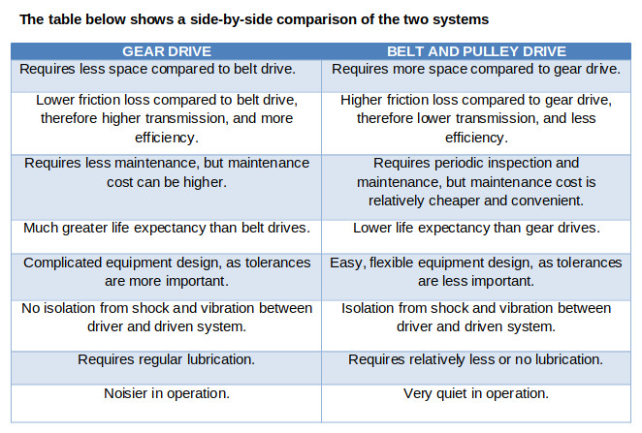

In these, also checked which of them would be appropriate to use in the rover as per the lunar and Martian surface conditions, as they are different from our normal earthy surfaces.

**Advantages of gears**

1. By using gear trains, large [velocity ratio](http://www.polytechnichub.com/velocity-ratio-of-machine-formula/) can be obtained with minimum space.
2. Gears are mechanically strong, so higher loads can be lifted.
3. Gears are used for transmission of large H.F.
4. They are used for transmitting motion over small centre distance of shafts
5. They are used for large reduction in speed and for transmission of torque.
6. Gears require only lubrication, hence less maintenance is required.
7. Using gear systems, we can transmit motion between non-parallel intersecting shafts.
8. They are used for positive drive, so its [velocity](http://www.polytechnichub.com/velocity-time-graph/) ratio remains constant.
9. They have long life, so the gear system is very compact.

**Disadvantages of gears**

1. They are not suitable for large [velocities](http://www.polytechnichub.com/velocity-time-graph/).
2. They are not suitable for transmitting motion over a large distance.
3. Due to the engagement of toothed wheel of gears, some part of machine may get permanently damaged in case of excessive loading.
4. They have no flexibility.
5. Gear operation is noisy.

I am in the drivetrain team of the rover

I have researched on different ways to power our vehicle manually.

First of all, which comes to our mind is Chain and sprocket system, but because it is not encouraged in our rover, I have not considered it for our rover.

Secondly the next one which comes is  
the belt system,

It could have been a better option, as it is simple, cost effective and it makes it jam protected. Also, it produces comparatively low noise and vibrations.

But the problems with this system is that it is not compact, it results in a lot of wear and tear its biggest drawback is

It is not possible at places with high torque applications and because in this competition we will require high torque at the tasks, Belt system goes out of the question.

Not to use

Not possible with high torque applications

I can say that for now, we don’t have a better alternative than Gearbox.

Benefits of it are:

Benefits, Advantages

How to use gearbox (implementation)

I have also worked on materials of chassis.

ASIS 4130