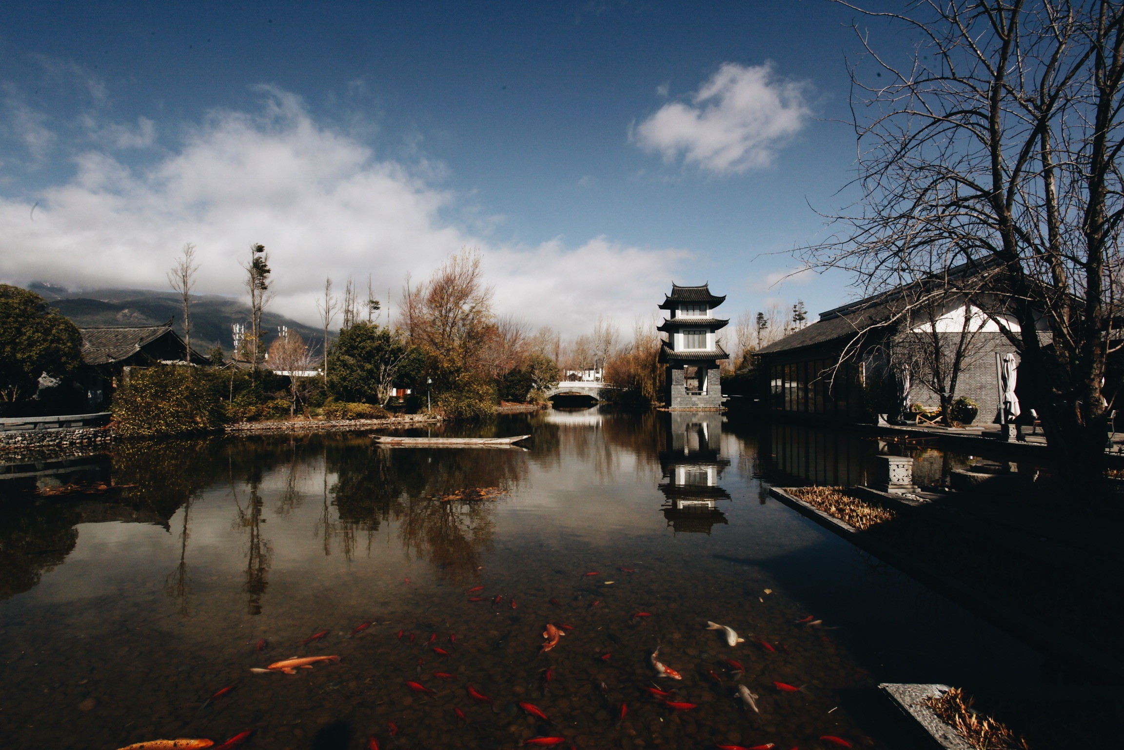

Retrieval Functions and Evaluations

Homework writeup

Tianye Song | CS 6501 | 4/13/17

# Question 1:

Ranking Algorithm Implementations:

|  |  |
| --- | --- |
| Boolean  Dot  Product | **protected** **float** score(BasicStats stats, **float** termFreq, **float** docLength) {  **return** 1;  } |
| TFIDF  Dot  Product | **protected** **float** score(BasicStats stats, **float** termFreq, **float** docLength) {  **double** firstComp = 1 + Math.*log*(termFreq);  **double** secondComp = Math.*log*((stats.getNumberOfDocuments() + 1)/(stats.getDocFreq()));  **double** s = firstComp * secondComp;  **return** (**float**)s;  } |
| Pivoted Length Normalization | **protected** **float** score(BasicStats stats, **float** termFreq, **float** docLength) {  **double** s = 0.75;  **double** comp1, comp2, comp3;  comp1 = (1 + Math.*log*(1 + Math.*log*(termFreq))) / (1 - s + s * docLength / stats.getAvgFieldLength());  comp2 = 1;  comp3 = Math.*log*((stats.getNumberOfDocuments() + 1) / (stats.getDocFreq()));  **double** result = comp1 * comp2 * comp3;  **return** (**float**)result;  } |
| Okapi BM25 | **protected** **float** score(BasicStats stats, **float** termFreq, **float** docLength) {  **double** k1=1.5, k2=750, b=1.0;  **double** comp1, comp2, comp3;  comp1 = Math.*log*((stats.getNumberOfDocuments() - stats.getDocFreq() + 0.5) / (stats.getDocFreq() + 0.5));  comp2 = ((k1+1) * termFreq) / (k1 * (1 - b + b * docLength/stats.getAvgFieldLength()) + termFreq);  comp3 = ((k2 + 1) * 1) / (k2 + 1); // here we assume thatt c(w;q)=1  **double** s = comp1 * comp2 * comp3;  **return** (**float**)s;  } |
| Jelinek Mercer | **protected** **float** score(BasicStats stats, **float** termFreq, **float** docLength) {  **double** lambda = 0.1;  **double** a,b;  **double** pwc = model.computeProbability(stats), pml = termFreq/docLength;  a = (1-lambda) * pml + lambda * pwc;  b = lambda * pwc;  **double** result = Math.*log*(a/b);  **return** (**float**)result;  } |
| Dirichlet Prior | **protected** **float** score(BasicStats stats, **float** termFreq, **float** docLength) {  docLen = docLength;  **double** mu = 2500; // default  **double** alphad = mu / (mu+docLength);  **double** a,b;  **double** pwc = model.computeProbability(stats);  a = (termFreq + mu * pwc)/(mu + docLength);  b = alphad * pwc;  **double** result = Math.*log*(a/b);  **return** (**float**)result;  }  **public** **float** getDocLen() {  **return** docLen;  } |

To add the term |q|log(ad) back to the Language Models, updated runSearch method in Searcher.java:

**private** SearchResult runSearch(Query luceneQuery, SearchQuery searchQuery)

{

**try**

{

System.***out***.println("\nScoring documents with " + indexSearcher.getSimilarity().toString());

Similarity sim = indexSearcher.getSimilarity();

**double** len = 0; // have to do this to figure out query length in the LM scorers

**if**(sim **instanceof** JelinekMercer)

{

Set<Term> terms = **new** HashSet<Term>();

luceneQuery.extractTerms(terms);

((JelinekMercer) sim).setQueryLength(terms.size());

len = terms.size();

}

**else** **if**(sim **instanceof** DirichletPrior)

{

Set<Term> terms = **new** HashSet<Term>();

luceneQuery.extractTerms(terms);

((DirichletPrior) sim).setQueryLength(terms.size());

len = terms.size();

}

TopDocs docs = indexSearcher.search(luceneQuery, searchQuery.fromDoc() + searchQuery.numResults());

ScoreDoc[] hits = docs.scoreDocs;

**if**(sim **instanceof** JelinekMercer)

{

**for**(ScoreDoc hit : hits)

hit.score += len * Math.*log*(0.1); // add back

}

**else** **if**(sim **instanceof** DirichletPrior)

{

**float** docL = ((DirichletPrior) sim).getDocLen();

**for**(ScoreDoc hit : hits){

**double** alphad = 2500 / (2500+docL);

hit.score += len * Math.*log*(alphad); // add back

}

}

// sort

**boolean** swapped = **true**;

**int** j = 0;

ScoreDoc tmp;

**while** (swapped) {

swapped = **false**;

j++;

**for** (**int** i = 0; i < hits.length - j; i++) {

**if** (hits[i].score < hits[i + 1].score) {

tmp = hits[i];

hits[i] = hits[i+1];

hits[i+1] = tmp;

swapped = **true**;

}

}

}

//

String field = searchQuery.fields().get(0);

SearchResult searchResult = **new** SearchResult(searchQuery, docs.totalHits);

**for**(ScoreDoc hit : hits)

{

… // the rest code remains unchanged.

}

Evaluation Function Implementations

Modified defaultNumResults to be 100000, so that all documents in the corpus are returned.

|  |  |
| --- | --- |
| Average  Precision | **private** **static** **double** AvgPrec(String query, String docString) {  ArrayList<ResultDoc> results = *_searcher*.search(query).getDocs();  **if** (results.size() == 0)  **return** 0; // no result returned  HashSet<String> relDocs = **new** HashSet<String>(Arrays.*asList*(docString.split(" ")));  **int** i = 1;  **double** avgp = 0.0;  **double** numRel = 0;  System.***out***.println("\nQuery: " + query);  **for** (ResultDoc rdoc : results) {  **if** (relDocs.contains(rdoc.title())) {  numRel ++;  avgp += (numRel / i);  System.***out***.print(" ");  } **else** {  System.***out***.print("X ");  }  System.***out***.println(i + ". " + rdoc.title());  ++i;  }  // compute average precision here  **if** (numRel == 0)  **return** 0;  avgp /= numRel;  **return** avgp;  } |
| P@10 | **private** **static** **double** Prec(String query, String docString, **int** k) {  ArrayList<ResultDoc> results = *_searcher*.search(query).getDocs();  **if** (results.size() == 0)  **return** 0;  **if** (results.size() < k)  k = results.size();  HashSet<String> relDocs = **new** HashSet<String>(Arrays.*asList*(docString.split(" ")));  **double** p_k = 0;  **double** numRel = 0;  **for**(**int** i = 0; i < k; i++){  **if** (relDocs.contains(results.get(i).title())){  numRel ++;  }  }  p_k = numRel / k;  **return** p_k;  } |
| Reciprocal  Rank | **private** **static** **double** RR(String query, String docString) {  ArrayList<ResultDoc> results = *_searcher*.search(query).getDocs();  **if** (results.size() == 0)  **return** 0;  HashSet<String> relDocs = **new** HashSet<String>(Arrays.*asList*(docString.split(" ")));  **double** relPosition = 0;  **double** rr = 0;  **for** (ResultDoc rdoc : results) {  **if** (relDocs.contains(rdoc.title())) {  relPosition = results.indexOf(rdoc)+1;  **break**;  }  }  **if** (relPosition == 0)  **return** 0;  rr = 1/relPosition;  **return** rr;  } |
| NDCG@10 | **private** **static** **double** NDCG(String query, String docString, **int** k) {  ArrayList<ResultDoc> results = *_searcher*.search(query).getDocs();  **if** (results.size() == 0)  **return** 0;  **if** (results.size() < k)  k = results.size();  HashSet<String> relDocs = **new** HashSet<String>(Arrays.*asList*(docString.split(" ")));  **double** numRel = 0;  **double** DCG = 0, IDCG=0;  **for**(**int** i = 0; i < k; i++){    **if** (relDocs.contains(results.get(i).title())){  DCG += 1/(Math.*log*(2+i) / Math.*log*(2));  numRel ++;  }  **else** {  DCG += 0/(Math.*log*(2+i) / Math.*log*(2));  }  }  // calculate ideal DCG  **for**(**int** i = 0; i<numRel; i++){  IDCG += 1/(Math.*log*(2+i) / Math.*log*(2));  }  **if** (IDCG == 0)  **return** 0;  **double** ndcg = DCG / IDCG;  **return** ndcg;  } |

Performances with Default Parameter Settings

|  |  |  |  |  |
| --- | --- | --- | --- | --- |
|  | MAP | P@10 | MRR | NDCG@10 |
| Boolean Dot Product | 0.23 | 0.29 | 0.59 | 0.62 |
| TFIDF Dot Product | 0.26 | 0.31 | 0.68 | 0.68 |
| Pivoted Length Normalization | 0.17 | 0.24 | 0.44 | 0.52 |
| Okapi  BM25 | 0.24 | 0.31 | 0.59 | 0.63 |
| Jelinek-Mercer | 0.28 | 0.34 | 0.68 | 0.69 |
| Dirichlet  Prior | 0.20 | 0.24 | 0.54 | 0.55 |

# Questions 2:

## bm25 parameter tuning:

There are three parameters to tune for BM25 model: k1, k2 and b, where:

k1∈[1.2,2],k2∈(0,1000),b∈[0.75, 1.2]

In this case, I manipulate the three parameters sequentially, starting with k1.

First, try extreme values for k1, with k2 = 750 and b = 1:

|  |  |  |  |
| --- | --- | --- | --- |
| K1 | 1.2 | 1.5 | 2 |
| MAP | 0.252 | 0.238 | 0.219 |

In this case, k1 = 1.2 yields max MAP.

Now try extreme values for k2 and see how MAP changes, with k1 = 1.2 and b = 1:

|  |  |  |  |
| --- | --- | --- | --- |
| K2 | 1 | 750 | 1000 |
| MAP | 0.252 | 0.252 | 0.252 |

Surprisingly, the changes in k2 does not affect MAP in this case.

The last parameter to tune is b. Let’s try corner cases for b, with k1 = 1.2 and k2 = 750

|  |  |  |  |
| --- | --- | --- | --- |
| b | 0.75 | 1 | 1.2 |
| MAP | 0.283 | 0.252 | 0.216 |

Seems like b = 0.75 gives the best MAP.

In summary, the parameter set with highest MAP yield is k1 = 1.2, b = 0.75, where k2 can be any real number R, such that R ∈(0,1000).

DP (Dirichlet Prior) PARAMETER TUNING:

There is one parameter, mu, for DP. The homework instruction spells out specifically that empirically the value for mu lies between 2000 to 3000.

I start out with testing MAP values for extreme mu values, namely mu = 2000, as well as mu = 3000

|  |  |  |  |
| --- | --- | --- | --- |
| Mu | 2000 | 2500 | 3000 |
| MAP | 0.200 | 0.196 | 0.190 |

Thus, empirically speaking, with mu = 2000 the DP model gives the best MAP of 0.200.

# Question 3:

With the optimal parameter setting for BM25 (k1 = 1.2, b = 0.75, k2 = 750), I obtain the following results:

|  |  |  |  |  |
| --- | --- | --- | --- | --- |
|  | MAP | P@10 | MRR | NDCG@10 |
| All filters active | 0.28 | 0.35 | 0.68 | 0.70 |
| No lowercase Filter | 0.28 | 0.35 | 0.68 | 0.70 |
| No LengthFilter | 0.28 | 0.35 | 0.68 | 0.70 |
| No stopFilter | 0.19 | 0.24 | 0.56 | 0.58 |
| No PorterStemFilter | 0.22 | 0.27 | 0.62 | 0.63 |
| Only lowercase and length filters | 0.28 | 0.35 | 0.68 | 0.70 |
| No filters at all | 0.14 | 0.19 | 0.48 | 0.51 |

For this given corpus, the filters stopFilter PorterStemFilter are very influential. Taking either one out leads to a noticeably decrease in the effectiveness of the BM25 retrieval model. However, when both stopFilter and PorterStemFilter are taken out, the model performs equally well as when all filters are active. In addition, when no filter is active, the model performs the worst comparing with all other scenarios.

In conclusion, the filters definitely improve model performance. Moreover, stopFilter and PorterStemFilter should either both be included, or both be excluded from the model for optimal performance.

# Question 4:

|  |  |  |
| --- | --- | --- |
| Models compared | queries | Average precisions (tfidf vs bdp) |
| Tfidf vs bdp | measurement of plasma temperatures in arc discharge using shock wave techniques | 1.0 vs 0.25 |
| Tfidf vs bdp | variable ultra high frequency attenuators | 0.59 vs 0 |
| Tfidf vs BM25 | measurement of plasma temperatures in arc discharge using shock wave techniques | 1.0 vs 0.5 |
| Tfidf vs BM25 | methods of calculating instantaneous power dissipation in reactive circuits | 0.83 vs 0.27 |
| BM25 vs DP | characteristics of the single electrode discharge in the rare gases at low pressures | 1.0 vs 0 |
| BM25 vs DP | information on high current transistor switches | 0.5 vs 0 |

For tfidf vs bdp: some words in the query, like plasma, arc and shock are rare in the documents. Tfidf model retrieves such rare terms better than bdp. This is because the term log((N+1)/df) magnifies the effect of rare terms on the score of a term.

Tfidf vs BM25: again, the tfidf model performs better with queries that have rare terms in them. BM25 accounts for rare term by the ln((N-df+0.5)/(df+0.5)) term, but penalize the effect. As a result, the tfidf model performs better.

BM25 vs DP:

# Question 5:

???