**Development of**

**Online Journal Management System**

**For DORP**

A Practicum Report Submitted By

# Md. Sabbir Talukdar

ID # 16103114

In Partial Fulfillment of the Requirements for the Award of

Bachelor of Computer Science and Engineering



## Department of Computer Science and Engineering

College of Engineering and Technology

**Spring 2020**

# Development of Online Journal Management System for DORP

Md. Sabbir Talukdar

ID#16103114

A practicum report submitted in partial fulfillment of the requirements for the degree of Bachelor of Computer Science and Engineering (BCSE)

The practicum has been examined and approved,

______________________________

Prof Dr Md Abdul Haque

Chairman

Dept. of Computer Science and Engineering

IUBAT – International University of Business

Agriculture and Technology

______________________________

Prof Dr. Utpal Kanti Das

Coordinator

Dept. of Computer Science and Engineering

IUBAT – International University of Business Agriculture and Technology

______________________________

MD Sakibul Islam

Lecturer

Dept. of Computer Science and Engineering

IUBAT – International University of Business Agriculture and Technology

**Department of Computer Science and Engineering**

**College of Engineering and Technology**

IUBAT – International University of Business Agriculture and Technology **Spring 2020**

## Letter of Transmittal

7th October, 2020

To

The Chairman, Practicum and Placement Board

College of Engineering and Technology - CEAT

IUBAT - International University of Business Agriculture and Technology

4 Embankment Drive Road, Sector - 10 Uttara Model Town, Dhaka-1230, Bangladesh

Subject: **Letter of Transmittal.**

Sir,

With due respect, I would like to approach you that it is a great opportunity as well as immense pleasure for me to submit this report titled “Online Journal Management System” for the fulfillment of my Practicum course.

It was undoubtedly a splendid opportunity for me to work on this project to actualize my theoretical knowledge and has an enormous exposure with the corporate culture of a renowned company. Now I am looking forward for your kind appraisal regarding this practicum report.

I shall remain deeply grateful to you if you kindly go through this report and evaluate my performance.

Thanking you

__________________

Md. Sabbir Talukdar

ID# 16103114

Program: BCSE

## Letter of Authorization

30th April, 2020

IUBAT- International University of Business Agriculture and Technology

4, Embankment Drive Road, Uttara Model Town Sector 10, Dhaka -1230, Bangladesh.

**Sub: Letter of Authorization**

Dear Sabbir Talukdar,

You will be happy to know that project on **“Development of Journal Management System”** I have received your proposal under my continue internship. Based on your proposal you will have to submit the project within given time. I hope you will successfully complete the project on time.

After successful completion of the project, you are requested to write a report based on the project.

For any kind of needs don’t hesitate to contact with me.

Co-supervisor

**Prof. Dr. Utpal Kanti Das**

Coordinator,

Department of Computer Science and

Engineering

Supervisor

**Md Sakibul Islam**

Lecturer,

Department of Computer Science and

Engineering

## Student’s Declaration

I am Md Sabbir Talukdar student of BCSE - Bachelor of Computer Science and Engineering program, under the College of Engineering and Technology (CEAT) of IUBAT- International University of Business Agriculture and Technology declaring that, this report on the topic of Development of Online Journal Management Sytem for DORP has been prepared for the fulfillment of the internship CSC 490, Practicum as well as the partial requirement of BCSE Bachelor of Computer Science and Engineering degree.

The report and the project on ―Development of Online Journal Management Sytem for DORP are originally prepared by me. All module and procedure of this project is being made after proper inspection and internet information.

It has not been prepared for any other purposes, rewards or presentations

……………………….

Md. Sabbir Talukdar

ID #16103114

Program: BCSE

## Acknowledgement

In the name of ALLAH, In the Name of Allah, the Most Beneficent, the Most Merciful.

It's my pleasure to take this occasion to thank a few people, who have, assisted, encouraged, directed and supported me throughout my practicum program.

First of all, I want to thank my parents, who have endowed their immeasurable-innumerable support and encouragement to attain this exquisite event of my life.

My sincere thanks to our **Vice Chancellor Dr. Abdur Rab** to give me an opportunity to submit this report

My outmost and sincere gratitude goes to **Prof. Dr. Utpal Kanti Das**, Coordinator of Department of Computer Science and Engineering, IUBAT-International University of Business Agriculture and Technology for allowing me to work on the project.

I would like to pay my gratitude to my faculty advisor **Md Sakibul Islam**, Lecturer of Computer Science & Engineering Department, who has given me the opportunity to make such a report for not only in this semester but also throughout my education life at IUBAT- International University of Business Agriculture and Technology by giving her valuable suggestions and advices at any time, at any situation. I would able to make this report effectively and properly only for her right direction.

Their continuous encouragement and contribution gave me the courage and determination needed to complete the internship and project properly.

## Supervisor’s Certification

This is to certify that Practicum report on **“Development of Online Journal Management System for DORP”** has been carried out by Md. Sabbir Talukdar bearing ID# 16103114, of IUBAT – International University of Business Agriculture and Technology as a partial fulfillment of the requirement of practicum defense course. The report has been prepared under my guidance and is a record of the accomplished work carried out successfully. To the best of my knowledge and as per his declaration, no parts of this report has been submitted anywhere for any degree, diploma or certification.

Now he is permitted to submit the report. I wish him success in all his future endeavors.

Practicum Supervisor

----------------------------------------

Md Sakibul Islam

Lecturer

Department of

Computer Science and Engineering

IUBAT- International University of Business Agriculture and Technology

## Departmental Certification

On behalf of the Department of Computer Science and Engineering of International University of Business Agriculture and Technology (IUBAT University) we, the undersigned, certify that this practicum report on “Online Journal Management System” for the award of Bachelor of Computer Science and Engineering (BCSE) degree was duly presented by Md. Sabbir Talukdar (ID No. 16103114) and accepted by the department.

_______________________________

Prof Dr. Utpal Kanti Das

Coordinator

Dept. of Computer Science and Engineering

IUBAT – International University of Business

Agriculture and Technology

_______________________________

Md Sakibul Islam

Assistant Professor

Dept. of Computer Science and Engineering

IUBAT – International University of Business

Agriculture and Technology

## Abbreviation

**OJMS**- Online Journal Management System

**SRS**-Software Requirements Specification

**Author**-The person who uploads his research paper for publishing

**Judge**- The person who reviews the paper uploaded by the Author and gives required feedback

**Admin/Publisher**- the person who chooses papers to publish based on Judge feedback

## Abstract

The primary objective of this report is to learn how to conduct a project and work in real field and write it down in a formal and specific way. The secondary objective of this report is to learn about how this Online Journal Management System can manage publications for the authors easily. The Online Journal Management System is developed for providing the publication services ability to publish research papers without facing any problem. There are three types of user in this system including admin, judge & authors. Admin can handle judge information and also handle author information. Admin can add paper categories. And author can upload their research papaers and can receive feedback from the judges. The admin holds all the rights for publishing the top research papaers. The objective of this system is to make the journal management easy, reliable, user friendly, and corrective. The main objective of this system is to automate the publication process, feedback systems, paper uploadings, judges siginings and so on. I have plans to implement other features in future. At the end of the day, what I can say is I put our honest effort and hard work to implement the system as efficient as possible. I wish to make it flawless in near future. This Journal Management System is an online system and all data is centralized which has overcome the Sharing problem in previous system. We provide free registration for the authors and judges. As data is maintained online, it is easy for a person to update the details, which has overcome the tedious updating in previous system. Journal management is easy and performance is good. It is a reliable service provided to both authors and publication agencies.

# Table of Contents

**Title Fly**…………………………………………………………………………………...………i

**Letter of Transmittal**……………………………………………………………………………iii

**Letter of Authorization**……………………………………………………………………….…iv **Student’s Certification**………………………………………………………………………..….**v**

**Acknowledgement**……………………………………………………………………………….vi

**Supervisor’s Declaration**……………………………………………………………………….vii **Department Certification**………………………………………………………………………vii

**Abbreviations**……………………………………………………………………………………ix

**Abstract**…………………………………………………………………………………………..x

**Table of Contents**………………………………………………………………………………..xi

**List of Tables** …………………………………………………………………………………xvi

**List of Figures**…………………………………………………………………………………xviii

**Chapter 1: The Organization …………………………..……………………………………. 1**

1.1 Organizational Overview………………………….…………….…………… 2

1.2Organization Services………………………………………...…………….…2

1.3 Our Location…………………………………………………….…………… 2

1.4 Organization Vision………………………………………….….…………… 2

1.5 Organization Mission………………………………….……………..……… 3

1.6 My Position in the Organization……………………………………….……..3

1.7 Organizational Structure……………………………………….…...………… 3

**Chapter 2: Project Introduction ……………………………………………………….……. 4**

2.1 Introduction ………………………………………………………...…………5

2.2 Project Overview………………………………………………………………5

2.3 Background of Study…………………………………………..………………5

2.4 Objectives……………………………………………………………...………6

2.4.1 Broad Objective……………………………………………………..7

2.4.2 Specific Objective……………………………………..……………7

2.5 Proposed System Benefits …………………………………………….………7

2.6 Methodology…………………………………………………….………….…8

2.6.1Dara Sources……………….…………………………..……………8

2.7 Limitation……………………………………………………………….…..…8

2.8 Process Model…………………………………………………………...….…9

2.8.1 Reason for choosing the Incremental Process Model…………….…9

2.9 Feasibility Study……………………………………………………….…..…10

2.9.1 Technical Feasibility………………………………………...…….10

2.9.2 Economical Feasibility…………………………………………….10

2.9.3 Operational Feasibility…………………………………………….11

**Chapter 3: Requirement Engineering ………………………………..……………………. 12**

3.1 Requirement Analysis………………………………………………………..13

3.2 Requirements Engineering………………………………………...…………13

3.2.1 User Requirements ………………………………………………..13

3.2.2 System Requirements ……………………………………….…….14

3.2.3 Functional Requirements ………………………………...……….18

3.2.4 Non Functional Requirements ……………………………...…….18

3.3 Requirements Engineering……………………………………………...……19

3.2.1 Use Case Symbol ……………………………………………...….19

3.2.1 Use Case Diagram ……………………….…………………….….20

3.2.1 Use Case Text……………………………………………….…….22

**Chapter 4: System Planning …………………………………………………………..……. 23**

4.1 Scope of Project………………………………………………………...……24

4.2 Functions of Proposed System……………………………….………………24

4.2.1 Function of Description…………………………………………...25

4.3 System Project Planning………………………………………………..……25

4.3.1 System Project Estimation ……………………………..…………25

4.3.2 Function Oriented Metrics ………………………………..………26

4.3.3 Function Point Estimation…………………………………...……28

4.4 Identifying Complexity…………………………………………………...…29

4.3.1 Identifying complexity of transition function ……………………29

4.3.2 Identifying complexity of data function …………….……………31

4.3.3 Unadjusted function point contribution for transaction function….33

4.3.1 Unadjusted function point contribution for data function ………..34

4.3.2 Performance and Environmental impact ………………………….36 4.3.3 Counting function points…….………………………………….....36

4.5 Task Scheduling…………………………………………….………….……36

4.6 Process Based Estimation……………………………………………………37

4.6.1 Effort Distribution……………..………………………………..…38

4.6.2 Project Schedule Chart…………………..…….…………………39

4.6 Cost Estimation…………………………………..…………………………40

4.7.1 Personnel Cost…………………………………………………….40

4.7.2 Hardware Co………………………………………………………41

4.7.3 Software Cost……………………………………………………...41

4.7.4 Other Cost…………………………………………………………41 4.7 Accounts Table………………………………………………………………42

**Chapter 5: Risk Engineering…………………………………………………………………. 43**

5.1 Risk Management………………………..…………………………………..44

5.1.1 Stages of Risk..........................................................................44

5.1.2 Categories of Risk……………………………………………45

5.2 The RMMMPlan……………………………………..……………………...46

**Chapter 6: Analysis Modeling … …………………………………………………...……. 51**

6.1 Analysis Modelling………………………………………………………….52

6.2 Activity Diagrams……………………………………………………….…..52

6.2.1 Activity Diagram for Admin………………………………………53

6.2.2 Activity Diagram for User………………………………………....54

6.2.3 Activity Diagram for Driver………………………….……………55

**Chapter 7: Designing ………………………………………………………………..………. 56**

7.1 Data Flow Diagram…………………………………….……………………57

7.1.1 Context Level Diagram………………………...………………….57

7.1.2 Level 1 DFD……………………………………………………....58

7.1.3 Level 2 Process 1 DFD……………………………………………..59

7.1.4 Level 2 Process 2 DFD…………………………………………….59

7.1.5 Level 2 Process 3 DFD……………………………………………60

7.1.6 Level 2 Process 4 DFD………………………………….………..60

7.1.7 Level 2 Process 5 DFD(…………………………………..……...61

7.1.8 Level 2 Process 6 DFD(……………………………….…………61

7.1.9 Level 2 Process 7 DFD(……………………………….………...62

7.2 Database Design………………………………………………………...…...64

7.2.1 Entity Relational Model………………………………..…………..64 7.2.2 Database Table Structure……………………………………..……65

7.3 Interface Design………………………………………....…………………..66 **Chapter 8: Quality Assurance & Testing…………………………………….………………. 72**

8.1 System Quality Management…………………………………….…………..73

8.1.1 Software Quality Management Process…………………..………..73

8.1.2 Quality Assurance Matrix……………………………………….....75

8.2 System Testing…………………………………………………………..…..76

8.2.1 Reasons for Performing System Testing……….………………….76

8.2.2 Characteristics of System Testing………………………….……...77

8.2.3 When to Perform System Testing………………………..………...77

8.2.4 Key Areas of System Testing………………………………..……..78

8.2.5 System Testing Methodology…………………………...…………78

8.3 Testing Design……………………………………………………..………...79

**Chapter 8: Conclusion ………………………………………….………………...…………. 82**

9.1 Preface………………………………………………………………..……...83

9.2 Practicum and Its Value………………………………………….…………..84

9.3 Limitations………………………………………………...………………...84

9.4 Conclusion………………………………………………..…………………85

9.5 Future Plan……………………………………………………………….….85

**Reference …………………………………………….………………...………………………. 86**

**Appendix…………….…………………………………………….………………...…………. 87**

Appendix…………………………………………………………………………………………88

**List of Tables**

Table-4.1: Functional Points……………………………………………………………..24

Table-4.2: Functional Point Estimation (Admin)………………….………………..........27

Table-4.3: Functional Point Estimation (User)…….……………….…………………….28

Table-4.4: Identify Complexity (Admin)………………………………………………...29

Table-4.5: Identify Complexity (User)………………………………….…………..........30

Table-4.6: Identify Complexity (DF)…….………………………………….…………...31

Table-4.7: Unadjusted function point contribution for transaction function…..…………33

Table-4.8: Unadjusted function point contribution for data function..…………………...34

Table-4.9: Performance and Environmental Impact...……………………………………35

Table-4.10: Process Based Estimation………….………………………………..………37 Table-4.11: Personnel Cost………………………………………………………………40

Table-4.12: Hardware Cost………………………………………………………………41

Table-4.13: Software Cost………………………………………………………………..41 Table-4.14: Other Cost………………………………..………………………………….41

Table-4.15: Total Cost……………………………………………………...…………….42

Table-5.1: Project Risk (P01)………………………………….........................................46

Table-5.2: Project Risk (P02)…………………………………………………………….47

Table-5.3: Project Risk (P03)…………………………………………………………….47

Table-5.4: Project Risk (P04)………………………….…………………………………47

Table-5.5: Technical Risk (TR01)….…………………………………………………….48

Table-5.6: Technical Risk (TR02)………………………………………………………..48

Table-5.7: Technical Risk (TR03)……….……………………………………………….48

Table-5.8: Business Risk (B01)…………………………………………………………..49

Table-5.9: Business Risk (B02)…………………………………………………………..49

Table-5.10: Business Risk (B03)…………………………………………………………50

Table-5.11: Business Risk (B04)………………………………………………………... 50

Table-8.1: Testing Scenario 1…………………………………………………………….79

Table-8.2: Testing Scenario 2…………………………………………………………….79 Table-8.3: Testing Scenario 3…………………………………………………………….79

Table-8.4: Testing Scenario 4…………………….……………………………………....80

Table-8.5: Testing Scenario 5…………………………………………………………….80

Table-8.6: Testing Scenario 6……………………………………………………………80

Table-8.7: Testing Scenario 7……….……………………………………………………81

## List of Figures

Figure-1.1: Organizational Structure of DORP…………………………………….……….3

Figure-2.1: Incremental Process Model...…………………………………………….........9 Figure-3.1: Use Case Diagram…………...………………………………………………20

Figure 4.1: Details Effort Based Estimation……………………………………….……..38

Figure-4.2: Project Schedule Chart………………………………………………………39

Figure-6.1: Activity Diagram for Admin.…………………………………………...........53

Figure-6.2: Activity Diagram for User…….……………………………………………..54

Figure-6.2: Activity Diagram for Driver….……………………………………….……..55

Figure-7.1: Context level DFD…………………………………………………………...57

Figure-7.2: Level 1 DFD…………………………………………………………………58

Figure-7.3: Level 2- Process 1 DFD ()……………………..……………………….…...59

Figure-7.4 Level 2- Process 2 DFD ()………………..……………………………...…59

Figure-7.5: Level 2- Process 3 DFD ()…….………………….……………………......60

Figure-7.6: Level 2- Process 4 DFD ()………………….……………………………..60

Figure-7.7: Level 2- Process 5 DFD ()…………………………………………………61

Figure-7.8: Level 2- Process 6 DFD ()…………………….…………………….…......61

Figure-7.9: Level 2- Process 7 DFD ()………………………………………………….62

Figure-7.10: Level 2- Process 8 DFD)…………………….………….…………………62

Figure-7.11: Level 2- Process 9 DFD ……………………………………………………63

Figure-7.12: ER Diagram …….……………………………………………..………...…64

Figure-7.13: “users” Table Structure………………………………………………….….65

Figure-7.14: “driver” Table Structure……………………………………………………65

Figure-7.15: “Car” Table Structure……….…………………………………………..….65

Figure-7.16: “Reservation” Table Structure……………………………………………...65

Figure-7.17: “Register driver” Table Structure…………………………………………..65

Figure-7.18: Interface design of Homepage…………………………………………….66

Figure-7.19: Interface design of Register page………………………………………….66

Figure-7.20: Interface design of Login page……………………………………………67

Figure-7.21: Interface design of Admin dashboard………………………….….……....67 Figure-7.22: Interface design of register driver…………………………………………68

Figure-7.23: Interface design of featured car ……………………………….…………..68

Figure-7.24: Design of car specifications ………………………………………………69

Figure-7.25: Design of reserve form…………………………………… ……….…..…69

Figure-7.26: Design of confirm reserve form…………………………………………..70

Figure-7.27: Design of payment gateway…………………………………..……………70

Figure-7.28: Design of successful alert…………………………………..………………71

Figure-8.1: Black box and White box testing…………………………………………….76

**Chapter 01: The Organization**

## 1.1 Organizational Overview

Development Organisation of the Rural Poor-DORP a national Non-Governmental Organisation (NGO) has been working in the development field for more than 2 decades in Bangladesh. The experiences of the organisation are not confined to specific field, rather diverse in action. The pioneer and founder of the organisation is the first generation development activist in the country, along-with his companions who have also long experience in different areas of development.

DORP became an organisation of a set of social workers with adequate educational and technical expertise including grass root people, with local level experiences in the areas of integrated development. Its participatory approach was method of practice from the very beginning of the organisation. In DORP’s evolution process,it has experimented out various approaches and undertaken some action-oriented research to identify direction of its programs with active participation of people specially the poor, women and riverine belt inhabitants as program partners

## 1.2 Organization Services

**Our services consist of**

* Livelihood, Mirco-Finance and Resettlement
* Software Development
* Health, Nutrition, Education and WASH
* Environment and Climate change

**1.3 Organization Location**

## 36/2, East Shewrapara Mirpur, Dhaka-1216

## 1.4 Organization Vision

A poverty free society, where all the deprived individuals become self-propelled in realizing their potentials and enjoy their rights with dignity.

## 1.5 Organization Mission

## We work with the poor, particularly with the women, Children and excluded communities, for bringing a positive shift in their socio-economic condition. Our role is to develop and promote sustainable models of capacity strengthening and facilitating people’s access to necessary inputs.

## 1.6 My position in the Organization

I am an intern executive of project management section of this organization. I am guided by a supervisor in this organization. He is very helpful and informative. I have learned so many new things from him. I have successfully completed my project in time. It was only possible under the guidance of my supervisor. It was also a great experience to maintain the office time for me. I have also maintained the other rules and regulation of this organization. I am really happy to work with this office. It‘s really a great opportunity for me doing great in my future career.

## 1.7 Organizational Structure

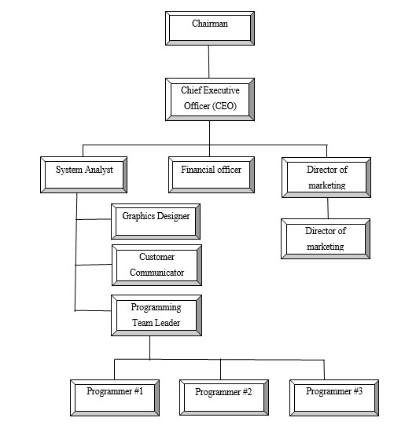

Figure 1.1: Organizational Structure of DORP

**Chapter 2: Project Introduction**

## 2.1 Introduction

Internship is a practical experience of theoretically gained knowledge and can measure as a groundwork trial to be aware with any organization and to make oneself confident enough to enter into service life and start building career. And also wonderful and effective way to connect academic experience with the professional work arena. It allows gaining valuable experience to the workplace, provides the opportunity for skill development, and gives a competitive edge in the job search. This chapter attempts to describe the objectives, scope and all topics of initialization period of this project.

## 2.2 Project Overview

Online Journal Management System is a Web based application that works within a centralized network. This project presents a review on the software program **Online Journal Management Sytem** as should be used in a publication system, a facility which is used to upload papers, receiving after paper has been reviewd by judges, publishing papers based on judge feedback. OJMS is built for managing and computerizing the traditional database, reserved fopr publocations. It maintains all author details, and publications details. The Project named as **“Development of Online Journal Managmeent System for DORP”**. It is a web based and database based application. This report based on internship, I completed this project at Development Organization of Rural Poor . In this report, I will describe how we developed this system and how it will work.

## 2.3 Background of Study

Today we can see different types of management software to manage our everyday tasks smoothly and perfectly. The company where I have done my intern is basically concerned about the making a publication platform & document management software. So for this reason I have chosen to develop Online Journal Management Sytem for this company. Because currently, staffs are using different types of platforms that are costly & inconveinient. To solve each problem in a standard way I have decided to do the journal Managmeent System, so that they can have a platform where they can publish their works free of charge.

## 2.4 Objectives

### 2.4.1 Broad Objective

### The general objective of this project is to use my institutional educational experience in the real life working environment by developing Online Journal Management System for Development Organization of Rural Poor .

### 2.4.2 Specific Objective

## View Paper Information

## Upload Papers

## Get feedback from judges

## Re uploading the papers

## Provide feedbacks on papers

## View paper pdf

## Manage Publications

## Manage Register Terminal

## Information

* Add, Update, Judge Details
* Manage paper categories
* Search contents based on the given information

## 2.5 Proposed System

This journalManagement System is an online system and all data is centralized which has overcome the Sharing problem in previous system. We provide free registration for the users. And we proved services to users who want to publish a paper. As data is maintained online, it is easy for a person to update the details, which has overcome the tedious updating in previous system. journal management is easy and performance is good. Here the author can upload a paper by inserting from a form along with other informatons, according to selected category. It is the reliable service provided to both authors and publishing agencies.

### 2.6 Methodology

The development process on ―Online Journal Management sytem for DORP, through Incremental Model will complete following the structure described later on Software Analysis & Design. This study on ― Online Journal Management sytem for DORP, through Incremental Model is tentative in nature. It aims to development of management System. The variables identified to manipulate through a handy inspection and from primary and secondary data

#### 2.6.1 Data Sources

For this project in data collection phase I collected two types of data

* Primary Data
* Secondary Data

**Primary** data are generated within the publication agencies. The publication agencies practical experience and observation helped me to generate the primary data.

**Secondary** data are generated by studying different articles, newspapers, research papers and of course information collected via Internet. Data, facts and statistics collected from different web sites and sources made us understand the project better.

### 2.7 Limitation of the Project

As I had mentioned early in this report that practicum is the bridge between theoretical and practical life, practicum program at IUBAT has given me this great opportunity to see how theories are put into action. In my case, there were lots of terms, conditions and systems that were not understandable for us at the beginning of my organizational attachment; however, lately I made myself familiar with those terms. So far, I have learned seeing my senior classmates and friends, they had experienced the same during their time as well. One of the limitations of this internship project is constraints of time. After applying the software engineering procedures, it is very difficult to develop the complete software within short time.

For this reason, the scope of the internship project has become short.

### 2.8 Process Model

In my project I am using the Incremental Model. Incremental Model is a process of software development where requirements are broken down into multiple standalone modules of software development cycle.

Each iteration passes through the **requirements, design, coding and testing phases**. And each subsequent release of the system adds function to the previous release until all designed functionality has been implemented. That‘s why I am chosen this type of process Model.

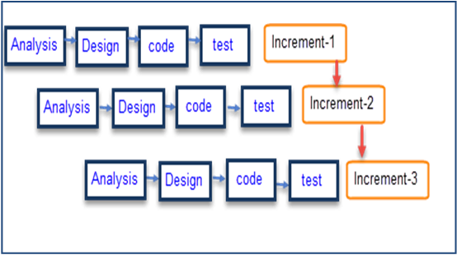

Figure 2.1: Incremental Process Model

#### 2.8.1 Reason for choosing the Incremental Process model

* In this model user can respond to each built.
* Lowers initial delivery cost.
* Software will be generated quickly during the software life cycle.
* It is flexible and less expensive to change requirements and scope.
* Thought the development stages changes can be done.
* Errors are easy to be identified.
* Generates working software quickly and early during the software life cycle

### 2.9 Feasibility Study

Feasibility study determines whether that solution is feasible or achievable for the organization.

There are three major areas of feasibility study.

* Technical feasibility
* Economic feasibility
* Operational feasibility

#### 2.9.1 Technical feasibility

The technical feasibility assessment is focused on gaining an understanding of the present technical resources of the organization and their applicability to the expected needs of the proposed system. It is an evaluation of the hardware and software and how it meets the need of the proposed system

|  |  |  |
| --- | --- | --- |
| SN | Hardware  Requirement | Software Requirement |
| 1. | Computer(Desktop/ Laptop/Equivalent) | Operating System(Windows 10 or equivalent) with browser(Google  Chrome/Firefox) |
| 2. | Proper electricity Support | Php (Laravel) |
| 3. | Adequate system memory and secondary  Memory | MySQL |

**Communication Interface**

* Client on Internet will be using HTTP/HTTPS protocol.
* Client on Internet will be using TCP/IP protocol.

#### 2.9.2 Economic feasibility

The purpose of the economic feasibility assessment is to determine the positive economic benefits to the organization that the proposed system will provide. My system is economically feasible because by using the proposed system many works can be done within small time and which is not possible by man power within the same time. It also reduces the man power needed for providing the Available cars Information, driver Information, Booking cars according to the date & time wise and generating report. So Bus agencies have to pay less salary where the current system needs many stuff and they are paying much salary. So I can say that, if they use proposed system they will be economical.

#### 2.9.3 Operational feasibility

User can easily operate the proposed system because the system is user friendly. It‘s easy to get transport routes information and easily book cars according to the demands and also cancel the booked cars within required time by contact with the agent. If the stuff of the organization has the basic to computer knowledge they could operate and manage the software easily. Every features and the activity that I combined within the system is designed and developed belongs to previous format they had used with a more attractive user interface.

**Chapter 3: Requirement Engineering**

### 3.1 Requirement Analysis

Requirement analysis provides the software designer with a representation of information, function and behavior that can be translated to data, architectural, interface and component level designs. In the following task phases the requirement analysis was done. [[2]](https://en.wikipedia.org/wiki/Software_engineer#cite_note-ABETACCRED1-2)

### 3.2 Requirements Engineering

Requirements engineering is, as its name suggests, the engineering discipline of establishing user requirements and specifying software systems. There are many definitions of Requirements Engineering; however, they all share the idea that **requirements** involves finding out what people want from a computer system, and understanding what their needs mean in terms of design. Requirements engineering is closely related to software engineering, which focuses more on the process of designing the system that users want. [[2]](https://en.wikipedia.org/wiki/Software_engineer#cite_note-ABETACCRED1-2)

* User requirements
* System requirements
* Functional requirements
* Non-Functional requirements
* Specification for each requirements

#### 3.2.1 User Requirements

* Admin can create judges
* Admin can view judge information
* Admin can update judge information
* Admin can delete individual judge information
* Admin can search individual judge
* Admin can view the authors details
* Admin can add paper categories
* Admin can view feedback from judges
* Admin can publish papers based on feedback
* Admin can assign judges to paper categories
* Judges can view paper pdf
* Judges can view paper information
* Judges can give feedback after paper review
* Judges can receive papers based on the category they are assigned to.
* Judges can download the papers
* Authors can upload paper
* Authors can choose paper category
* Author can add Co-Authors
* Author will be notified when the paper is published
* Author can see the judge feedbacks
* Author can manage paper informations

#### 3.2.2 System Requirements

1. Admin can create judge
   * First of all, admin will login into the system.
   * Check whether it is admin or not.
   * Select **judge Information** option and add new user information
   * If the form does not fill up properly then system will show the error message ―Please fill out this field.
   * If admin will give wrong input then system will show validation message.

1. Admin can view judge information
   * First of all, admin will login into the system
   * Check whether it is admin or not
   * Admin can view users information by clicking on Users Information

1. Admin can update judge information
   * First of all, admin will login into the system.
   * Check whether it is admin or not.
   * Admin can update users info by click on **update** option

1. Admin can delete individual judge information •

First of all, admin will login into the system.

* + - * Check whether it is admin or not.
      * Admin will select the added user information individually and click on **Delete** option.

1. Admin can search judge information

• First of all, admin will login into the system.

* + Check whether it is admin or not.
  + If admin click on **search** option, system will show individual users info

1. Admin can view feedback
   * First of all, admin will login into the system.
   * Check whether it is admin or not.
   * Admin can view the individual or whole report of users info
   * Admin can view feedback by clicking on “view feedback”

1. Admin can add categories
   * First of all, admin will login into the system
   * Check whether it is admin or not
   * By clicking in **Add paper category, author can add new paper category**

**3.2.3 Functional Requirements:**

1. Admin can maintain whole system.
2. Admin can add, view, search, update, & delete Paper Categories
3. Admin can add, view, search, update and delete Judge information
4. Admin can publish papers based on the feedbacks from judges
5. Admin can assign paper Categories to Judges
6. Judges can receive papers based on the category assigned to them
7. Judges can search papers based on any information
8. Judges can give feedbacks after viewing the paper
9. Judges can approve the papers
10. Authors can receive message after the judges have reviewed
11. Authors can receive messages after the admin has published the paper
12. Author can upload paper.
13. Author can add co-authors
14. Author can view the feedbacks
15. Admin can search based on any informations

3.2.**4 Non-Functional Requirements:**

1. Admin can log in by using email and password.
2. Author can log in by using email and password.
3. Judge can log in by using email and password.
4. This system support only Windows 7/8/10

**3.3.1 Use Case Symbols**

**System**

Draw your system's boundaries using a rectangle that contains use cases. Place actors outside the system's boundaries.

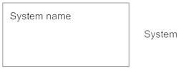

**Use Case**

Draw use cases using ovals. Label the ovals with verbs that represent the system's functions.

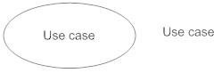

**Actors**

Actors are the users of a system. When one system is the actor of another system, label the actor system with the actor stereotype.



**Relationships**

Illustrate relationships between an actor and a use case with a simple line. For relationships among use cases, use arrows labeled either "uses" or "extends." A "uses" relationship indicates that one use case is needed by another in order to perform a task. An "extends" relationship indicates alternative options under a certain use case

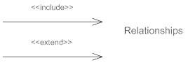

#### 3.3.2 Use Case Diagram

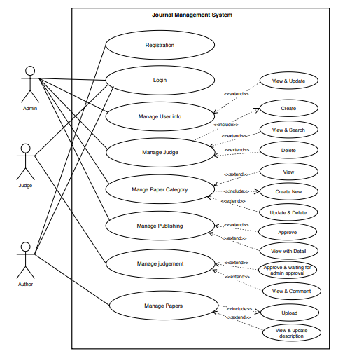

**Figure 3.1: Use case diagram**

#### 3.3.3 Use Case Text

|  |  |
| --- | --- |
| User Title: Registration  Actor: Author | |
| Description:  Author can register himself | |
| User Title: Login  Actor: Admin, author, judge | |
| Description:  Admin, judge and author can login by thir own id and password | |
| User Title: Manage User Information  Actor: Admin | |
| Description:  Admin can manage user information | |
| User Title: Manage Judge Information  Actor: Admin | |
| Description:  As an admin, I can create, update, and delete the judge information | |
| User Title: Manage paper category  Actor: Admin | |
| Description:  As an admin, I can create, update, and delete paper categories | |
| User Title: Manage Publishing  Actor: Admin | |
| Description:  Admin can manage publications based on judge feedback | |
| User Tittle: Manage feedback  Payment Actor: judge |
| To review and give feedback of the paper |
| User Title:  Actor: | |
| Description: | |

|  |
| --- |
| User Title:  Actor: |
| Description: |

**Chapter 4: System Planning**

**4.1 Scope of Project**

* Web based application, can be accessible from anywhere by internet browser.
* Report will be automatically generated.
* Searching system is available here for all the transaction.
* Platform independent; run on Windows, Mac or Linux.
* No license fees or renewal fees

### 4.4 Identifying Complexity

#### 4.4.1 Identifying complexity of transition function

#### 4.4.3 Unadjusted function point contribution

Table 4.7 show the Unadjusted function Point Contribution for Transaction Function

##### Table 4.7: Unadjusted Function Point Contribution for Transaction Function

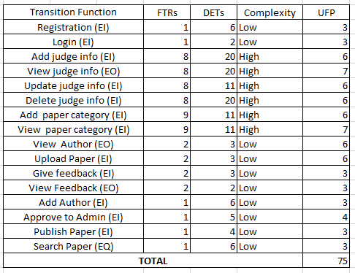

#### 4.4.4 Unadjusted function point contribution

Table 4.8 show the Unadjusted function Point Contribution for Data Function

**Table 4.8: Unadjusted Function Point Contribution for Data**

##### Function

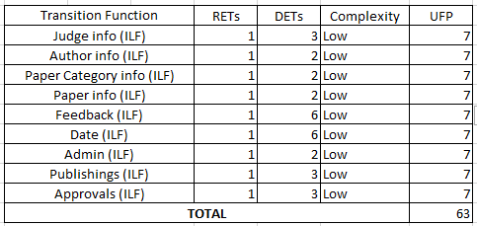

#### 4.4.5 Performance and Environmental Impact

Table 4.9 shows the Performance and environmental impact here.

**Table 4.9: Performance and Environmental Impact**

|  |  |  |
| --- | --- | --- |
|  | **GSC** | **TDI** |
|  | Data Communication | 2 |
| 2 | Distributed Data Processing | 0 |
| 3 | Performance | 3 |
| 4 | Heavily Used Configuration | 1 |
| 5 | Transaction Rate | 0 |
| 6 | Online Data Entry | 3 |
| 7 | End-user Efficiency | 4 |
| 8 | Online Update | 2 |
| 9 | Complex Processing | 2 |
| 10 | Reusability | 3 |
| 11 | Installation Ease | 3 |
| 12 | Operational Ease | 3 |
| 13 | Multiple Sites | 3 |
| 14 | Facilitate Change | 3 |
| **Total Degree of Influence (TDI**)    (Range 0 to 70->influence size by +-32%) | | 32 |

#### 4.4.6 Counting Function Point

|  |  |
| --- | --- |
| Language | Hours  Per  Function  Point |
| ASP* | 06.1 |
| Visual Basic | 08.50 |
| Java | 10.6 |
| SQL | 10.8 |
| C++ | 12.4 |
| C | 13.0 |
| C# | 15.5 |
| PHP | 15.5 |

Value adjustment factor (VAF) = (0.65+ (0.01* TDI))

= (0.65+ (0.01* 32))

= 0.97

UFP= UFP (Data function) + UFP (Transaction function)

= 88 + 84 = 1i72

AFP= UFP * VAF = 172 * 0.97 = 167 Approx.

Total time calculation frame = 167 * 15.5 [Productivity of PHP is 15.5] = 2588.5 per hour

= 2589 person hours / 7.5 hours

= 345 person days / 3 [person in a group]

= 115 days

= 3 months 25 days for three persons

**Approximately 4 months required for three persons to finish the project.**

### 4.5 Task Scheduling

Project scheduling is an activity of distributing the estimated efforts within the planned project duration. There are some basic rules for project scheduling. They are as follows Compartmentalization– The project must compartmentalize into a number of manageable activities and tasks.

**Interdependency –** The interdependency of each compartmentalized activity or task must be determined. Some tasks must occur in sequence while others can occur in parallel. **Time allocation –** Each task to be scheduled must allocated some number of work units. **Effort validation –** Every project has a defined number of staff members. It should ensure that no more than the allocated number of people has scheduled at any given time.

**Defined responsibilities –** Every task that is scheduled should assign to a specific team member.

**Defined outcomes –** Every task that is scheduled should have a defined outcome. The outcomes normally a work product or a part of a work product.

### 4.6 Process Based Estimation

In process-based estimation, process is decomposed into a relatively small set of tasks and the effort required to accomplish each task is estimated. Process based estimation begins with a delineation of software functions obtained from the project scope. A series of software process activities must be performed for each function

Table 4.10:Process based estimation

|  |  |  |  |  |  |  |  |  |
| --- | --- | --- | --- | --- | --- | --- | --- | --- |
| **Activity** | **CC** | **Planning** | **Engineering** | | **Construction** | | **Imp.** | **Total** |
|  |  |  | **Analysis** | **Design** | **Code** | **Test** |  |  |
| **Function** |  |  |  |  |
| **F1** | 0.021 | 0.073 | 0.195 | 0.204 | 0.333 | 0.081 | 0.032 | 0.939 |
| **F2** | 0.020 | 0.071 | 0.165 | 0.229 | 0.264 | 0.052 | 0.044 | 0.845 |
| **F3** | 0.026 | 0.070 | 0.200 | 0.275 | 0.339 | 0.071 | 0.036 | 1.017 |
| **F4** | 0.023 | 0.063 | 0.189 | 0.292 | 0.358 | 0.067 | 0.035 | 1.027 |
| **F5** | 0.025 | 0.069 | 0.172 | 0.247 | 0.297 | 0.048 | 0.042 | 0.900 |
| **F6** | 0.026 | 0.064 | 0.191 | 0.293 | 0.334 | 0.063 | 0.026 | 0.997 |
| **F7** | 0.017 | 0.069 | 0.183 | 0.291 | 0.332 | 0.039 | 0.027 | 0.958 |
| **F8** | 0.028 | 0.052 | 0.199 | 0.295 | 0.336 | 0.056 | 0.042 | 1.008 |
| **F9** | 0.012 | 0.061 | 0.185 | 0.352 | 0.315 | 0.052 | 0.029 | 1.006 |
| **F10** | 0.018 | 0.064 | 0.185 | 0.382 | 0.233 | 0.081 | 0.067 | 1.030 |
| **F11** | 0.022 | 0.055 | 0.207 | 0.255 | 0.335 | 0.064 | 0.044 | 0.982 |
| **F12** | 0.028 | 0.062 | 0.208 | 0.325 | 0.342 | 0.055 | 0.041 | 1.061 |
| **F13** | 0.024 | 0.057 | 0.183 | 0.272 | 0.376 | 0.070 | 0.048 | 1.03 |
| **Total** | **0.29** | **0.83** | **2.462** | **3.712** | **4.194** | **0.799** | **0.513** | **12.8** |
| **Effort** | **2%** | **8%** | **20%** | **25%** | **35%** | **6%** | **4%** | **100%** |
|  |  |  |  |  |  |  |  |  |

#### 4.6.1 Effort Distribution

The project estimation technique leads to estimates of work units required to complete the software development. A detailed view of the effort distribution chart illustrated below

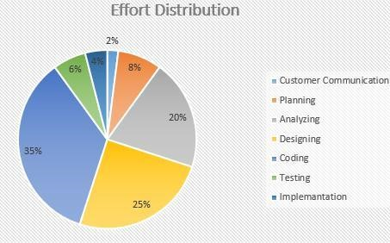

Figure 4.1: Details Effort Based Estimation Description:

* Customer Communication – 2%
* Planning – 8%
* Testing – 6%
* Analyzing – 20%
* Designing – 25%
* Coding – 35%
* Implementation – 4%

#### 4.6.2 Project Schedule Chart

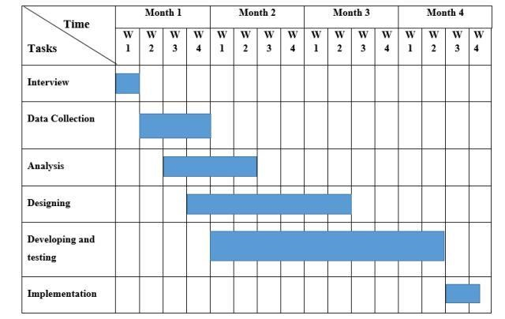

Figure 4.2: Project Schedule Chart

### 4.7 Cost Estimation

The approximation of the cost of a program is cost estimation. In this project, there are five factors to analyze and calculate the cost. Given bellow,

* Personnel cost
* Software cost
* Hardware cost
* Other cost

✓

#### 4.7.1 Personnel cost

* Number of days in a year = 365
* Number of government holidays in a year =24
* Number of weekly holidays in a year =52
* Total number of working days to develop the project =365-(52+24) =289 days
* Total number of working days per months to develop the project =289/12 =24.083 days
* Organization working hours per day = 7.5 hours
* Organization working hours per month=24.083*7.5= 180.623 hours

##### Table 4.11: Personnel Cost

|  |  |  |  |  |
| --- | --- | --- | --- | --- |
| **Type** | **No.**  **Members** | **of** | **Months** | **Salary** |
| System Analyst | 1 |  | 1 | 45,000.00 |
| Designer | 1 |  | 1 | 20,000.00 |
| Coder | 1 |  | 1 | 25,000.00 |
| **Total** |  |  |  | **9**0**,000.00** |

#### 4.7.2 Hardware Cost

Cost of the computer that used to complete the project.

**Table 4.12: Hardware cost**

|  |  |  |  |  |
| --- | --- | --- | --- | --- |
| Name | Number | Price | Description | Total |
| Computer | 2 | 45,000 | 45,000 / 24 * 4 | 7,500 |

Total Hardware Cost = 7,500.00 TK

#### 4.7.3 Software Cost

It is the cost of the software is which used in this project.

**Table 4.13: Software Cost**

|  |  |  |  |  |
| --- | --- | --- | --- | --- |
| **SL** | **Software** | **Number** | **Amount** | **Total** |
| 1 | OS (Windows 10) | 1 | 100 Tk. | 280tk |
| 2 | MS Office 2013 | 1 | 80 Tk. |
| 3 | Atom | 1 | 100 Tk. |  |
| 4 | XAMP | 1 | Free |  |

#### 4.7.4 Other Cost

**Table 4.14: Other cost**

|  |  |  |
| --- | --- | --- |
| **Name** | **Price** |  |
| Pen and paper |  | 250 Tk. |
| Mobile |  | 250Tk. |
| Transport |  | 500 Tk. |
| **Total** |  | **1000 Tk.** |

### 4.8 Accounts Table

**Table 4.15: Total cost**

|  |  |
| --- | --- |
| **Particulars** | **TK** |
| Salary- |  |
| • System Analyst | 45,000.00 |
| • Designer | 20,000.00 |
| • Coder | 25,000.00 |
|  | 90,000.00 /= |
| Hardware Cost –    • Computer | 7,500.00 |
|  | 7,500.00/= |
| Software Cost – |  |
| • OS (Windows 10) | 100.00 |
| • MS Office 2013 | 80.00 |
| • Atom | 100.00 |
| • Xamp | Free |
|  | 280.00/= |
| Other Costs- |  |
| • Pen and paper | 250.00 |
| • Mobile | 250.00 |
| • Transport | 500.00 |
|  | 1,000.00 /= |
| **Total cost** | **98,780.00 /=** |

**Chapter 5: Risk Engineering**

A risk is a serious problem that might or might not happen. It is necessary to analyze the potential risks in a project. If the risks of a software project are not properly analyzed and estimated, many problems can plague the software project. Anyone developing ant type of system encounter with it and it has to be managed.

### 5.1 Risk Management

Risk analysis and management are a series of steps that help a software team understand and manage uncertainty. Many problems can plague of software project. A risk is a potential problem; it might happen, it might not. But regardless of the outcome, it’s a really good idea to identify it, assess its probability of occurrence, and estimate its impact, and establish a contingency plan should the problem actually occur. Risk analysis and management are a series of steps that help a software them to understand and manage uncertainty. [[6]](https://en.wikipedia.org/wiki/Software_engineer#cite_note-ABETACCRED1-2)

#### 5.1.1 The Stages of Risk

To establish a risk management model the following phases are followed:

**Identification:** Risk identification is the process of detecting potential risks or hazards through data collection. A range of data collection and manipulation tools and techniques exists. The team is using both automated and manual techniques to collect data and begin to characterize potential risks to Web resources. Web crawling is one effective way to collect information about the state of Web pages and sites. [[6]](https://en.wikipedia.org/wiki/Software_engineer#cite_note-ABETACCRED1-2)

**Classification:** Risk classification is the process of developing a structured model to categorize risk and fitting observable risk attributes and events into the model. The team combines quantitative and qualitative methods to characterize and classify the risks to Web pages, Web sites, and the hosting servers.

**Assessment:** Risk assessment is the process of defining relevant risk scenarios or sequences of events that could result in damage or loss and the probability of these events. Rosenthal describe the characteristics of a generic standard for risk assessment as "transparent, coherent, consistent, complete, comprehensive, impartial, uniform, balanced, defensible, sustainable, flexible, and accompanied by suitable and sufficient guidance.

**Analysis:** Risk analysis determines the potential impact of risk patterns or scenarios, the possible extent of loss, and the direct and indirect costs of recovery. This step identifies vulnerabilities considers the willingness of the organization to accept risk given potential consequences, and develops mitigation responses.

**Implementation:** Risk management implementation defines policies, procedures, and mechanisms to manage and respond to identifiable risks. The implemented program should balance the value of assets and the direct and indirect costs of preventing or recovering from damage or loss.

To take comprehensive care of a web-based system we must consider the following points:

1. Hardware and software environment including any upgrades to the operating system and Web server, the installation of security patches, the removal of insecure services, use of firewalls, etc.
2. Administrative procedures such as contracting with reputable service providers, renewing domain name registration, etc.
3. Network configuration and maintenance including load balancing, traffic management, and usage monitoring.
4. Backup and archiving policies and procedures including the choice of backup media, media replacement interval, number of backups made and storage location.

#### 5.1.2 Categories of Risk

There are different categories of risks that should be considered in any software project. The following categories of risks have been considered in this software project.

1. **Project risks:** These risks threaten the project plan. If these risks become real, it is likely that the project schedule will slip and that costs will increase. Project risks identify potential budgetary, schedule, personnel, resource, customer and requirement problems and their impact on the software project.
2. **Technical risks:** These risks threaten the quality and timeliness of the software to be produced. If a technical risk becomes a reality, implementation may become difficult or impossible. Technical risks identify potential design, implementation, interface, verification and maintenance problems. Moreover, specification ambiguity, technical uncertainty, technical obsolescence are also risk factors.
3. **Business risks:** These risks threaten the viability of the software to be built. The business risks can be market risks, building a system that no one really wants. Strategic risks, building a system that no longer fits into the overall business strategy for the company. Management risks, losing the support of senior management due to a change in focus or a change in people. Budget risks, losing budgetary or personnel commitment.

### 5.2 The RMMM Plan

* **Risk Mitigation:** Proactive planning for risk avoidance.
* **Risk Monitoring:** Assessing whether predicted risks occur or not, ensuring preventive steps are being properly applied, collect information for future risk analysis, attempt to determine which risks caused which problem.
* **Risk Management:** Actions to be taken in the event that mitigation steps have failed and the risk has become a live problem [[6]](https://en.wikipedia.org/wiki/Software_engineer#cite_note-ABETACCRED1-2)

**Type of Impact:** Catastrophic (1), Marginal (2), Tolerable (3), Critical (4).

**Type of Probability:** very low (75%

**Project Risks:** Threaten the project plan. In my system, the bellow mentioned projects risks I needed manage.

#### Table 5.1: Project Risk (P01)

|  |  |  |
| --- | --- | --- |
| **Project Risk (P01)** | | **Date: 23-01-20** |
| Name | Changes the requirements | |
| Probability | Low (25%) | |
| Impact | Marginal (2) | |
| Description | Customer may change their requirements. | |
| Mitigation & Monitoring | Requirements are redefined by the company due to time or business needs. Meeting will be held with the company regularly. This insures that the product we are producing solves a problem. | |
| Management | Emergency meeting between both parties to identify new project requirements and goals. | |
| Status | Not occur | |

#### Table 5.2: Project Risk (P02)

|  |  |  |
| --- | --- | --- |
| **Project Risk (P02)** |  | **Date: 30-01-2**0 |
| Name | Poor Quality Documentation | |
| Probability | Low (15%) | |
| Impact | Catastrophic (1) | |
| Description | Poor quality documentation of the members. | |
| Mitigation & Monitoring | Meeting will be held routinely to offer documentation suggestions and topics. The progress on documentation will also have a monitor in each meeting | |
| Management | The addition of new topics or removal of unnecessary topics into the documentation will assigned to responsible person. | |
| Status | Monitoring it. | |

#### Table 5.3: Project Risk (P03)

|  |  |  |
| --- | --- | --- |
| **Project Risk (P03)** |  | **Date: 06-02-2**0 |
| Name | Lack of Development Experience. | |
| Probability | Moderate (30%) | |
| Impact | Catastrophic (1) | |
| Description | Lack of developmental experience of the members. | |
| Mitigation & Monitoring | Each member of the team should watch and see areas where another team member may be weak. | |
| Management | The members who have the most experience in a particular area will be required to help for overcome problem arises for this risk. | |
| Status | We have not encountered such issues yet | |

#### Table 5.4: Project Risk (P04)

|  |  |  |
| --- | --- | --- |
| **Project Risk (P04)** |  | **Date: 13-02-2**0 |
| Name | Poor Comments in Code | |
| Probability | Low (15%) | |
| Impact | Marginal (2) | |
| Description | Code of the developed system is not up to the mark. | |
| Mitigation & Monitoring | A formal written standard must be established to ensure quality of comments in all code. | |
| Management | We should call a meeting with the development team to get rid of this problem and improve the quality of comments in code. | |
| Status | We are monitoring the issue. | |

**Technical Risks:** threaten product quality and the timeliness of the schedule. As this is my practicum project, therefore these types of risks need to be take care of properly. **Table 5.5: Technical Risk (TR01)**

|  |  |  |
| --- | --- | --- |
| **Technical Risk (TR01)** | | **Date: 2**0**-02-2**0 |
| Name | Computer Crash | |
| Probability | Moderate (25-40%) | |
| Impact | Catastrophic (1) | |
| Description | Computer may crash due to several reasons. | |
| Mitigation & Monitoring | We should take proper follow up of computers. We also take regular data backup every day, We can use IPS to stop unexpected shutdown. | |
| Management | If our computer has been crashed then we will restore backup. | |
| Status | We have not encountered such issue yet | |

#### Table 5.6: Technical Risk (TR02)

|  |  |  |
| --- | --- | --- |
| **Technical Risk (TR02)** | | **Date: 27-02-2**0 |
| Name | Technology Doesn’t Meet Specifications. | |
| Probability | Low (25%) | |
| Impact | Catastrophic (1) | |
| Description | Customer doesn’t have the technology to their desired specification. | |
| Mitigation & Monitoring | That ensures that the product we are producing, and the specifications of the customer are equivalent. | |
| Management | The customer should be immediately notified and whatever steps necessary to rectify this problem should be done. Preferably a meeting should be held between the development team and the customer to discuss at length this issue. | |
| Status | We have not encountered such issue yet | |

#### Table 5.7: Technical Risk (TR03)

|  |  |  |
| --- | --- | --- |
| **Technical Risk (TR03)** |  | **Date: 05-**03**-2**0 |
| Name | Poor Training Skill in Team Members. | |
| Probability | Moderate (30%) | |
| Impact | Catastrophic (1) | |
| Description | Poor Training Skill in Team Members to Train the Client. | |
| Mitigation & Monitoring | The training team should have a clear knowledge about the entire functionality of the software. System analyst need to ensure and monitor it while training session start. | |
| Management | We should arrange a meeting with the train team and come to a point to solve this problem. | |
| Status | We have not encountered such issue yet | |

**Business Risk:** Threaten the viability of the software to be built (market risks, strategic risks, management risks, budget risks). As I am developing it as my practicum project by myself, classic business risks won’t be encountered here. The Probability of all type of Business Risks is therefore, determined as Low.

#### Table 5.8: Business Risk (B01)

|  |  |  |
| --- | --- | --- |
| **Business Risk (B01)** | | **Date: 12-03-2**0 |
| Name | Insufficient Budget | |
| Probability | Low (10%) | |
| Impact | Marginal (2) | |
| Description | If the budget is low project may not complete. | |
| Mitigation & Monitoring | The project needs streaming server that is costly to set-up. We ming services to reduce the budget risk. | |
| Management | Refinement in project goal. A new plan for regulate the budget. | |
| Status | Not encountered | |

#### Table 5.9: Business Risk (B02)

|  |  |  |
| --- | --- | --- |
| **Business Risk (B02)** |  | **Date: 19-03-2**0 |
| Name | End Users Accept System | |
| Probability | Low (10%) | |
| Impact | Critical (4) | |
| Description | The system fails to gain user’s faith. | |
| Mitigation & Monitoring | In order to prevent this from happening, the software will develop with the end user in mind. The user-interface will design in a way to make use of the program convenient and pleasurable. | |
| Management | Training the users to familiarize them with the new system. Releasing patches/bug fixes for greater user satisfaction. | |
| Status | The risk has not been arisen yet. | |

#### Table 5.10: Business Risk (B03)

|  |  |  |
| --- | --- | --- |
| **Business Risk (B03)** |  | **Date: 26-**03**-2**0 |
| Name | Not pay the installment of Software Cost. | |
| Probability | Very Low (05%) | |
| Impact | Catastrophic (1) | |
| Description | Customer doesn’t pay for the installment of Software Cost. | |
| Mitigation & Monitoring | We should make a good communication between customers and ensure that the entire Installment will be completed | |
| Management | The only course of action available would be find out the reason and come in a solution. | |
| Status | Not encountered. | |

#### Table 5.11: Business Risk (B04)

|  |  |  |
| --- | --- | --- |
| **Business Risk (B04)** |  | **Date:** 02**-**04**-20** |
| Name | Late delivery of the project | |
| Probability | Very Low (05% | |
| Impact | Catastrophic (1) | |
| Description | The project may take more time to complete what was estimated | |
| Mitigation & Monitoring | Steps have been taken to ensure a timely delivery by determining the scope of project. | |
| Management | The only course of action available would be to request an extension to the deadline from customer. | |
| Status | My project is completed in time. | |

**Chapter 6: Analysis Modeling**

Analysis modeling uses a combination of text and diagrammatic forms to depict requirements for data, function, and behavior in a way that is relatively easy to understand, and more important, straightforward to review for correctness, completeness and consistency. This section presents resources for conventional and object-oriented analysis (OOA) methods as well as resources for UML. [[1]](https://en.wikipedia.org/wiki/Software_engineer#cite_note-ABETACCRED1-2)

### 6.1 Analysis Modeling

Objectives of analysis model

* Domain Analysis
* Describe what the client requires
* Establish a basis for the creation of a software design
* Define a set of requirements that can be validated once the software is built.

### 6.2 Activity Diagram

Activity diagrams are graphical representations of workflows of stepwise activities and actions with support for choice, iteration and concurrency. In the Unified Modeling Language, activity diagrams are intended to model both computational and organizational processes.

#### 6.2.1 Activity Diagram of Admin

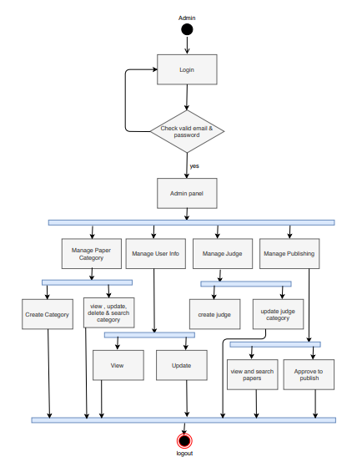

Figure 6.1 Activity Diagram for admin

#### 6.2.2 Activity Diagram of Judge

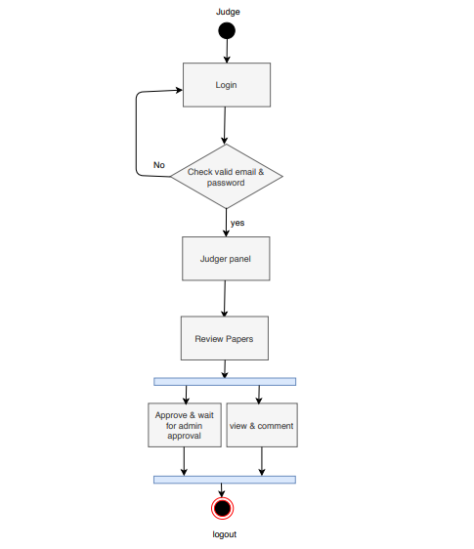

Figure 6.2 Activity Diagram of Judge

#### 6.2.3 Activity Diagram of Author

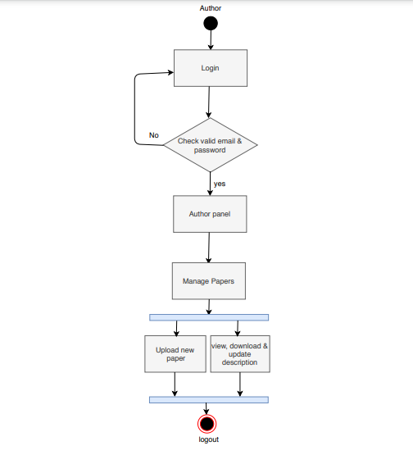

Figure 6.1 Activity Diagram for driver

**Chapter 7: Design**

### 7.1 Data Flow Diagram (DFD)

A data flow diagram (DFD) is a graphical representation of the "flow" of data through an information system, modeling its process aspects. A DFD is often used as a preliminary step to create an overview of the system, which can later be elaborated DFDs can also, be used for the visualization of data processing.

A DFD shows what kind of information will be input to and output from the system, where the data will come from and go to, and where the data will be stored. It does not show information about the timing of process or information about whether processes will operate in sequence or in parallel. [[1]](https://en.wikipedia.org/wiki/Software_engineer#cite_note-ABETACCRED1-2)

#### 7.1.1 Context Level Diagram

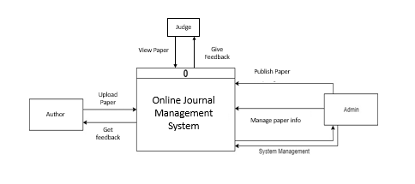

Figure 7.1 Context Level Diagram

#### 7.1.2 Level 1 DFD

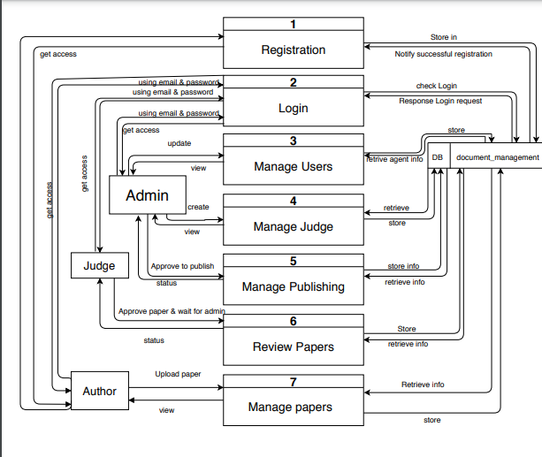

Figure 7.2 DFD Level-1

#### 7.1.3 Level 2- Process 1 DFD

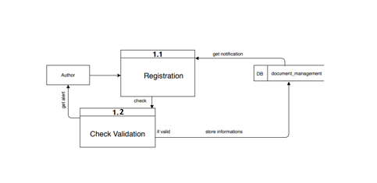

Figure 7.3 Level 2- Process 1 DFD

#### 7.1.4 Level 2- Process 2 DFD

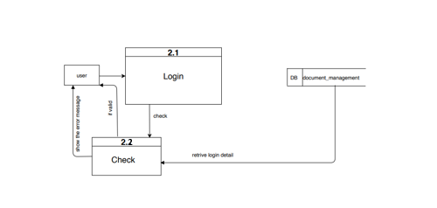

Figure 7.4 Level 2- Process 2 DFD

#### 7.1.5 Level 2- Process 3 DFD

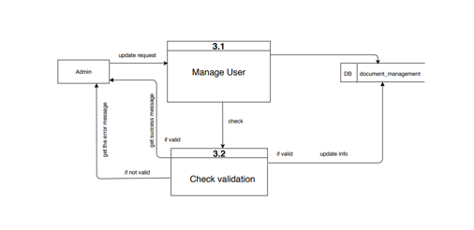

**Figure 7.5 Level 2- Process 3 DFD**

#### 7.1.6 Level 2- Process 4 DFD (Add Car Info)

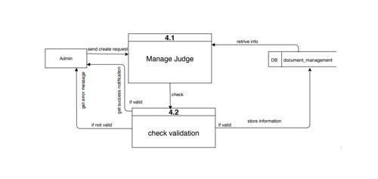

Figure 7.6 Level 2- Process 4 DFD

#### 7.1.7 Level 2- Process 5 DFD

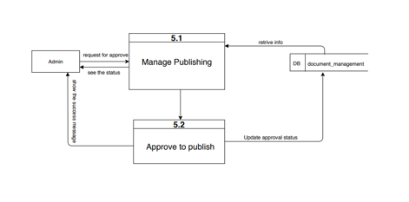

Figure 7.7 Level 2- Process 5 DFD

#### 7.1.8 Level 2- Process 6 DFD

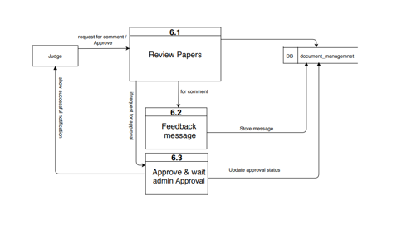

**Figure 7.8 Level 2- Process 6 DFD**

#### 7.1.9 Level 2- Process 7 DFD

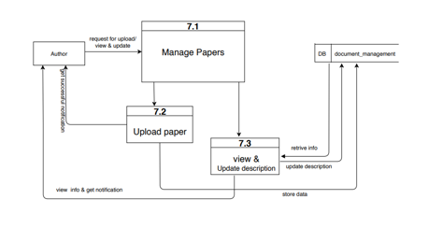

**Figure 7.9 Level 2- Process 7 DFD**

#### 

### 7.2 Database Design

#### 7.2.1 Entity Relationship Model

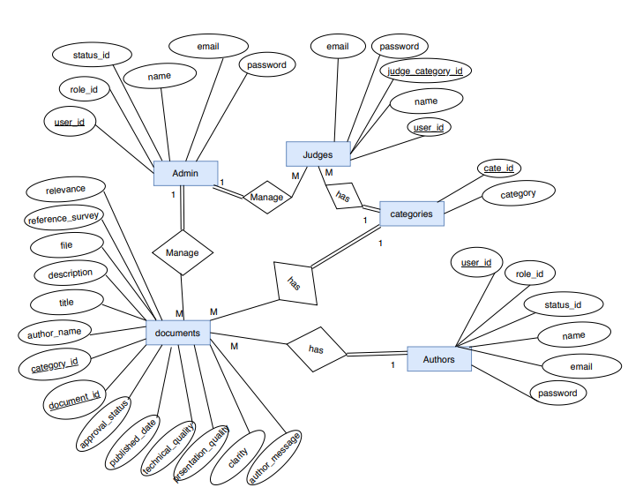

Figure 7.12 ER Diagram

7.2.2 Database Table Structure

7.3 Interface Design:

**Chapter 8: Quality Assurance and Testing**

### 8.1 System Quality Management

A quality management software system that is automated and connects all departments is essential for a regulated or ISQ-compliant company. A QMS or a TQM (total quality management) system can connect each phase in a products development lifecycle with every department in a company. This gives everyone an opportunity to provide feedback. Automated, routing, with escalation, ensure the rapid responses to inputs needed from the department. By building quality into products as opposed to forcing QA to bear the burden of the responsibility, everyone wins, engineering, regulatory, QA, manufacturing, sales and marketing.

The quality of software is assessed by a number of variables. These variables can be divided into external and internal quality criteria. External quality is what a user experiences when running the software in its operational mode. Internal quality refers to aspects that are code- dependent, and that are not visible to the end-user. External quality is critical to the user, while internal quality is meaningful to the developer only.

Some quality criteria are objective and can be measured accordingly. Some quality criteria are subjective and are therefore captured with more arbitrary measurement. [[4]](https://en.wikipedia.org/wiki/Software_engineer#cite_note-ABETACCRED1-2)  Types of quality, they are given below:

* Test coverage
* Testability
* Portability
* Thread-safeness
* Conciseness
* Maintainability
* Documentation ➢ Legibility

#### 8.1.1 Software Quality Management Process

* The aim of Software Quality Management (SQM) is to manage the quality of software and development and of its development process.
* A quality product is one which meets its requirements and satisfies the user.
* A quality culture is an organization environment where quality is viewed as everyone’s responsibility.

Some of the specific SQM processes defined in standard:

**Quality Assurance Process**: Quality Assurance makes sure the project will be completed based on the previously agreed specifications, standards and functionality required without defects and possible problems. Its monitors and tries to improve the development process from the beginning of the project to ensure this. It is oriented to prevention. [[8]](https://en.wikipedia.org/wiki/Software_engineer#cite_note-ABETACCRED1-2)

**Verification and Validation Process:** In software project management, software testing, and software engineering, verification and validation (V and V) is the process of checking that a software system meets specifications and that it fulfils its intended purpose. It is normally the responsibility of software testers as part of the software development lifecycle.

In the verification, a client will either view the software, or see it implemented in a test situation. At this point it is imperative that the client who is needed of the software is able to ascertain that this software is hitting all the parameters initially requested or desired. Only when this assurance is made should the next part of the verification and validation process be started.

While this is not the last chance to “tweak” the software into doing the tasks required it is part of the last steps before a project is completed, and in being too quick to approve the software as this could cause problems later, and could also result in more money required for the software’s later changes.

The next step of verifications and validation of software is simple. Client Company will approve the software and validate it as being what is required. This stage usually means a systematic checking off various requirements. While this might sound tedious, it is necessary part of the procedure to ensure that again, the result is exactly to the specifications of all concerned. The entire verification and validation process are part of a normal sequence of quality control for software. [[8]](https://en.wikipedia.org/wiki/Software_engineer#cite_note-ABETACCRED1-2)

**Review and Audit Process:** A software audit review, or software audit, is a type of software review in which one or more auditors who are not members of the software development organization conduct “An independent examination of a software product, software process, or set of software processes to assess compliance with specifications, standards, contractual agreements, or other criteria” Two types of reviews or audits presented in the standard: [[8]](https://en.wikipedia.org/wiki/Software_engineer#cite_note-ABETACCRED1-2)

1. **Management Reviews**

The purpose of a management review is to monitor progress, determine the status of plans and schedules, confirm requirements and their system allocation, or evaluate the effectiveness of management approaches used to achieve fitness for purpose. This support decisions about changes and corrective actions that are required during a software project. [[8]](https://en.wikipedia.org/wiki/Software_engineer#cite_note-ABETACCRED1-2)

1. **Technical Reviews**

The purpose of technical review is to evaluate a software product to determine its suitability for its intended use. The objective is to identify discrepancies from approved specifications and standards. The result should provide management with evidence confirming (or not) that the product meets the specifications and adheres to standards and that changes are controlled”. A technical review requires that mandatory inputs be in place in order to proceed:

* + Statements of objectives
  + A specific software product
  + The specific project management plan
  + The issues list associated with this product

#### 8.1.2 Quality Assurance Matrix

Quality Assurance Matrix (QAM) is a systematic process and analysis tool, with the aim of eliminating potential risks and previous quality concerns on the base principles of [Plan-DoCheck-Act (PDCA).](http://www.qmindset.com/index.php?page=pdca) QAM helps us to identify process phases we need to focus on, in order to eliminate defects. QAM contains the whole manufacturing process chain, together with relevant information about both potential and occurred failures, and how these failures are prevented, or detected by quality gates. [[5]](https://en.wikipedia.org/wiki/Software_engineer#cite_note-ABETACCRED1-2)

QAM is essential in planning, with the benefits and features, such as:

* Gives a structured and systematic overview of the production process and process risks
* Useful in New Product Introduction
* Useful in case of already existing production
* Helps to identify potential
* Helps to effectively eliminate existing
* Very useful complement of FMEA and CP
* QAM is Living document

### 8.2 System Testing Methodology

**Black-box Testing**

Black-box testing which is also known as behavioral testing focuses on the functional requirements of the software. It enables the software engineer to derive sets of input conditions that will fully exercise all functional requirements for a program. Black-box testing method will be applied to test the modules of LMS.

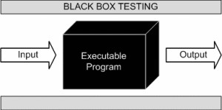

Figure 8.1: Black box testing

#### 8.2.1 Reasons for Performing System Testing

System testing is performed by professional or individual testers for various reasons. From evaluating the system to ensuring its compliance with the specified requirements, this type of testing offers great aid to the testing team as well as the other stakeholders of the project. Few of the other reasons for performing this testing are: It ensures that the product meets the quality standards.

* Verifies that the software system meets the functional, technical and business requirements requested by the customer/client.
* Performs end to end testing of the software product, which prevents system failures and crashes during it implementation to the live environment.
* It is performed in an environment that is similar to the production environment, which enables the developers as well as the concerned stakeholders to get an idea of the user’s reaction to the product.
* It plays a significant role in delivering a quality product to the end users.
* It is during this stage of software testing life cycle (STLC) that the Application Architecture and Business Requirements are tested.

Ensures that the input provided to the system offers expected output/result

#### 8.2.2 Characteristics of System Testing

Software testing is aimed at identifying any bugs, errors, faults, or failures (if any) present in the software.

1. To identify the test strategy.
2. To check the sufficiency of requirements.
3. To create functional test conditions.
4. To check the consistency of design with the requirements.
5. To check the sufficiency of design.
6. To create structural and functional test conditions.
7. To check the consistency of implementation with the design.
8. To check the (sufficiency of implementation.
9. To create structural and functional test conditions for programs/units.
10. To check the sufficiency of the test plan.
11. To test the application programs.

12 To put the tested system under operation.

13. To make changes· in the system and retest the modified system.

#### 8.2.3 When to Perform System Testing

System testing can be performed in the following situation:

* After the completion of unit & integration testing.
* Before the beginning of the acceptance testing.
* On complete integration of modules.
* On completion of software development process, based software requirements specification
* On the availability of test environment

**8.2.4 Key Areas of System Testing:**

Some of the aspects, on which system testing focuses are

* **Performance:** It makes sure that the software system performs as per requirements of the user, without depicting any defects or issues.
* **Security:** Protects the product from any security breaches, data theft, etc., which can sacrifice critical data & information of the organization.
* **Recovery:** Ensures that the recovery of the system is as per expectations and in an accurate condition.
* **Interface:** System testing also focuses on the interface of the product and ensure that all requirements are met accurately and no issues occur when two components of the system are integrated together.
* **Install-ability:** Here, the focus of system testing is to make sure that the product installed and implemented to the production environment without any difficulty and issue.
* **Usability:** This is another important aspect that is covered by system testing. It ensures optimum user experience of the system.
* **Documentation:** The accuracy of the document is also tested and monitored by this type of testing.
* **Load/Stress:** System testing also makes sure that the system performs and functions accurately under different and extreme load and stress.

#### 8.2.5 System Testing Methodology

Software Testing Methodology is defined as strategies and testing types used to certify that the Application Under Test meets client expectations. Test Methodologies include functional

and non-functional testing to validate the AUT. Examples of Testing Methodologies are [**Unit**](https://www.guru99.com/unit-testing-guide.html)

[**Testing**,](https://www.guru99.com/unit-testing-guide.html) [**Integration Testing**,](https://www.guru99.com/integration-testing.html) [**System Testing**,](https://www.guru99.com/system-testing.html) [**Performance Testing**](https://www.guru99.com/performance-testing.html) etc. Each testing methodology has a defined test objective, test strategy, and deliverables.

### 8.3 Testing Design

**Chapter 9: Conclusion**

### 9.1 Preface

### 9.2 Practicum and Its Value

### 9.3 Limitations

**9.5 Conclusion**:

### 9.4 Future Plan

### References

**Appendix**

### Appendix

**AFP-**Adjusted Function Point

**DET-**Data Element Type

**DFD-**Data Flow Diagram

**DT-** Data Transition

**EI-**External Input

**EIF-**External Interfaces File

**EO-** External Output

**EQ-** External Query

**ER-** Entity Relationship

**ERP-** Enterprise Resource Planning

**FP-**Function Point

**FTR-**File Type Referenced

**GSC-**General System Characteristics

**OBTMS-** Online Bus Ticket Management System

**ILF-**Internal Logical File

**IT-** Information Technology

**OOA-** Object-Oriented Analysis

**QA-** Quality Assurance

**RET-** Record Element Type

**RMMM-** Risk Mitigation, Monitoring, & Management

**SDLC-** Software Development Life Cycle

**UML-** Unified Modeling Language

**TDI-** Total Degree of Influence

**VAF-**Value Adjustment Factor

**UFP-** Unadjusted Function Point **UI-** User Interface

**88** |P a g e