- Image representation:
The code for this question is in colab notebook Implicit_1.ipynb. The code expects the script siren.py to be under '/content/drive/MyDrive/Colab Notebooks ' (or at the same folder if run locally) and the images under /content/drive/MyDrive/Colab Notebooks/data/48/ (or under ./data/48 if run locally)
The network is built such that it expects image coordinates and image index as input and gives the pixel value in the form of RGBA as in that coordinate for the image index output.
There are 3 ways of giving the network different data that what is as trained on (hence generalization).
First, we could give an index outside of the set trained on, either larger or lower, or a non-integer index like 3.5. The outcome of this would be meaningless as expected.
The other two options is to give coordinates outside the trained of. Since the network is basically a memory network that has calculated the function of the input in the realm of [-1,1] any coordinates outside of those would give meaningless results.
But since it’s a continues function, it is possible to give the function coordinates inside this realm with increasing resolution. And this is discussed in the next section as upsample.
- Image interpolation:
- Upsample:
Demonstration for upsample is in the same notebook as 1.
- Interpolate between pairs of images:
The code expects the script siren.py to be under '/content/drive/MyDrive/Colab Notebooks ' and the images to be under '/content/drive/MyDrive/Colab Notebooks/data/48/'
The networks is built such that it expects image coordinates and an interpolation value as input and gives the pixel value in the form of RGBA in that coordinate for the interpolated image output. The ground truth of the interpolated image is calculated as image1*t+image2*(1-t)
The way interpolation is implemented in this network is by “fading” out one image and “fading” in the second image. When the two images are distinct the result id crude and gives unsatisfactory result to the eye. The main drawback of this solution is that it is bound to specific two images and is not a general solution.
- A way to improve the previous result is to aim for a sort of “morphing” result. One way to do so is interpolate in the feature space instead of the image space. This network will be consistent from 3 networks. The first two networks will be the same Siren network that was used in question 1 to produce different images. The last network will also be a Siren network (perhaps reduced to less layers) but instead of a coordinate input it will receive a Sine layer as an input. The idea is to take the last two Sine layers from the first two networks, interpolate by summing he two with an interpolation parameter, and use this as an input to the third network. Training the third network will be done on synthetic data that is built by a morphing software, to get many interpolated pairs of images. My idea is that with training the feature space network on different pairs of images we could get a generalization for any pair of images.

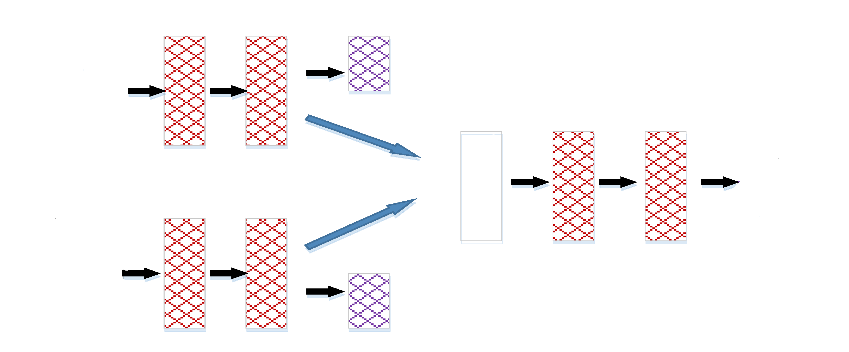
Interpolated pixel value
x,y, image idx
Interpolated layers
x,y, image idx
Same network for both images

