Online Shop 2024 – Full Industrial Level Documentation

1. Business Objective
Objective of this project is to build an end-to-end analytics platform for Online Shop 2024 dataset. The platform enables strategic reporting, customer segmentation using RFM model, product performance tracking, and manager level region-based secure data access using Power BI Row Level Security.

2. Scope of Work
- Download and install MySQL Server and Workbench
- Import raw CSV data into MySQL
- Profile and clean data using optimized SQL scripts
- Develop Python scripts to calculate RFM scores
- Perform Market Basket Analysis using Apriori algorithm
- Build fully interactive Power BI dashboards
- Implement Row Level Security for managers
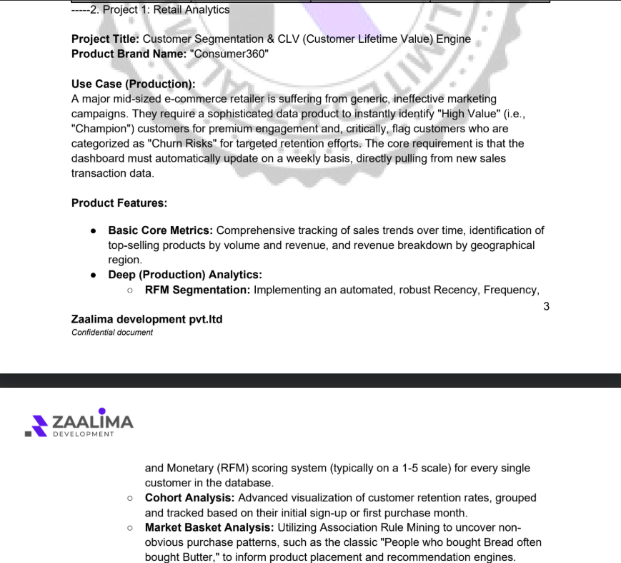

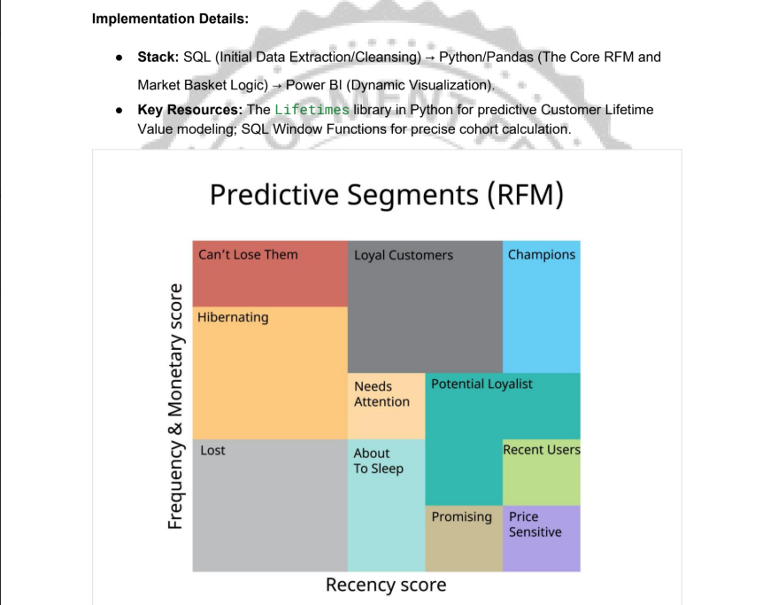

3. Data Sources
The following raw tables were used from Kaggle Online Shop 2024 dataset:
- customers.csv
- orders.csv
- order_items.csv
- products.csv
- payment.csv
- shipments.csv
- suppliers.csv
- reviews.csv
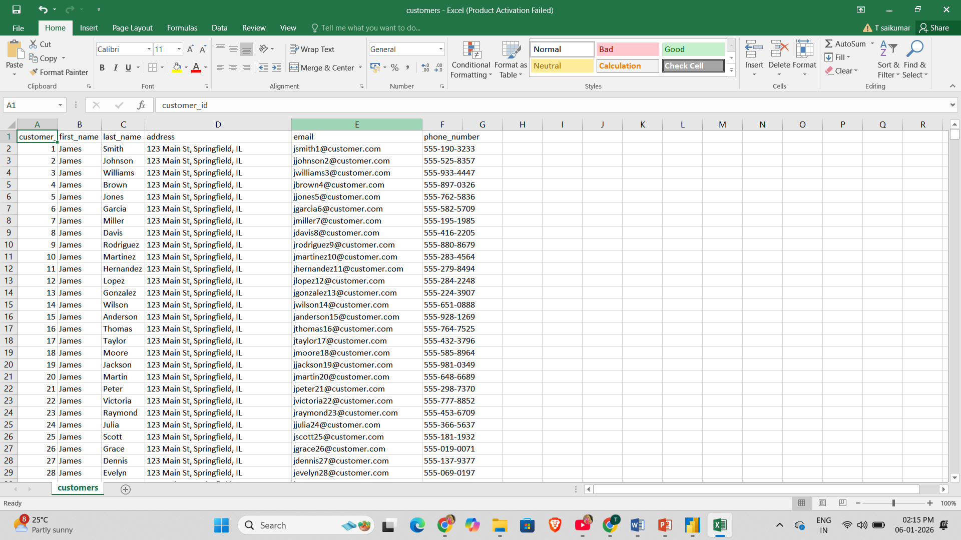

4. Data Modeling – MySQL
Star Schema Design implemented:
Fact Table:
fact_sales – order_id, customer_id, product_id, quantity, revenue, date_key, region
Dimension Tables:
dim_customer – customer_id, first_name, last_name, email, phone_number, address
dim_product – product_id, product_name, category, price, supplier_id
dim_date – date_key, full_date, year, month, day
dim_region – region_key, region_name
dim_manager – manager_key, manager_name, region_name
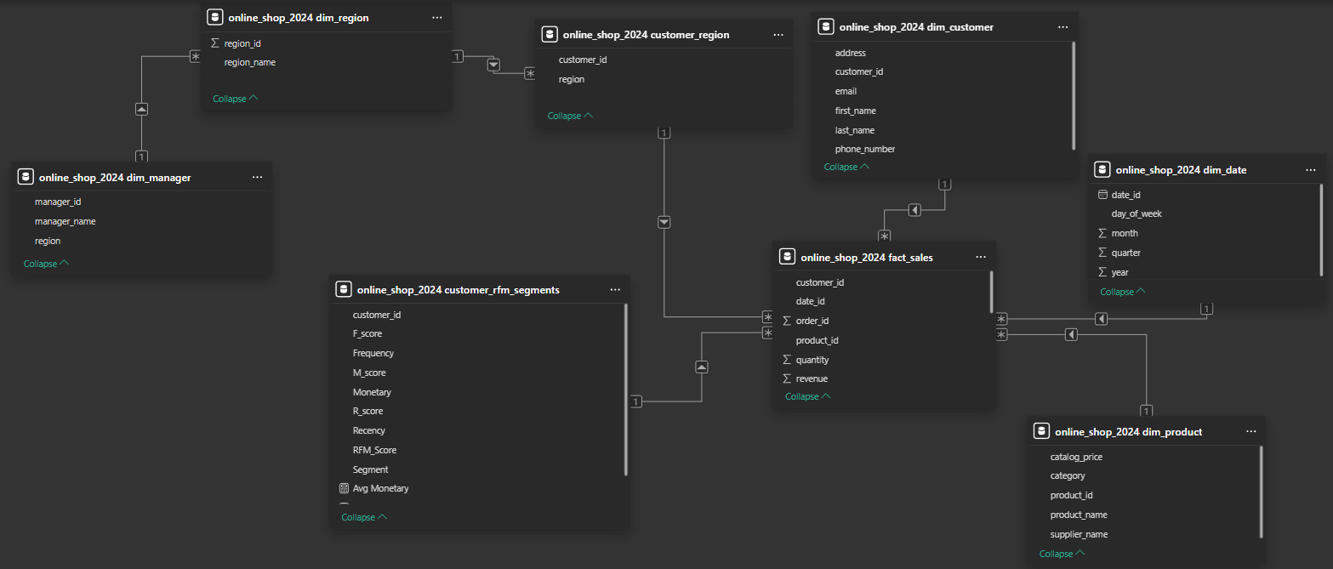

5. Data Cleaning – Week 2 (SQL)
Data Quality Checks performed:
- NULL value analysis across all columns
- Duplicate detection and resolution
- Business rule validation: quantity > 0, price > 0
- Standardized date formats
- Created clean SQL views for reporting
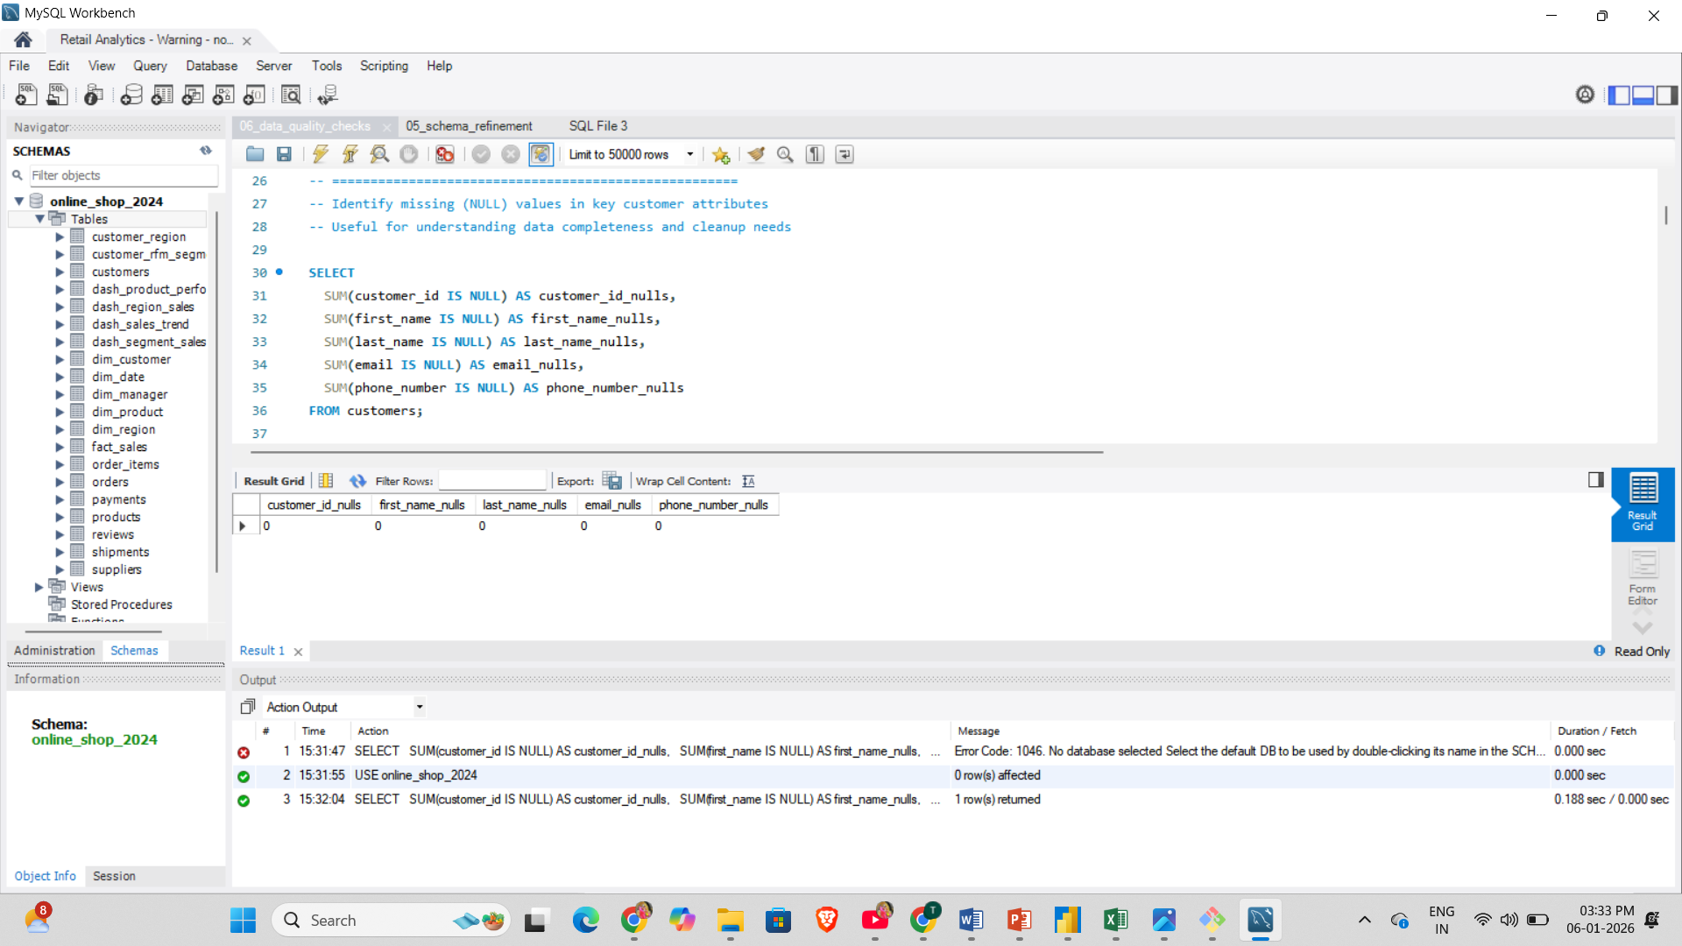

6. Python Analytics – Week 3
Python layer implementation:
- Connected MySQL using SQLAlchemy
- Pulled cleaned views into pandas
- Calculated Recency, Frequency, Monetary score (1–5 scale)
- Classified customers into segments like Champions, Loyal, Needs Attention, etc.
- Applied Apriori algorithm to identify frequent product pairs
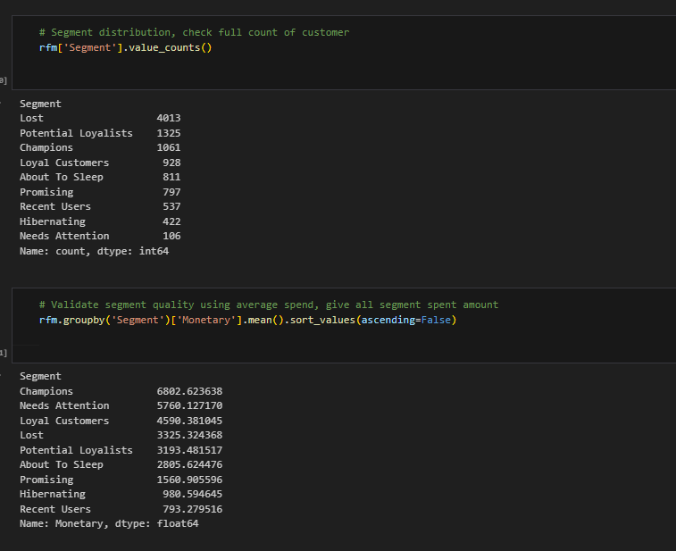

7. Power BI Dashboards
Dashboard-1: Executive Sales Overview
- KPIs: Total Revenue, Total Orders, Total Customers
- Visuals: Revenue by Region, Monthly Trend
- Slicers: Year and Region
Dashboard-2: Customer Analytics (RFM)
- KPIs: Champions Customers, Repeat Customers
- Visuals: Segment Distribution Donut, Revenue by Segment
- Slicers: Year, Region, Segment
Dashboard-3: Product Performance
- Cards: Revenue, Quantity, Distinct Products
- Charts: Top 10 Products, Category Contribution, Monthly Trend
- Slicers: Year, Month, Region, Category
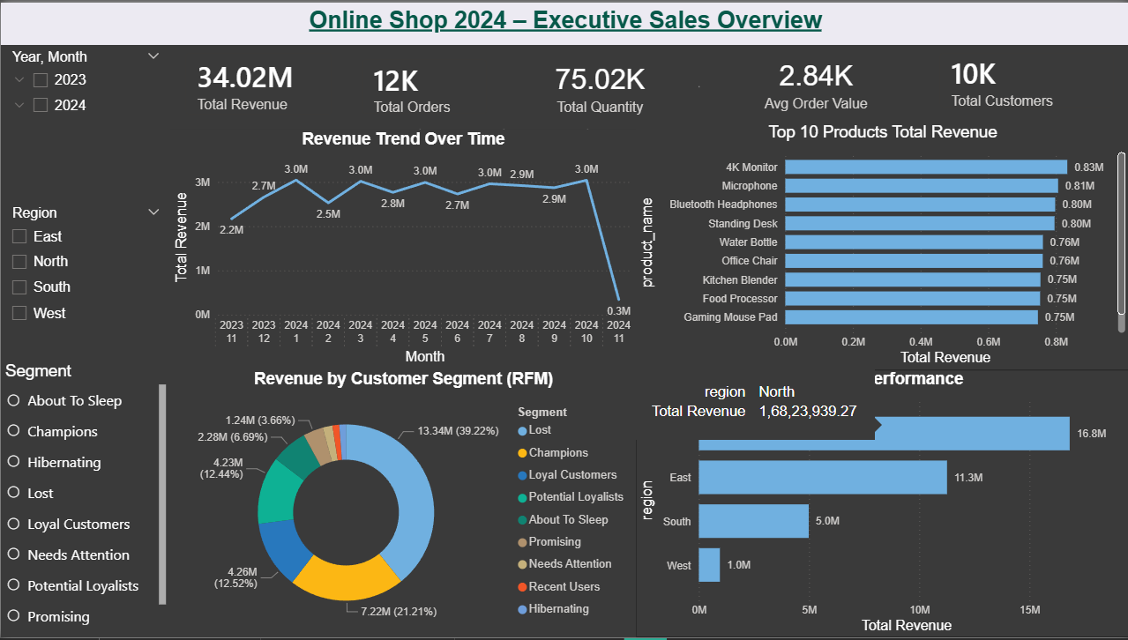
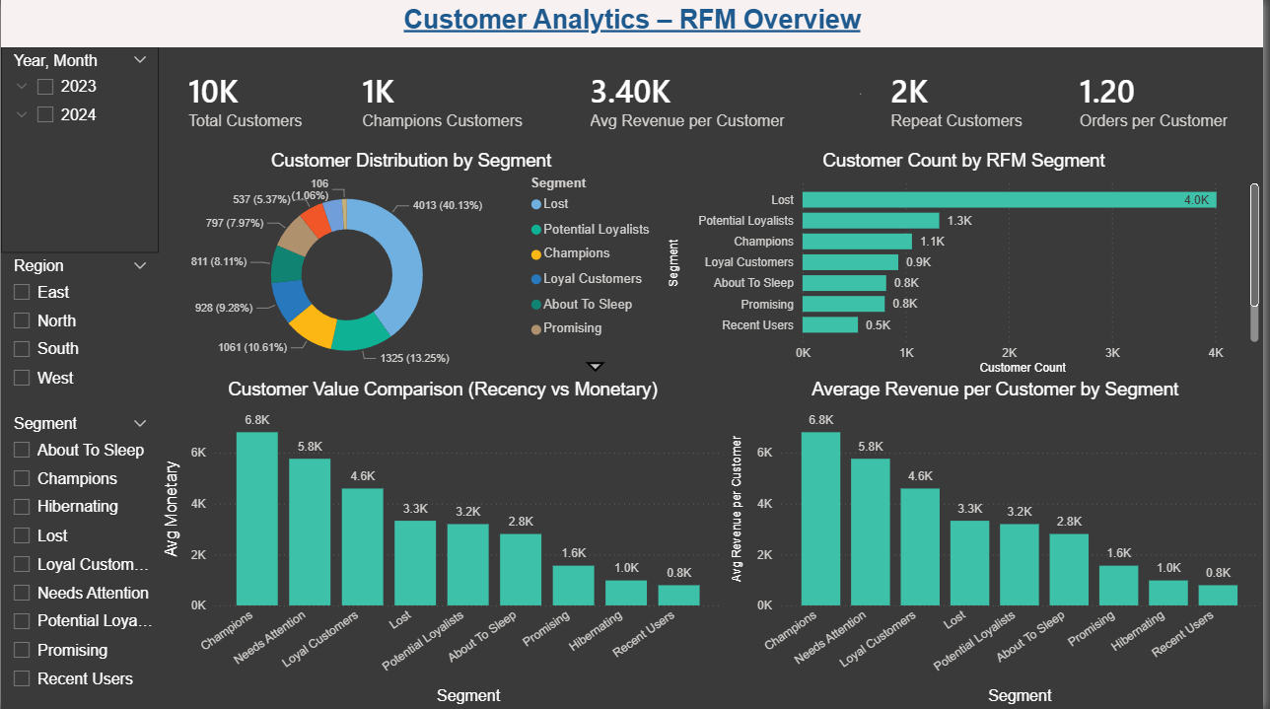
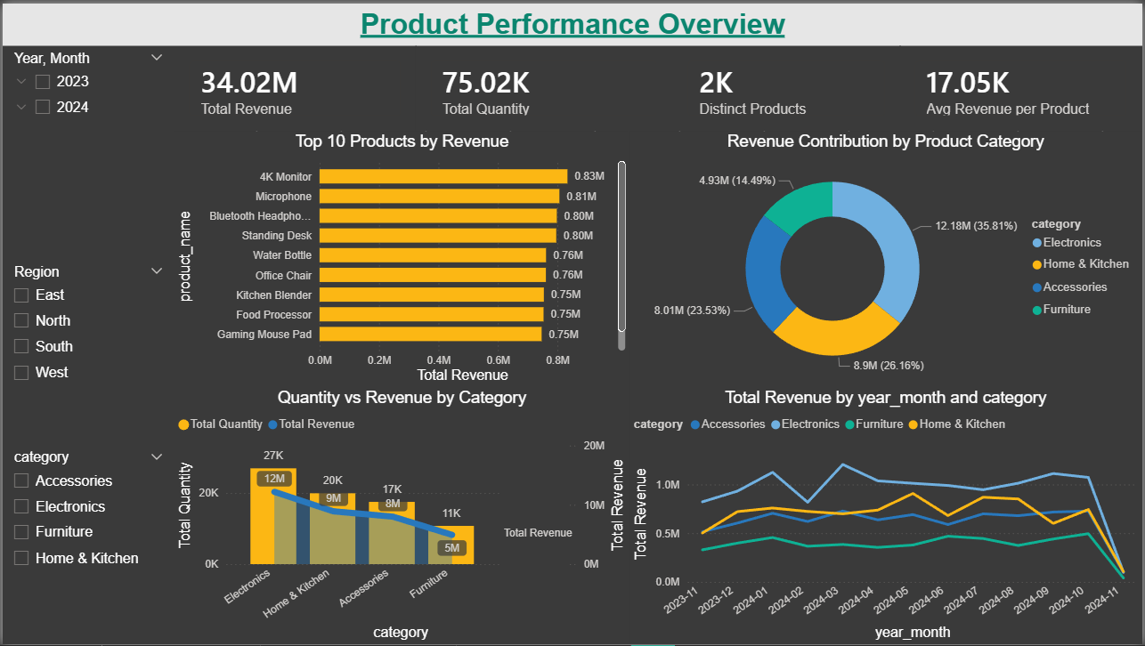

8. Outcomes & Insights
Key insights achieved:
- Top performing products and regions identified
- Customer value segments derived from RFM
- Seasonality patterns detected
- Governance and security implemented successfully
- Market Basket Analysis showed diversified purchasing behavior
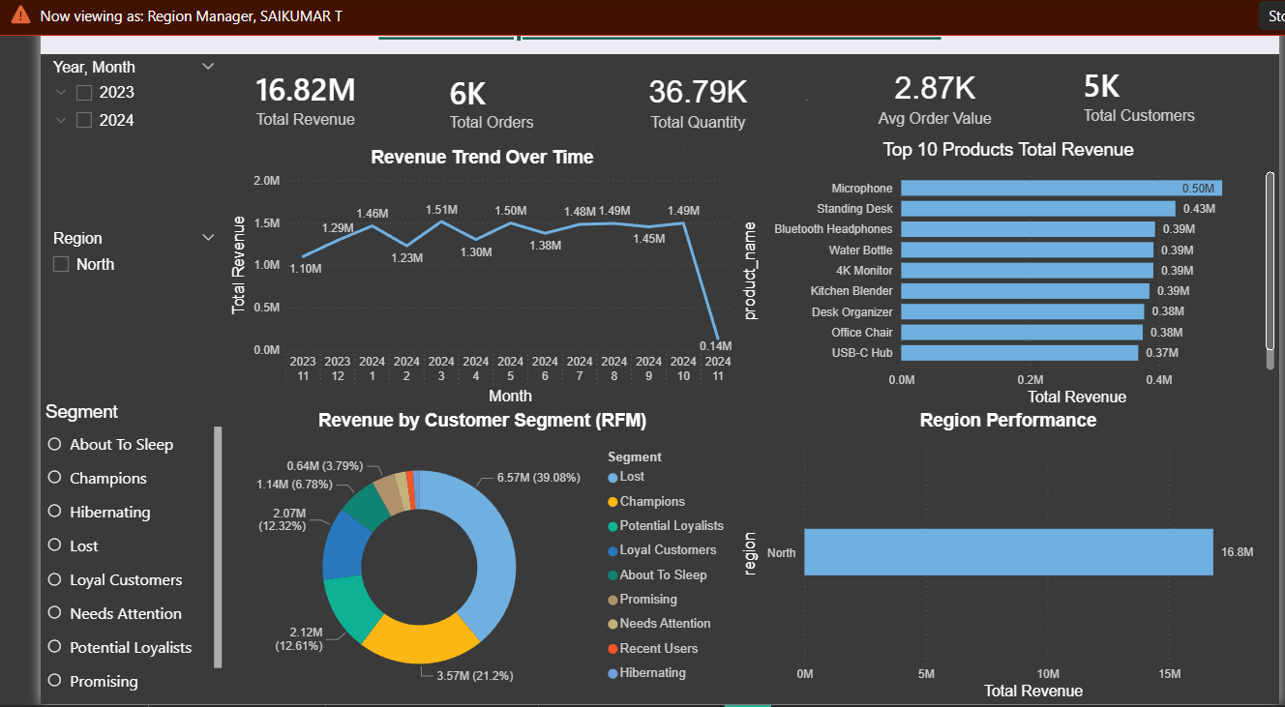

9. Recommendations
- Add real region master data for deeper analysis
- Automate Python data refresh pipeline
- Implement SCD Type-2 for dimensions
- Expand forecasting models

