OUTPUT TICTAC:
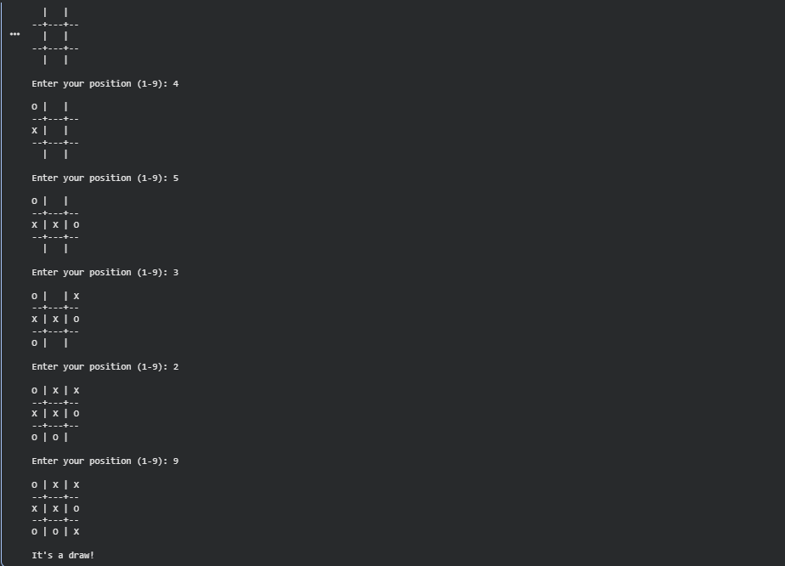

OUTPUT VACCUM CLEANER:
