HW1
aa <- read.delim("SRBCT_train.txt") # 讀檔
bb <- as.matrix(aa[,-c(1,2)]) # 扣掉第 1、2 col，因為是 character
dim(bb) # 觀察維度
Ouput:
[1] 2308 63

題目一：Get mean & sd value for each gene cross samples
# Get mean value for each gene cross samples
# 求 means
# 方法一 -> 使用 apply
mean_gene_cross_samples1 <- apply(bb, 1, mean)
mean_gene_cross_samples1

# 方法二 -> 使用內建函式 rowMeans
mean_gene_cross_samples2 <- rowMeans(bb)
Ouput: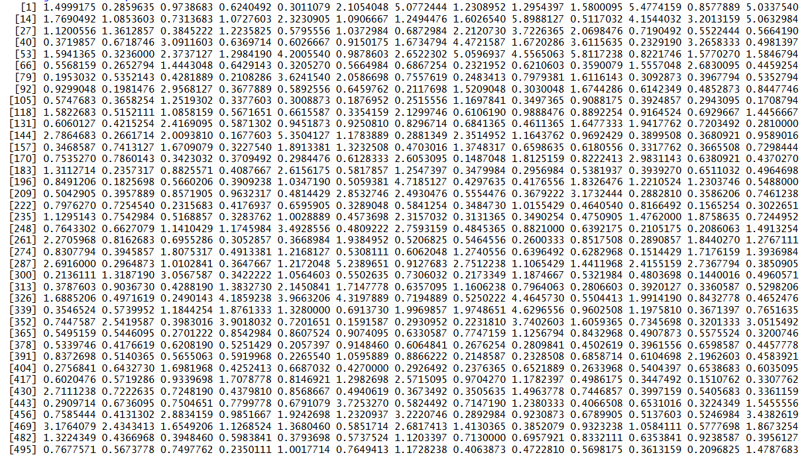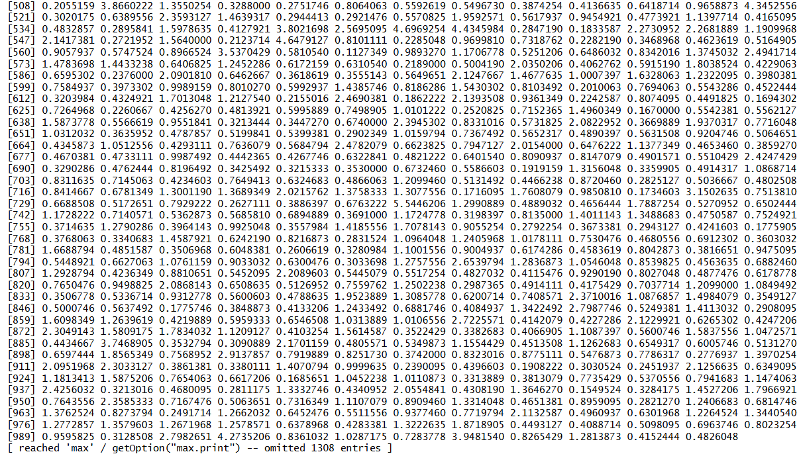
# 驗證結果是否相同
# AI
all.equal(mean_gene_cross_samples1, mean_gene_cross_samples2)
Ouput:
[1] TRUE

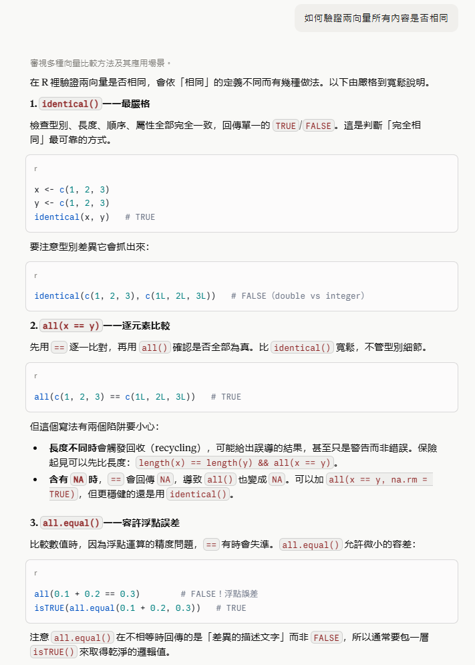

# Get sd value for each gene cross samples
# 求 sd
sd_gene_cross_samples <- apply(bb, 1, sd)
sd_gene_cross_samples
Ouput:

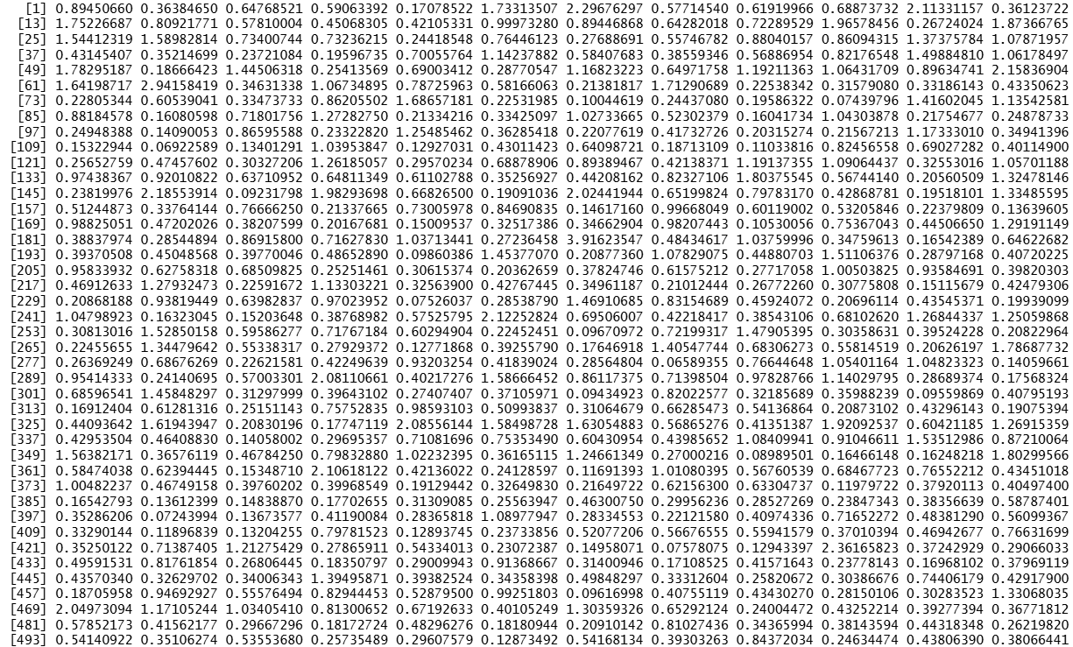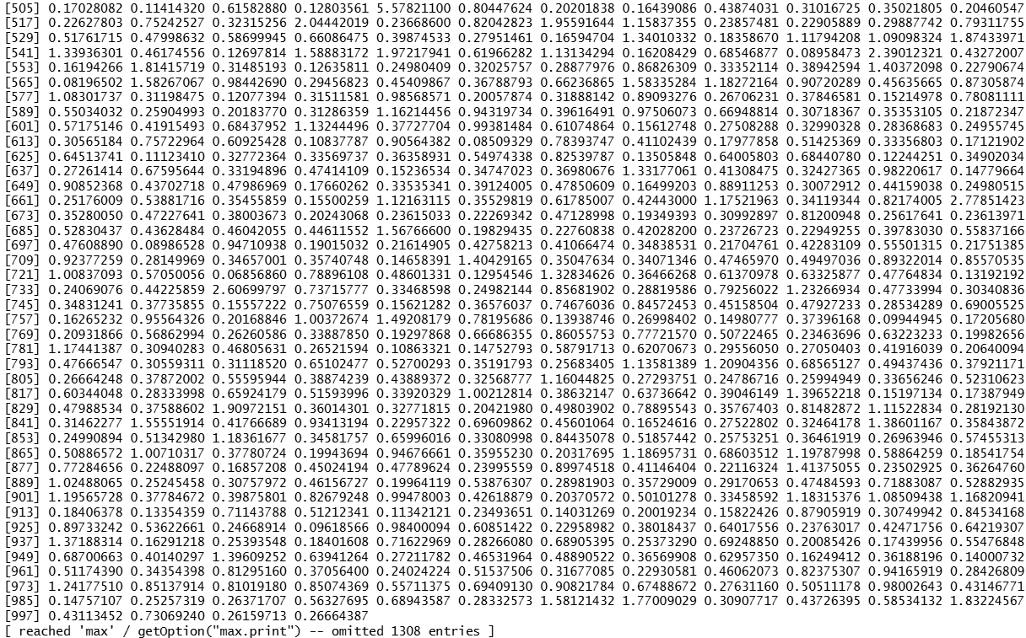

題目二：Get mean & sd value for each sample cross genes
# Get mean value for each sample cross genes
# 題目二：Get mean & sd value for each sample cross genes

# 求 means
# 方法一
mean_sample_cross_genes1 <- apply(bb, 2, mean)
# 方法二
mean_sample_cross_genes2 <- colMeans(bb)
Ouput:
[1] 0.8999231 0.9107066 0.9121858 0.9216109 0.9393284 0.9246767 0.9181976 0.9211571 0.9080536 0.9379128 0.9000853 0.9039657 0.9176309
[14] 0.8991331 0.8911080 0.8915395 0.9212825 0.9070417 0.9039065 0.8974366 0.8833335 0.8983932 0.8853999 0.8999410 0.8912325 0.8921722
[27] 0.8891327 0.8815866 0.8788212 0.8820618 0.8865663 0.8988042 0.9210532 0.9083504 0.9061526 0.8964495 0.9260049 0.9098169 0.9065384
[40] 0.9023300 0.8988161 0.8996560 0.8955150 0.9109578 0.9330225 0.9104899 0.9240139 0.9156453 0.9120389 0.9096284 0.9137515 0.9013536
[53] 0.9162928 0.9240076 0.9189305 0.9310080 0.9385528 0.9221431 0.9259349 0.9295506 0.9279080 0.9167595 0.8906594

# 驗證結果是否相同
all.equal(mean_sample_cross_genes1, mean_sample_cross_genes2)
Ouput:
[1] TRUE
# Get sd value for each sample cross genes
# 求 sd
sd_sample_cross_genes <- apply(bb, 2, sd)
sd_sample_cross_genes

Ouput:
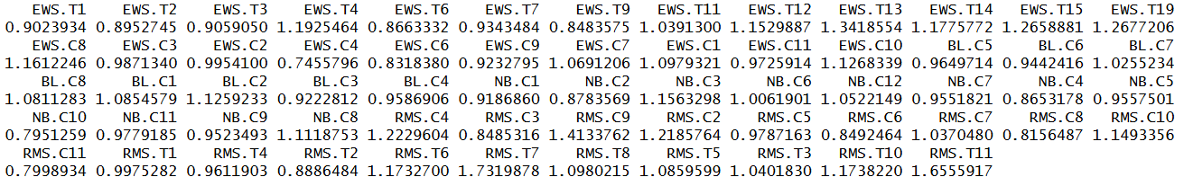
# Select top 30% genes with larger sd values
# AI
n_top30_cols <- ceiling(nrow(bb) * 0.3)
top30_genes_sd <- order(sd_gene_cross_samples, decreasing = TRUE)[1:n_top30_cols]
top30_genes_sd
Ouput:
