HW3
# 讀檔
data_SRBCT <- read.delim("SRBCT_train.txt")
data1 <- as.matrix(data_SRBCT[ , -c(1:2)])
# 提取 Image_id
Image_id <- data_SRBCT[,1]
Image_id # 觀察

Output:
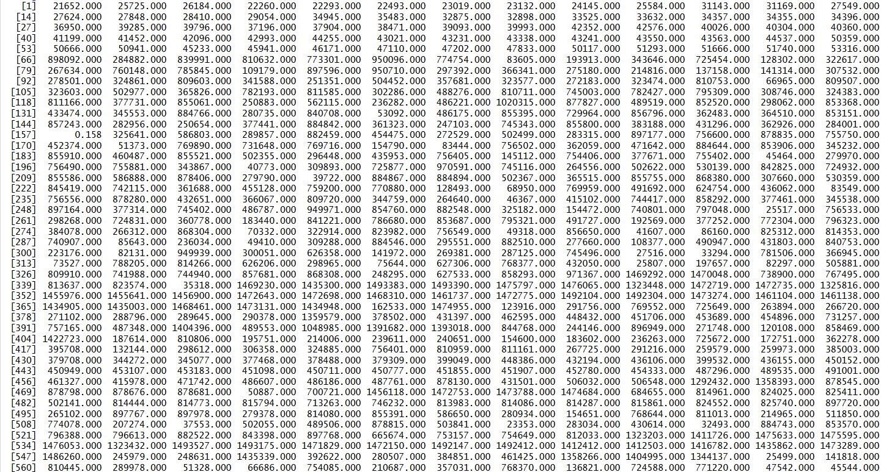
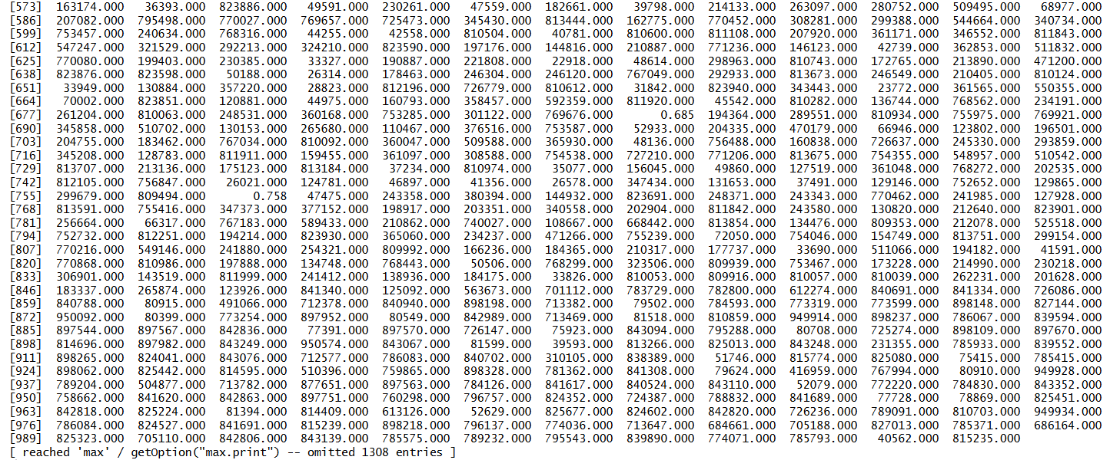

# 取得所有欄位名稱
cols <- colnames(data1)
labels <- sub("\\..*", "", cols)
table(labels) # 透過各類別數量觀察是否有分割錯

Output:
labels
BL EWS NB RMS
8 23 12 20

# 幫四種類別設定顏色跟點類型
categories = c("EWS", "BL", "NB", "RMS")
color <- c("EWS" = "blue", "BL" = "green", "NB" = "red", "RMS" = "black")
pch <- c("EWS" = 15, "BL" = 16, "NB" = 17, "RMS" = 18)

# 套用到每一欄
col_color <- color[labels]
col_pch <- pch[labels]
col_color # 觀察
col_pch # 觀察
Output:
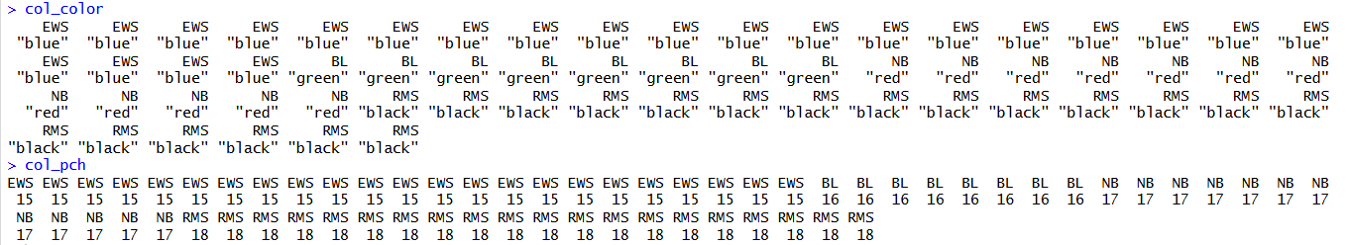

# – Scatter plots for Image ID 770394, 814260, 491565
# – Diff. colors, symbols & legends for samples in
diff. categories
## 準備想要視覺化的資料
## 從 data1_norm 提取 Image_id = 770394、814260、491565列的值
plot_data1 <- rbind(data1_norm[which(Image_id == 770394), ],
data1_norm[which(Image_id == 814260), ],
data1_norm[which(Image_id == 491565), ])
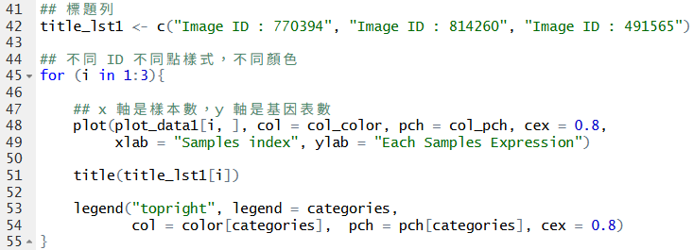
Output:
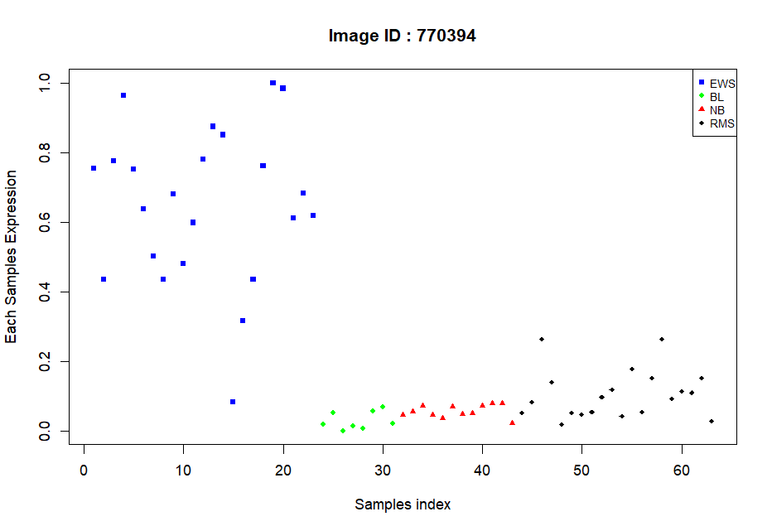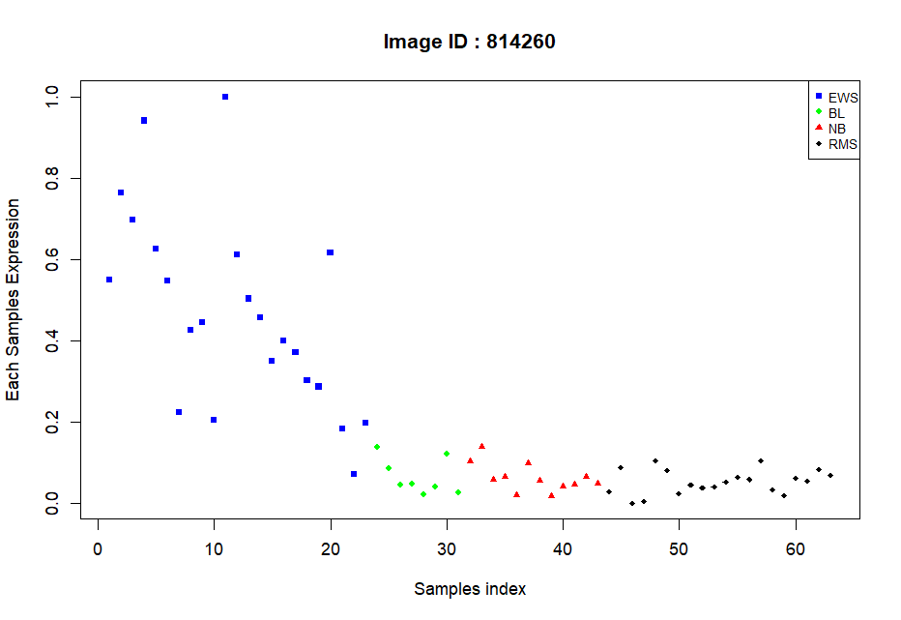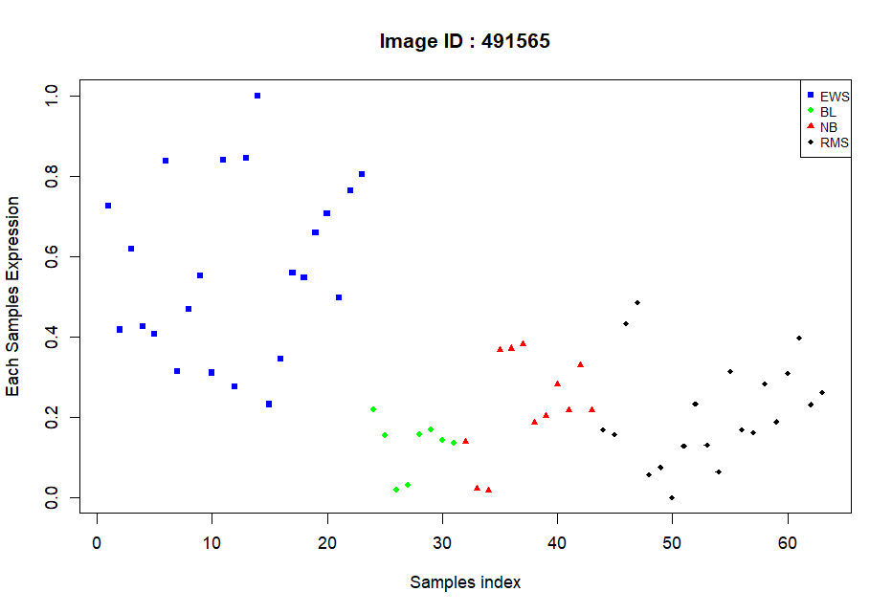

# – Scatter plots for 770394 vs 236282
# – Diff. colors, symbols & legends for samples in diff.
categories
## 從 data1_norm 提取 Image_id = 770394、236282 那列的值
Image_id_770394 <- data1_norm[which(Image_id == 770394), ]
Image_id_236282 <- data1_norm[which(Image_id == 236282), ]
# x 軸為 770394，y 軸為 236282
plot(Image_id_770394, Image_id_236282,
col = col_color, pch = col_pch,
xlab = "ID : 770394", ylab = "ID : 236282")

title("Image ID : 770394 vs 236282")
legend("topright", legend = categories,
col = color[categories], pch = pch[categories],
cex = 0.8)
Output:
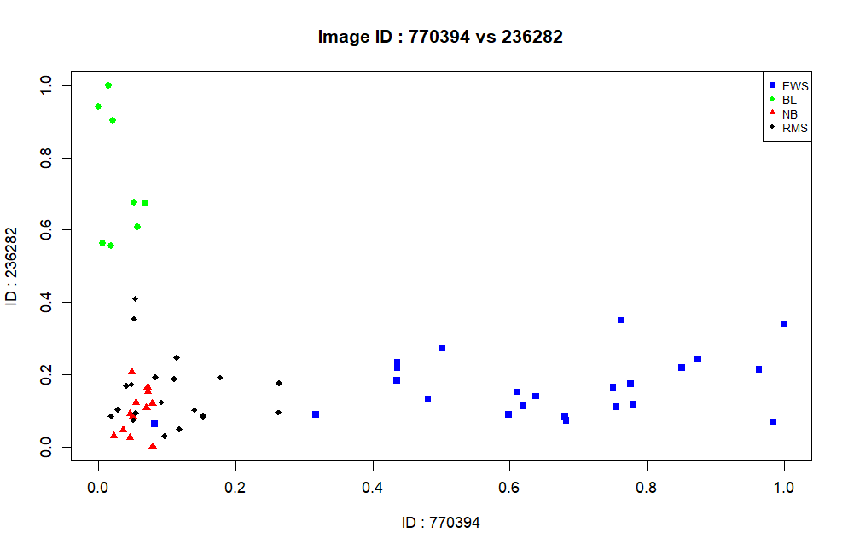

# – Scatter plots for 812105 vs 784224
# – Diff. colors, symbols & legends for samples in diff.
categories
## 從 data1_norm 提取 Image_id = 812105、784224那列的值
Image_id_812105 <- data1_norm[which(Image_id == 812105), ]
Image_id_784224 <- data1_norm[which(Image_id == 784224), ]

# x 軸為 812105，y 軸為 784224
plot(Image_id_812105, Image_id_784224,
col = col_color, pch = col_pch,
xlab = "ID : 812105", ylab = "ID : 784224")

title("Image ID : 812105 vs 784224")
legend("topright", legend = categories,
col = color[categories], pch = pch[categories],
cex = 0.8)
Output:
