HW3_加分
加分題 A
# 讀檔
data_SRBCT <- read.delim("SRBCT_train.txt")
data1 <- as.matrix(data_SRBCT[ , -c(1:2)])
# 提取 Image_id
Image_id <- data_SRBCT[,1]
# 用 normalize 後的 SRBCT_train.txt,分別計算每個 gene
在 EWS / BL / NB / RMS 四組樣本各自的平均表現量
min_max_norm <- function(x){
(x - min(x)) / (max(x) - min(x))
}
data1_norm <- t(apply(data1, 1, min_max_norm))

# 取得所有欄位名稱
cols <- colnames(data1)
labels <- sub("\\..*", "", cols)

# 取出 EWS / BL / NB / RMS 四組樣本各自的資料
EWS_data <- data1_norm[, which(labels == "EWS")]
BL_data <- data1_norm[, which(labels == "BL")]
NB_data <- data1_norm[, which(labels == "NB")]
RMS_data <- data1_norm[, which(labels == "RMS")]

# 四組樣本各自的平均表現量
EWS_data_mean <- apply(EWS_data, 1, mean)
BL_data_mean <- apply(BL_data, 1, mean)
NB_data_mean <- apply(NB_data, 1, mean)
RMS_data_mean <- apply(RMS_data, 1, mean)

# 接著找出符合下列三種表現樣式的 genes
# SNR 公式:
# SNR = (μtarget − μothers) / (σtarget + σothers)
# 其中 μ 為該群樣本在此 gene 的平均值、σ 為標準差。
SNR <- function(t_mean, t_sd, o_mean, o_sd){
(t_mean - o_mean) / (t_sd + o_sd)
}
# 1. BL-low pattern:BL 組的平均低於 EWS、NB、RMS 三組各自的平均
bl_low_rows <- which(BL_data_mean < EWS_data_mean &
BL_data_mean < NB_data_mean &
BL_data_mean < RMS_data_mean)
bl_low_rows # 觀察
Output:
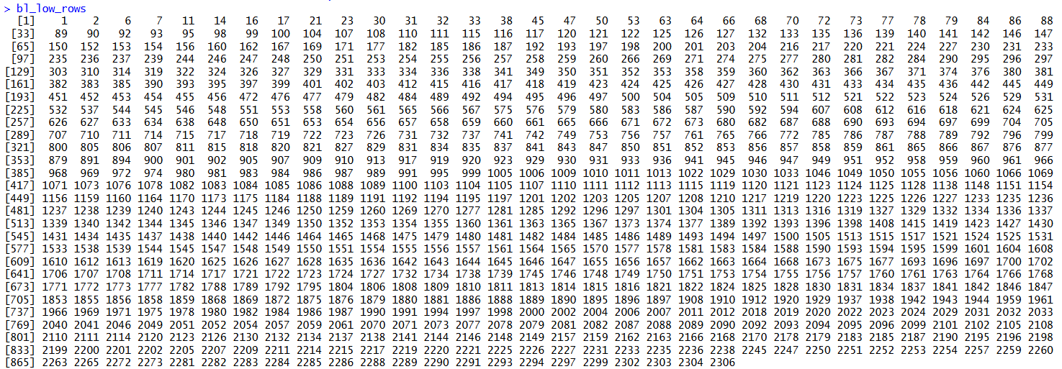
# 過濾:只留下 BL 組的平均低於 EWS、NB、RMS 三組各自平均的資料
bl_low_data <- data1_norm[bl_low_rows, ]

# 對每個 gene 計算 SNR (signal-to-noise ratio), 並挑出 SNR 值最小的那個 gene。
# target為過濾後BL類別的資料，其餘為others
# 計算target、others的mean、sd，以計算snr
target1 <- bl_low_data[, which(labels == "BL")]
target1 # 觀察
target1_mean <- apply(target1, 1, mean)
target1_sd <- apply(target1, 1, sd)

others1 <- bl_low_data[, -which(labels == "BL")]
others1 # 觀察
others1_mean <- apply(others1, 1, mean)
others1_sd <- apply(others1, 1, sd)

snr1 <- SNR(target1_mean, target1_sd, others1_mean,
others1_sd)
idx1 <- which.min(snr1) # 索引相對於 bl_low_data
Output:
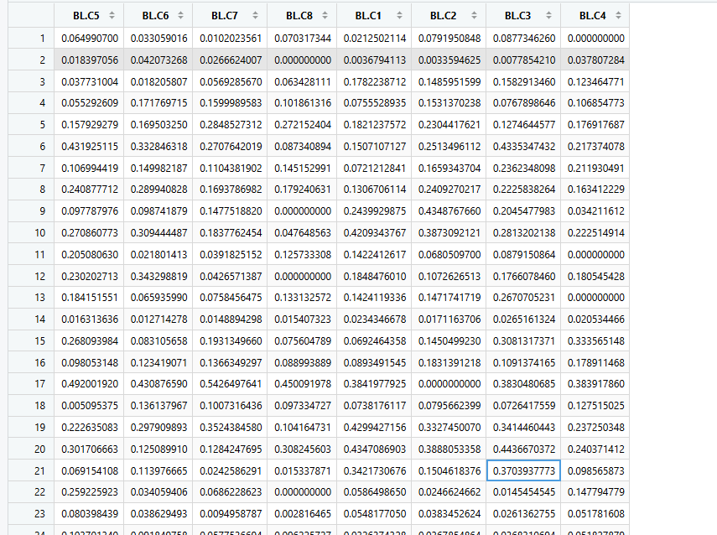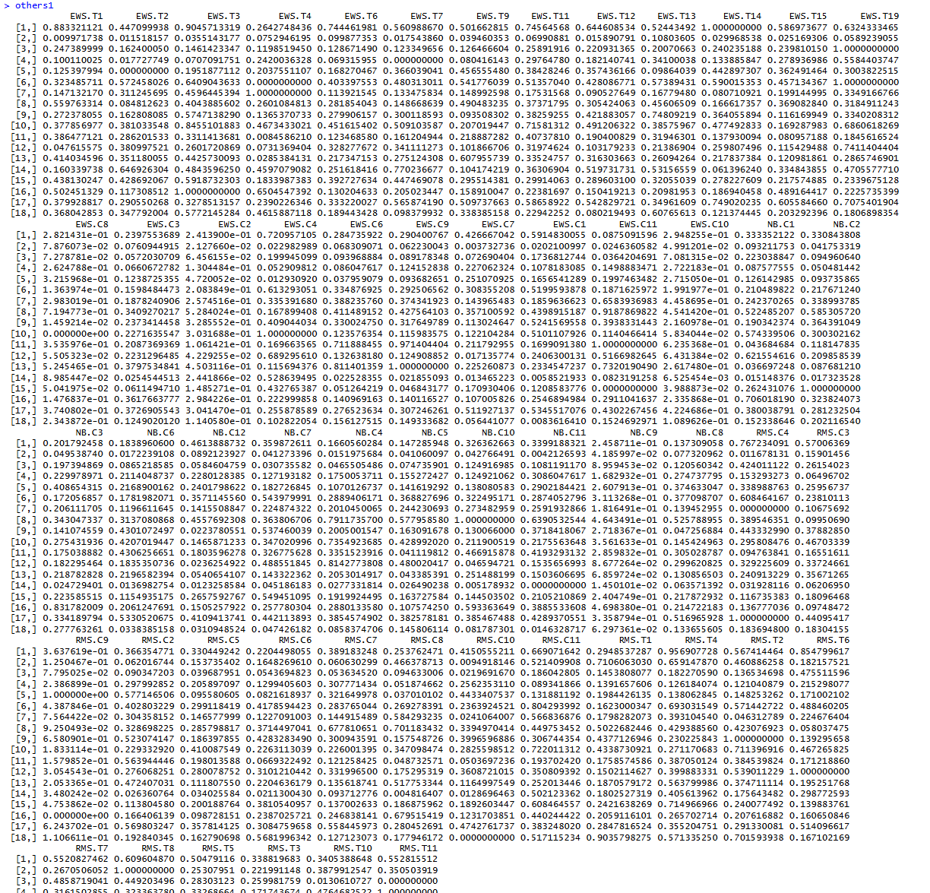

# 2. EWS–NB-low pattern:EWS 與 NB 兩組的平均, 低於 BL 與 RMS 兩
組的平均
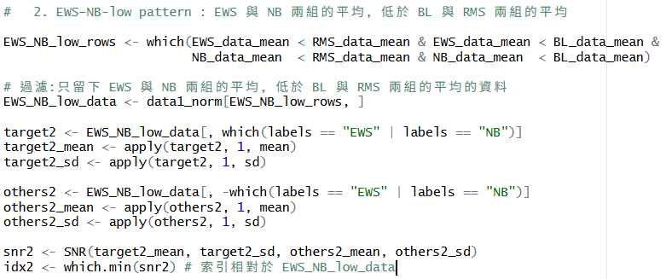
# 3. EWS–RMS-low pattern : EWS 與 RMS 兩組的平均, 低於 BL 與 NB
兩組的平均
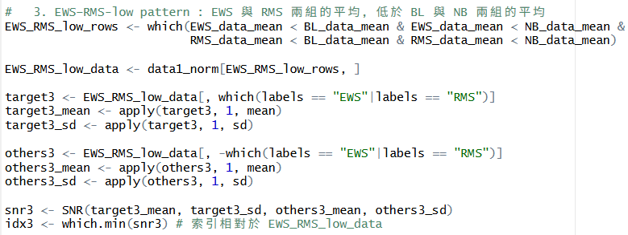

# 畫出所選 gene 在全部樣本上的 normalized 表現量 scatter plot
# 用四種不同顏色 + 四種不同符號分別代表 EWS / BL / NB / RMS(每組各自一種顏色與一種符號)
# 幫四種類別設定顏色跟點類型
categories <- c("EWS", "BL", "NB", "RMS")
color <- c(EWS = "blue", BL = "green", NB = "red",
RMS = "black")
pch <- c(EWS = 16, BL = 17, NB = 15, RMS = 18)
col_color <- color[labels]
col_pch <- pch[labels]

# picture1
# 這個 gene 在所有樣本的 normalized 值
gene_expr1 <- data1_norm[bl_low_rows[idx1], ]
plot(gene_expr1, col = col_color, pch = col_pch,
xlab = "Samples index",
ylab = "Each Samples Expression",
main = paste("Image ID :", Image_id[bl_low_rows[idx1]]))

legend("topright", legend = categories,
col = color[categories], pch = pch[categories])

Output:
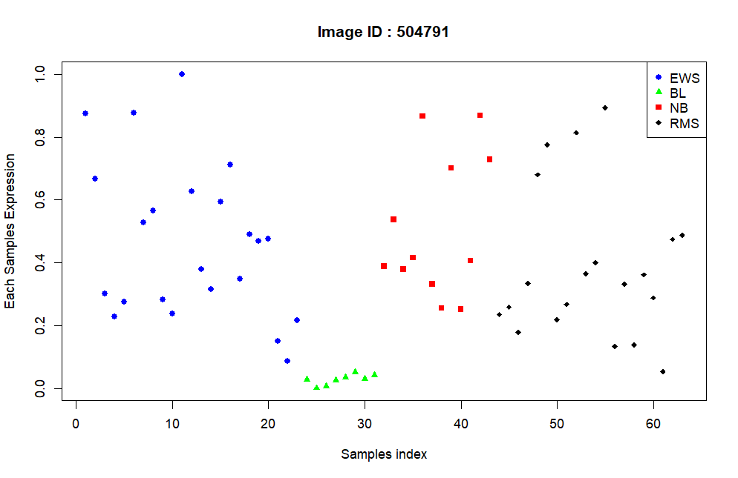

# picture2
# 這個 gene 在所有樣本的 normalized 值
gene_expr2 <- data1_norm[EWS_NB_low_rows[idx2], ]
plot(gene_expr2, col = col_color, pch = col_pch,
xlab = "Samples index",
ylab = "Each Samples Expression",
main = paste("Image ID :", Image_id[EWS_NB_low_rows[idx2]]))

legend("topright", legend = categories,
col = color[categories], pch = pch[categories])
Output:
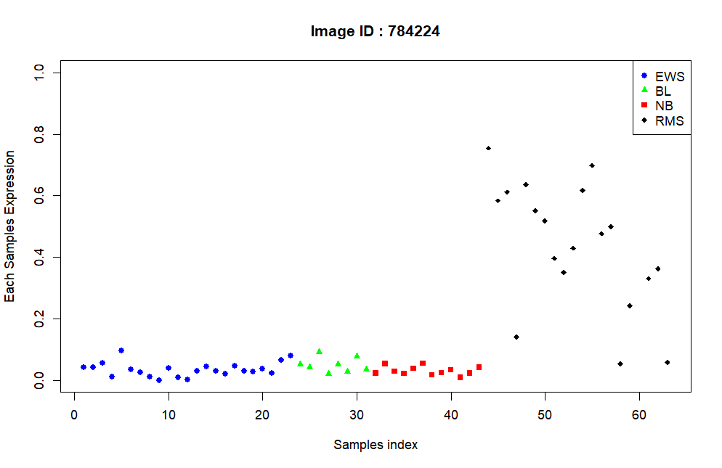

# picture3
# 這個 gene 在所有樣本的 normalized 值
gene_expr3 <- data1_norm[EWS_RMS_low_rows[idx3], ]
plot(gene_expr3, col = col_color, pch = col_pch,
xlab = "Samples index",
ylab = "Each Samples Expression",
main = paste("Image ID :", Image_id[EWS_RMS_low_rows[idx3]]))

legend("topright", legend = categories,
col = color[categories], pch = pch[categories])
Output:
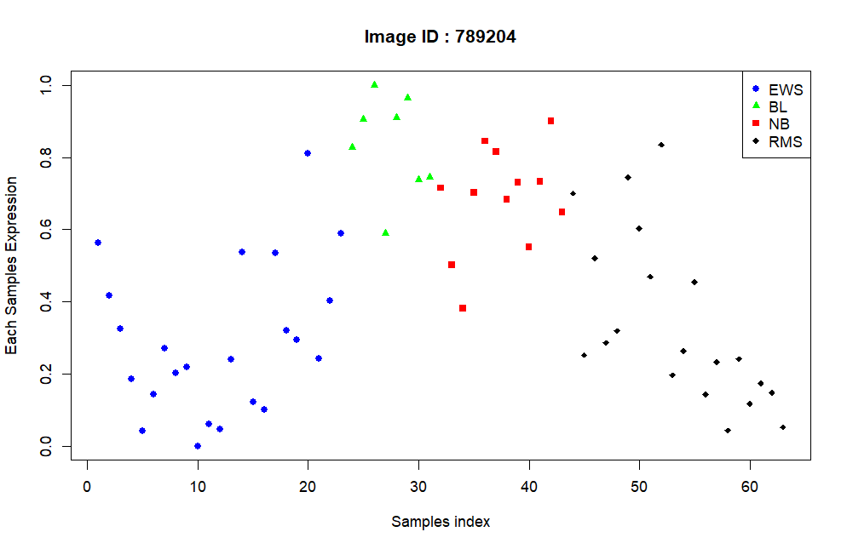

加分題 B
# 用 par(mfrow = ...) 把主題目第 3、4 點的四張 scatter plot 排成一張組合圖,
# 但不要用方方正正的 2×2 等分排版。請自己設計版面
## 想法:我想把第四點的兩張圖放在第一列（大圖），三張個別個案例在第二
列（小圖）
# +-----+-----+-----+
# | 1 | 2 | ← 第4點的兩張,較寬
# +-----+-----+-----+
# | 3 | 4 | 5 | ← 第3點的三張
# +--------+--------+
# 準備想要視覺化的資料
plot_data1 <- rbind(data1_norm[which(Image_id == 770394), ],
data1_norm[which(Image_id == 814260), ],
data1_norm[which(Image_id == 491565), ])

# – Perform scatter plots for Image ID “770394” vs “236282”

Image_id_770394 <- data1_norm[which(Image_id == 770394), ]
Image_id_236282 <- data1_norm[which(Image_id == 236282), ]

# – Perform scatter plots for Image ID “812105” vs “784224”
Image_id_812105 <- data1_norm[which(Image_id == 812105), ]
Image_id_784224 <- data1_norm[which(Image_id == 784224), ]

# AI
layout(matrix(c(1, 1, 1, 2, 2, 2,
3, 3, 4, 4, 5, 5), nrow = 2, byrow = TRUE),
heights = c(2, 1) # 上列高度是下列的 2 倍
)

plot(Image_id_770394, Image_id_236282,
col = col_color, pch = col_pch,
xlab = "ID : 770394", ylab = "ID : 236282")

plot(Image_id_812105, Image_id_784224,
col = col_color, pch = col_pch,
xlab = "ID : 812105", ylab = "ID : 784224")

# 不同 ID 不同點樣式，不同顏色
for (i in 1:3){
# x 軸是樣本數，y 軸是基因表數
plot(plot_data1[i, ], col = col_color, pch = col_pch,
cex = 0.8,
xlab = "Samples index",
ylab = "Each Samples Expression")
}
# 畫完重置,恢復成一個視窗一張圖
layout(1)
Output:
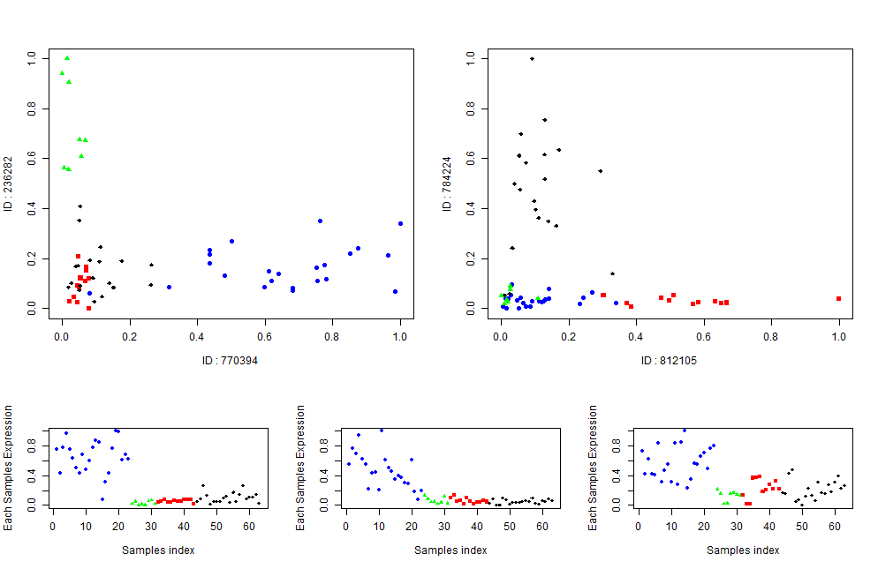

AI:

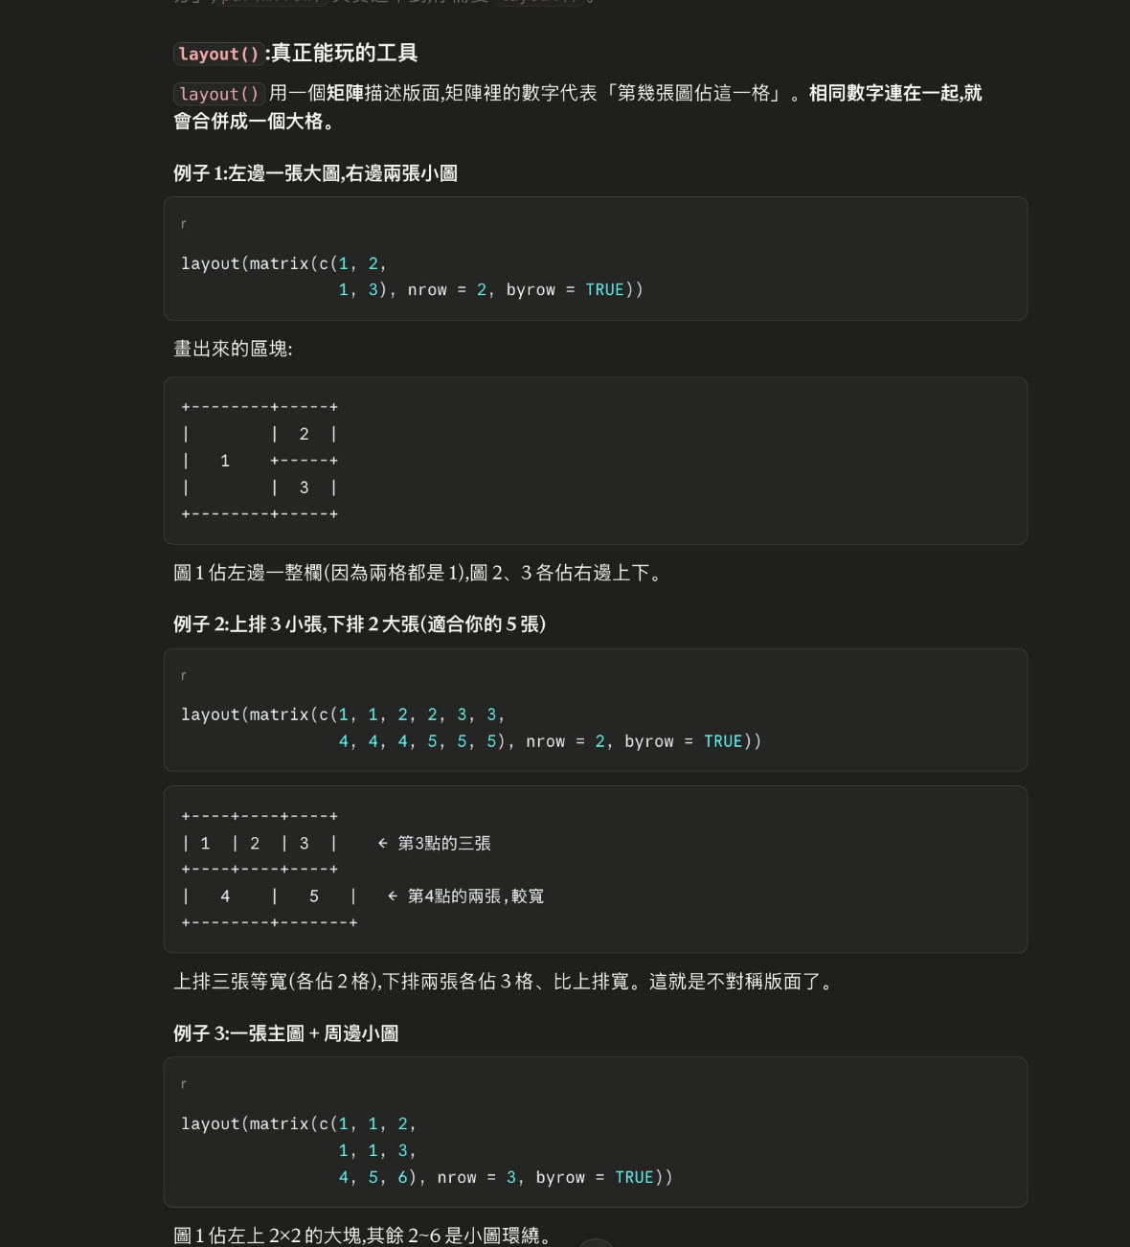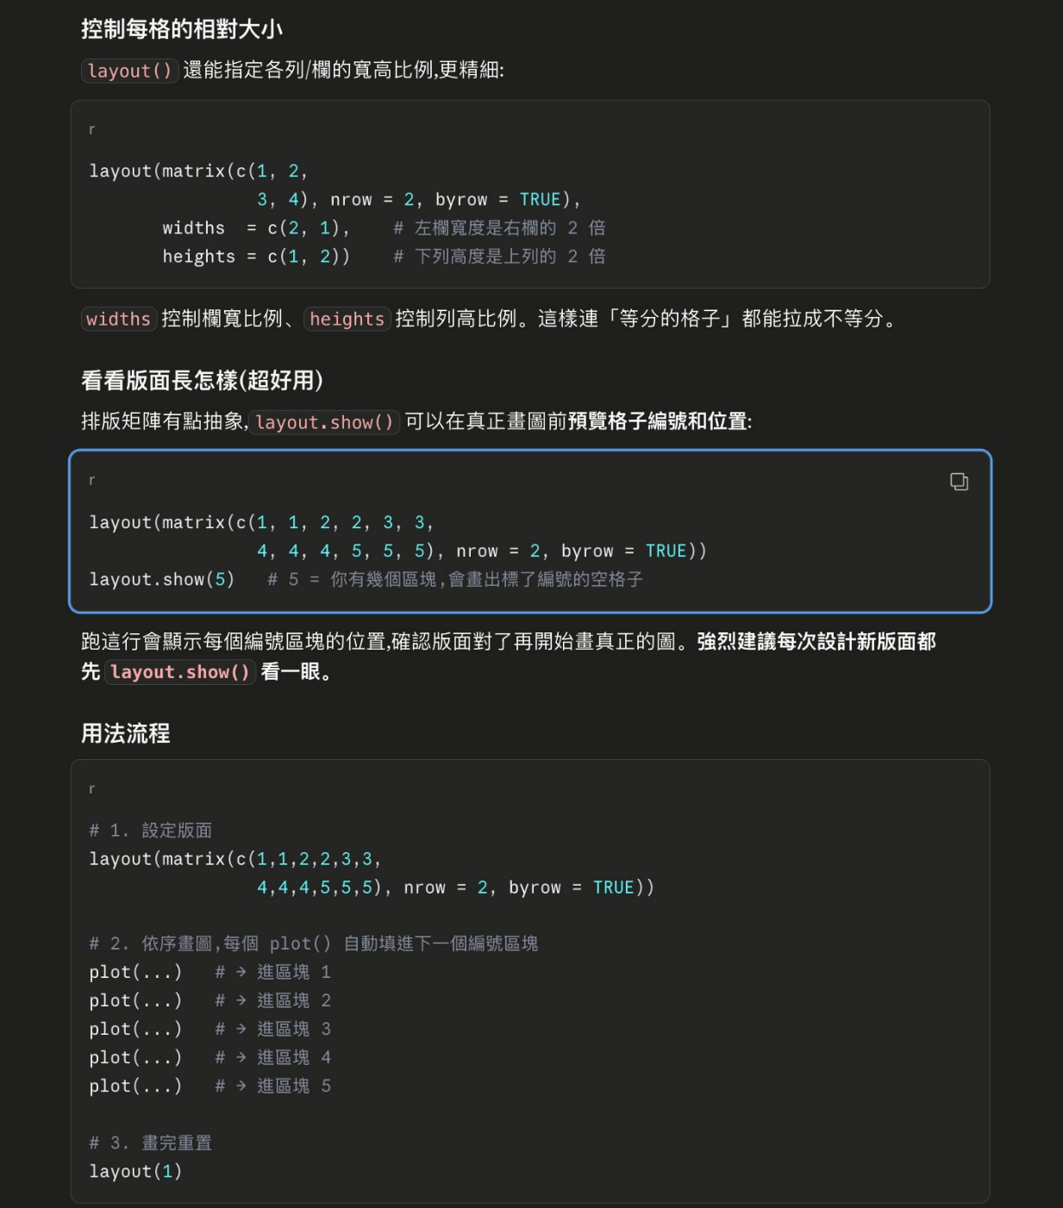

# 加分題 C
# 改用 cycleData_peak.txt 這份資料(酵母菌細胞週期, 800 genes × 77 個時間點, 最後一欄 peak 是該 gene 的高峰期別)。
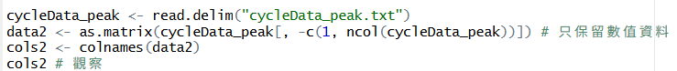
# AI
labels2 <- sub("\\..*|[0-9]+$", "", cols2)
table(labels2) # 檢查名稱有沒有分錯
Output:
> table(labels2) # 檢查名稱有沒有分錯
labels2
alpha cdc15 cdc28 clb2 cln3 elu
18 24 17 2 2 14
AI:

# 1. peak 欄共有 5 種期別:G1 / G2/ M / S/G2 / M/G1 / S
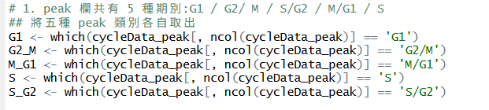
# 2. 從每一種期別中, 自己挑一個沒有缺值(NA) 的 gene(共挑 5 個)
## 我挑每類別中沒有缺值的第一筆資料
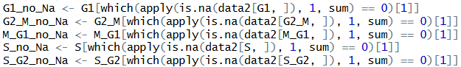
# 檢查挑選的資料是否有缺值，與peak類別是否正確
sum(is.na(data2[G1_no_Na, ]))
cycleData_peak[G1_no_Na, ncol(cycleData_peak)]
sum(is.na(data2[G2_M_no_Na, ]))
cycleData_peak[G2_M_no_Na, ncol(cycleData_peak)]
sum(is.na(data2[M_G1_no_Na, ]))
cycleData_peak[M_G1_no_Na, ncol(cycleData_peak)]
sum(is.na(data2[S_no_Na, ]))
cycleData_peak[S_no_Na, ncol(cycleData_peak)]
sum(is.na(data2[S_G2_no_Na, ]))
cycleData_peak[S_G2_no_Na, ncol(cycleData_peak)]

Output:
# 檢查挑選的資料是否有缺值，與peak類別是否正確
> sum(is.na(data2[G1_no_Na, ]))
[1] 0
> cycleData_peak[G1_no_Na, ncol(cycleData_peak)]
[1] "G1"
> sum(is.na(data2[G2_M_no_Na, ]))
[1] 0
> cycleData_peak[G2_M_no_Na, ncol(cycleData_peak)]
[1] "G2/M"
> sum(is.na(data2[M_G1_no_Na, ]))
[1] 0
> cycleData_peak[M_G1_no_Na, ncol(cycleData_peak)]
[1] "M/G1"
> sum(is.na(data2[S_no_Na, ]))
[1] 0
> cycleData_peak[S_no_Na, ncol(cycleData_peak)]
[1] "S"
> sum(is.na(data2[S_G2_no_Na, ]))
[1] 0
> cycleData_peak[S_G2_no_Na, ncol(cycleData_peak)]
[1] "S/G2"

# 3. 為這 5 個 gene 各畫一張 scatter plot(表現量隨時間點變化)
# 4. 用 rainbow() 或自訂色系上色,並加上 legend
# 上色規則:這份資料的 77 個欄位分屬數種實驗條件,每種條件底下是一系列
時間點(alpha 18 欄 / cdc15 24 欄 / cdc28 17 欄 / elu 14 欄 /
cln3 2 欄 / clb2 2 欄)。
# 同一個實驗條件的所有時間點用同一種顏色, 不同條件用不同顏色。
categories2 <- unique(labels2)

# 設定不同時間點的顏色
color2 <- c( "alpha" = "#003E19", "cdc15" = "#EECB27",
"cdc28" = "#E13239", "elu" = "#1F1762",
"cln3" = "#A13E97", "clb2" = "#5BBDC8" )

# 設定不同時間點的點樣式
pch2 <- c("alpha" = 15, "cdc15" = 16, "cdc28" = 17,
"elu" = 18, "cln3" = 19, "clb2" = 20)

# 套用到所有時間點
col_color2 <- color2[labels2]
col_pch2 <- pch2[labels2]

# G1
plot(data2[G1_no_Na, ],
col = col_color2, pch = col_pch2,
xlab = "Samples idx", ylab = "Expression")

legend("topright", legend = categories2,
col = color2[categories2], pch = pch2[categories2], cex = 0.6)

title("G1 peak gene")
Output:
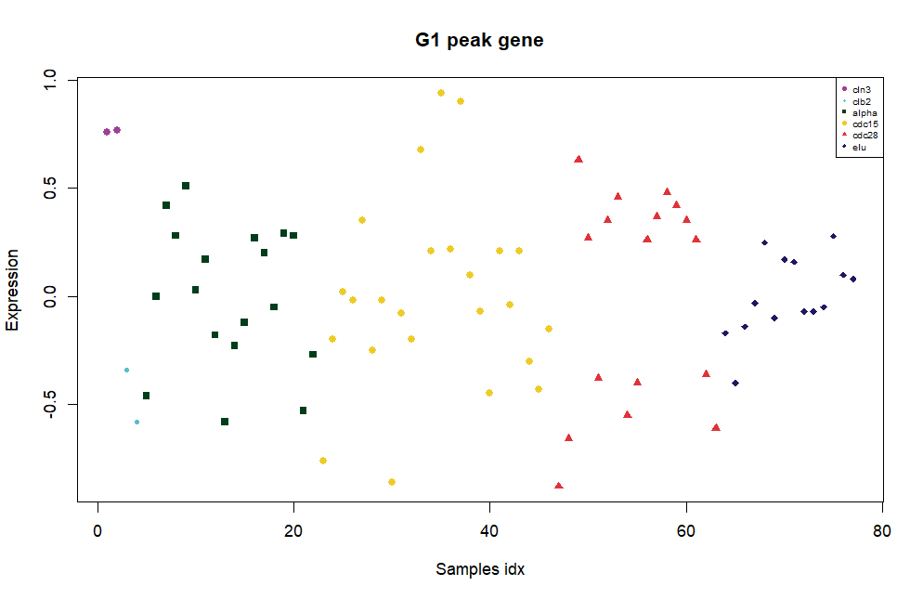

# G2/M
plot(data2[G2_M_no_Na, ],
col = col_color2, pch = col_pch2,
xlab = "Samples idx", ylab = "Expression")

legend("topright", legend = categories2,
col = color2[categories2], pch = pch2[categories2],
cex = 0.6)

title("G2/M peak gene")
Output:
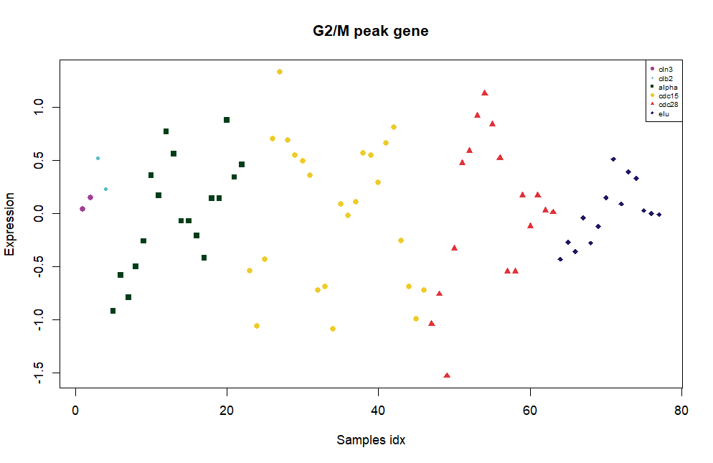

# M/G1
plot(data2[M_G1_no_Na, ],
col = col_color2, pch = col_pch2,
xlab = "Samples idx", ylab = "Expression")

legend("topright", legend = categories2,
col = color2[categories2], pch = pch2[categories2],
cex = 0.6)

title("M/G1 peak gene")
Output:
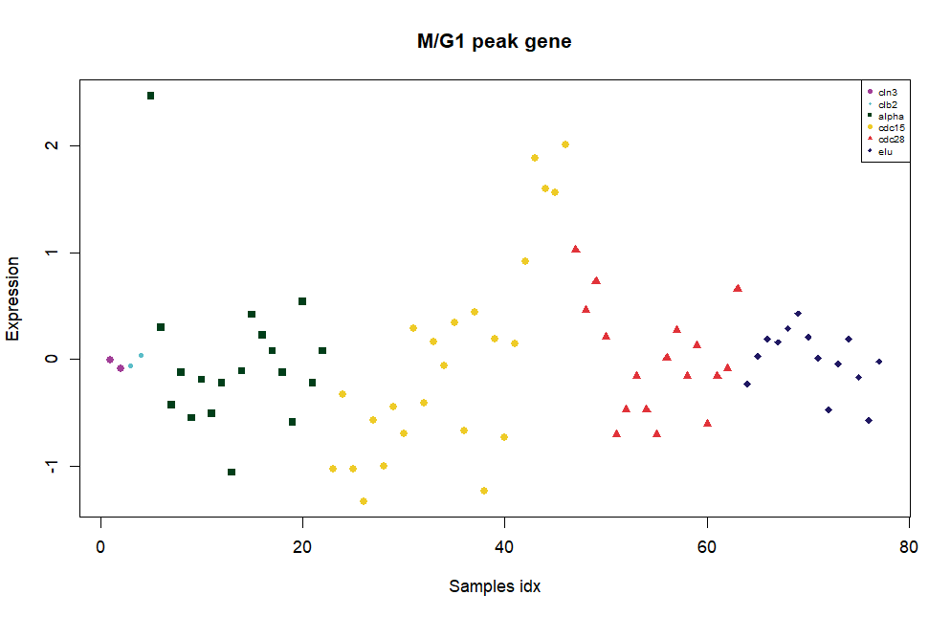

# S
plot(data2[S_no_Na, ],
col = col_color2, pch = col_pch2,
xlab = "Samples idx", ylab = "Expression")

legend("topright", legend = categories2,
col = color2[categories2], pch = pch2[categories2],
cex = 0.6)

title("S peak gene")
Output:
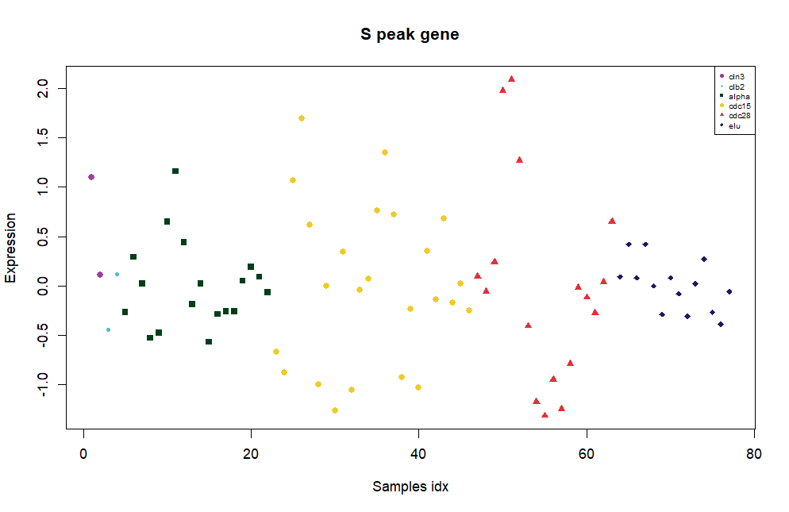

# S/G2
plot(data2[S_G2_no_Na, ],
col = col_color2, pch = col_pch2,
xlab = "Samples idx", ylab = "Expression")

legend("topright", legend = categories2,
col = color2[categories2], pch = pch2[categories2],
cex = 0.6)

title("S/G2 peak gene")
Output:
