HW4
## 讀檔
MLL_train <- read.delim("MLL_train.txt")
data <- MLL_train[-c(1:49), ]
# 1. Remove genes with name starting AFFX...(控制探針,共 49 個)
data <- MLL_train[-c(1:49), ]
# 2. Normalize data by each row(0~1)
data_norm <- t(apply(data[, 3:ncol(data)], 1, min_max_norm))

## 取得欄位名稱
col_name <- colnames(data_norm)
col_name # 觀察

## 清理欄位名
labels <- sub("_.*", "", col_name)
table(labels) # 觀察

Output:
> table(labels) # 觀察
labels
ALL AML MLL
20 20 17

# 3. Find top 10 differentially expressed genes using t-test,
每組一次(該組 vs 其他),條件:mean(該組) > mean(其他)
• 三組各 10 個 → 合併成 30 selected genes
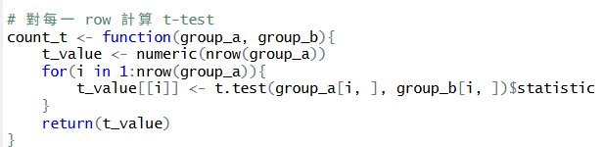
## ALL
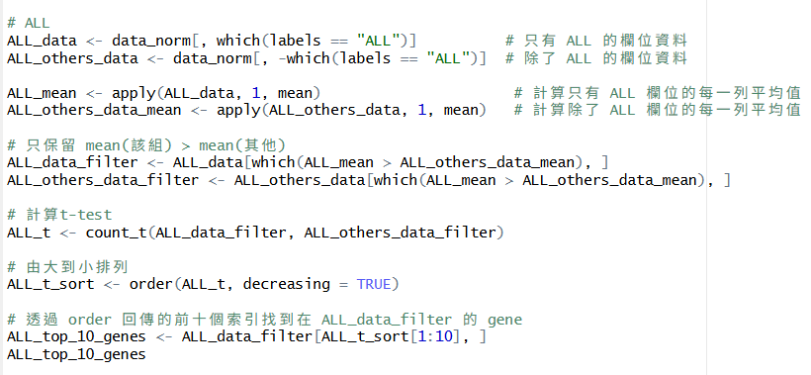
Output:
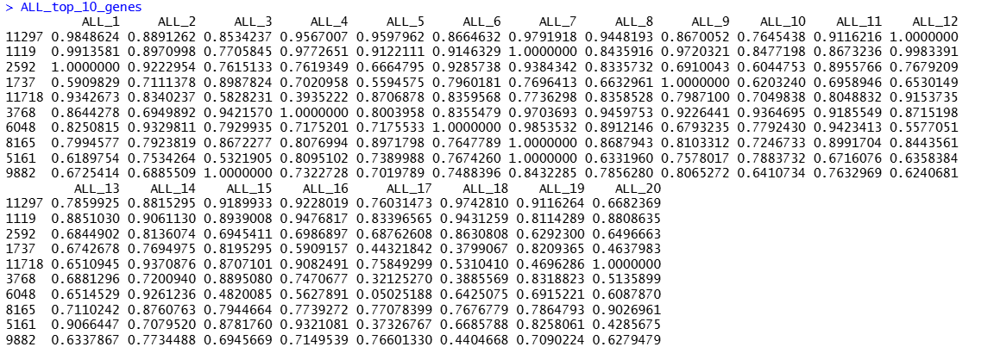

## MLL
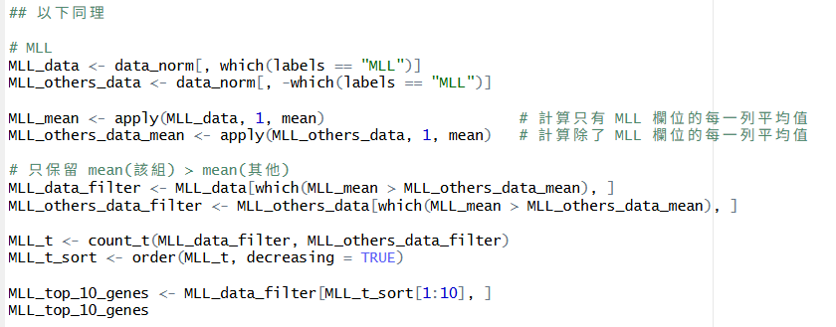
Output:
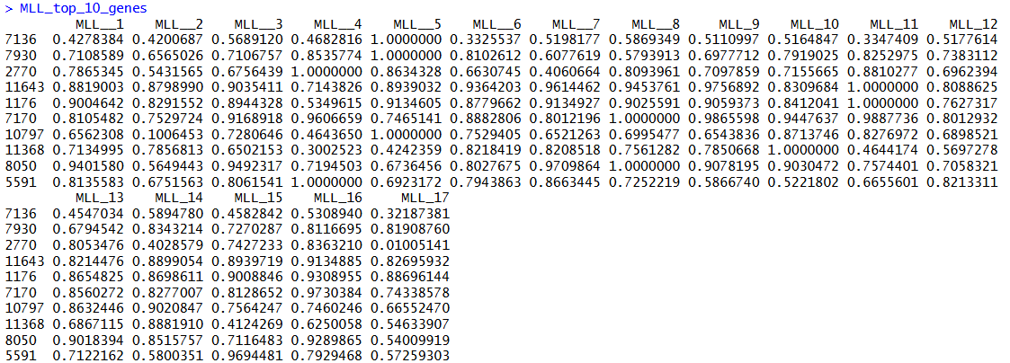
## AML
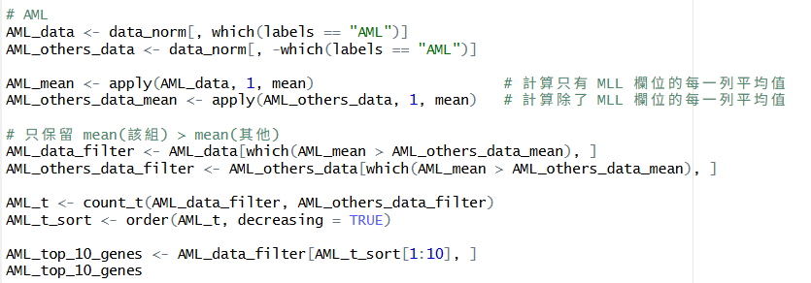

Output:
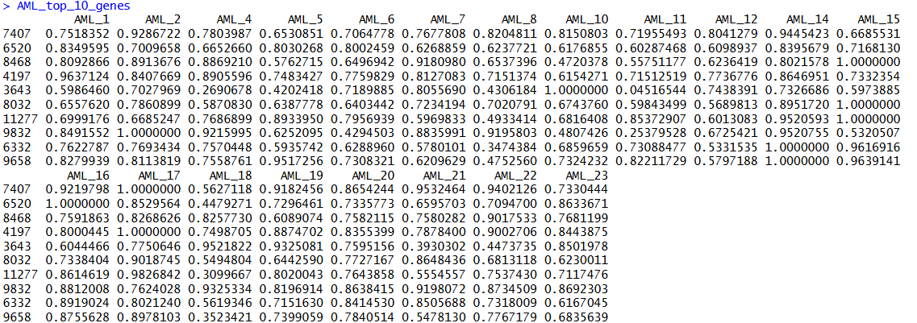
## 將三組各 10 個 → 合併成 30 selected genes
selected_genes <- c(rownames(ALL_top_10_genes),
rownames(MLL_top_10_genes),
rownames(AML_top_10_genes))
## 檢查是否有重複挑選的基因
selected_genes <- unique(selected_genes)
selected_genes
length(selected_genes)
Output:
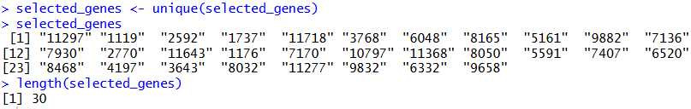
# 4. Use SVM to classify (條件:training data 同時當 testing data)
## 安裝套件
BiocManager::install("e1071")
library("e1071")

## 訓練模型
train_data <- data_norm[selected_genes, ]
x_train <- t(train_data)
y_train <- factor(labels)
svm_model <- svm(x_train, y_train)
pred <- predict(svm_model, x_train)
# 5. Make confusion matrix
confusion_matrix <- table(Predicted = pred, Actual = y_train)
confusion_matrix
Output:
> confusion_matrix
Actual
Predicted ALL AML MLL
ALL 20 0 0
AML 0 20 0
MLL 0 0 17

