HW5
# HW4 的 30 個 DE genes
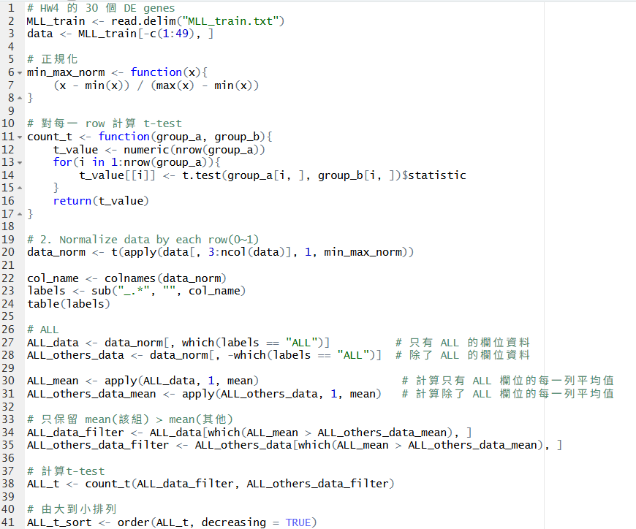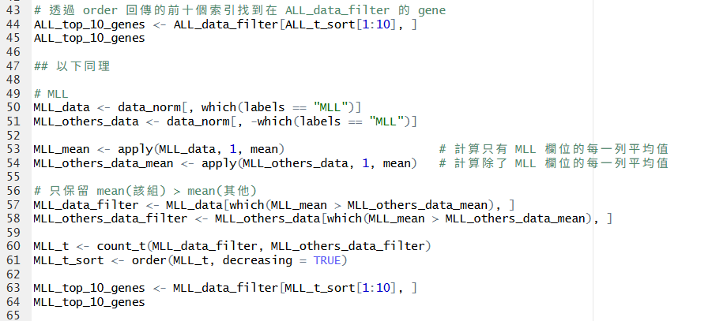

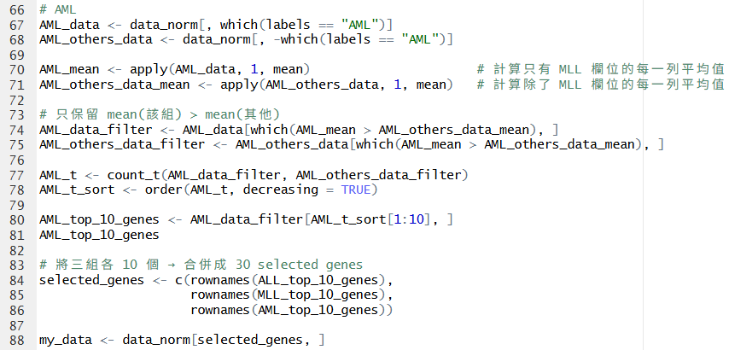
- 畫 2D MDS plot 與 2D PCA plot三種顏色分別代表三類樣本(ALL /
MLL / AML), 並附上 legend
# 安裝套件
library(gplots)
# 設定顏色
color <- c("ALL" = "#EECB27",
"MLL" = "#E13239",
"AML" = "#1F1762")
col_list <- color[labels]
col_list # 觀察
Output:
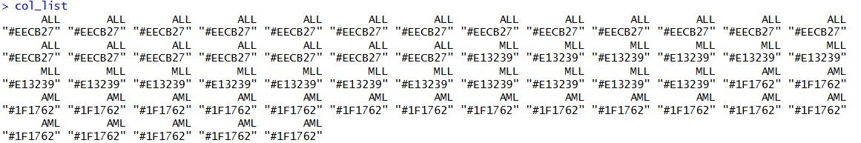

# PCA
my_data_prcomp <- prcomp(t(my_data))

# 畫出 PC1、PC2 個別主導幾 %
pv <- summary(my_data_prcomp)$importance[2, 1:2] * 100
xlab_txt <- paste0("PC1 (", round(pv[1], 1), "%)")
ylab_txt <- paste0("PC2 (", round(pv[2], 1), "%)")

plot(my_data_prcomp$x[, 1],
my_data_prcomp$x[, 2], col = col_list, pch = 17,
xlab = xlab_txt, ylab = ylab_txt)

legend("topright", legend = names(color),
col = color[names(color)], pch = 17, cex = 0.8)
Output:
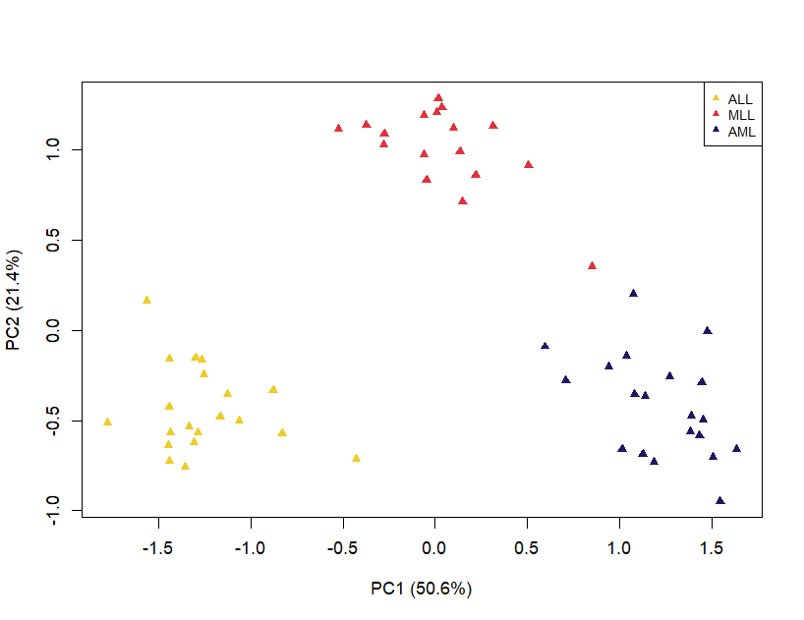

# MDS
my_data_mds <- cmdscale(dist(t(my_data)), k = 2, eig = TRUE)
# 特徵值 → 每個維度解釋的比例
eig <- my_data_mds$eig
## 只用正特徵值當分母
pv_mds <- eig[1:2] / sum(eig[eig > 0]) * 100

xlab_mds <- paste0("MDS1 (", round(pv_mds[1], 1), "%)")
ylab_mds <- paste0("MDS2 (", round(pv_mds[2], 1), "%)")

plot(my_data_mds$points[, 1], my_data_mds$points[, 2],
col = col_list, pch = 16,
xlab = xlab_mds, ylab = ylab_mds)

legend("topright", legend = names(color), col = color,
pch = 16, cex = 0.8)
Output:
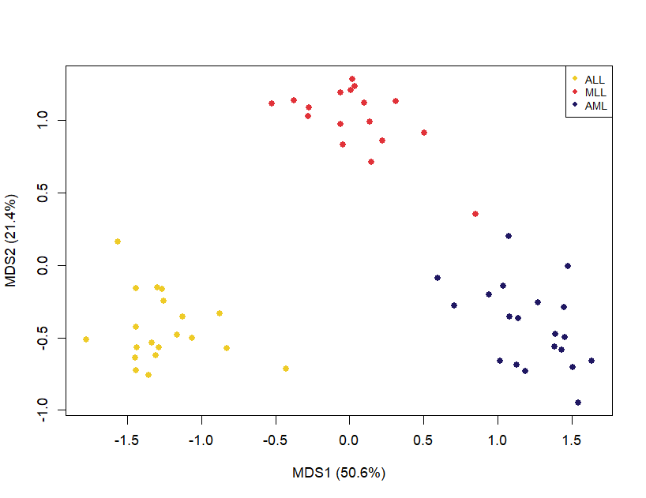

# AI
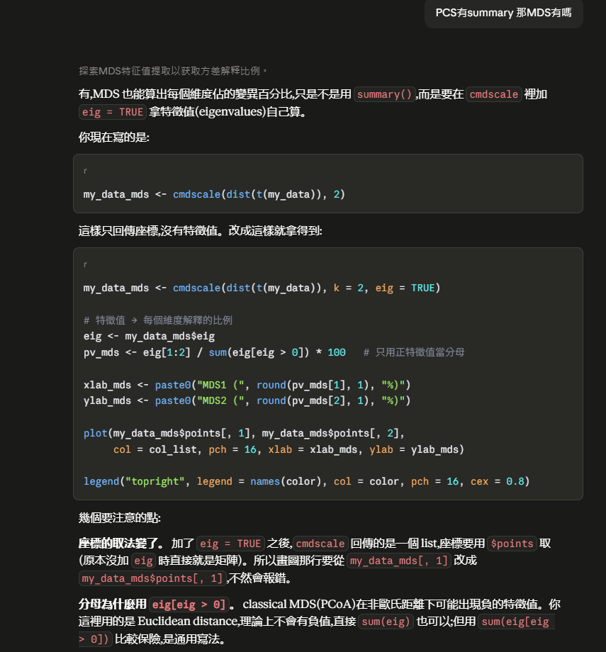

# 2. 用同樣的 30 個 DE genes,畫一張 heatmap + dendrogram
# • 條件 : Average linkage + Euclidean distance
# 計算距離的方法 : euclidean
my_dist <- function(x) {
dist(x, method = "euclidean")
}
# 分群方法 : average
my_hclust <- function(d) {
hclust(d, method = "average")
}

heatmap.2(my_data,
Rowv = F, Colv = TRUE,
dendrogram = "both",
distfun = my_dist,
hclustfun = my_hclust,
scale = "row",
trace = "none",
# 樣本上方加一條 ALL/MLL/AML 顏色條
ColSideColors = col_list,
# (欄邊界, 列邊界), 避免標籤被切
margins = c(6, 8),
# 30 個基因名縮小才放得下
cexRow = 0.6,
cexCol = 0.7,
xlab = "Samples", ylab = "Genes")

legend("topright", legend = names(color), fill = color,
border = NA, bty = "n", cex = 0.8)

Output:
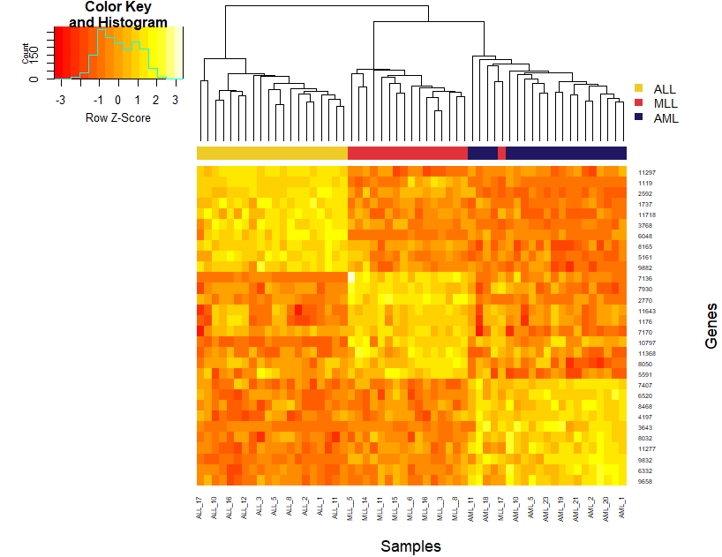

# AI
