

Microsoft Dynamics

Install Guide

Note: Before installing this Power App, contact TSANet to obtain credentials and URL for the Beta and Production environments

Installation

Installation from the AppSource

- Open the link https://appsource.microsoft.com/en-us/product/dynamics-365/tsanet-org.tsanetd365
- Push the Contact button
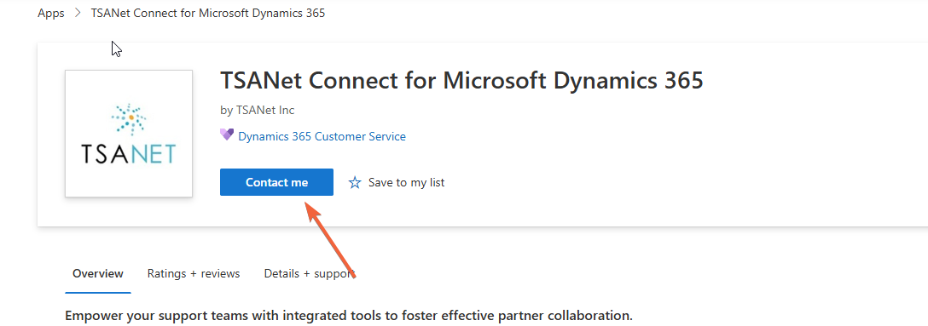
- Confirm all the information.

Manual Installation of the Package

- Open the git hub https://github.com/tsanetgit/MS_Power_App and download the latest managed solution.
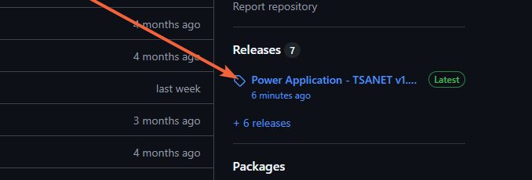

- Open https://make.powerapps.com in your Microsoft tenant.

- Select your environment.
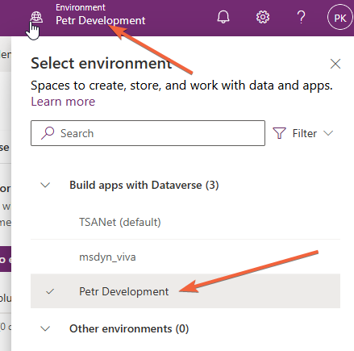

- Click on Import Solution
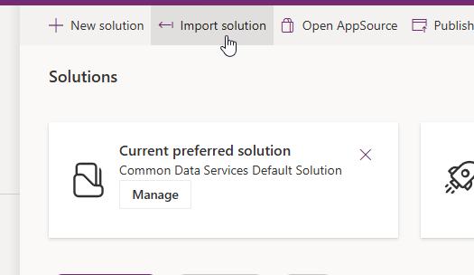

- Select downloaded managed solution.
- Confirm by the Next button.
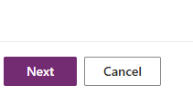
- Create Connections and confirm by the Next button.
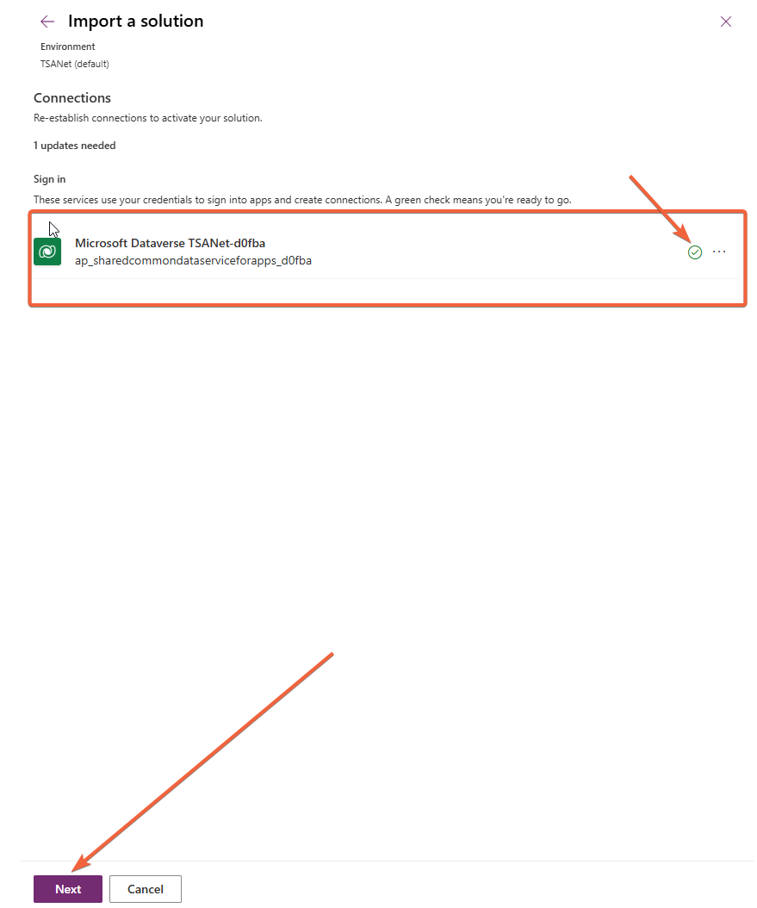

- Ignore legacy environment variables step.

- The package is now being installed.

Configuration
All settings can be configured in the TSANET Configuration application.
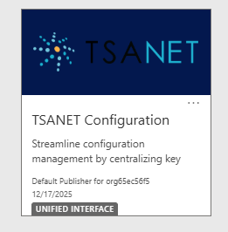

TSANet Credentials

The packages uses authentication to communicate with TSANet Connect. The configuration is in the application “TSANET Configuration”, where you can select from available environments and specify credentials. You can either use OAuth2 or Bearer token authorization.
Note: Contact TSANet for Credentials and URL

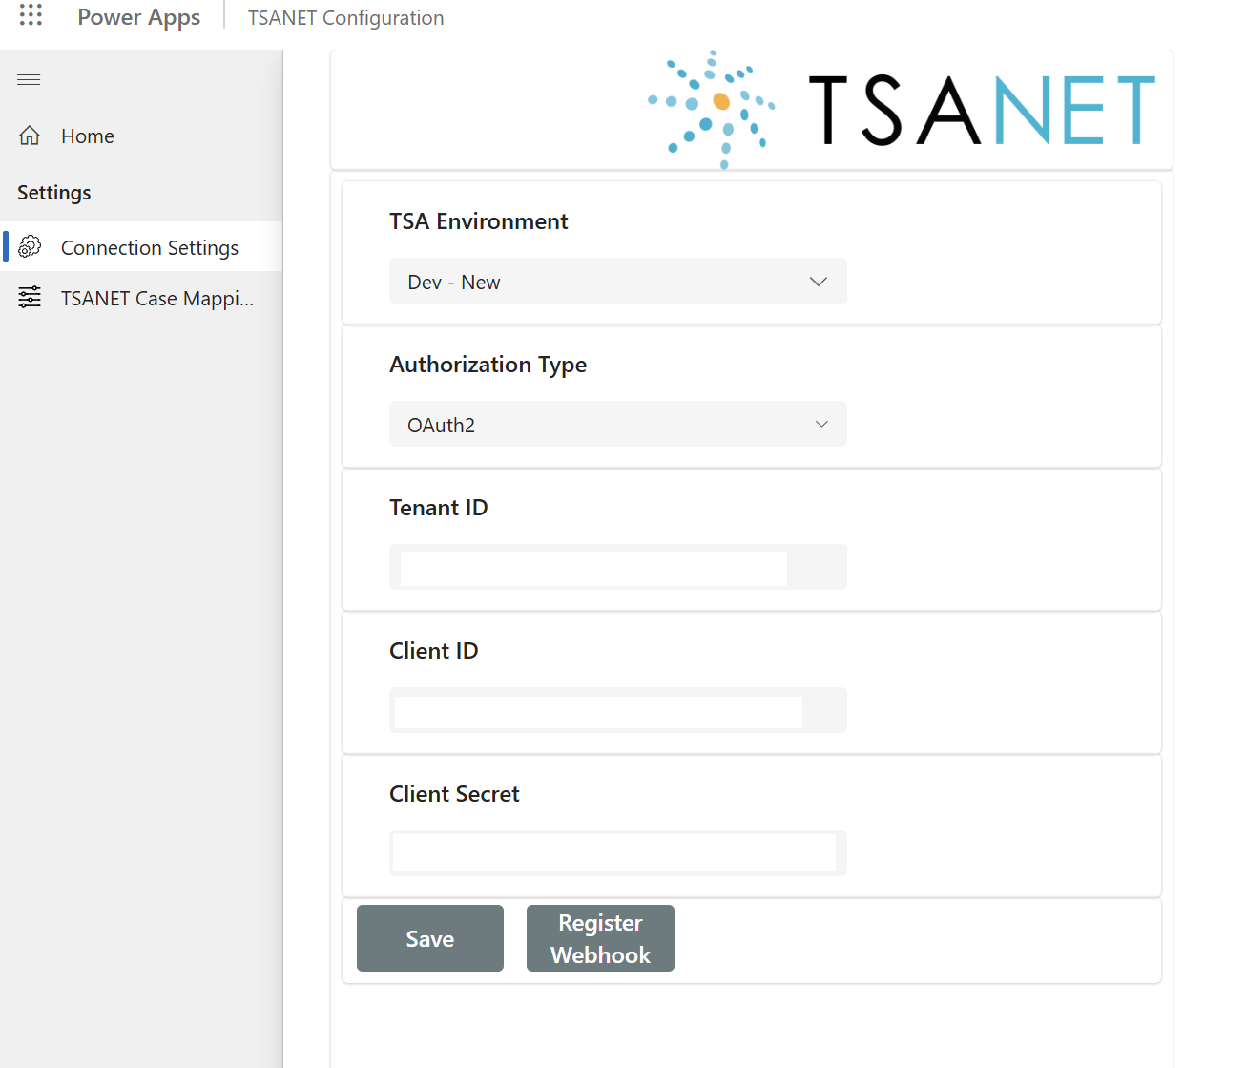

Environments
TSAnet has the following environments.

- Developer: Only used by developers who are making changes to the package
- Beta: Used by Members to test before moving to production
- Prod: Used by Members in Production

Contact TSANet for credentials and URL to the correct environment.

Register webhook
You can register the webhook in the configuration using the "Register webhook" button. The system pop ups the webhook setting where you can leave authorization type as none and click on submit.

The system then registers your Power Automate endpoint in the TSANET, and new or updated cases and notes will be processed directly to your system.

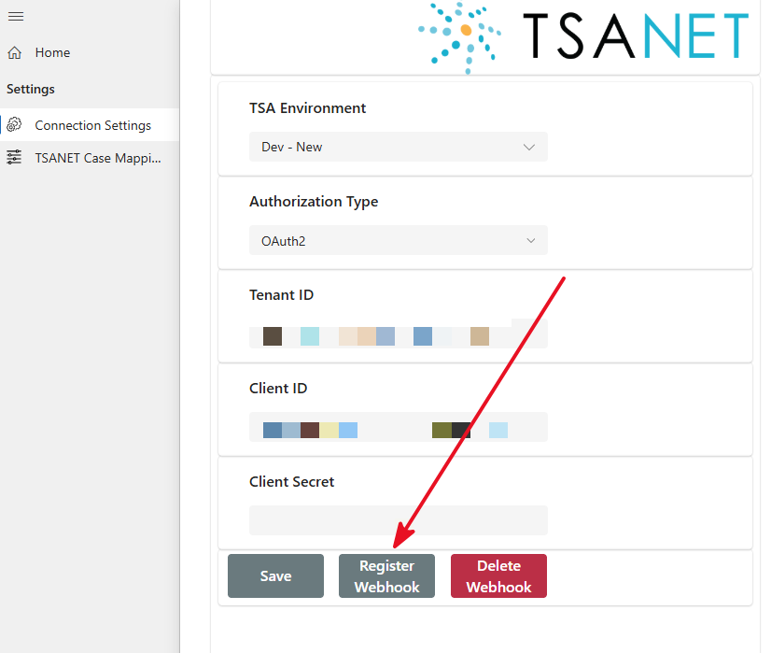

OAUTH2 Authentication
The Tenant ID, Client ID, and Client Secret fields represent service principal credentials from your own Entra ID tenant. Once saved, these are sent to TSANet Connect, which stores them and uses them to obtain its own OAuth token to authenticate when sending webhook notifications to your endpoint. This configuration is not stored in Dataverse — it's held and managed entirely on TSANet's side.
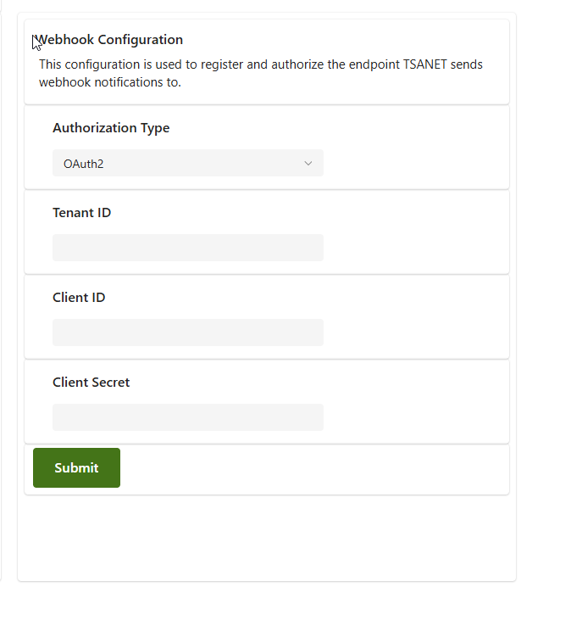

To ensure the webhook endpoint only accepts requests from TSANet, the following Environment Variables must be set before deployment:

- Authorization type – User
- Service Principal Object ID – the Object ID (from Enterprise Applications) of the service principal authorized to trigger this webhook

These values are filled in during Solution import into each environment and restrict the HTTP trigger to authorized calls only.

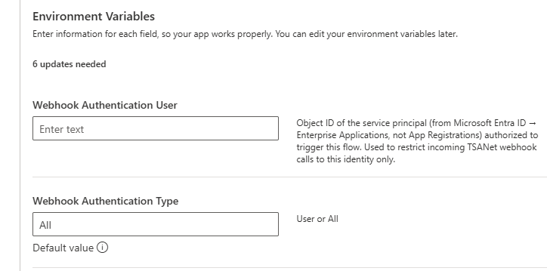

Delete webhook registration
You can delete your existing webhook registrations in the configuration using the " Delete webhooks " button. The system then removes existing webhook registration and stops sending new events.
You can register for webhook anytime in the future again.

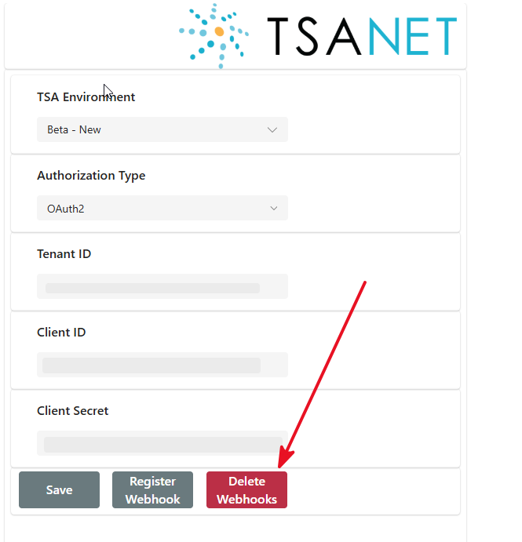

Use TSANET in your solution

Add components to application.

- Open https://make.powerapps.com in your Microsoft tenant.

- Select your environment.

- Open existing unmanaged solution or create the new

- Select Apps in the menu and open your application
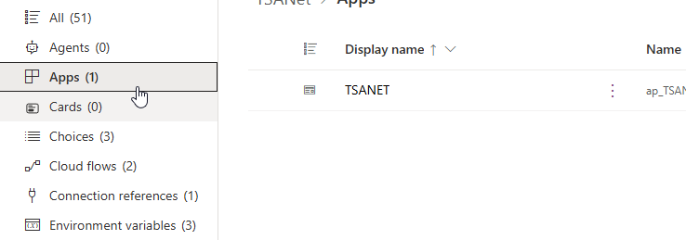

- Click on edit
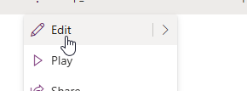

- Click on New
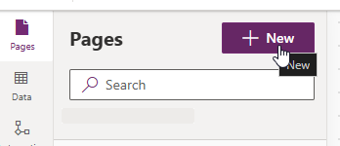

- Select Dataverse table
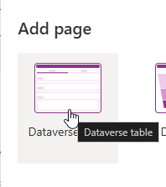
- Select TSANET tables
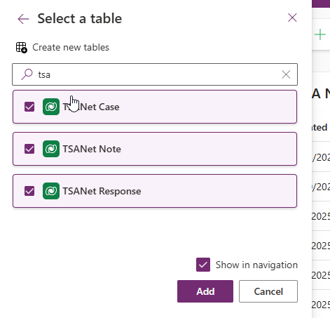
- Click on Add

Setup TSANET table relationship
You must create relationships between tables to use TSANET within your existing solution.

- Open https://make.powerapps.com in your Microsoft tenant.

- Select your environment.

- Open existing unmanaged solution or create the new

- Open Tables -> TSANET Case
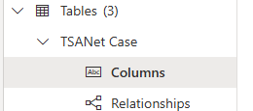

- Create new column “Your table” with details below:
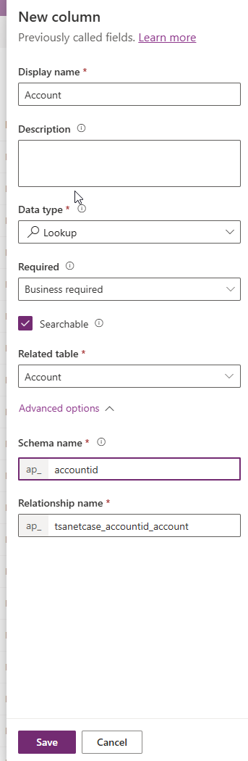

Add TSANET Case subgrid to the form

Once you have created relationship, you can add the subgrid to the form.

- Open https://make.powerapps.com in your Microsoft tenant.

- Select your environment.

- Open existing unmanaged solution or create the new.
- Open Tables -> “Your custom table”
- Open the main form
- Select Components -> Grid -> Subgrid
- Check “Show related records”
- Select table “TSANet Cases” and confirm by the button “Done”
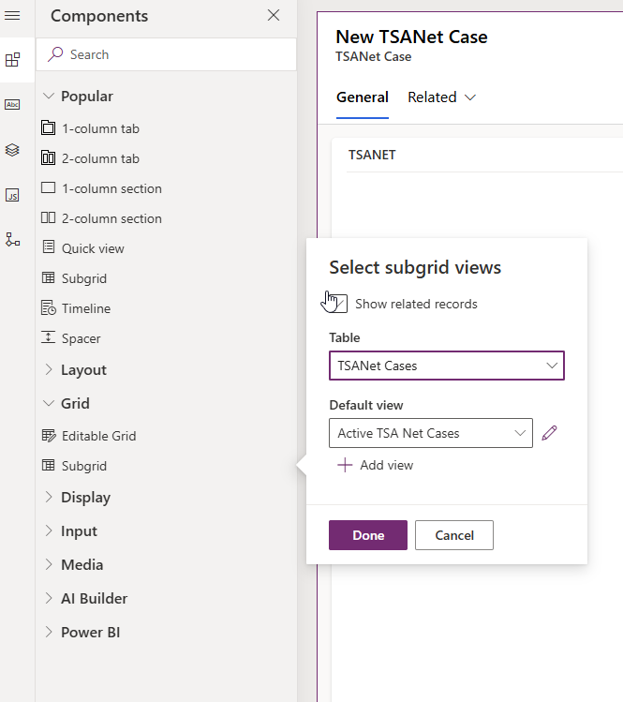

Assign Permissions

Users must have assigned “TSANET User” role, or you can modify your role with the following permissions.

Permissions:
- TSANET Case
- TSANET Note
- TSANET Response
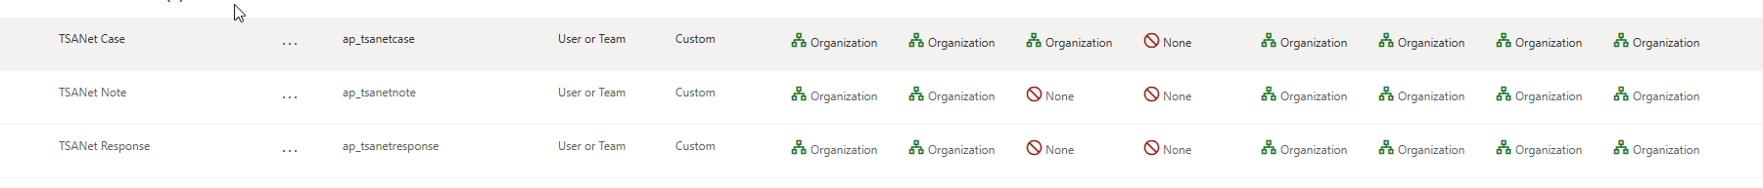

You can follow these instructions to assign the role.
- Open https://admin.powerplatform.microsoft.com/
- Select your environment
- Click on settings
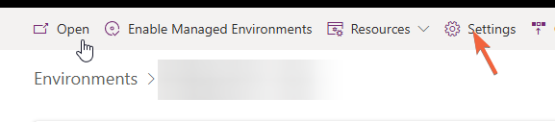

- Click on Users + permissions -> Users
- Select the user
- Click on Manage security roles
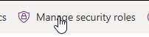

- Select the “TSANET User” role and click on save

Package Details and Configuration Options

Data model

TSANET Case
A collaboration case within the TSANet framework that serves as the primary record for tracking collaboration between member organizations during a support issue.

Logical Name | Display Name | Attribute Type | Description | Additional data
ap_companycode | Company Code | Integer | Company Code | Minimum value: 0 Maximum value: 2147483647
ap_companyname | Company Name | String | Company Name | Format: Text Max length: 100
ap_direction | Direction | Picklist |  | Options: 0: Inbound 1: Outbound Default: 1
ap_formjson | Form JSON | Memo | The current form data from the TSANET. | Format: Text Max length: 200000
ap_name | ID | String | TSANET Unique identifier | Format: Text Max length: 100
ap_sentjson | Sent JSON | Memo | Sent JSON data, only for outbound cases for logging purposes. | Format: Text Max length: 200000
ap_submittercasenumber | Submitter Case Number | String |  | Format: Text Max length: 100
ap_tsanetcaseid | TSA Net Case | Uniqueidentifier | Unique identifier for entity instances
createdby | Created By | Lookup | Unique identifier of the user who created the record. | Targets: systemuser
createdon | Created On | DateTime | Date and time when the record was created. | Format: DateAndTime
createdonbehalfby | Created By (Delegate) | Lookup | Unique identifier of the delegate user who created the record. | Targets: systemuser
importsequencenumber | Import Sequence Number | Integer | Sequence number of the import that created this record. | Minimum value: -2147483648 Maximum value: 2147483647
modifiedby | Modified By | Lookup | Unique identifier of the user who modified the record. | Targets: systemuser
modifiedon | Modified On | DateTime | Date and time when the record was modified. | Format: DateAndTime
modifiedonbehalfby | Modified By (Delegate) | Lookup | Unique identifier of the delegate user who modified the record. | Targets: systemuser
overriddencreatedon | Record Created On | DateTime | Date and time that the record was migrated. | Format: DateOnly
ownerid | Owner | Owner | Owner Id | Targets: systemuser team
owningbusinessunit | Owning Business Unit | Lookup | Unique identifier for the business unit that owns the record | Targets: businessunit
owningteam | Owning Team | Lookup | Unique identifier for the team that owns the record. | Targets: team
owninguser | Owning User | Lookup | Unique identifier for the user that owns the record. | Targets: systemuser
statecode | Status | State | Status of the TSA Net Case | States: 0: Active 1: Inactive
statuscode | Status Reason | Status | Reason for the status of the TSA Net Case | States: 1: Open 2: Closed 120950001: Information 120950002: Rejected 120950003: Accepted
timezoneruleversionnumber | Time Zone Rule Version Number | Integer | For internal use only. | Minimum value: -1 Maximum value: 2147483647
utcconversiontimezonecode | UTC Conversion Time Zone Code | Integer | Time zone code that was in use when the record was created. | Minimum value: -1 Maximum value: 2147483647
versionnumber | Version Number | BigInt | Version Number | Minimum value: -9223372036854775808 Maximum value: 9223372036854775807

TSANET Note
The object is used for logging and managing communications or updates related to a TSANet Case. It allows members to document important information about the case in real-time.

Logical Name | Display Name | Attribute Type | Description | Additional data
ap_creatoremail | Creator (Email) | String |  | Format: Text Max length: 100
ap_creatorname | Creator (Name) | String |  | Format: Text Max length: 100
ap_description | Description | Memo | Note description | Format: Text Max length: 2000
ap_name | Summary | String | Not subject | Format: Text Max length: 100
ap_priority | (DEPRECATED) Priority | Picklist |  | Options: 3: Low 2: Medium 1: High Default: 3
ap_tsanetcaseid | TSA Net Case | Lookup |  | Targets: ap_tsanetcase
ap_tsanetnoteid | TSA Net Note | Uniqueidentifier | Unique identifier for entity instances
ap_tsanotecode | Note ID | String | TSANET unique identifier | Format: Text Max length: 100
createdby | Created By | Lookup | Unique identifier of the user who created the record. | Targets: systemuser
createdon | Created On | DateTime | Date and time when the record was created. | Format: DateAndTime
createdonbehalfby | Created By (Delegate) | Lookup | Unique identifier of the delegate user who created the record. | Targets: systemuser
importsequencenumber | Import Sequence Number | Integer | Sequence number of the import that created this record. | Minimum value: -2147483648 Maximum value: 2147483647
modifiedby | Modified By | Lookup | Unique identifier of the user who modified the record. | Targets: systemuser
modifiedon | Modified On | DateTime | Date and time when the record was modified. | Format: DateAndTime
modifiedonbehalfby | Modified By (Delegate) | Lookup | Unique identifier of the delegate user who modified the record. | Targets: systemuser
overriddencreatedon | Record Created On | DateTime | Date and time that the record was migrated. | Format: DateOnly
ownerid | Owner | Owner | Owner Id | Targets: systemuser team
owningbusinessunit | Owning Business Unit | Lookup | Unique identifier for the business unit that owns the record | Targets: businessunit
owningteam | Owning Team | Lookup | Unique identifier for the team that owns the record. | Targets: team
owninguser | Owning User | Lookup | Unique identifier for the user that owns the record. | Targets: systemuser
statecode | Status | State | Status of the TSA Net Note | States: 0: Active 1: Inactive
statuscode | Status Reason | Status | Reason for the status of the TSA Net Note | States: 1: Active 2: Inactive
timezoneruleversionnumber | Time Zone Rule Version Number | Integer | For internal use only. | Minimum value: -1 Maximum value: 2147483647
utcconversiontimezonecode | UTC Conversion Time Zone Code | Integer | Time zone code that was in use when the record was created. | Minimum value: -1 Maximum value: 2147483647
versionnumber | Version Number | BigInt | Version Number | Minimum value: -9223372036854775808 Maximum value: 9223372036854775807

TSANET Response
The object captures formal replies or actions taken with an inbound TSANet Case.

Logical Name | Display Name | Attribute Type | Description | Additional data
ap_description | Description | Memo | Description or next steps | Format: Text Max length: 2000
ap_engineeremail | Engineer Email | String |  | Format: Email Max length: 300
ap_engineername | Engineer Name | String |  | Format: Text Max length: 300
ap_engineerphone | Engineer Phone | String |  | Format: Text Max length: 300
ap_internalcasenumber | Internal Case Number | String | Internal Case Number is used for incoming case approvals. | Format: Text Max length: 100
ap_name | Name | String |  | Format: Text Max length: 100
ap_tsanetcaseid | TSA Net Case | Lookup |  | Targets: ap_tsanetcase
ap_tsanetresponseid | TSA Net Response | Uniqueidentifier | Unique identifier for entity instances
ap_tsaresponsecode | Response ID | String | TSANET unique identifier | Format: Text Max length: 100
ap_type | Type | Picklist | Response type | Options: 1: Approval 0: Reject 2: Request Information 3: Information Response 4: Close 5: Approval Update Default: -1
createdby | Created By | Lookup | Unique identifier of the user who created the record. | Targets: systemuser
createdon | Created On | DateTime | Date and time when the record was created. | Format: DateAndTime
createdonbehalfby | Created By (Delegate) | Lookup | Unique identifier of the delegate user who created the record. | Targets: systemuser
importsequencenumber | Import Sequence Number | Integer | Sequence number of the import that created this record. | Minimum value: -2147483648 Maximum value: 2147483647
modifiedby | Modified By | Lookup | Unique identifier of the user who modified the record. | Targets: systemuser
modifiedon | Modified On | DateTime | Date and time when the record was modified. | Format: DateAndTime
modifiedonbehalfby | Modified By (Delegate) | Lookup | Unique identifier of the delegate user who modified the record. | Targets: systemuser
overriddencreatedon | Record Created On | DateTime | Date and time that the record was migrated. | Format: DateOnly
ownerid | Owner | Owner | Owner Id | Targets: systemuser team
owningbusinessunit | Owning Business Unit | Lookup | Unique identifier for the business unit that owns the record | Targets: businessunit
owningteam | Owning Team | Lookup | Unique identifier for the team that owns the record. | Targets: team
owninguser | Owning User | Lookup | Unique identifier for the user that owns the record. | Targets: systemuser
statecode | Status | State | Status of the TSA Net Response | States: 0: Active 1: Inactive
statuscode | Status Reason | Status | Reason for the status of the TSA Net Response | States: 1: Active 2: Inactive
timezoneruleversionnumber | Time Zone Rule Version Number | Integer | For internal use only. | Minimum value: -1 Maximum value: 2147483647
utcconversiontimezonecode | UTC Conversion Time Zone Code | Integer | Time zone code that was in use when the record was created. | Minimum value: -1 Maximum value: 2147483647
versionnumber | Version Number | BigInt | Version Number | Minimum value: -9223372036854775808 Maximum value: 9223372036854775807

TSANET Case Mapping
The object contains mapping configuration for various automated processes described in partner’s configuration.
Logical Name | Display Name | Attribute Type | Description | Additional data
ap_attributetype | Attribute Type | Choice |  | Options:  1: Text, Int, Decimal, Bool (no color)  2: Lookup (no color)  3: OptionSet (no color)  4: Money (no color)  Default: N/A
ap_casemappingid | Case Mapping | Uniqueidentifier | Unique identifier for entity instances
ap_isrequired | Required for Case Create | Two options |  | True: Yes  False: No  Default Value: False
ap_lookupentityname | Lookup Table Name | Text |  | Format: Text  Max length: 100
ap_lookupsearchattribute | Lookup Search Attribute | Text |  | Format: Text  Max length: 100
ap_mappingtype | Mapping Type | Choice |  | Options:  120950000: Response Form (no color)  120950001: Case Create (no color)  120950002: TSA Case defaults from Case (no color)  Default: N/A
ap_name | Name | Text |  | Format: Text  Max length: 850
ap_sourcejsonpath | Source (Json Path or Attribute) | Text | Handle paths like "customFields.Customer Case #" | Format: Text  Max length: 200
ap_targetattribute | Target Attribute (Json Path or Attribute) | Text |  | Format: Text  Max length: 100
createdby | Created By | Lookup | Unique identifier of the user who created the record. | Targets:  systemuser
createdbyname | N/A | Text | N/A | Format: Text  Max length: 100
createdbyyominame | N/A | Text | N/A | Format: Text  Max length: 100
createdon | Created On | DateTime | Date and time when the record was created. | Format: DateAndTime
createdonbehalfby | Created By (Delegate) | Lookup | Unique identifier of the delegate user who created the record. | Targets:  systemuser
createdonbehalfbyname | N/A | Text | N/A | Format: Text  Max length: 100
createdonbehalfbyyominame | N/A | Text | N/A | Format: Text  Max length: 100
importsequencenumber | Import Sequence Number | Whole number | Sequence number of the import that created this record. | Minimum value: -2147483648  Maximum value: 2147483647
modifiedby | Modified By | Lookup | Unique identifier of the user who modified the record. | Targets:  systemuser
modifiedbyname | N/A | Text | N/A | Format: Text  Max length: 100
modifiedbyyominame | N/A | Text | N/A | Format: Text  Max length: 100
modifiedon | Modified On | DateTime | Date and time when the record was modified. | Format: DateAndTime
modifiedonbehalfby | Modified By (Delegate) | Lookup | Unique identifier of the delegate user who modified the record. | Targets:  systemuser
modifiedonbehalfbyname | N/A | Text | N/A | Format: Text  Max length: 100
modifiedonbehalfbyyominame | N/A | Text | N/A | Format: Text  Max length: 100
overriddencreatedon | Record Created On | DateTime | Date and time that the record was migrated. | Format: DateOnly
owneridname | N/A | Text | Name of the owner | Format: Text  Max length: 100
owneridyominame | N/A | Text | Yomi name of the owner | Format: Text  Max length: 100
owningbusinessunit | Owning Business Unit | Lookup | Unique identifier for the business unit that owns the record | Targets:  businessunit
owningbusinessunitname | N/A | Text | N/A | Format: Text  Max length: 100
owningteam | Owning Team | Lookup | Unique identifier for the team that owns the record. | Targets:  team
owninguser | Owning User | Lookup | Unique identifier for the user that owns the record. | Targets:  systemuser
timezoneruleversionnumber | Time Zone Rule Version Number | Whole number | For internal use only. | Minimum value: -1  Maximum value: 2147483647
utcconversiontimezonecode | UTC Conversion Time Zone Code | Whole number | Time zone code that was in use when the record was created. | Minimum value: -1  Maximum value: 2147483647
versionnumber | Version Number | BigInt | Version Number | Minimum value: -9223372036854775808  Maximum value: 9223372036854775807

TSANET Setting
The object contains the settings of the TSANET connector, for example the credentials.

Logical Name | Display Name | Attribute Type | Description | Additional data
ap_clientid | Client ID | Text |  | Format: Text  Max length: 100
ap_name | Name | Text |  | Format: Text  Max length: 850
ap_secret | Secret | Text |  | Format: Text  Max length: 100
ap_tsanetsettingid | TSANET Setting | Uniqueidentifier | Unique identifier for entity instances
ap_uri | URI | Text |  | Format: Text  Max length: 400
createdby | Created By | Lookup | Unique identifier of the user who created the record. | Targets:  systemuser
createdbyname | N/A | Text | N/A | Format: Text  Max length: 100
createdbyyominame | N/A | Text | N/A | Format: Text  Max length: 100
createdon | Created On | DateTime | Date and time when the record was created. | Format: DateAndTime
createdonbehalfby | Created By (Delegate) | Lookup | Unique identifier of the delegate user who created the record. | Targets:  systemuser
createdonbehalfbyname | N/A | Text | N/A | Format: Text  Max length: 100
createdonbehalfbyyominame | N/A | Text | N/A | Format: Text  Max length: 100
importsequencenumber | Import Sequence Number | Whole number | Sequence number of the import that created this record. | Minimum value: -2147483648  Maximum value: 2147483647
modifiedby | Modified By | Lookup | Unique identifier of the user who modified the record. | Targets:  systemuser
modifiedbyname | N/A | Text | N/A | Format: Text  Max length: 100
modifiedbyyominame | N/A | Text | N/A | Format: Text  Max length: 100
modifiedon | Modified On | DateTime | Date and time when the record was modified. | Format: DateAndTime
modifiedonbehalfby | Modified By (Delegate) | Lookup | Unique identifier of the delegate user who modified the record. | Targets:  systemuser
modifiedonbehalfbyname | N/A | Text | N/A | Format: Text  Max length: 100
modifiedonbehalfbyyominame | N/A | Text | N/A | Format: Text  Max length: 100
overriddencreatedon | Record Created On | DateTime | Date and time that the record was migrated. | Format: DateOnly
ownerid | Owner | Owner | Owner Id | Targets:  systemuser  team
owneridname | N/A | Text | Name of the owner | Format: Text  Max length: 100
owneridyominame | N/A | Text | Yomi name of the owner | Format: Text  Max length: 100
owningbusinessunit | Owning Business Unit | Lookup | Unique identifier for the business unit that owns the record | Targets:  businessunit
owningbusinessunitname | N/A | Text | N/A | Format: Text  Max length: 100
owningteam | Owning Team | Lookup | Unique identifier for the team that owns the record. | Targets:  team
owninguser | Owning User | Lookup | Unique identifier for the user that owns the record. | Targets:  systemuser
timezoneruleversionnumber | Time Zone Rule Version Number | Whole number | For internal use only. | Minimum value: -1  Maximum value: 2147483647
utcconversiontimezonecode | UTC Conversion Time Zone Code | Whole number | Time zone code that was in use when the record was created. | Minimum value: -1  Maximum value: 2147483647
versionnumber | Version Number | BigInt | Version Number | Minimum value: -9223372036854775808  Maximum value: 9223372036854775807

Flows

The TSANet managed package includes flows designed for flexible automation. These flows enable actions such as updating TSANet records, creating new TSANet Cases, accepting or rejecting requests, requesting more information, or adding new notes. Additionally, all these actions are available in flows under the TSANet section, allowing you to customize the logic to meet your needs.

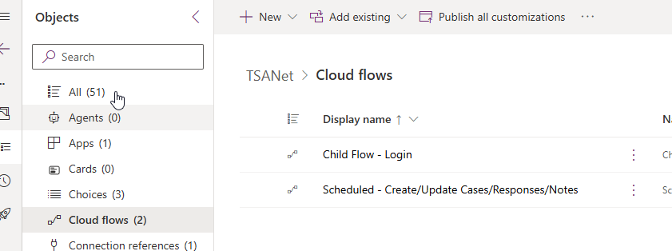

Flows

- Child Flow – Login: The flow authorizes to the API and returns the token.
- Scheduled – Create/Update Cases/Responses/Notes: The scheduled flow that retrieves the current case status or creates new inbound cases.

Actions
The TSANet managed package includes various actions designed to enhance and streamline workflows in Dynamics/Power Apps. These actions enable seamless integration and automation, such as retrieving data, creating cases, and updating existing records. You can incorporate these actions into custom flows to tailor functionality to specific business requirements.

Available Actions
- GetCase: Fetches case details based on the specified criteria.
- GetCompanyByName: Retrieves companies using its name as the search parameter.
- GetFormByCompany: Retrieves a form linked to a specific company for further processing.
- PostCase: Creates a new case with all required and optional fields populated.
- PostCaseApproval: Initiates the approval process for a case, ensuring compliance and proper documentation.
- PostCaseApprovalUpdate: Updates the status of an approval, reflecting changes to the case approval process.
- PostCaseNote: Adds notes to an existing case, enabling better tracking and communication.

Plugins
The TSANet managed package includes a set of plugins that handle various customizations and business logic within Power Apps. These plugins can be triggered by specific user actions, API calls, or system events. Together, they provide flexibility and automation to meet diverse business requirements.

Available Plugins
- CommonIntegrationPlugin: A generic integration plugin used for managing common tasks and actions, ensuring seamless data flow between systems.
- GetCasePlugin: Retrieves case information based on predefined parameters. Typically triggered by the GetCase action.
- GetCompanyPlugin: Fetches company details by name or identifier. Triggered by the GetCompanyByName action.
- GetFormByCompanyPlugin: Returns forms associated with a specific company. This plugin is linked to the GetFormByCompany action.
- PostCasePlugin: Handles the creation of new cases. It is triggered when the PostCase action is executed, ensuring that all data is validated and recorded accurately.
- PostCaseApprovalPlugin: Manages the approval process for cases. This plugin is invoked when the PostCaseApproval action is performed.
- PostCaseApprovalUpdatePlugin: Updates case approval statuses and is tied to the PostCaseApprovalUpdate action for real-time approval tracking.
- PostCaseNotePlugin: Adds notes to an existing case. Triggered by the PostCaseNote action, it facilitates better communication and documentation.
- PostCaseResponseOnCreatePlugin: Automatically generates a response when a case is created. Triggered by system events to streamline case follow-ups.

Key Features
- Action-Triggered Plugins: These plugins are invoked by specific actions performed in Dynamics or Power Apps, providing precise control over workflow customization.
- System-Triggered Plugins: Plugins like PostCaseResponseOnCreatePlugin are automatically triggered by internal events, ensuring seamless operations without manual intervention.
- Customizable Logic: Each plugin contains specific business logic that can be tailored to meet unique organizational needs, enabling a fully adaptable Dynamics/Power Apps experience.

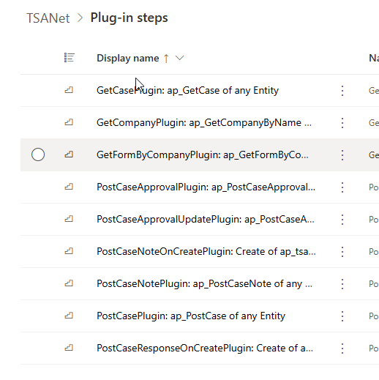

JavaScripts
The TSANet solution includes a set of JavaScript files that extend the functionality of Power Apps forms and actions. These scripts handle front-end customizations, UI enhancements, and client-side integrations to improve the user experience and ensure seamless interactions.

JavaScript Files Overview
- CaseResponse.js: Manages client-side logic for case responses. This script ensures that responses are appropriately captured and displayed on the form.
- CaseTSA.js: Contains specific logic and actions related to TSANet cases. It drives custom behaviors for case management, ensuring compliance with TSANet workflows. This script uses html webresource and generates the form for displaying or creating cases.
- CaseTSAButtons.js: Handles button actions on case forms.
- CommonIntegration.js: Manages frontend to backend integration for connecting external systems with Dynamics. All scripts uses backend API that handling the communication with the TSANET.
- CommonScripts.js: A library of reusable JavaScript functions and utilities used across various forms and modules. This script reduces redundancy and ensures consistent behavior.
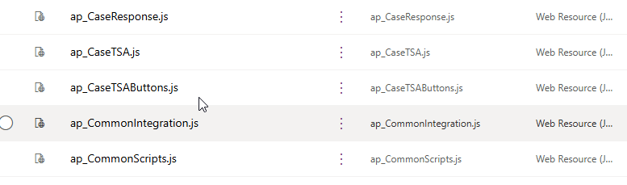

HTML Webresource
The CaseCustomForm.html file serves as the core HTML template for rendering the TSANET case UX in Power Apps. It is designed to provide a user-friendly and responsive form for creating, updating, and managing cases. The file incorporates custom JavaScript, CSS, and Power Apps form elements to ensure seamless functionality and a modern user experience.

Key Features
- Custom Layout: Provides a structured and intuitive layout for case-related fields, ensuring users can easily input and view case details.
- Integration with JavaScript: Works in conjunction with scripts like CaseTSA.js and CaseTSAButtons.js to enable dynamic actions and form behavior.
- Dynamic Elements: Includes buttons, dropdowns, and interactive components for improved usability.
- Styling: Utilizes custom CSS (or SCSS if extended) to align the form with organizational branding and ensure responsive design.

Partner’s Configuration
Here is the example of partner configuration described in following chapters.

Automatically create TSA Note by email
This function enables the automatic creation of a TSA Note whenever an email is received or sent within the Dynamics Case. The system monitors email activities linked to the case and triggers the creation of a new TSA Note, capturing the content and metadata of the email. This ensures that all email communications are logged and associated with the relevant TSANet Case for better traceability and collaboration.

You can enable or disable the functionality using environment variable “Auto Create TSANote by Email”.
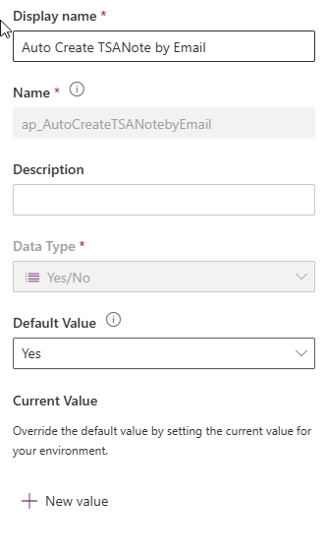

Automatically create TSA Note by note
This function allows for the automatic generation of a TSA Note when a new note is manually added to a Dynamics Case. Upon detecting a new note entry, the system creates a corresponding TSA Note record, ensuring that all updates and annotations are consistently reflected in the TSANet Case. This automation helps maintain comprehensive documentation and improves the efficiency of case management.

You can enable or disable the functionality using environment variable “Auto Create TSANote by Note”.
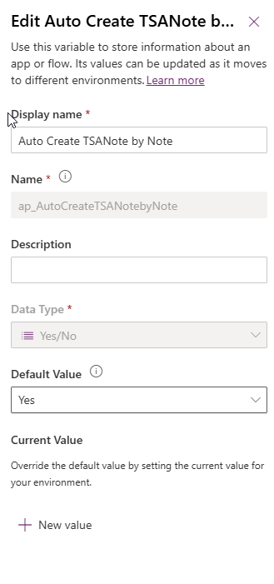

Automatically create Case from Response Form
This function enables members to automatically create a Dynamics Case when a TSA Case is accepted. It streamlines the case management process by leveraging predefined mappings and automation logic.
1) Administrator can add new fields on the TSANET Case Response table. These fields can be prefilled from the TSANET Case data using the 'Case mappings' setting. This allows for seamless data transfer and ensures that relevant information is readily available during case creation.
2) Administrator can map any field from the TSANET Case Response table to the case creation logic using the 'Case mappings'. Additionally, they can define which fields are mandatory, ensuring that all required data is captured before a case is created. This provides flexibility and control over the automation process.

Automatic Case Routing
System provides possibility to automate incoming TSA Case routing. You can enable it using environment variable “Auto Routing of New Case”.

Routing:
  - System search for existing cases using Customer Case #. If the case is found system relates the TSA Case with the Case and approves it.
  - If the case is not found, system search for the customer using the name and creates a case for the customer and relates it with the TSA Case and approves it.
  - If the customer is not found, the process ends.
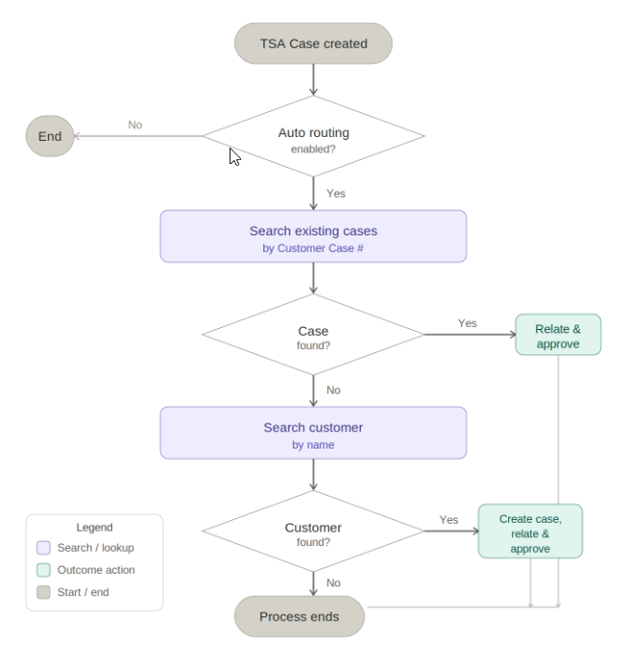
Process can be customized using Power Automate editor, the name of the process is “On Create Case - Auto Route”.
You can customize following parts of the process:
- GetCustomerFields – There you can get the data from the incoming TSA Case. You can save that data into variables for further usage.
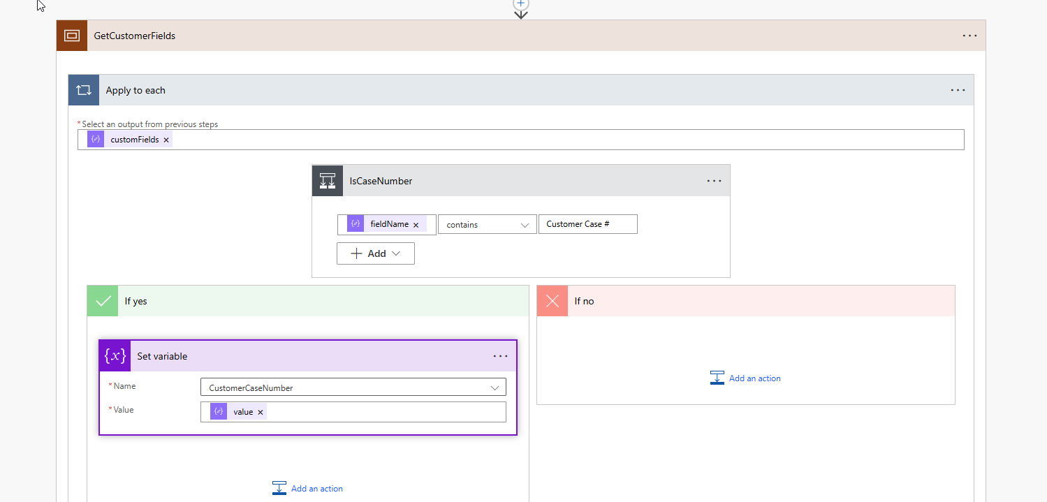
- SearchExistingCase – Here is the query for retrieve of existing case from the Dynamics. You can edit the filter rows according to screenshot.
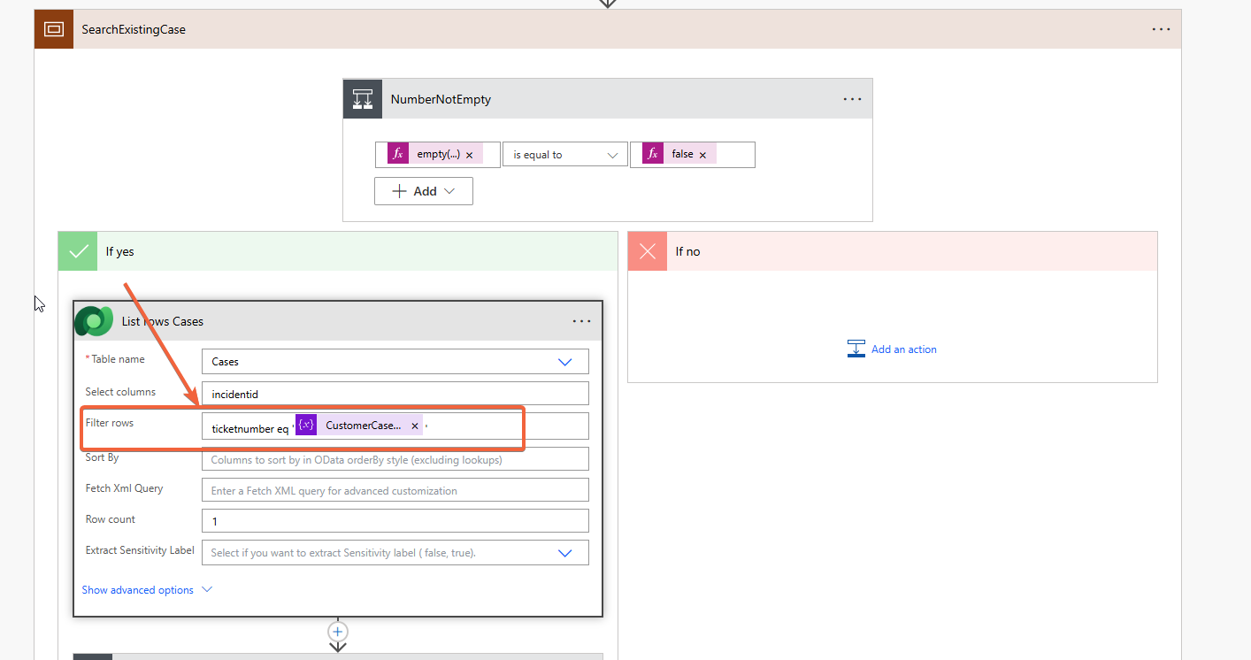
- CreateCase – If the Case is not found, system creates a case. You can edit the case creation and retrieving existing account in this scope.

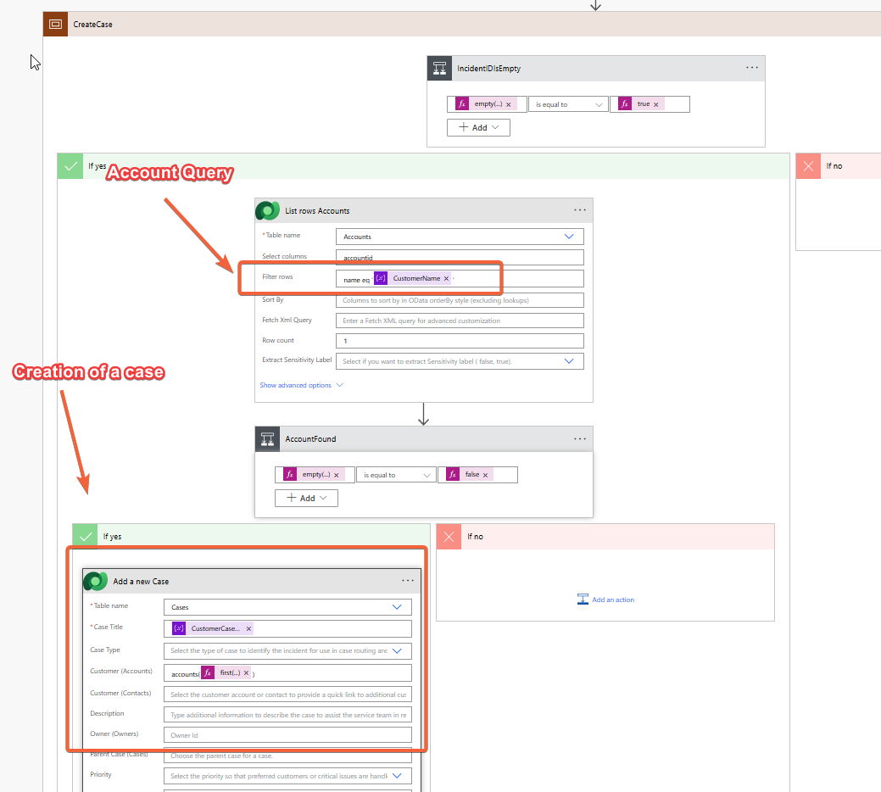

Prefill defaults from the case
The system can prefill the defaults from the related case. The setting is dynamic so the administrator can set any attribute to be prefilled from the case into any TSANET form. The system supports the expand, so you can use attributes from the related tables as well.

Example 1 – prefill the case summary
In this example the system prefills the case title into the problemSummary form field.
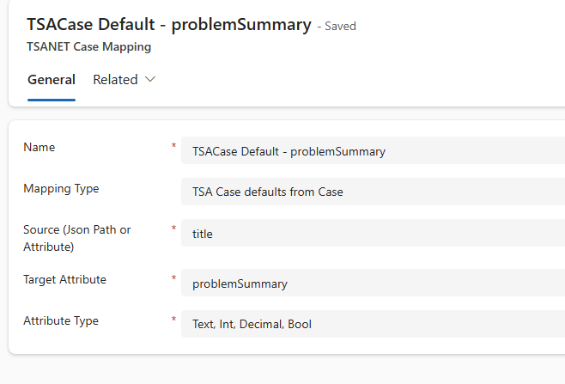

Example 2 – prefill the customer name
More complex scenario where the system prefills the customer name which is in the table related to the case.
